Barba Azul Nature Reserve 2015
June Update
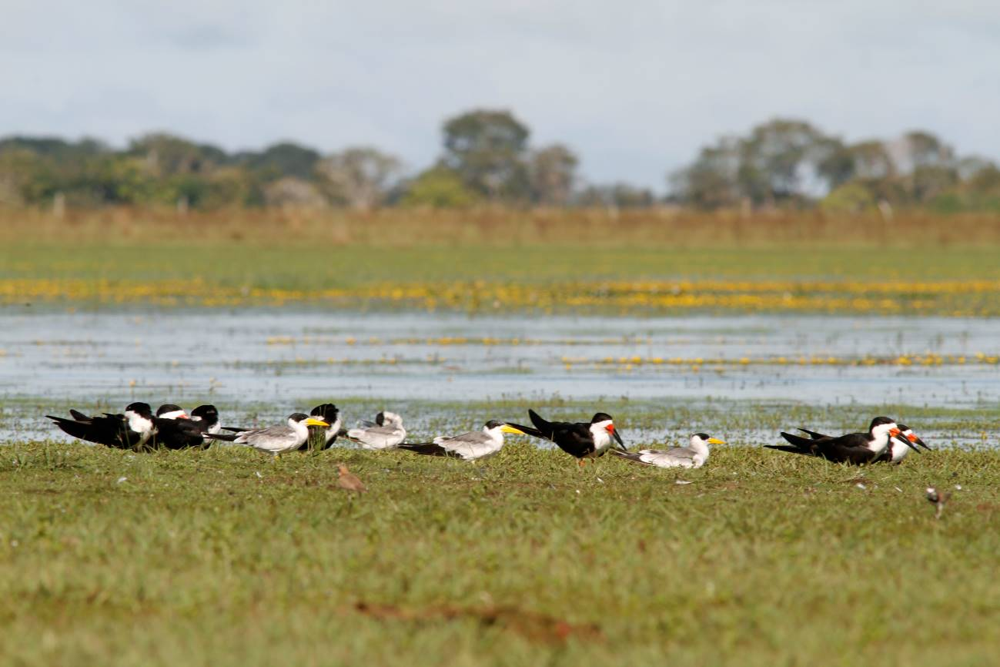

Introduction
February to April in Bolivia are the heavy rainy season months where a lot of activities are stalled because of poor roads (read mud), strong rains, and flooding. This is also when the Blue-throated Macaw breeds, which complicates things. This year was a more typical flooding season in the Beni, without exaggerated flooding, but the rainy season appears to be extending. This will mean heavy truck usage might not be possible until July.

Conservation and development of the Barba Azul Nature Reserve is supported in 2015 by:
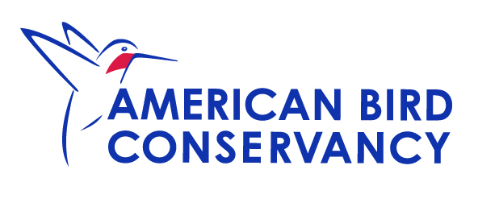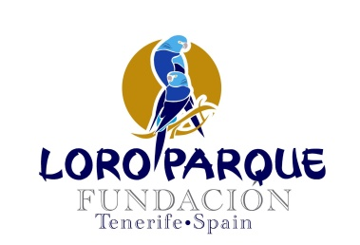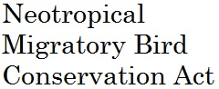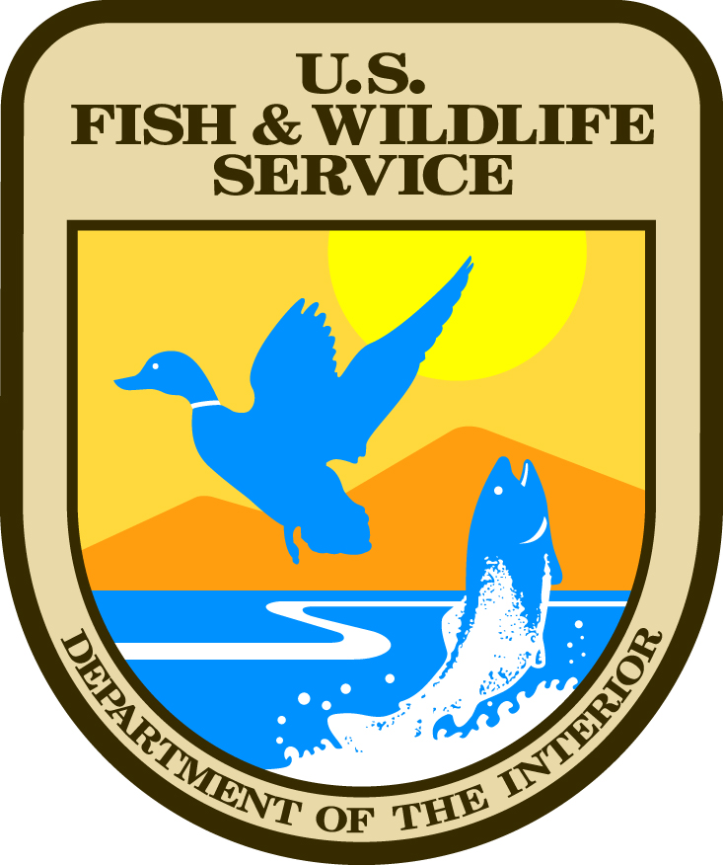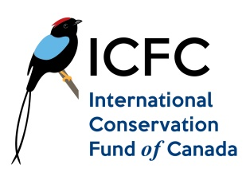

2015 Goals
For 2015 we will continue to conduct protection activities in Barba Azul throughout the year, such as fence mending, border patrols, cattle removal, grass mowing, runway upkeep, infrastructure maintenance, firebreak mowing, and overall protection vigilance.
Our development goals for 2015 are:
1) Remove cattle from tourism areas
2) Create a permanent firebreak on Barba Azul North
3) Create local socially beneficial activities
4) Maintain and improve the nest box program
5) Begin savanna age-class research
6) Complete tourism infrastructure
7) Design a management plan for Barba Azul East (free of cattle 2016)

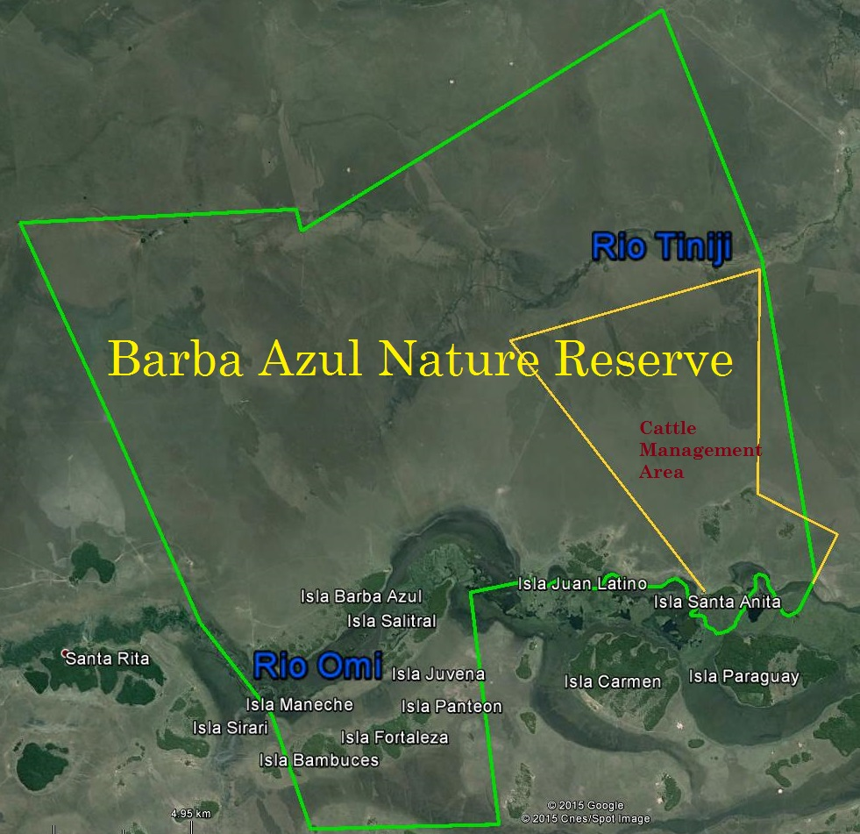
Figure 1. Barba Azul Nature Reserve with cattle management area

Protection

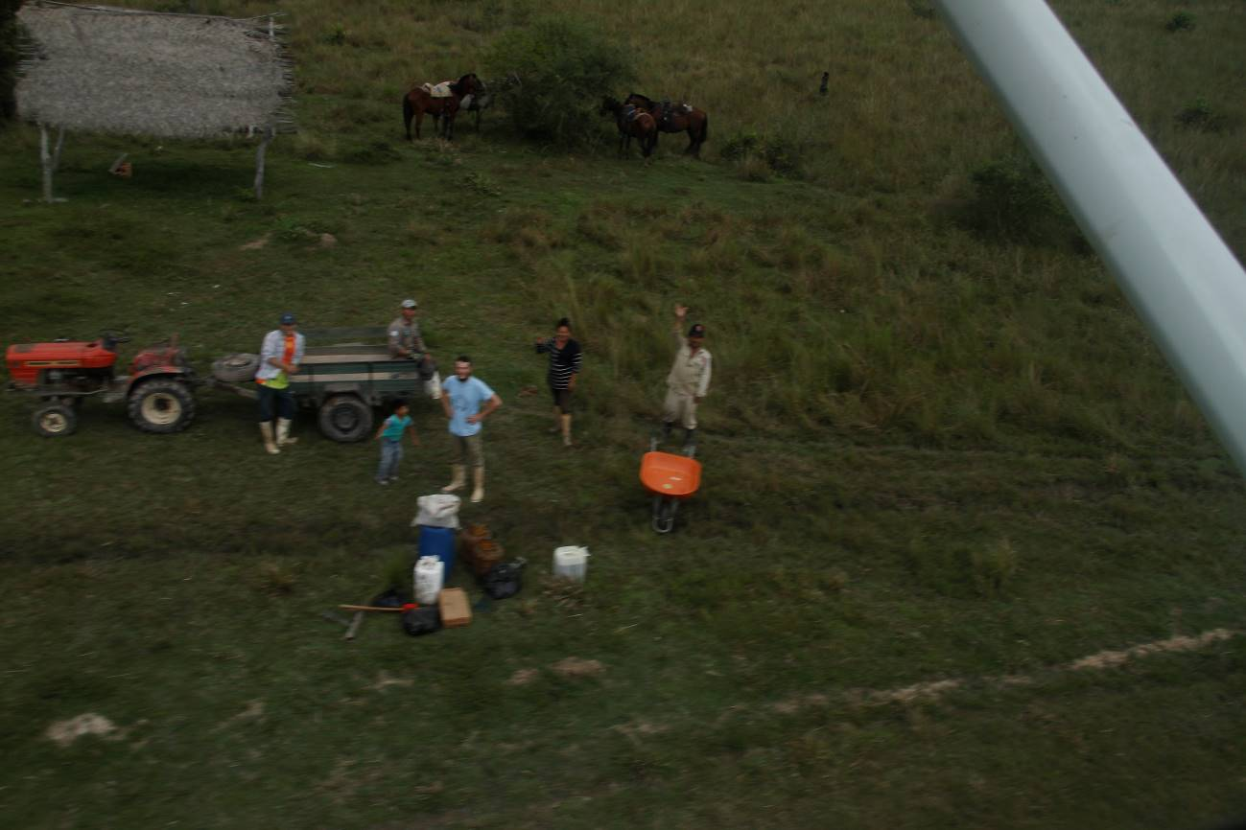
Figure 2. Flying off from Barba Azul, left to right, friendly neighbor rancher, Luis (Rosario and Rene’s son), Rene (sitting), Nicolas Lefrique (French volunteer), Rosario, and Hernan.
Staff
New Barba Azul Manager
After many emails and lengthy skype conversations, Tjalle Boorsma from the Netherlands, returned to Bolivia to take on the position as Barba Azul Manager. Tjalle completed his masters in forestry conservation in the Bolivian Chiquitania forest. He has started work on the condition that he would be required to raise his salary. Barba Azul has become more complicated and really needs someone who can dedicate their time just to this project. Tjalle is fluent in English, which is very important as he can take on the many donor responsibilities requiring English proposals and reports. Barba Azul received support this year from World Land Trust for a Motacu reforestation project, which will be one of the Tjalle’s key projects.
Hernan, Rosario and Rene are all established and ready for this year’s dry season events (July to September). Tjalle will be working out a series of systems with them to improve management on Barba Azul, like waste, food, gasoline, and flight systems.
A French masters student Nicolas Lefrique joined the crew in January until the end of May. His help and research was with the nest box program on Rio Tiniji and recording Blue-throated Macaw movements throughout the Barba Azul during this data- weak period.
Firebreaks
Tractor
We still do not have a tractor, which is concerning as we are getting closer to the burning period (July- Oct). ABC and ICFC are both placing a tractor now for priority fundraising. We are hoping to purchase the best economical and durable tractor. We will again next week review potential used tractors, to 1) demonstrate that used tractors in Bolivia are not a good investment due to poor maintenance and treatment, or 2) find a wonderful tractor only driven on Sundays that we can purchase. We do have funds to rent a tractor in the worst case scenario, but we are holding off on that plan until June.

Management

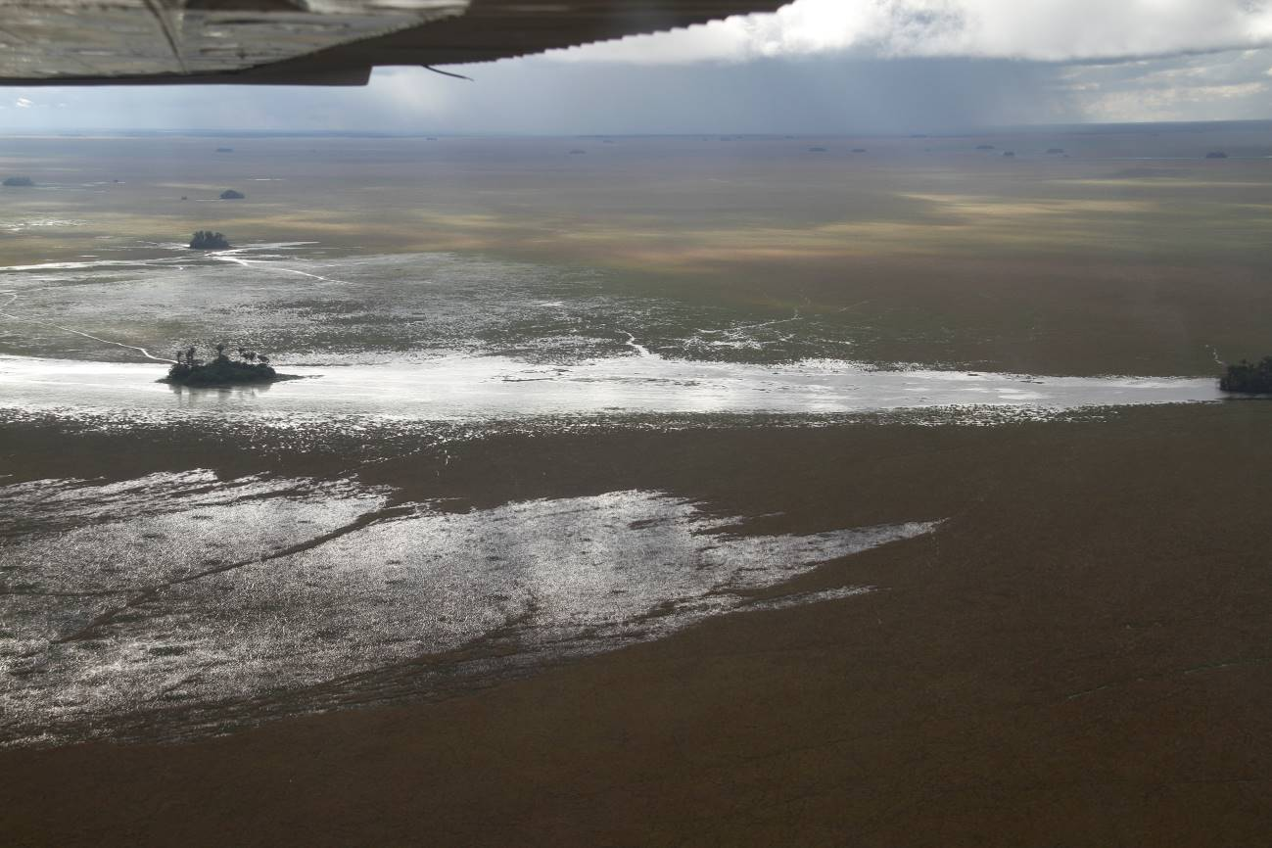Figure 3. Rio Tiniji slowly drying out later than usual in 2015 (08MAY15).

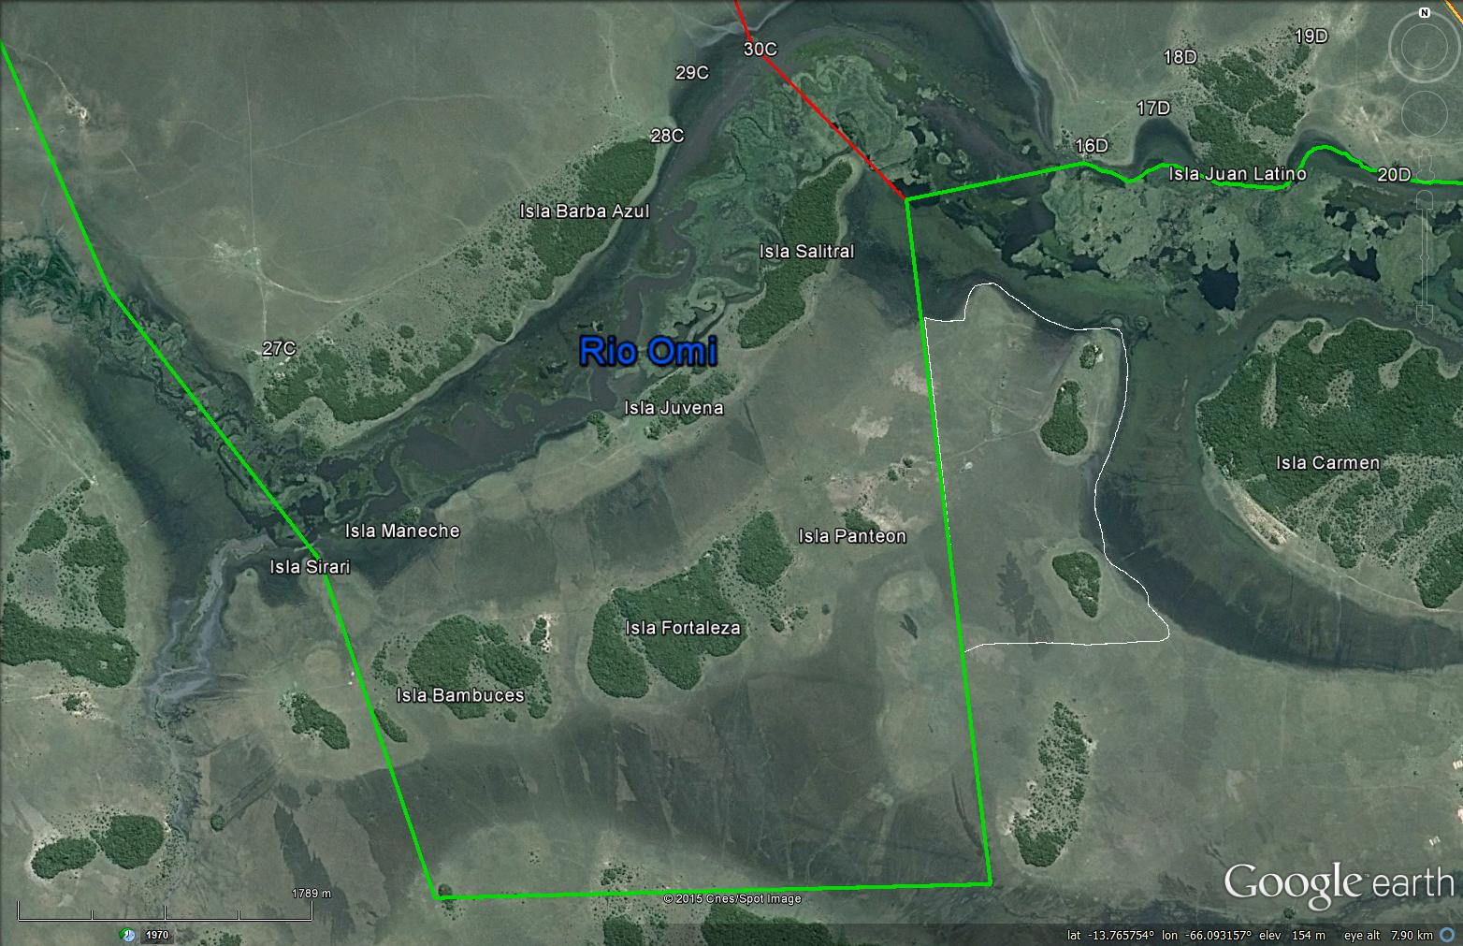
Figure 4. Forest Islands in Barba Azul south.
Motacu Palm Forest Protection
From May 6-10 Bennett and Tjalle reviewed Barba Azul to set up a plan for the Motacu Palm Reforestation program. The priority for the next few months is to make sure invading cattle have been removed, and that other forest islands are fenced off before planting. Tjalle will review the forest islands of Rio Tiniji in June. The plan is to use the abundant saplings on Isla Barba Azul to replant in the islands of Rio Tiniji, moving trees in Sept, and planting in October and November. We also want to investigate the feasibility of creating some forest islands, which depends on whether or not we will have a tractor .
The large question that arose was why does the Blue-throated Macaw seem to prefer certain Motacu Palm Fruits over others. Are there two species involved, or subspecies? Do nutrients affect fruit flavor? Does palm age affect palm flavor? It was clear that this would be an excellent topic for graduate research in Barba Azul (see research section).

Nest boxes
The Cincinnati Zoo & Botanical Garden and Bird Endowment supported the nest box program in Barba Azul for the breeding season of 2014-2015. Nicolas was able to work at maintaining and improving the nest box program from February to May
The two purchased canoes in 2014 were instantly of use, as we found the Rio Tiniji area was too flooded for horse work, but flooded enough to survey the nest boxes by canoe- once the canoe was dragged from Rio Omi to the western point of Rio Tiniji by foot. So we now have a nest box review methodology that can be applied next year. However it would be better to have a sturdier canoe for this applied application.
We are awaiting Nicolas’ final report by the middle of June.

Management Plan
Armonía has been awarded a March Conservation Fund and American Bird Conservancy grant to purchase ~20 head of cattle for the ranch. These will be used to start low impact cattle ranching experiments in a reduced area of the Barba Azul East area (see figure 1 cattle management area). Hernan will manage this program, as well as assisting Barba Azul during tourist visits etc.
We have funds to fence of the southern border, but need to wait until a large truck can bring in the fence support posts from Santa Ana. When we have the posts, the fence can be completed, which hopefully will happen by the end of July.
Our cattle ranching experience from the winter will be applied to design a management plan for Barba Azul East which will be part of the overall Barba Azul Nature Reserve management plan.

Private Reserve Creation
Tjalle has as one of the key priorities for the next two months to establish a plan to create local socially beneficial activities. The key to this would be a simple classroom. We hope to develop this in order to bring in construction materials in the dry season window from July to September.

Research
A proposal was submitted to Savanna Conservation Trust to conduct savanna age-class research. We are waiting to hear their response.
Tjalle conducted his Masters research in a research station in Bolivia. He is interested in promoting Barba Azul to researchers to help develop a sustainable model. He has already contacted Universities in the Netherlands, and is working up a potential list of research topics. The field station is good accommodations for researchers, and does not require much improvement now. It would be ideal to construct a lab space, but not the highest priority.

Tourism
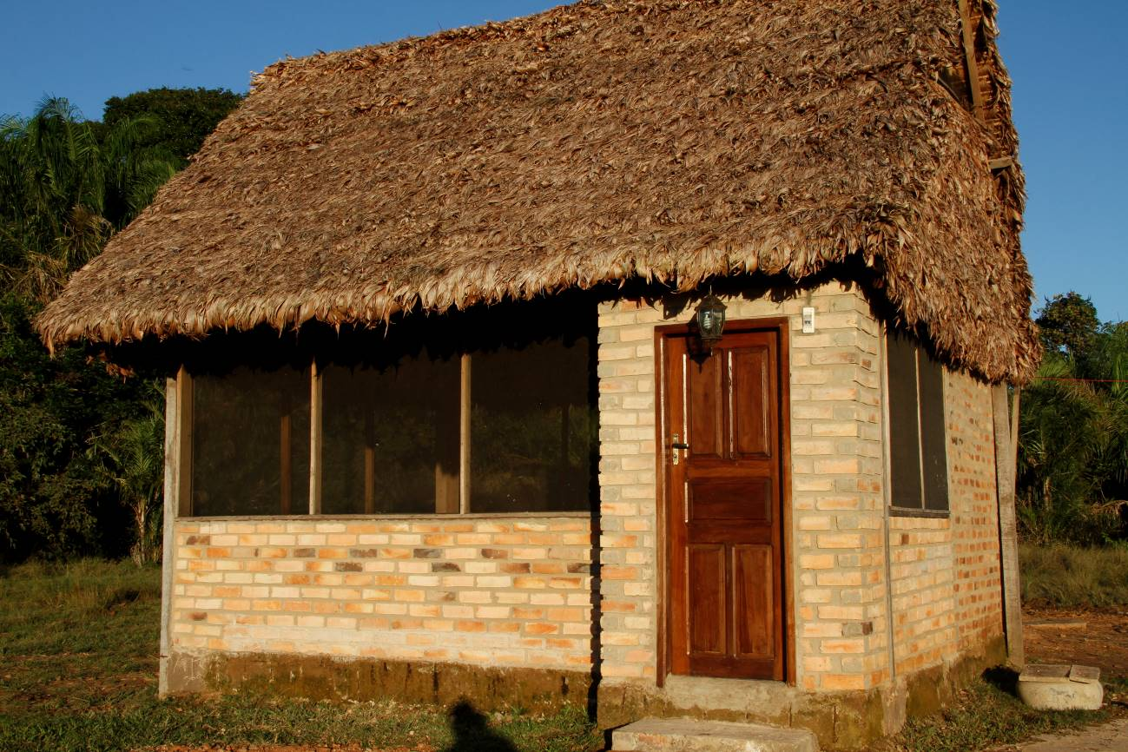
Figure 3. The four tourist cabins have been completed with twin beds and private bathroom.
Barba Azul has not received tourists yet for 2015, but visits are booked for August, September, October and November. A surprising interest are for short tours of a week to visit the Sadiri Jungle Lodge and then Barba Azul. We are reviewing cheaper alternatives to visit the lodge by land during the dry season.
Tourism Cabins
The four cabins (each with two single beds and private bathroom) are completed. This ended up being a much more complicated process, because we tried to conduct the work as inexpensively as possible directly hiring work crews.
We now need to refine the cabins with furniture, and to sleep in each with a view of fixing potential hiccups with roofing, small holes attracting bats, insect problems, and making sure they are tightly mosquito proof.
To complete the tourist infrastructure we have priced out the refurbish construction, with a price quote of $45,000. We will be looking into this further in the next month.
Horses
Daniel Robison created a horse management plan for Barba Azul that we are applying. Presently we are still negotiating the prices, which have increased (almost doubled) from last year because of the excessive flooding. We are hoping we can purchase 5 more horses, with a total of 8 tame healthy horses.
Promotion
Through World Land Trust support we are developing the new Armonía web page which will have information regarding visiting the Barba Azul. We hope that will be ready in the next two months. And supported by March Conservation Trust and America Bird Conservancy, Armonía will be able to hire a fulltime communication and tourism coordinator, who will be responsible for promoting the Barba Azul and Red-fronted Macaw Lodges.
On May 9th, 2015, Tjalle and Bennett participated in the ebird Global Big Day counting 132 birds on Barba Azul (see Appendix 1). We coordinated our field training visit to end on this day to take advantage of this promotion potential for the reserve.
We created the Barba Azul Nature Reserve channel on YouTube and in my spare time I published three amateur introduction videos on Barba Azul.
Barba Azul Nature Reserve Introduction
https://www.youtube.com/watch?v=9vQKEmmGWo0
Barba Azul Nature Reserve – Motacu Palm Forests
https://www.youtube.com/watch?v=1Mu6jCFK_qE
Barba Azul Nature Reserve: Savanna
https://www.youtube.com/watch?v=9IWLhNNvUcc
In the oncoming months I hope to produce videos on Motacu Regeneration, Savanna Succession, and Motacu Seed dispersal.

Appendix 1
Report on Global Big Day 9 May
One-hundred and thirty-two bird species were recorded at the Barba Azul Nature Reserve, Beni, Bolivia on the Big Day May 9th. Bennett Hennessey and the Barba Azul Nature Reserve manager Tjalle Boorsma walked and power boated 6 km on the Big Day in Barba Azul from 6 am (sunrise at 6:30) until 6:30 pm visiting the habitats of Cerrado, Palm Forest, Gallery Forest, Dry Forest, Savanna, Marsh, River, and a variety of aquatic environments. We added 3 new species to the Barba Azul list for a total of 253 species.
Some species of note were the 6 Blue-throated Macaws, which are Critically Endangered. Over 40 Blue-throated Macaws had been recorded on Barba Azul in April, but they would appear to be foraging somewhere else at the moment. We expect over 100 in Barba Azul in the months from July to October like in the last three years. We had 7 parrot species. We also had other threatened species like the Orinoco Geese (6), Muscovy Duck (3), Sharp-tailed Tyrant (3), and Adults and juveniles of the Black-masked Finch (21). The bird of the day for its tricky to find qualities, was a perched Streamer-tailed Tyrant caught during a periodic scan of the river edge marsh vegetation.
May is the beginning of Bolivia's winter, and two days earlier the Beni Savannas experienced the first strong cold front of the year, which also brought in some Austral migrant species from Argentina pampas and wetlands. We recorded large numbers of some Austral migrants like over 25 Wood Storks, 120 Bare-faced Ibises, 50 Black-necked Stilts, 40 Large-billed Terns, 110 Nacunda Nightjars. The most surprising part, was that we did not see a single swallow. Nine species of swallow have been recorded on Barba Azul, but the majority are not residents, but a nice split between Boreal migrants, and Austral migrants- whereby May is the period of absence.
The ideal period in the Barba Azul Nature Reserve for a big day would be in early September, when Barba Azul has the full complement of Austral migrants and the 11 species of Boreal migrant shorebirds, like the Buff-breasted Sandpiper and Upland Sandpiper, and the Macaw numbers are high, with both the Blue-throated Macaw and the Blue-and-yellow Macaw in the hundreds.
eBird text of the big day
Bennett Hennessey and Tjalle Boorsma recorded birds for this perfect day, two days after a wet cold front wave. Clear sky, low wind, slightly cloudy midday and slightly cooler than normal for this Big Day count of the Barba Azul Nature Reserve. We began before sunrise in the Barba Azul forest Island recording night birds and forest dawn chorus. At around 7 am, we walked out through Cerrado habitat, recording Cerrado species. At around 8 am we continued walking north into tall lightly flooded savanna where we made a 2 hour loop back to the eastern edge of Barba Azul Forest. We returned to the field station for lunch and a short break. At 13h30 we headed out on the River Omi, noting species for two hours, with many shore stops to scan for species. We walked into Cerrado, forest and tall grass on the west end of Barba Azul Isla forest island. At 17h00 we returned to the field station to visit close sites with known bird populations.

