“You don't build a business, you build people, and then people build the business” Zig Zigla

ANNUAL REPORT 2019

Table of Contents
Executive Summary 2
1. Increased access to quality education for marginalized children 4
1.2 School feeding, water and sanitation program 6
2. Increased access to craftsmanship and entrepreneurship education 6
2.1 Integrating craftsmanship education in the mainstream education system 8
2.2 Establishing Skills Enrichment Center for youths 8
3. Increased access to micro-credit as business startup capital 9
4. Increased access to knowledge, skills and technologies 9
4.1 Propagating fruit value addition knowledge, skills and technologies to small holder farmers 10
5. Increased afforestation for improved biodiversity and soil fertility 12
6. Monitoring, Evaluation and Learning activities for skills acquisition 13
7. Challenges, lessons learned and recommendations 14

Executive Summary

Teso Women Development Enterprise Ltd (Teso Women), established in 2008 to promote sustainable community development initiatives through education. Our vision is a just and sustainable World where everyone lives in dignity. Our mission is to empower communities with knowledge, skills and technologies for sustainable socio-economic independence. We believe that helping people gain knowledge, skills and new technologies, from new farming techniques, children’s and youths’ education, human rights, biodiversity, environmental protection and conservation, to improved health and hygiene practices will help people live a better life. The organisation endeavors to achieves her objectives, through education, believing in the power of education to improve people’s live and livelihoods. Last year, Teso Women implemented several strategies in pursuit of the following results areas: - increased access to quality education for marginalized and disadvantaged children/youths; increased access to craftsmanship education skills for self-reliance to marginalized and disadvantaged children/youths; increased knowledge, skills and technologies for increased productivity and incomes for small holder farmers; and increased knowledge in biodiversity, afforestation for environmental restoration and protection.
During the year, a lot of progress was made towards achieving above results areas. Since its inception New Hope Nursery and Primary School enrolled the largest number of children. The school enrolled a total of 450 children and recruited 2 more teachers to meet increased educational needs. During the year, the school partnerships increased. The school partnered with Compassion International through Pentecostal Assemblies of God, Kyere Branch. This partnership benefited a total of 49 children who received full sponsorship. The school also partnered with Okuraja Foundation, a local charity which receives child sponsorship funding from individuals in the developed world. Okuraja Foundation sponsored a total of 25 children in the school. Skills enrichment for self-reliance at the school also progressed as planned. A total of 200 youths were trained in nursery management, orchard management, pests and disease control, postharvest handling techniques, and fruit value addition techniques. In addition, a total of 1,500 small holder farmers were trained in fruit value addition against a planned annual target of 200. Value addition, knowledge, skills and technologies were disseminated to small holder farmers. Adoption of disseminated knowledge, skills and technologies means that small holder farmer can reduce losses due to improved postharvest handling techniques, while adoption of fruit value addition technologies is likely to result in increased incomes due to added value. While knowledge and skills’ acquisition continue to be high among trainees, the organization is yet to assess adoption of new technologies.

During the year, institutional capacity of Teso Women Development Enterprise was enhanced. The organisation received additional tools and equipment curtsey of Trellis Fund of the University of California Davis, which facilitated transformation of orange and mango fruits from their original form to products such as preserves, juice, mango jam, mango ketchup. The tools included juice extractor/Juicer, Jags, Pans, Ladle, Funnels, Filters and industrial thermometers. These technologies were very useful during fruit value addition training. The team did not procure a pasteurizer because of its high cost. Alternative pasteurization methods such as the use of juice/jam glass bottles were utilized. The other technologies acquired by the organization and disseminated to fruit farmers is the Zero Energy Cooling Chamber (ZECC). The ZECC utilizes evaporative cooling mechanism of water to create low temperature which is necessary for storing fruits and vegetables. Since the ZECC does not require electricity for its operation, and the construction materials are easily sourced locally, this technology is not only appropriate for the rural setting but it is also a cost-efficient alternative to refrigeration technology. 60% of the trained farmers have reported having adopted the ZECC technologies and reduced losses due fruit perishability resulting into increased income.
During the year, the strategic direction of environmental protection overall objective shifted more towards biodiversity conservation. Instead of focusing only on promoting tree planting for increased tree cover, the team focused on biodiversity education following reports which highlight biodiversity degradation in the country. A total of 300 community leaders benefited from biodiversity workshops that focused on traditional management and conservation of endangered tree species including shea tree (Vitellaria paradoxa); Tamarindus indica and the Banyana tree in Uganda

The greatest challenge encountered during the year is the high rate of school dropout among the children who progressed to secondary school. While Teso Women endeavors to provide quality education to children and youths at preschool and primary levels, a majority of the children and youths drop out of school in secondary level due inadequacies in their families to provide for the financial requirements needed for their continued education at the higher levels. Once they drop out of secondary schools, they join their colleagues who continue wallowing in poverty, with no chances of joining any gainful employment since they do not have skills required by potential employers. Teso Women plans introduce a youth skilling center. Introduction of Skills Enrichment Education will not only benefit in school children and youths but it will also benefit out of school children and youths, and will greatly alleviate the high rate of unemployment and rampant poverty among the youths. The other challenge was lack of funds to facilitate biodiversity conservation interventions.

Increased access to quality education for marginalized children

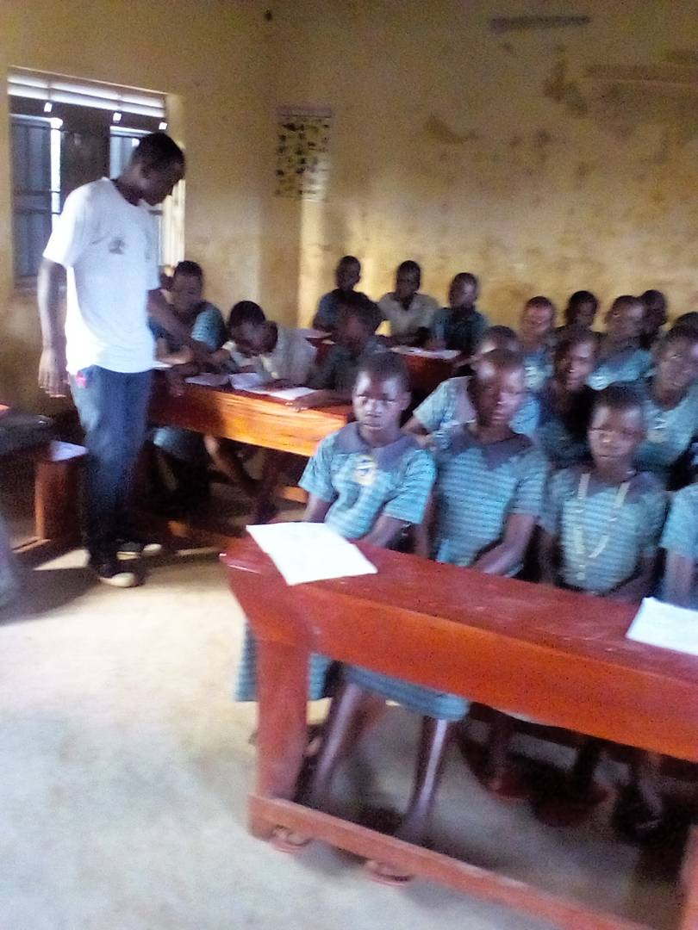
Children in rural areas of Teso region rarely receive quality education they need, forcing many of them to dropout, or leave schools without vital basic survival skills. Outside the classrooms, children face huge inequalities including poverty, discrimination based on gender and cultural attitudes that hinder many of them from exploiting their full potential. They often struggle accessing schools, and when they do, classrooms are often inappropriate for learning, dilapidated, or insufficient in number, leaving children without appropriate place to learn and play from. Without access to age-appropriate textbooks, materials and games, children struggle to engage in class, struggle to learn, and don’t even find learning as fun. During the year, a total of 450 marginalized children were enrolled in both preschool and primary education. The number of children wearing school uniform also increased and the community involvement in the management of the school was enhanced through election of Parents Teachers Association (PTA) Executives. Progress continues to be made towards receipt of feedback from the community and disseminating information to the community. The PTA committee now plays a vital role in linking the pre-school and the primary school with the community which had enhanced delivery of quality education.

1.1 Improved institutional capacity of Teso Women to offer quality education

During the year, Teso Women greatly improved its capacity to offer quality education to marginalized children. The school received financial contributions and in-kind support from the community which was used for constructing new toilet facilities. The number of qualified teaching staff increased to 15, and 4 support staff were recruited. New Hope Nursery and Primary School received in-kind donations of four-seater desks and chairs to cope with increased school enrolment. Friends of the school donated an assortment of requisite text books both for learning and teaching. Although not sufficient yet, at least the school has a library which is one of the building blocks for quality learning and teaching. More text books are expected next year from partners and well-wishers who have been contacted for assistance. This notwithstanding, the library has no computers which means that our learners have no access yet to computers. Management is hopeful that the school will acquire computers for the library by the end of next financial year.

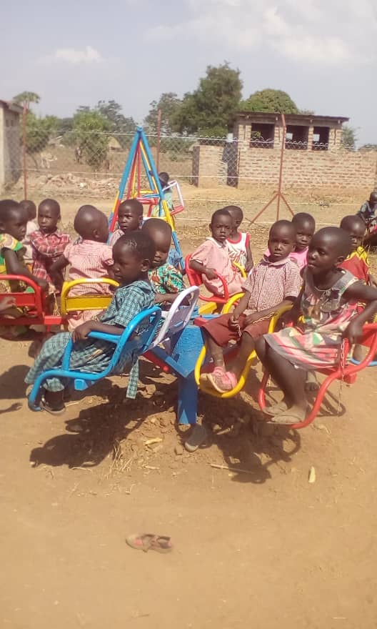
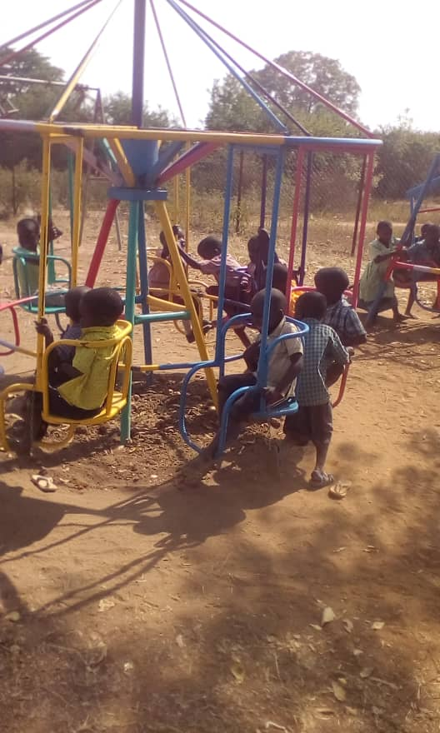
During the year, the school also acquired play materials for early childhood education and development. Children's play unlocks their creativity and imagination, and develops reading, thinking, and problem solving skills as well as developing motor skills. It provides the base foundation for learning. Playing is one of the important components of a child's life and it is one of the major activities that promotes children's imagination and creativity. Children can learn the basic and social skills and develop through play. Thus components such as play materials, play ground and play mates have a considerable role in play. Play positively impacts on a child and facilitate learning and explorinmg the world around him or her with a rich imagination in a joyful way. Mangement hopes to acquire more play materials for preschool education next financial year,
Pre school playing materials for nursery section

1.2 School feeding, water and sanitation program

During the reporting period, the school faced a challenge of feeding learners. This challenge was compounded by a long drought which affected the food yields in the region. Food prices skyrocketed against limited financial resources. This notwithstanding, the community was resilient and continued contributing food, firewood and finances. Through these contributons, the school was able to construct latrines and acquire tap water which is being used for all school water needs. The challenge though, is the rampant hepatitis B, which is a major concern even to local and centrals governments. Teso Women also plans to source for water purification / filtration system for distilling drinking water for children, teachers and other employees.

Increased access to craftsmanship and entrepreneurship education

The rate of unemployment and underemployment among the youths in Teso region is a major concern to many people in the area. 86% of the youths in the region are either unemployed or under employed, causing many of them to resort to taking illicit drugs and acts of criminality which are detrimental to social cohesion. Unemployment and under employment among the youths is made worse by the high rate of school drop out in the region. Youths unemployment, under employement and high rate of school drop out are among the many challenges raised during community consultative meetings and dialogue meetings. These are among the threats to social cohesion which must be addressed urgentlty otherwise the number of children and youths resortg to taking illicit drugs will continue rising.

Statistics at New Hope Nusery and Primary School show that many of the youths who join secondary schools rarely complete their secondery school education. They often drop out of secodary schools due to rampant household poverty. Many families fail to educate their children due to deep rooted household poverty. Sensitising and educating people on how to be more productive and earn more income is critical in reducing household poverty. While the small holder farmers' trainig program where farmers are trained how to increase their productivity and earn more income is already making impact towards reducing household poverty, there is need for skills enrichment. Enriching learners with craftsmanship/vocational education ensures that even if they drop out of school, they are able to create jobs for self-reliance and creat wealth for themselves. We also note that the rampant youths unemployment is also attributable to the country's failed education system which is theoratical and not grounded on skills for self reliance. A majority of youths who are seeking for jobs do not have requisite skills that are needed by potential employers. In addition, our education system does not integrate craftsmanship education to enable youths acquire skills for job creation, self employment and wealth creation for self-reliance.
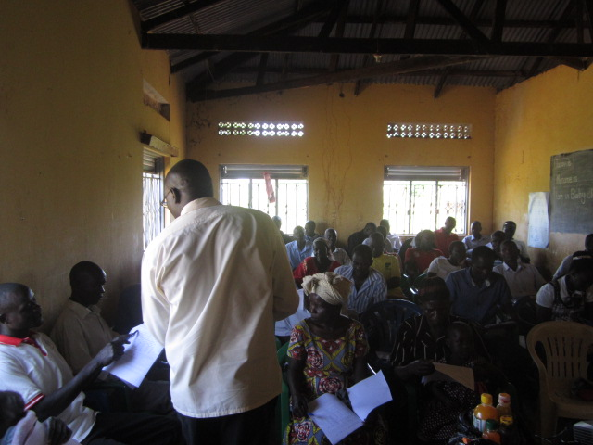
Popular views from the community indicate the need for integrating craftsmanship skills at the school. In addition, there is a general desire among the beneficiaries for the organisation to establish a youths’ skilling center where youths are provided with vocational skills for self-reliance. That is why management is seeking for support from develoment partners for initiating youths skills enrichment education which will provide much needed artisan skills to youths to enable them create jobs, earn income and be self- reliant. Support for the skills enrichment center has been requested from several donors who are expected to respond positively. While some of them have expressed their willingness to support this program, the organisation is yet to hear from others. Tools Wth A Mission has already donated vocational training tools and equipment for this program, now awaiting shipment. These tools are expected to arrive early next year. Once received, the vocational training department will offer the following courses:- sewing machine maintenance, sewing machine operations, fashion and design, building construction, drawing, practicals, science and calculations, life skills, business skills/entrepreneurship, mechanics, carpentry and joinery, electrical installations and plumbing. The training will cover both informal and formal training. Informal training which will last for 6 months will be intended for young people who cannot afford the costs of formal vocational training, such as orphans, extreme poor, children infected with HIV / AIDS, child mothers and families of minors. Emphasis on informal training will be on learning a skill. The formal vocational training will be based on government’s approved curriculum, and it will last for 2 years, and comprised of both theory and practical lessons. Students will be admitted if they meet government’s entry requirements. At the end of the formal training they take a theory and practical exam under the supervision of the Directorate General of Polytechnic Education. The challenge however, is inadequacy of training tools and equipment.
Community consultative meetings

2.1 Integrating craftsmanship education in the mainstream education system

In order to create jobs for youths for self-reliance, integration of craftsmanship education in the mainstream education is critical. Integration of vocational education will enhance survival skills of the youth in the region and it will promote self-employment, wealth creation and job creation for self-reliance. During the reporting period, a total of 100 youths received career guidance in both mainstream education and vocational training opportunities. A majority of youths who received career guidance desired to acquire vocational training. While there is overwhelming willingness from the youths to acquire vocational skills due to eminent likelihood of dropping out of the mainstream education, there is no institution in the region offering such skills. Thus, integrating craftsmanship or vocational education in the current education system is a step in the right direction. It will also be a step towards establishing a much-needed vocational training center in the region.

2.2 Establishing Skills Enrichment Center for youths

Last year, the plan to establish a Youths Skills Enrichment Center was approved by the Board. Before its approval, the plan was enriched with views collected from community dialogue meetings and community consultative meetings. Thus, the plan developed to address a general consensus in the region which indicate that the main challenge facing the youths in Teso region is the increasing rate of unemployment and underemployment. The views from the coinsultative meetings were vindicated by the labour statistics in the region which indicate that 86% of the youths are either unemployed or underemployed, and yet many of them do not have requisite skills required by potential employers. This problem is compounded by the high school drop out rate among the youths. Unemployed youth live a life of frustration and desparation which has reduced their seflesteem and self confidence. This has led some of them to resort to violence, drug addiction and criminality. From our community dialogue and consultation meetings, it is clear that idle and unemployed youths have become a big problem. Thus, the need to faciltate youths to acquire vocational skills for self reliance. Progress towards establishing a youths’ skilling center is in advanced stages. Teso Women has already acquired land for the construction of the Skills Enrichment Center. Progress is also being realized in acquiring requisite tools and training materials. The head of the Skills Enrichment Center has been identified and will be recruited soon. Additionally, training tools and equipment are being sourced from well-wishers, existing and potential donors.

Increased access to micro-credit as business startup capital

During the reporting period, the revolving micro-credit financing to women and out of school youths was initiated. The same facility was provided to staff to facilitate them to initiative businesses that can generate income for their family members. The aim of the fund is to promote entrepreneurship among the women and out of school youths by providing catalytic funding. The revolving micro-credit funding started with a total of 15,000,000 Uganda Shillings (4,167 US dollars). Through the revolving micro-credit funding, seed funding for business startup has been given to 100 women and out of school youths. The recovery rate so far is very encouraging. All women and out of school youths who received micro credit funding were able to pay back the funds. Additionally, the beneficiaries of the micro-credit fund utilize the money as planned. The challenge however, is that available funding for micro credit is too little as compared to its demand. There is need to source for more funding for promoting entrepreneurship and enterprise development for employment creation and wealth generation self-reliance.

Increased access to knowledge, skills and technologies

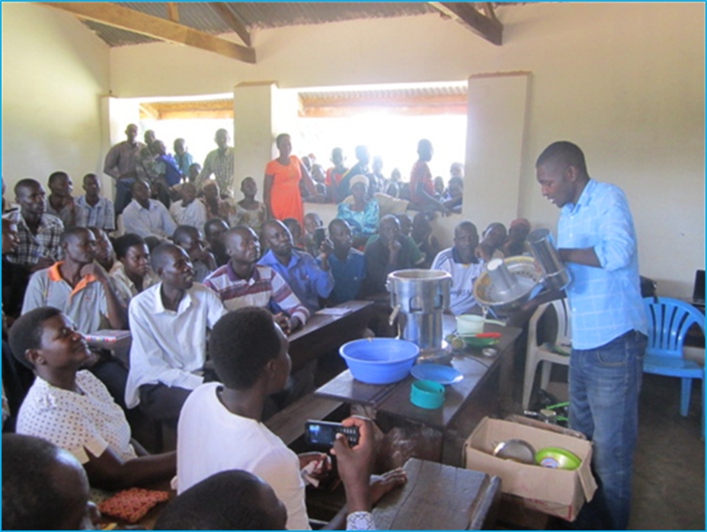
Teso is one of the regions in Uganda where the mango/orange fruit sector is one of the fastest growing sectors. This sector is particularly important for rural economy because of its potential to increase incomes of farmers through value addition. However, most mango/orange fruits are wasted due to their perishability. Processing enables farmers to expand their productivity without fear of fruit deterioration and guarantees that products (nectar, pulp or juice) reach the consumers in a desired condition. The challenge in the path of growth of the mango/orange fruit industry in the region is inadequacy of knowledge, skills and technologies for fruit processing and value addition. Propagation of fruit processing and value addition knowledge, skills and technologies enable fruit farmers to keep mango/orange products in un altered condition for a long time without impairing on its quality, palatability, taste, colour, flavor and nutritive value.
Fruit value addition training session conducted by Samson

4.1 Propagating fruit value addition knowledge, skills and technologies to small holder farmers

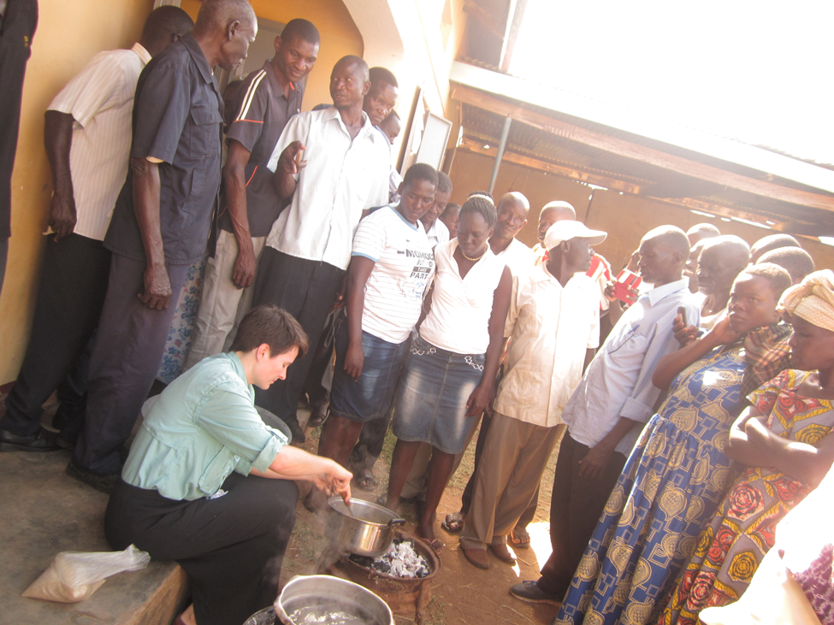
Using our unique education approaches of training trainers; farmer-to-famer mentorship and value addition demonstrations, a total of 1,500 small holder famers were trained and gained knowledge and skills for increasing their production and earn more incomes for their households. This training was made possible by the capacity building project funded by the Trellis Fund of the University of California Davis. The Trellis Fund also facilitated Claire E Adkison, a postharvest and fruit value addition expert to travel to Teso to conduct these trainings. She was able to train a total of 10 post-harvest and value addition trainers, and mentored 1 local horticulture graduate student who led the team to train additional farmers after her departure. We also trained small holder farmers on sustainable agricultural practices to improve food production, nutrition and food security, while testing and refining our training approaches.
Claire E Adkison demostrating mango jam preparation

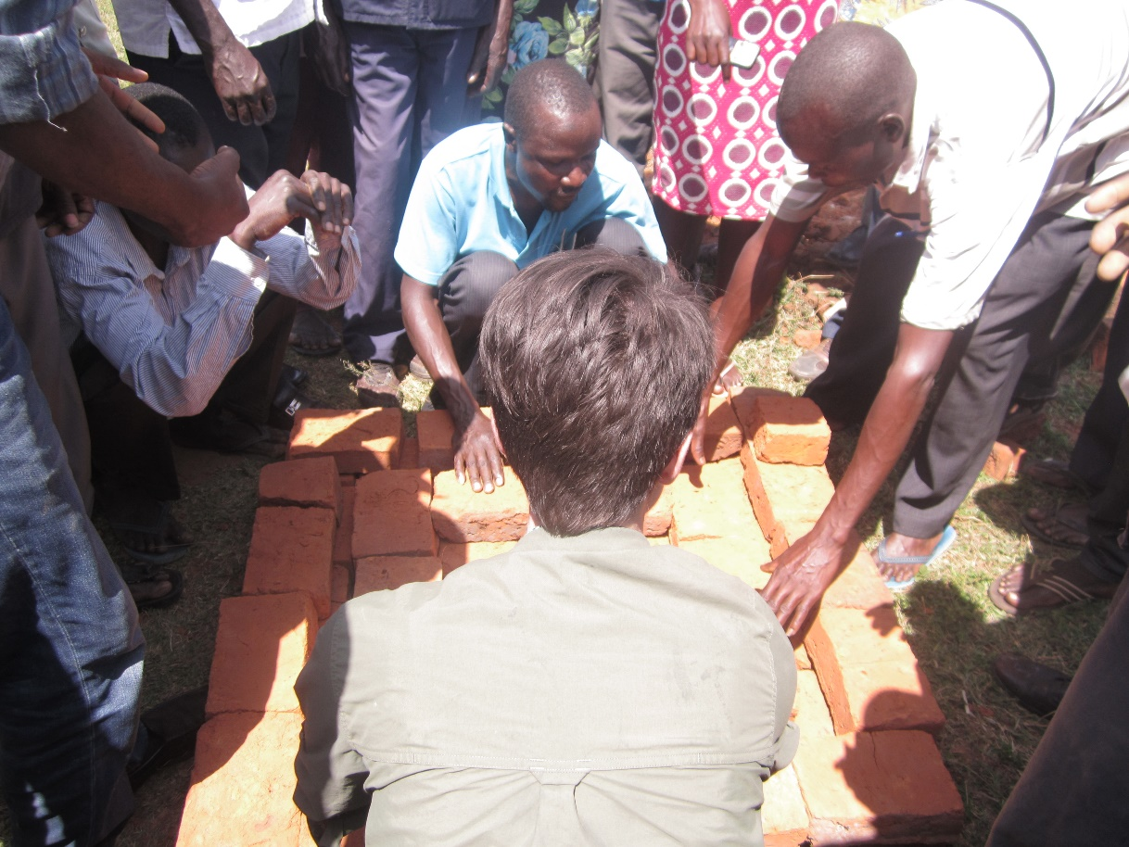
Some of the training sessions aimed at stimulating business ideas and entrepreneurial capabilities of small holder farmers. During the training sessions, fruit products that were promoted included juice, mango jam, nectar, and pulp which any farmer could consider processing after acquiring skills and sell to earn income.
Claire Adkison demonstrating construction of ZECC to farmers

Farmers were also trained in various methods for preserving fruits after harvest. Among such methods is the use of Zero Energy Cooling Chamber (ZECC), a cooling facility which uses evaporative mechanism of water to cool the fruits while in storage. The ZECC technology was invented in India. Construction of ZECC was demonstrated in all training sessions.
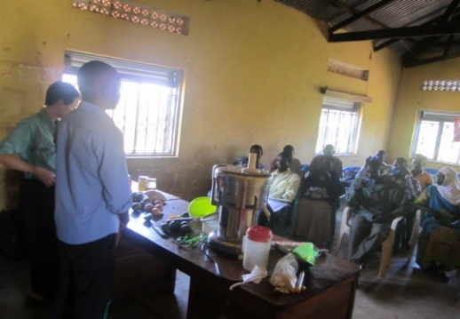
Mango and orange value addition technologies were procured for demonstration purposes. These include the juice extractor (Juicer, jags, pans, ladle, funnel, filter) which are being used for value addition training. The team did not procure a pasteurizer because of its high cost. Alternative pasteurization methods like heating the juice/jam in glass bottles are being utilized. This necessitated procurement of pans and charcoal for demonstrating the pasteurization processes for different value-added fruit products. Additionally, bricks and grass for demonstrating the construction of the no cost cooling chamber (nicknamed Village Fridge) by the trainees were procured.
Some of the value addition technologies on display

The monitoring and evaluation plan was developed, shared and approved by the donor. This plan was used to assess success of activity implementation and attainment of planned results. However, we had a challenge of measuring post-harvest losses. Since it is difficult to measure post-harvest losses due to social and cultural limitations the team agreed to remove that indicator from the project monitoring and evaluation plan.

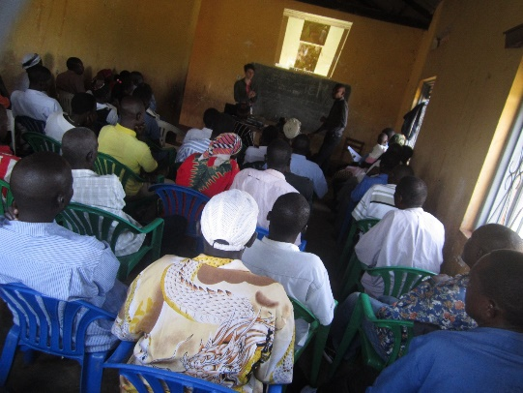
Our initial plan was that the graduate student trains only staff and volunteers during the TOT. This training should have taken place in March. However, due to unavoidable delays, our graduate student arrived in August. This necessitated flexibility in planning. Thus, we decided that the graduate student trains staff, volunteers and small-scale farmers. Thus, a total of 69 people inclusive of staff and volunteers were trained by the graduate student. It is the trained staff and volunteers who trained additional small holder farmers.
Farmers being trained by graduate and local students

5. Increased afforestation for improved biodiversity and soil fertility

Over the years, a lot of information has been disseminated by government to promote biodiversity conservation in the country. This led to a shift of strategy, instead of putting more emphasis on afforestation, the team now focusses on biodiversity preservation and conservation. In Uganda, at the genetic level, the most important change in recent decades has been the loss of well over a hundred cichlid fish species from Lake Victoria, following the introduction in late colonial days of the Nile Perch. In addition, most tree and animal species are becoming critically endangered, while most of them are headed to extinction. Losses in the remaining species has mainly been driven by loss of habitats including forests, woodlands and wetlands. Thus, the most significant requirement in the country is to reduce and eventually halt deforestation, woodland loss, and swamp conversion. It is against this background that the team shifted its focus more to biodiversity conservation. During the reporting period, a total of 300 community leaders benefited from biodiversity conservation workshops that focused on traditional management and conservation of endangered tree species including shea tree (Vitellaria paradoxa); Tamarindus indica and the Banyana tree in Uganda. Next year, the team plans to include critically endangered fish species and other tree species in its biodiversity conservation efforts.
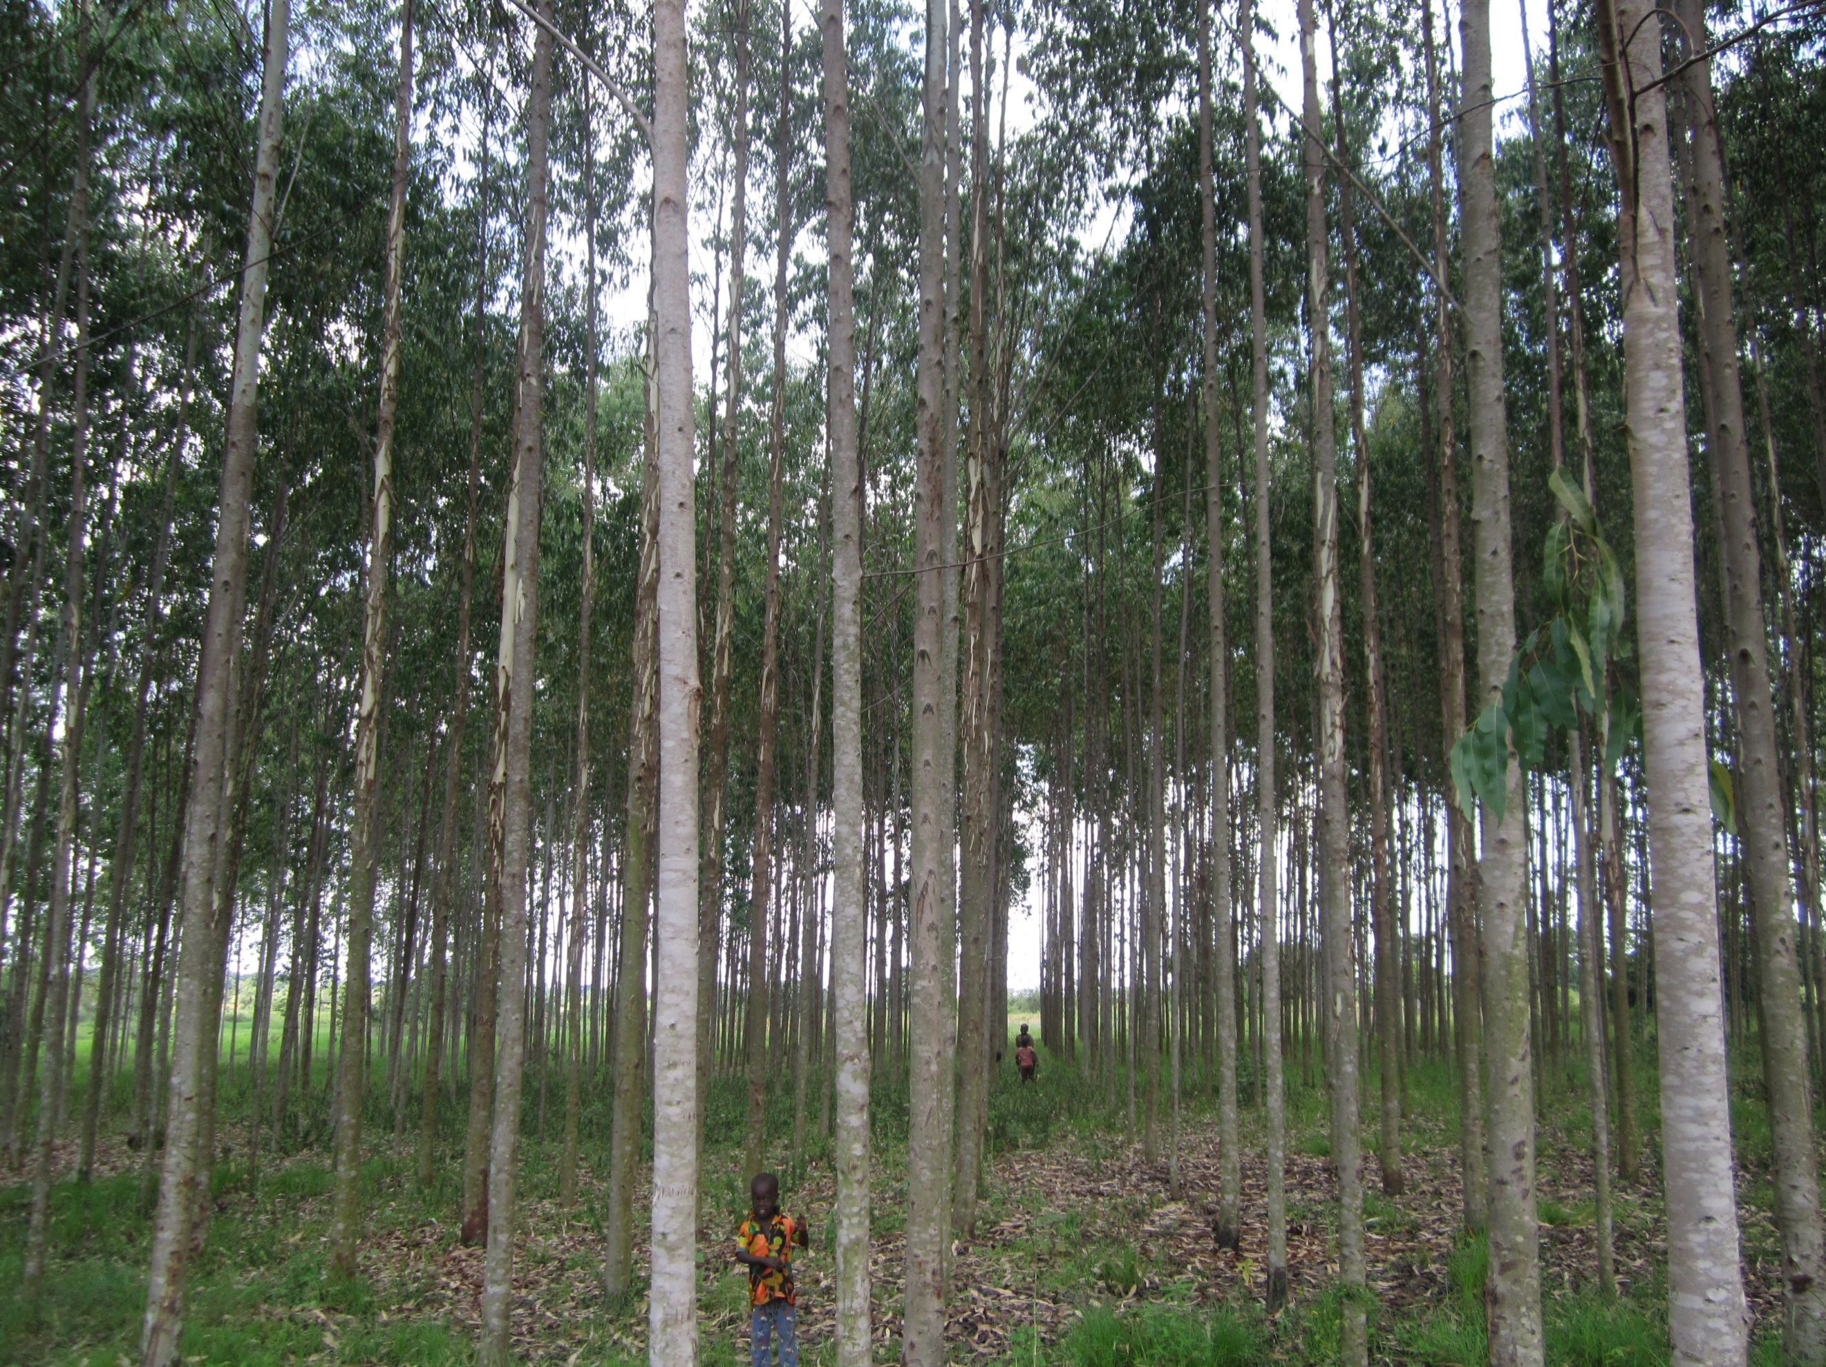
During the reporting period, afforestation program continued as planned. Maintenance of a model or demonstration forest was the main activity during the year. Most of the poles in the model forest are ready for sale. Once sold, revenue earned will be used for sustaining operations of the organization. In addition, 3 acres of land was acquired for tree planting during the year. Seedlings of high yielding and fast-growing trees will be planted next financial year.
Fast growing and High yielding model forest ready for sale

6. Monitoring, Evaluation and Learning activities for skills acquisition

Performance management of each result area was done through monitoring indicators. Knowledge acquisition at preschool and primary levels was measured through regular tests and end of term examinations. For pupils in candidate classes, mock examinations and final examinations continue to be carried out according to government schedules. Our candidates continue to excel both mock and final examinations as compared to those in the neighbouring schools. Additionally, the early childhood education program is proving to be one of the best in the district. Many parents openly show their preference for New Hope Nursery and primary school as compared to the neighbouring schools.
For the small holder farmers’ training program, success is measured using a cascade of input, output, outcome and impact indicators. Availability of training materials was measured based on physical availability of training booklets. A total of two training booklets which included Zero Energy Cool Chamber and Juice processing were produced to facilitate propagation fruit value addition knowledge, skills and technologies were developed. Establishment of the value addition demonstration centre as a room equipped with training equipment and dedicated for training farmers in fruit value addition was planned. This indicator was measured based on physical availability of a dedicated room for training farmers. Mango and orange value addition technologies were acquired. These include the juice extractor (Juicer), jags, pans, ladles, funnels, filters, and thermometers which were very helpful during demonstration of production of preserves, juice and mango jam. However, the team did not procure a pasteurizer because of its high cost. Alternative pasteurization methods like heating the juice/jam in glass bottles were utilized. Pans and charcoal for demonstrating the pasteurization processes for different value-added fruit products were procured. Additionally, bricks and grass for demonstrating the construction of the zero-cost cooling chamber (nicknamed Village Fridge) by the trainees were also procured. While the plan was to establish a static demonstration centre, our learning was that the farmers were reluctant to come to the centre because of their busy schedules. The team adopted a mobile approach where fruit value addition demonstrations were done in the communities
The number of fruit farmers trained in fruit value addition was monitored through physical counting of the number of trainees who registered in the training register, while acquisition of knowledge and skills was measured by administering pre-training and post training evaluation forms and analyzing responses. Adoption of fruit processing/value addition technologies was not monitored since it is an impact indicator which needs time to assess. This notwithstanding, lack of appropriate and affordable technologies was a major concern which is likely to prohibit adoption of new technologies.
The number of small-scale fruit farmers being trained was monitored against the planned target of 210. In addition, acquisition of knowledge and skills during training was monitored by administering pre-training and post training evaluation forms. Responses from trainees analyzed and showed 88% knowledge acquisition levels.

7. Challenges, lessons learned and recommendations

The greatest challenge encountered during the year is the high rate of school dropout among the children who progress to secondary school. Our learning is that most of the youths who drop out of secondary schools are always idle since they do not possess skills for self-reliance. To address this challenge, there is urgent need for introduction of Skills Enrichment Education by mainstreaming craftsmanship in the current education system to provide survival skills to youths for self-reliance. There is also urgent need for establishing a vocational training institute to enhance skills of out of school youths. Both programs will have positive impacts on our current endeavors of providing quality education both at early childhood education and primary levels.

Relatedly, while Tools With A Mission has donated training tools and equipment, the donated tools are inadequate given the demand for vocational education, in a region where such institution has never been established. Inadequate training tools and equipment mostly affects Informal training where the demand is highest. There is therefore need for management to source for more vocational training tools and equipment.

During the year, a total of 100 women and out of school youths received micro credit funding to facilitate business startup. The challenge was that available funds were not able to meet the high demand, which was overwhelming. There is there need to source for more funding to increase the level of micro credit funds available for borrowing to facilitate business startup.

Small holder farmers, training program progress as planned. Adequate training materials were developed. However, our learning is that there was need to develop videos for demonstrating preparation of preserves, juice and jam for the famers to watch. There is need to enrich future training sessions with videos as training aids for small holder farmers. Additionally, since most of the small holder farmers are not educated, there is need to translate all training materials to local language to ease knowledge and skills acquisition for those who can read the local language.

