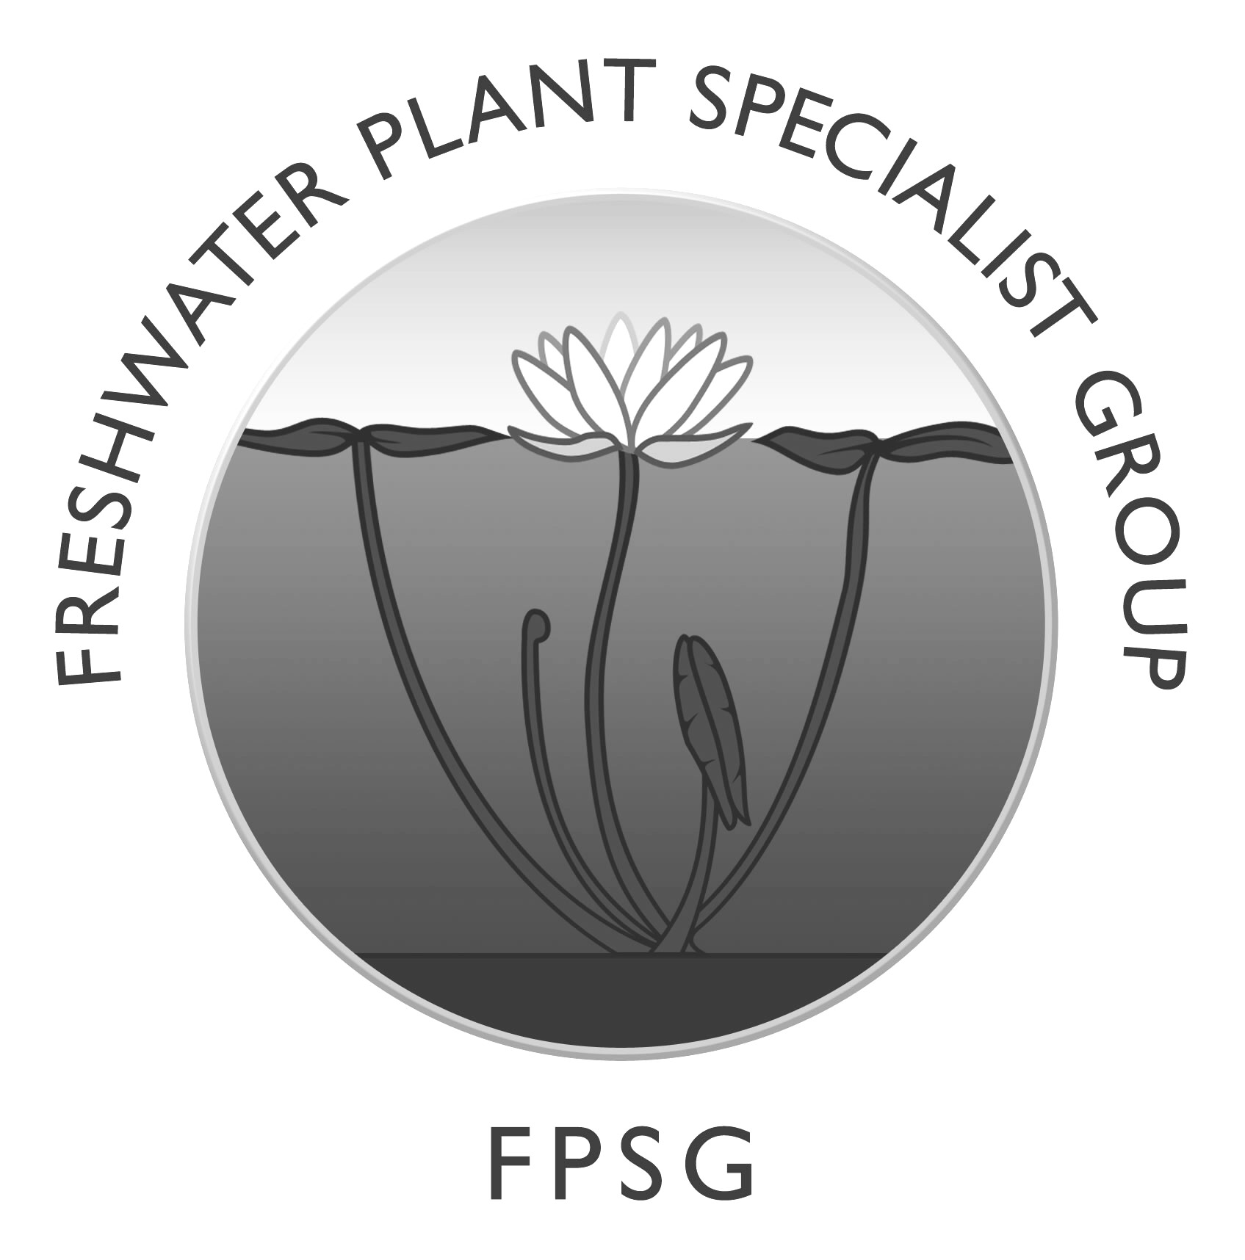
IUCN SSC FRESHWATER PLANT SPECIALIST GROUP

Chair: Richard Lansdown, based in Stroud in Gloucestershire, UK
RLA: Melanie Bilz, based in Technische Universität Berlin

The FPSG was formally established in 2012 with the support of the Fondation Tour du Valat and Plantlife and is hosted by the Wildfowl and Wetlands Trust, Slimbridge, Gloucestershire, UK.

We currently have 128 members in 60 countries.

The FPSG exists to promote and further the conservation of wetland-dependent plants and the habitats upon which they depend. To do this we need to identify which species, estimated to be at least 20,000 worldwide, are truly dependent upon wetlands, review their status against the IUCN Red List Criteria and then address their conservation needs.

Four sub-groups have been established within the FPSG:

Charophytes - organised by Nick Stewart. Charophytes represent a large group within aquatic plants and the best known algae with a large following. The subgroup is preparing Red List assessments for the taxa which they know to be of conservation concern as their first priority.
Isoetes – organised by Angelo Troia. It has become increasingly clear that Isoetes is a genus of which many taxa are extremely threatened, often through restricted distribution but also in many cases due to direct threats and particularly through climate change. The Isoetes sub-group (with Angelo as coordinator of the Isoetes Research Group (http://isoetes.myspecies.info/) is currently working to publish a global list of recognised taxa which will then be subject to comprehensive re-listing and preparation of a global conservation action plan.
Non-marine halophytes – organised by Hossein Akhani. This sub-group has been established partly because of Hossein’s depth of knowledge of the group and partly as it sites alongside the main focus of the FPSG. The FPSG will provide support, information and anything else that may help for the work carried out by the sub-group.
Podostemaceae (plus Hydrostachyaceae) – organised by Tom Philbrick (philbrickt@WCSU.EDU). It has become abundantly clear that the Podostemaceae are among the most highly threatened wetland-dependent plants throughout the tropics, again mainly through a combination of restricted range, direct threats and climate change. The Podostemaceae sub-group is currently working to publish a global list of recognised taxa which will then be subject to comprehensive re-listing and preparation of a global conservation action plan.

Based on the 64 spreadsheets of the names, distribution and Red List status of wetland-dependent plants which were produced through BioFresh funding, Nur Ritter has very kindly converted these into an online relational database with approximately 25,000 entries of which approximately one third are “accepted”, one third synonyms and one third “unresolved”. We are now seeking funding for ongoing maintenance of this database before we can formally launch it. Once launched, FPSG members will be able to edit individual species accounts so that it can become a powerful tool for all those working on wetland conservation.

Working with IUCN FBU, we produced another 500 Red List Assessments for wetland-dependent plants in 2014.

Achievements by FPSG members include:
- Publication of a note on alien water plants in Hungary by Kiraly Gergely and colleagues; preparation of taxonomic and descriptive accounts of Cyperaceae and Juncaceae for the Flora of the Arabian Peninsula and Socotra by Lorna MacKinnon;
- Contribution of an account for the Plantaginaceae for the “Catálogo de las Plantas vasculares de Bolivia” by Blanca León;
- Publication of a guide to water plants and swimming ponds by Klaus van de Weyer and colleagues;
- Contribution of accounts for Ceratophyllaceae, Cymodoceaceae, Podostemaceae, Pontederiaceae and Potamogetonaceae to the Red Book of the Brazilian Flora, as well as contribution of details of the Cabombaceae, Ceratophyllaceae, Hydrocharitaceae, Juncaginaceae, Nymphaeaceae, Pontederiaceae and Potamogetonaceae to the official record of the Red List of the flora of Rio Grande do Sul State by Claudia Bove and her team who also presented the conservation status of the aquatic flora from Rio de Janeiro State (Brazil) in the XI Congreso Latinoamericano de Botánica, Salvador in October 2014.
- Simonetta Bagella and her colleagues have produced an Interactive Guide to the Flora of Mediterranean Temporary Ponds of Sardinia.
- Núria Flor-Arnau defended her PhD thesis "Diversity, ecology and uses in bioindication of charophyte algae and macrophytes in the Iberian Peninsula; a group of FPSG members collaborated to produce a chapter on invasive freshwater plants of the Balkans for an ESENIAS book; Jean-Paul Ghogue and colleagues have establish the project "Identification of suitable sites for translocation of endemic Podostemaceae threatened by dams in the Sanaga River (Cameroon)”; the Conservatoire Botanique National de Brest have established a PhD and other actions toward implementation of the conservation action plan for Eryngium viviparum; research was undertaken into the ecology of Damasonium alisma contributing to a global conservation action plan, Mateja Germ and colleagues carried out the first survey of aquatic plants in man-made lagoons in south-west Slovenia and Patrick Grillas has carried out research into the ecology of Tolypella salina, Riella helicophylla and Althenia filiformis at a Camargue site where they are threatened.

Our main aspirations for 2015 are to produce global conservation action plans for the Podostemaceae and Isoetes and to obtain funding for maintenance of the online database, so that we can continue to develop it as a major conservation resource. We also hope to begin to initiate and support more conservation initiatives on the ground, including work on the ecology and conservation of Lythrum thesioides in the Nîmes areaWork has also begun on a book on the charophytes of Mediterranean France led by Jean-Baptiste Mouronval, with contributions by Patrick Grillas.

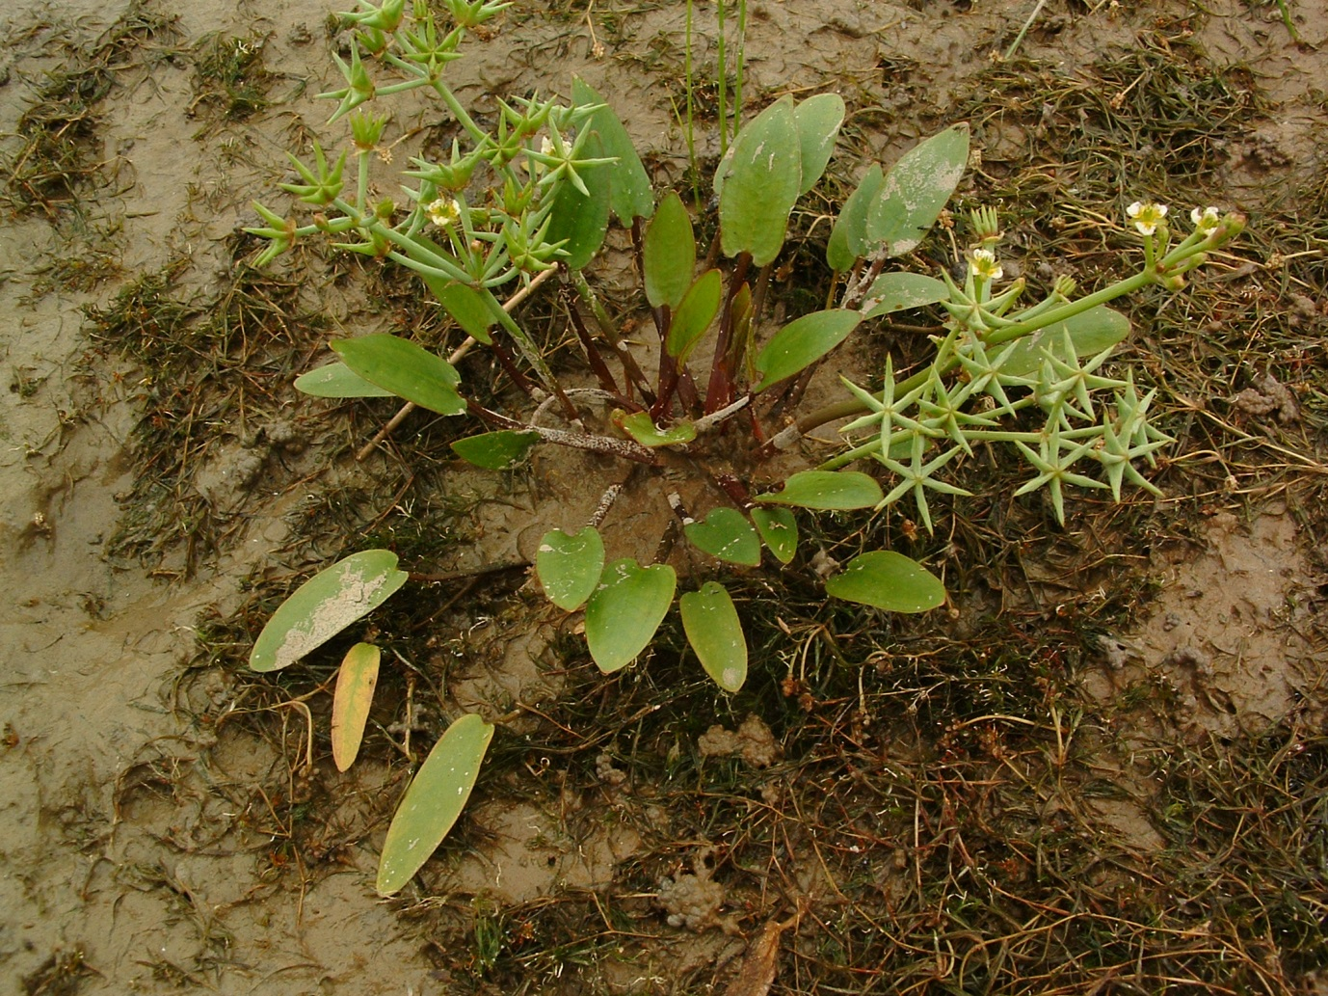

Starfruit Damasonium alisma which is declining throughout its range
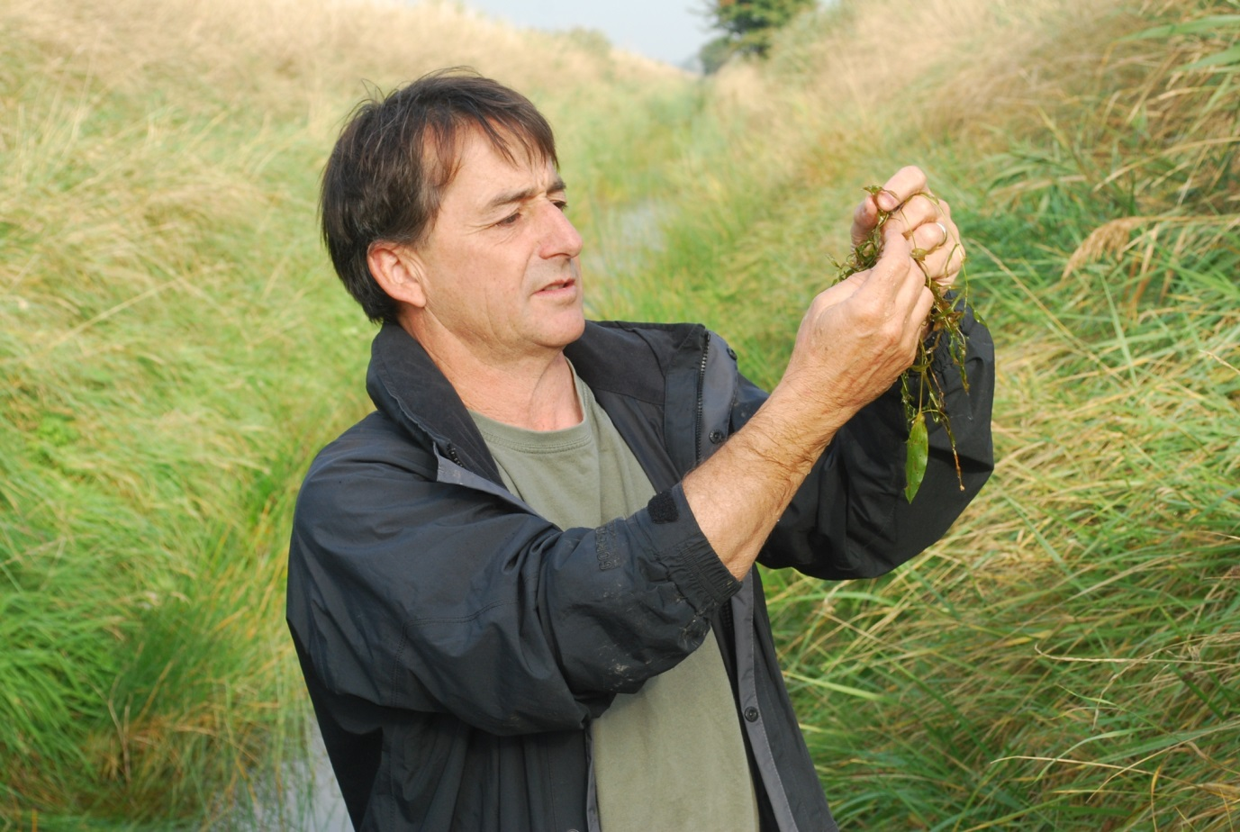

FPSG Chair Richard Lansdown with Potamogeton gramineus and a serious expression

