PERSONAL INFORMATION | Mehari Girmay (PhD)
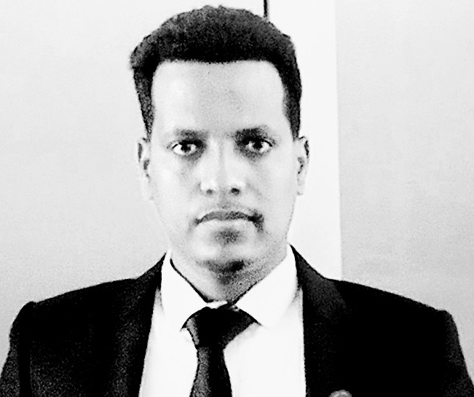 | Home Address: Addis Ababa, Ethopia
 | +251(0)914098176 / +251(0)943943844
 | meharigrm@gmail.com
 | http://www.mehari.girmay/oa/Tsn0xoet
 | Sex: Male| Date of birth 25/11/1988 | Nationality: Ethiopia

WORK EXPERIENCE
From 2022 - Now  From 2015 – August 2022  From Feb 2014-Feb 2015  From July 2010 –June 2012 | Senior Plant Ecologist/Botanist  Role and responsibilities in the institution  - Conducting Botanical and Ecological research  - Collecting plants for adaptation & population enrichment/conservation in the garden  - Technical support for junior experts and researchers  - Project design and writing  Environmental impact assessment and monitoring
 | Environment & Community Development Directorate at Ministry of Mining , Ethiopia
Role and responsibilities in the institution
- Conducting Ecological research and monitoring
- Environmental Monitoring and Evaluating of Projects
- Collecting, analysing and documenting of ecological data
- Identify and evaluate the potential impacts of projects & put alternative mitigation measures
- Reviewing social and environmental impacts mining projects documents
- Working closely with project proponents, different governmental officials and communities
- Designing various environmental and social training packages and providing trainings
- Collecting of community development funds (CDF) from projects and distributing to the communities in/around the project area based on their need assessments
- Organizing and conducting urgent field monitoring if it require
- Resolve problems by organizing diffident meetings according to the relevant national and international legal frameworks

Laboratory technician and teaching
Kenfe secondary and preparatory school, Tigray-Ethiopia
Role and responsibilities in the institution
- Providing laboratory guidance and trainings for natural science teachers
- Teaching Biology for preparatory students
- leading, organizing and participating in different school committees and leaderships

Teaching
Ferfer secondary school, Gode Zone, Somali Regional State, Ethiopia
Role and responsibilities in the institution
- Teaching of Biology and chemistry
- Leading of different clubs and committees

Educational Qualification and Training

- Educational Qualifications
From October 2016- October 2021  From September 2012 –December 2013  From September 2008 –June 2010 | PhD
 | From the Department Plant Biology and Biodiversity management of Addis Ababa University (Ethiopia)
- Ecology and Biodiversity management

MSC
From the Department Biology of Haramaya University (Ethiopia)
- Applied Biology

BSc
From Department Biology, Dilla University
- Biodiversity
Computer & software skills  Other Skills & experiences | Excellent knowledge Windows deal with most word processing programs, spreadsheets, internet browsing, data archiving, statistical analysis, GIS, SPSS, R Packages and specific programs created for ecological, environmental, social and data analysis  - Providing various training/lecture in for different stakeholders related to Environment, Climate, Biodiversity and Ecosystem services  - Knowledge of effective participatory Monitoring, Evaluation and lesson learning systems and in the process of project  - Analyse, interpret and compiling environmental and social data using respective software packages  - Long-time experience of consultation and field monitoring in different Regions of Ethiopia  - Project formulating, planning, writing, monitoring and evaluation  - Sufficient experience in implementing of researches and publications related to environment, Biodiversity, climate change and natural resources

Publications and project experiences
- Publications  - Projects  - Google scholar address | The following 7 articles are my publications  Mehari Girmay, Tamrat Bekele , Ermias Lulekal, Sebsebe Demissew (2022). Soil Seedbank Study of Hirmi Woodland Vegetation: Implications for Restoration and Conservation of Natural Vegetation, in Tigray, Northern Ethiopia . Journal of Trees, Forests and People, 8, pp 1-7.  Mehari Girmay, Tamrat Bekele, Sebsebe Demissew, Ermias Lulekal (2020). Ecological and floristic study of Hirmi woodland vegetation in Tigray Region, Northern Ethiopia. Journal of Ecological Processes, 9(1), pp.1-19.  Mehari Girmay, Ermias Lulekal, Tamrat Bekele, Sebsebe Demissew (2021). Use and management practices of medicinal plants in and around mixed woodland vegetation, Tigray Regional State, Northern Ethiopia. Journal of Ethnobotany Research and Applications, 21, pp.1-26.  Mehari Girmay (2019). Phytoremediation of Heavy Metals Released from Mining Waste Drainage using Selected Plant Species, in Ethiopia. Budapest International Research in Exact Sciences (BirEx) Journal, 1(3), pp. 1-4.  Mehari Girmay (2018). Assessment for Artisanal Gold Mining Impacts on Vegetation Ecology and climate change at Shire Districts. Journal of Education, 6(4), pp.54-58.  Mehari Girmay, Ermias Lulekal, Birhanu Belay and Kflay Gebrehiwot (2022). Wild Edible plants study in a Dryland Ecosystem of Ethiopia. Daagu International Journal of Basic and Applied Research 4: 105-119.  Mehari Girmay (2022). A review on Principles of botanical garden: futures and function, establishment (Under Review)  I have served as principal investigator and manager for the following projects (funded from Rufford small grant, British foundation)  - Rehabilitation of rare and threatened species through capacitating and involvement of the local community in/around Hirmi Forest and surrounding churches, Tigray (Active Project)  - Vegetation Ecology and Ethnobotanical Study of Hirmi Forest, North West Zone of Tigray Region, Ethiopia  - Restoration Potential of Hirmi Forest: threats and possible mitigation mechanisms as inference for its conservation, in Northern Ethiopia  https://scholar.google.com/citations?user=34SfoxcAAAAJ&hl=en

