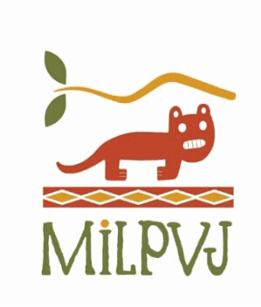

Curriculum Vitae: Pedro Heredia

-Industrial Engineering Studies (1984-1990)
-Studies in foreing trade (1993-1995)
-Manager of the textile company Tecniprint SRL in the city of Lima (1997-2000)
-Founder of the Milpuj Conservation Area (2011)- Amazonas
-Environmental Consultant at the Peruvian Amazon Research Institute (IIAP) -Chachapoyas (2011-2015)
-Founder and Director of the RED AMA-Voluntary Conservation Network of Peru (2013-20022) (http://redama.org.pe).
-Founder of the hotel “La Casa de Doña Lola” as support for the management of the Milpuj Conservation area (2015)
-Project coordinator Critical Ecosistems Partnership Fund (CEPF) Phase II (2019)
-Founding member of the small wild cat working group of the neotropics
-Project coordinator Critical Ecosistems Partnership Found (CEPF) Phase III (2023)
-Currently he is dedicated to the management of ACP Milpuj.

