AWE DJONGMA’A Marcel Marcel
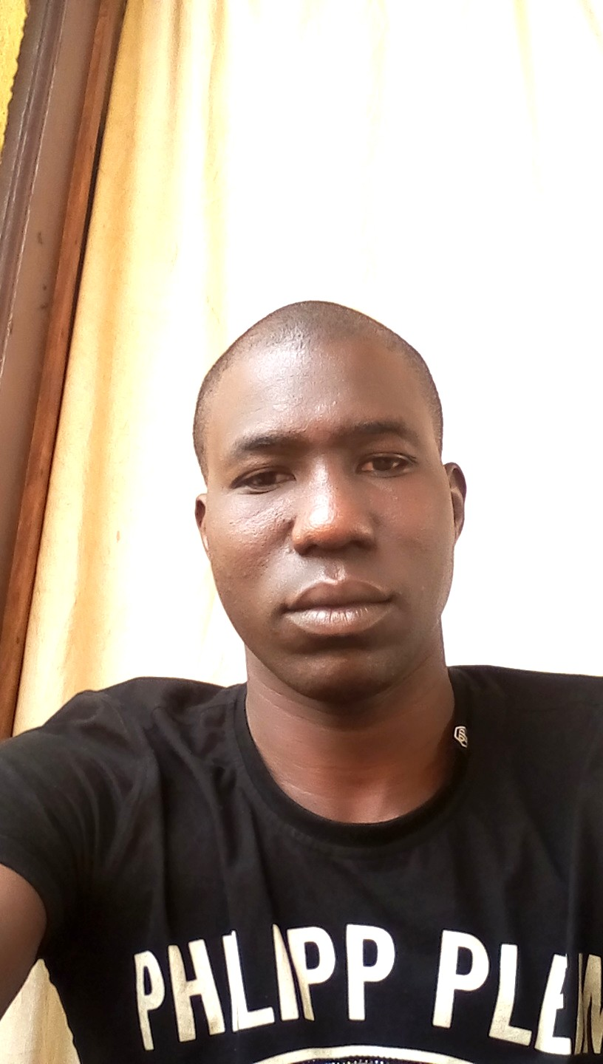

Gender: Male
Date and place of birth: June 9, 1992
Region: Far North
Nationality: Camerounian
Languages: French, English
E-mail : marcelawedjongma@gmail.com
Phone number : +237 698 708 035

SCHOOL AND ACADEMIC TRAINING
- 2010, BEPC at Dziguilao high school.
- 2012, Probatory D at the Bilingual high school of Kaèlé.
- 2015, Baccalauréate D at high school of Guidiguis.
- 2016, License 1 in Animal Biology at the University of Dschang.
- 2018, License 2 in Animal Biology at the University of Dschang.
- 2019, Bachelor’s degree in Bilogy of Animal Organisms at the University of Dschang.
- 2020, Master I in Ecology and Wildlife conservation at the University of Dschang.
- 2021, Master’s degree in Ecology and conservation of biodiversity at the University of Maroua.

COMPUTER KNOWLEDGE
Skills: - mastery of word;
- Excel ;
- Power point
- remote sensing and PAST.

POJECT COMPLETED
Obtaining a Master’s degree, and Ecology and conservation of biodiversity at the University of Maroua

EXPÉRIENCES PROFESSIONNELLES
- October 2019, impregnation course at the Zoo-Botanical garden of Mvog-Betsi.
- March 2020, participation in training on data collection on vultures at the Mbéré Valley National Park and the Bouba Djidda National Park.
- June 2021, participation in a socio-economic and demographic survey in Diamaré on the threats affecting vultures in their habitat.

- Participation in a scientific day at the University of Maroua with certificat issued (2022).
- April 2023, participation in the collection of data on bird diversity in Lake Tchad, projet initiated by PROLACC.

Miscellaneous: - Observation and capture of birds;
- reanding and research ;
- Conference debate;

ARTICLE BEING PUBLISHED
AWE DJONGMA’A Marcel.M, Ghislain Noé Kougoum Piebeng, Simon.A Tamungang wansang Daksala 2023. Impact of socio-economic and legal activities on the conservation of vultures in the North, Cameroon.

