Project 152511649 Report from January 21, 2016 to January 21, 2017
Overview
Indigenous tilapiine fishes namely; Victoria tilapia (Oreochromis variabilis) and Singidia tilapia (Oreochromis esculentus) are critically endangered fishes endemic to lakes Victoria and Kyoga in East Africa. These fish species became displaced from these major lakes through inter-specific species competition for food, space, and mates by the introduced superior breeds of fish species such as Nile tilapia (Oreochromis niloticus) coupled with environmental degradation. Remnant population of these fish species is now restricted to a few refuge impoundments and satellite lakes such as Kayanja, Kayugi, Nawampasa and Kawi of these major lakes basins. This project, as a whole was aimed at providing updated information about ecology, habitat, distribution, and population status of Victoria tilapia and Singidia tilapia in lakes Kayanja and Kayugi. It was anticipated that this information will help conservationists and other stakeholders to enact appropriate actions needed to conserve these fish species in the wild. Specific activities carried out were (a) mapping the distribution pattern and quantify abundance of Victoria tilapia and Singidia tilapia in lakes Kayanja and Kayugi, (b) Identification and mapping of the spawning, breeding and nursery grounds of these fish species, (c) Identification and documenting various threats to the habitats of these fish species, and (d) suggestions of recommendations that could help to conserve these fish species and their habitats.

Introduction
In Uganda, many indigenous tilapiine cichlids, such as Victoria tilapia (Oreochromis variabilis) and Singidia tilapia (Oreochromis esculentus) are critically endangered (IUCN Red List, 2006) and yet in the past, they were key Uganda’s fish species for both commercial and artisanal fisheries. Many researchers have documented factors attributing to the decline in the population of indigenous tilapiines, including the aggressive competition for food, spawning, and nursery grounds from introduced Nile tilapia (Oreochromis niloticus), and environmental degradation like pollution, habitat modification, fragmentation and loss (Njiru et al., 2008; 2006; Yongo et al., 2005; Balirwa et al., 2003; Lowe- McConnell, 2009; Ogutu-Ohwayo and Balirwa, 2006). These fish species have suffered a large reduction in extent of their occurrence and is now restricted to a few refuge impoundments and satellite lakes of the Victoria and Kyoga lake basins (Ogutu-Ohwayo, 1990; Balirwa, 1992). Since these species were assessed and published as critically endangered by IUCN in 2006, no active research was carried out to learn more about their distribution patterns and population status in these satellite lakes, therefore considerable additional research was needed to provide basic baseline data to support conservation actions needed to halt the extinction of this species in the wild, and this explains why this project was undertaken.
Methods and materials
The study was implemented on two lakes Kayanja, geographically located at latitude -0.277156 and longitude 31.86403 and Kayugi geographically located at latitude -0.321452 and longitude 31.84717. A reconnaissance survey was conducted to identify the sampling sites within the two study lakes based on key habitat characteristics including lake depth, vegetation cover, human activities in the vicinity and accessibility to the sites. Three experimental sites were selected on each of the two study lakes. In addition, one fish landing site closest to the experimental study sites on each of the two study lakes was selected to obtain commercial catch data.
Fish Sampling and Mapping of Spawning and Nursery areas
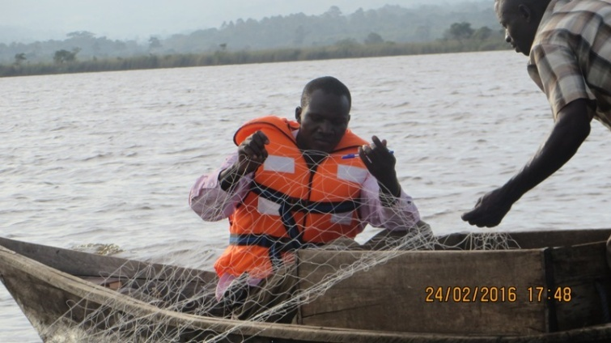
We sampled fish populations at pre-selected experimental sites for collection of primary fish data (Fig: 1) and at two fish landing sites for secondary data. Experimental gill-net fishing was conducted at each site with three fleets of graded multi-filament gill nets of mesh sizes ranging from 25.4 mm to 139.7 mm at an interval of 12.7 mm and sizes 152.4 mm to 254 mm at 25.4 mm intervals set parallel to the shoreline out towards the open water. The nets were set in the evening (1700h – 1800h) and lifted at dawn the following morning. At each study site, coordinates for each location where Victoria tilapia, Singidia tilapia and their main competitors, Superior breeds namely; Nile tilapia and Tilapia ziillii were caught or sighted was recorded using GPS
Figure1 : Casting of Mutlti-filament Gill nets during Fish Survey
The retrieved fish specimens were removed according to fleet and mesh size, identified to species level, weighed (to 0.1 g), and length measurements taken to nearest centimetre. Where possible, photographs of the fresh coloured fish were taken to aid identification. The maturity stages of the gonads were determined as described in Nikolsky (1963): Stage I and II – immature (inactive); III – immature (ripening); IV – mature (active ripe and recycling in females); V – ripe; VI – spawning (ripe and running in males), and VII – spent. Gonads from mature females were removed, weighed to the nearest 0.01 g, and preserved in ethanol for further laboratory analysis. Fish stomachs were dissected out and stomach fullness was visually evaluated and categorized as: Empty (E), ¼-full (Q), ½-full (H), ¾-full (T) and Full (F). Fish stomachs were preserved in 10% formaldehyde and taken back to the laboratory for further analysis.
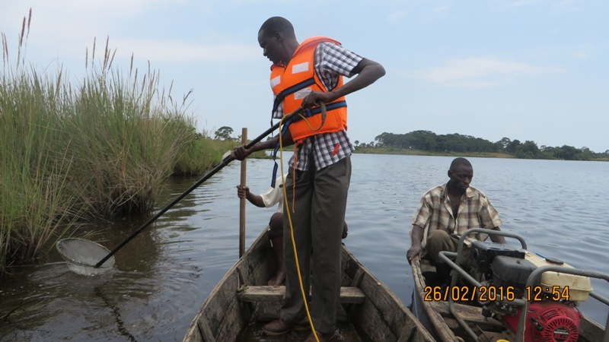
In addition to experimental fishing, we used minnow traps and electro-fishing methods (Fig.2) on Lake Kayanja. At the shallow inshore areas of each site, fish populations were sampled using a pulsed electro-fisher with an 8-watt generator and two anodes (Amisah, 2000). Two 30-minute runs were made at each site at an interval of 15 minutes to allow processing of the catch and recovery of conditions for fish re-occupancy. All the fish immobilized by the electric current were collected into a water filled container. Minnow traps were also set overnight in selected sites of the lake.
Figure 2: Using Electro- fisher in Lake Kayanja
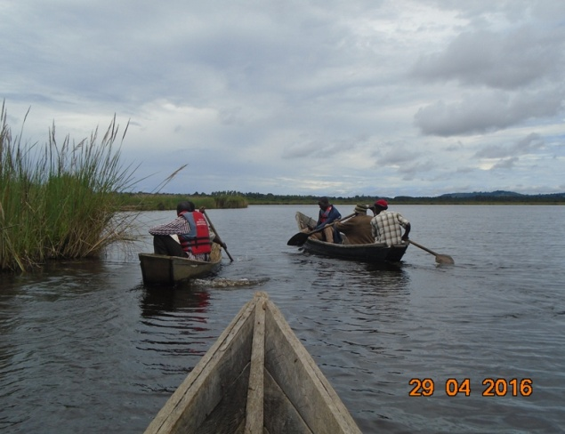
On each of the two study lakes, we identified and mapped spawning and nursery grounds (Fig.3). These sites were identified using both traditional knowledge of the fishermen and technical skills of research team. The criteria were based on known indicators such as shallow muddy bottom, presence of water lily, river inlets and riverrine forest. These locations were geo-referenced using Global Positioning System (GPS).
Figure 3: Mapping of Breeding and Nursery areas

Assessments of water quality and threats to lakes Kayanja and Kayugi
We conducted In-situ measurements for dissolved oxygen (DO) (mg-1), temperature (°C), conductivity (µS cm-1) and pH using a CTD 90 multiprobe (sea and sun technology) and lake transparency was measured using a black and white 20 cm diameter secchi disc. Using a 2-litre van Dorn sampler, water samples were taken at the depth of 0.5 m and transferred to 500 ml cleaned plastic bottles. From these, 200 ml were filtered through 0.45 µm pore size GF/C. The filter papers were used for chlorophyll-a determination. Filtrates were analyzed for ammonia, nitrite, nitrate, soluble reactive silica and soluble reactive phosphorous following APHA 1995. The unfiltered samples were used for the analyses of total nitrogen and total phosphorus. 20 ml of water were also transferred to scintillation vials to which Lugol’s solution was added for the algal species composition and biovolume determination under a magnification of X400 using a Leica inverted microscope as described in Utermohl (1958). Physical observations and ground-truthing in conjunction with group discussion were used to collect data for major threats to lakes Kayanja and Kayugi.
Major project findings /Results
Distribution, occurrence and relative abundance of native tilapia in lakes Kayanja and Kayugi
Victoria tilapia (Oreochromis variabilis) was not recorded in both lakes. However, presence of Singidia tilapia (Oreochromis esculentus) was recorded in both two lakes. They (O.esculentus) were majorly found in areas identified and mapped as breeding and nursery areas. These critical sites are characterized by known indicators like shallow muddy bottoms, presence of waterweeds such as water lily, river inlets and riverrine forest. In terms of numbers, Singidia tilapia (Oreochromis esculentus) were most abundant (relative to the rest of the species caught per lake) in Lake Kayugi (5.4%) than Lake Kayanja (2.1%). The study also revealed presence of introduced (exotic) tilapia i.e. Nile tilapia (Oreochromis niloticus) in Lake Kayanja and Tilapia zillii in both lakes.
In terms of Tilapia zillii were most abundant in Lake Kayugi (1.5%) thank Lake Kayanja (1.2%). Relative abundance of Nile tilapia in Lake Kayanja was (0.65%) to rest of fish species caught from this same lake.
Feeding ecology Biological Characteristics of Singidia tilapia and introduced tilapias
A total of 67 fish stomachs of (Oreochromis esculentus) (45), Nile tilapia (9) and Tilapia zillii (13) were analysed from lakes Kayanja and Kayugi. The diet of (Oreochromis esculentus) consisted insect remains (IR), high plant material (HPM), detritus (Det), blue-greens algae, diatoms, green algae, zooplankton and ostracods while that of Nile tilapia consisted fish remains, high plant material (HPM) and detritus (Det). Tilapia zillii fed mainly on fish remains (FR), insect remains, high plant material and detritus. A comparison of diet from the two lakes revealed that (Oreochromis esculentus) from L.Kayugi feed more in diatoms, blue-green algae and green algae whereas those from L. Kayanja feed more detritus, higher plant materials and zooplanktons (Fig: 4).

Figure 4: Percent mass of prey items in stomachs of O. esculentus collected from lakes Kayanja and Kayugi

The Oreochromis esculentus examined were in the size range (11-30 cm TL) with Lake Kayugi having larger sizes (17-30 cm TL) than Lake Kayanja (11-27 cm TL). The mean condition factor K was 1.48±0.02 on Lake Kayanja and 1.6±0.03 on Lake Kayugi.

Major threats to Indigenous tilapiine fish species in lakes Kayanja and Kayugi
- Cage fish farming of Nile tilapia in Lake Kayanja (Fig: 5), a superior fish species that outcompetes both Victoria tilapia and Singidia tilapia for food, spawning and nursery ground.
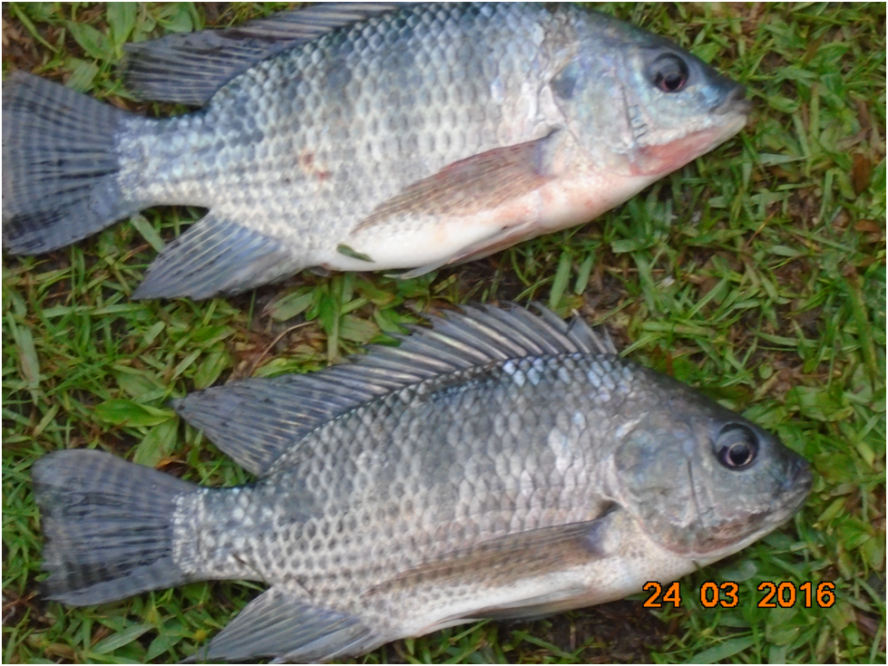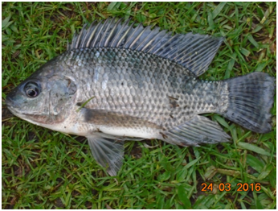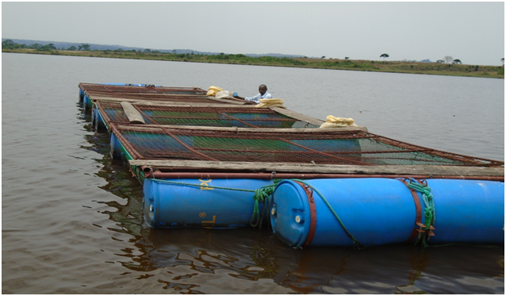

Nile tilapia – Superior Breeds of Fish

Fish Cage

Figure 5: Cage for Nile Tilapia Culture in Lake Kayanja
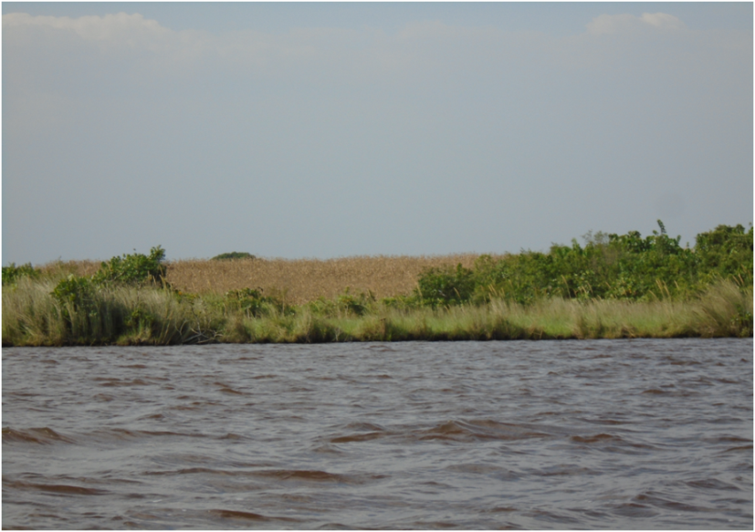
- Destruction of the buffer zones as result of cultivation up to lake shores (Fig:6), and thus increasing the chances of unused agro-chemical such as fertilizers from farms to enter these lakes through surface runoffs , thus polluting the aquatic environment.

Maize Farm

Figure 6: Maize Farm Located at the Shores of Lake Kayanja
- 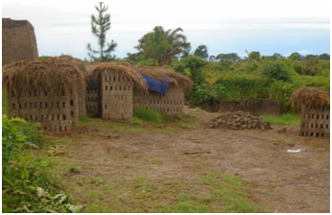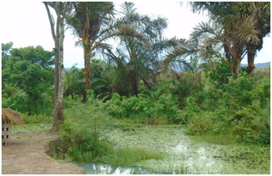 Destruction of riparian vegetation by local communities through brick making (Fig: 7), and this could increase the chances of pollutants entering the lake ecosystem.

Figure 7: Brick making along the shores of Lake Kayugi
d) Poor waste disposal and management especially in Lake Kayanja where a beach has been established for recreational, leisure and special events and activities. Generally during and after such events, many contaminated polythene papers, non-biodegradable plastic bottles, and human wastes find their ways in to the lake, thus polluting the aquatic ecosystem.
Water Quality of lakes Kayanja and Kayugi
The water quality for both lakes was assessed to understand their limnological characteristics and other aspects important for management.
Physico-chemical parameters measured at various sites in lakes Kayanja and Kayugi
The water transparency was higher in Lake Kayugi (0.9 – 1 m) compared to Lake Kayanja (0.45 – 0.66 m) although there were variations between stations within the lakes. Turbidity values were high in both lakes (Lake Kayanja (12.3 – 13.3 FTU); Lake Kayugi (12.9 – 14.7 FTU)). Dissolved oxygen concentration ranged between 6.67 – 7.16 mg/L in Lake Kayanja and 6.45 – 6.95 mg/L in Lake Kayugi while water column temperatures were 25.6 – 26.4 °C and 25.7 – 26.7 °C respectively. pH ranged 7.3 – 7.5 in Lake Kayanja and averaged 7.4 in Lake Kayugi. The conductivity values on Lake Kayanja ranged 15.8 – 18.2 µS/cm and 12 – 18.6 µS/cm on Lake Kayugi. The nitrite (NO2-) concentration in Lake Kayanja (16.6 – 27.0 µgL-1) was higher than in Lake Kayugi (9.3 – 13.6 µgL-1), while the nitrate (NO3-) concentration in the former (75.7 – 84.3 µgL-1) was lower than the latter (80.0 – 126 µgL-1). Ammonia (NH4+) ranged 0.6 – 3.5 µgL-1 in Lake Kayanja and 0.3 – 1.6 µgL-1 in Lake Kayugi. Soluble Reactive Phosphorous (SRP) in Lake Kayanja ranged 8.1 – 19.2 µgL-1 and 12.3 – 13.7 µgL-1 in Lake Kayugi while Soluble Reactive Silicon (SRSI) ranged 1789.5 – 6417.5 µgL-1 in the former and 391.5 – 2356.0 µgL-1 in the latter. The range of the Total Phosphorus (TP) concentrations in Lake Kayanja (TP = 117.3 – 347.6 µgL-1) was higher than that of Lake Kayugi (TP = 103.9 – 270.8 µgL-1) while the Total Nitrogen (TN) concentrations ranged 8630.8 – 10134.4 µgL-1 in the former and 5097.4 – 11788.4 µgL-1 in the latter.
Brief discussions
Originally, the native tilapiine fishes namely; Singidia tilapia (Oreochromis esculentus) and Victoria tilapia (Oreochromis variabilis) were the most abundant and important artisanal and commercial fish species on lakes Victoria and Kyoga but today, they are apparently displaced from these main lakes. However, remnants of these species are present in some of the satellite lakes like Kyanja, Kayugi Kawi and Nawampasa of lakes Kyoga and Victoria basins but are not the most abundant fish species where they occur.
Distribution, occurrence and relative abundance of native tilapia in lakes Kayanja and Kayugi
This study revealed no presence of Victoria tilapia in lakes Kyanja and Kayugi. However, Singidia tilapia were recorded in both lakes with a decline in their relative abundance (relative to the rest of the species caught per Lake) in comparison with earlier studies (1997 -1999) carried out in both lakes. The decline was higher (about 21%) in Lake Kayanja than that of Lake Kayugi (1.3%) and this could be attributed to the increase in habitat degradation and other human activities such fishing pressure in the former than the later. The high number of O. esculentus in Lake Kayugi could also be attributed to the traditional myths (e.g. no use of wooden boats except rafts on this lake; no drawing water from the lake using sooty saucepans) being practiced by Lake Kayugi community. These traditional myths seem to be playing a big role in reducing fishing efforts and pollution on this lake, and thus fostering the conservation of Oreochromis esculentus and other aquatic wildlife of this Lake.
Introduced (exotic) tilapias that were not previously encountered during earlier studies have started to feature in these lakes i.e., Nile tilapia in Lake Kayanja, and Tilapia zillii in both lakes. This could be attributed to human activities like fish farming in Lake Kayanja. Presence of exotic fish species in these lakes will hinder Oreochromis esculentus from accessing enough food, space, and other resources they need for their continued survival and existence. This is a serious challenge that needs to be addressed by relevant stakeholders to revive the population of native tilapias in these lakes.

Feeding Ecology and Biological Characteristic of Singidia tilapia
According to this study, higher pants materials, detritus, blue-green algae, diatoms and green algae were the major food items eaten by Singidia tilapia and introduced tilapias ( Nile tilapia and Tilapia Zillii). This finding complements on what other researchers have documented about the aggressive competition for food between native tilapias and introduced tilapias (Ogutu-Ohwayo, 1990, and Twongo, 1995). The mean condition factor K of O. esculentus was higher on Lake Kayugi (1.6) than on Lake Kayanja (1.4) and this could be attributed to the abundance and inclusion of diatoms as the main food diet in the former than the latter. Diatoms contributed 5% to the total O. esculentus diet on Lake Kayugi and only 0.64% on Lake Kayanja.
Water quality and threats to lakes Kayanja and Kayugi
Native tilapiine fishes of lakes Kayanja and Kayugi are exposed to numerous threats such as habitat, modification, fragmentation, destruction and loss, water pollution, cage farming of Nile tilapia and competition for food, spaces and other resources from introduced tilapias. These findings correlate with what other researchers (Njiru et al., 2008; 2006; Yongo et al., 2005; Balirwa et al., 2003; Lowe- McConnell, 2009; Ogutu Ohwayo and Balirwa, 2006) have documented about threats to native tilapias and their habitats.
From this study, although most of the water quality indicators such as Dissolved Oxygen, pH, and water column temperature of the two lakes were falling within the ranges normal ranges for freshwater water quality; turbidity values were high in both lakes and this could be attributed to presence of algal community and silts from increased agricultural activities. The concentration of Total Phosphorus was higher in Lake Kayanja than Kayugi, and this could be due to increased use of phosphate fertilizers to boost agricultural activities and destruction of the buffer zones in the former than the latter.
Conclusions
Native tilapiines, such as Singidia tilapia (Oreochromis esculentus) which have disappeared from the main lakes are surviving in satellite lakes of the Victoria and Kyoga lake basins. Satellite lakes are therefore acting as functional refuge habitats for critically endangered fishes and other aquatic resources that support the livelihoods of millions of people in Uganda. From this study, in both lakes Kayanja, and Kayugi, fish habitat modification, fragmentation and loss, water pollution and presence of introduced or exotic fish species were noted as the major threats that could jeopardize the ecological integrity of these lakes to support the conservation of these endangered fishes in future. As long as the population of introduced tilapias like O. niloticus continues to increase in these lakes coupled with increased habitats degradation, reviving the population of native tilapias in these lakes by relevant stakeholders will be a challenge.

Recommendations
- There is need to engage all stakeholders particularly government agencies and fishermen in best practices to abate, minimize and mitigate threats to fish and their habitats in Uganda.
- There is need for proper management guidelines for satellite lakes to regulate and control development activities such as cage fish farming, agriculture within and around these lakes.
- There is need to develop and implement strategic recovery plans for native tilapiine fishes of Uganda to revive the population of these fish species in the wild.
- There is need to gazette, monitor and protect critical habitats for native tilapias not only in lakes Kayanja and Kayugi, but also in other satellite lakes.
- There is need for enhanced fishing community involvement in the conservation and management of satellite lakes fisheries resources in Uganda.
- There is need for enhanced public awareness about satellite lakes fisheries resources among all stakeholders to make them know the values and contribution of these resources to their wellbeing and livelihoods, as well as the actions they need to undertake to conserve and sustainably use these resources.

