Semester Report July 2017
DEPARTMENT OF FOREST RESOURCES AND CONSERVATION

Njumbe Peter Salle: CEO, (Agroforester and Ecologist)
Derrick Mesape: (Wildlife Biologist)
Lienou Jules Apollinaire: (Agricultural Engineer)

Table of contents
Introduction……………………………………………………………………………………3
Project Goal……………………………………………………………………………………3
Objectives……………………………………………………………………………………...3
Methodology…………………………………………………………………………………..5
Results………………………………………………………………………………………..19
Challenges……………………………………………………………………………………27
Recommendations……………………………………………………………………………27
Conclusion…………………………………………………………………………………....28
Appendix……………………………………………………………………………………..30

Acknowledgment
We wish to extend our sincere gratitude to our funder and partner Mohamed Bin Zayed, Species Conservation Fund. Special thanks go to the Divisional Delegation of Forestry and Wildlife for Kupe-Muanenguba for their technical support and encouragement in the realization of this project.
Our heartfelt gratitude to all the: chiefs, traditional council members, elites, youths and NGOs like CAD whose assistance facilitated the success of our activities in the project sites.
Many thanks to the team of ABiRSD for the wonderful job carried out in the field.
We are grateful to all other actors who contributed in one way or the other to the success of our activities in our project sites.
Finally we thank the Almighty God for protection and guidance.

Introduction
The proposed Mount Muanenguba Integral Ecological Reserve in the Southwest and the Littoral Regions in Cameroon is rich in biodiversity. The presence of twin lakes at its caldera normally referred to as male and female lakes. Mount Muanenguba is linked with another mountain called mount Kupe thus giving the name Kupe Muanenguba from where the division got its name. This mountain is rich in diverse bird’s species, reptiles, mammals and amphibians. Amphibians in the proposed Mount Muanenguba Integral Ecological Reserve are threatened by hunting, habitat fragmentation through deforestation, pollution and slash and burn agriculture prevalent in the area. Amphibians are unsustainably hunted by members of the adjacent Communities particularly long-fingered frog (Cardioglossa manengouba) for their protein in-take. This frog is endemic species in the area. It can be found at water sources as well as farmlands in the area. Its spatial distribution and density in the proposed Muanenguba Integral Ecological Reserve have reduced drastically.
To contribute to the conservation of amphibians in the proposed Integral Ecological Reserve, the Association for Biodiversity Research and Sustainable Development (ABiRSD) carried field trip in March and June in Kupe-Muanenguba area. During the field trips trees were planted on the landscape Muanenguba. Also survey was carried out around Muanenguba Mountain. Field visit were made around the Mount Kupe.
In order boost income generating activities and food security while conserving wildlife species in South West and Littoral Region of Cameroon, other activities on nursing of fast growing trees, fruit seedlings production, plantain seedlings production, cassava cuttings production to be used in our project sites were carried out.
Goal
The goal of the project is to restore habitats of frog species and their relative density in the Muanenguba landscape Cameroon.
Objectives
- To carry out survey on frogs, threats and distribution in Muanenguba landscape.
- To restore degraded landscape through tree planting in Muanenguba Mountain area.
- To sensitize communities on the importance of frog species, sustainable farming practices and promotes alternatives to unsustainable income generating activities such as poultry, pig rearing, snail farming, mush room farming, fish farming etc.
Methods
- Line transect and quadrate survey method and guided questionnaire was used
- Sensitization and mobilization
- On-site demonstration
- The use of cameras.
- Cartographical delimitation of the area with the use of GPS.

Activities:
Objective 1: To carry out survey on frogs, threats and distribution in Muanenguba landscape.
To carry out survey on amphibians and distribution in Muanenguba landscape:
Field activities were organized on the 15th to the 20th of June at the Muanenguba landscape and near Mt Kupe. This areas harbors endangered Cardioglosa manengouba and other threatened amphibians. Group discussion was organized by ABiRSD field staff and villagers of Kupe on amphibians. The reasons for the group discussion were to:
1. To identify potential areas of amphibians and other threatened wildlife species in the area. 2. To identify possible threats to amphibians and other threatened wildlife species in the area. 3. Identify conservation measures to ensure the sustainability of these species. Also some water bodies and marshy areas were critically censored at specific distances and direction. Encountered or any sign of species were identified and its GPS coordinate recorded. The different human signs in the area were also recorded. Pictures were taken on any sign or species encountered during the survey. Guided reconnaissance walk was used during the survey. These walks spanned 1 km each in the different areas and at different orientations.
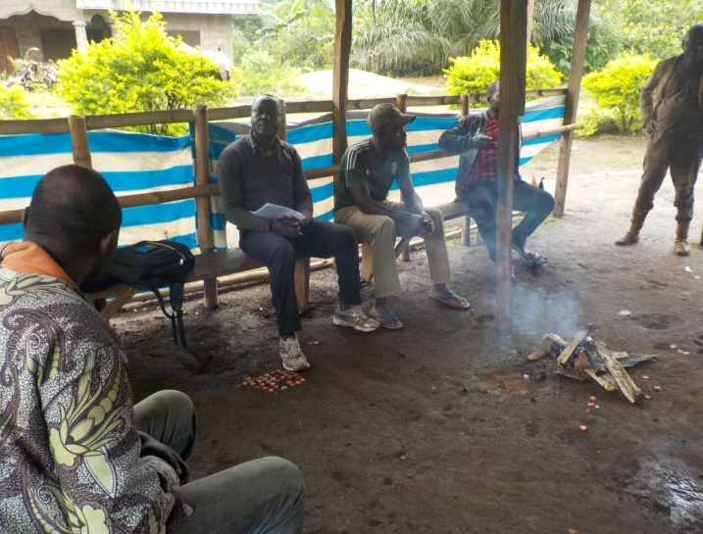
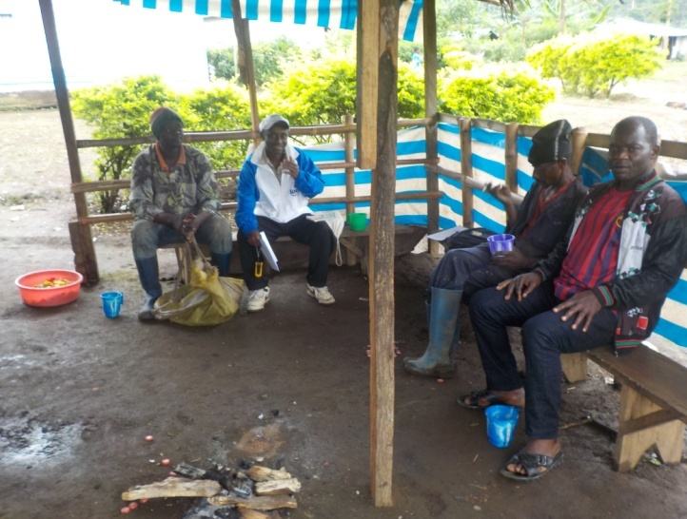
Group discussion with villagers in Kupe
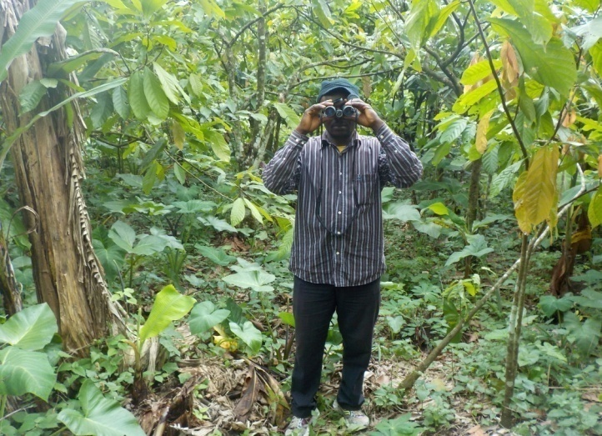
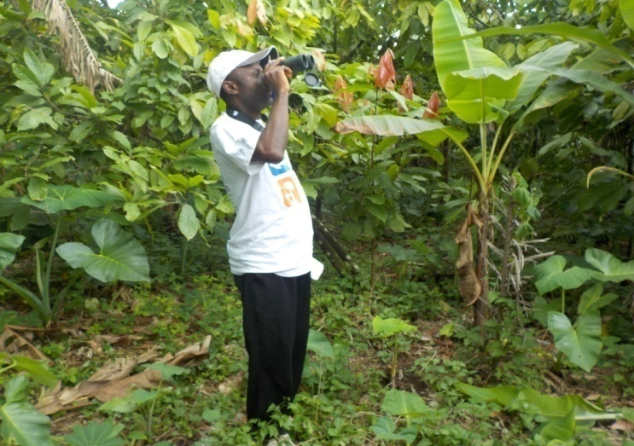
Field survey in Kupe landscape
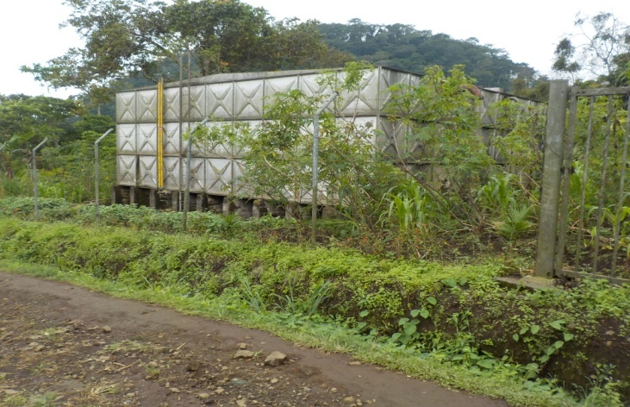
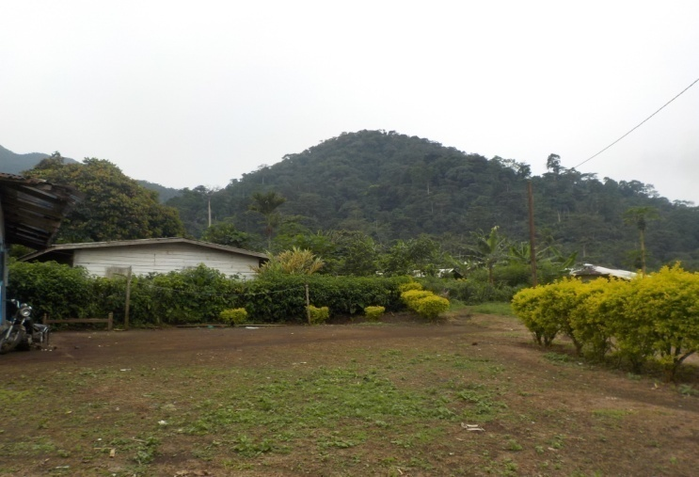
Landscape of Mount Kupe Water source of Kupe
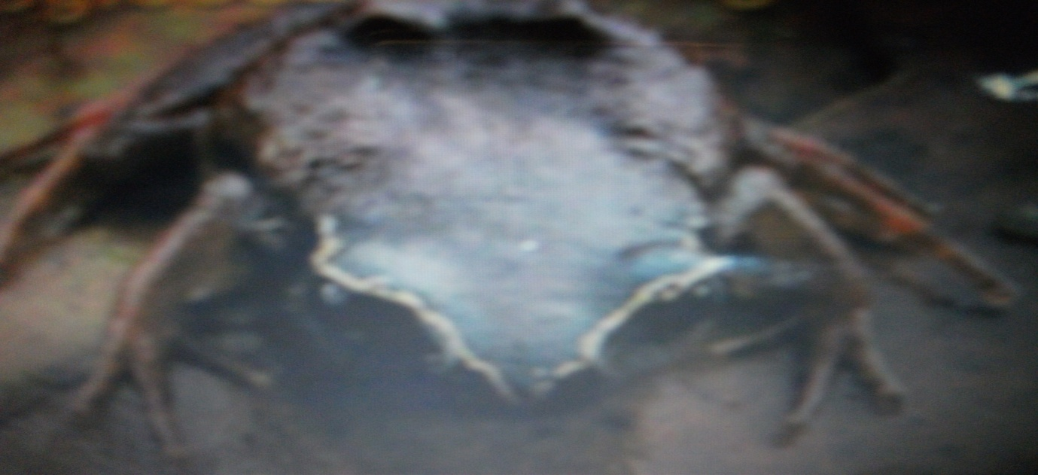
Cadioglossa manenguba
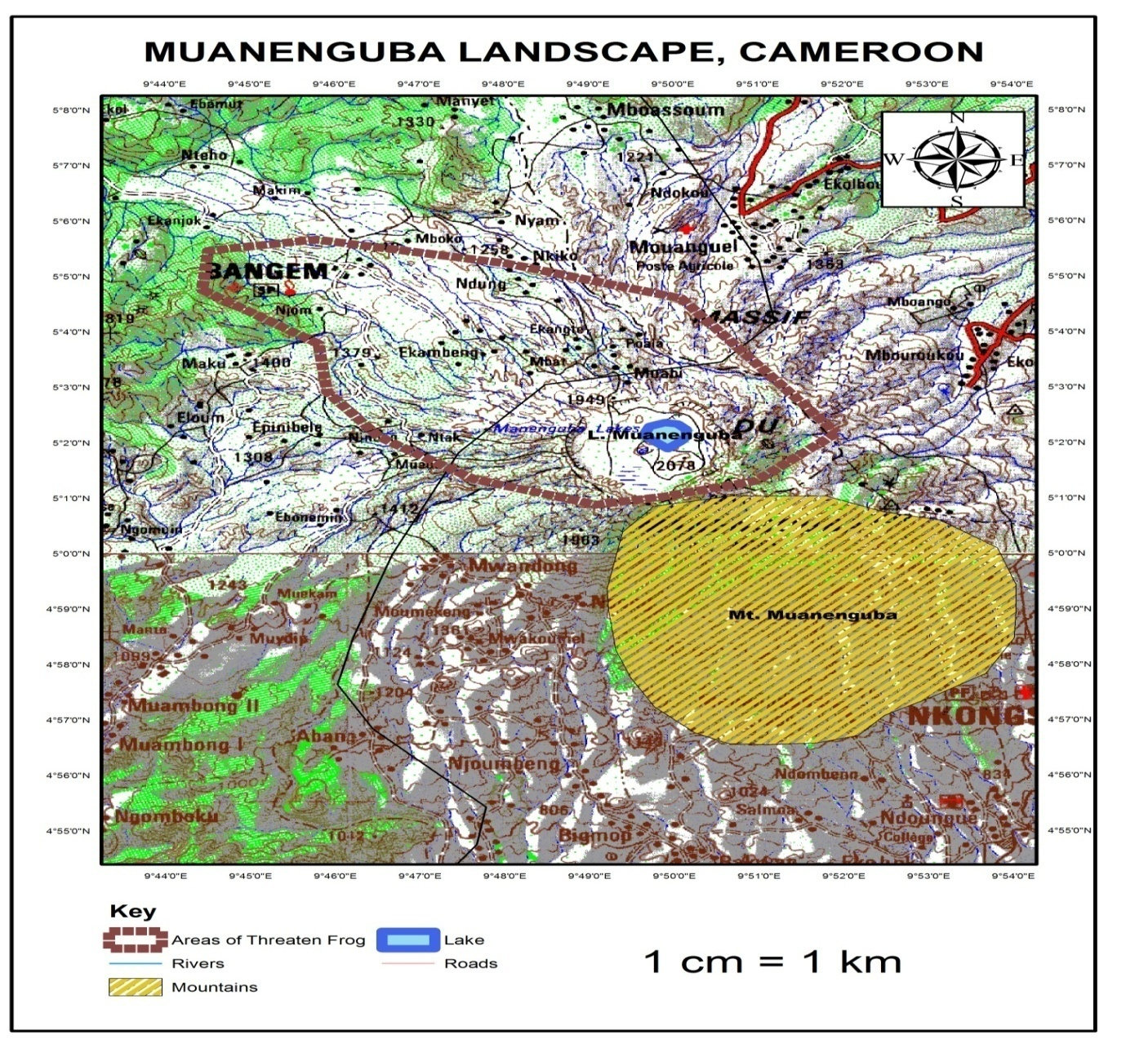

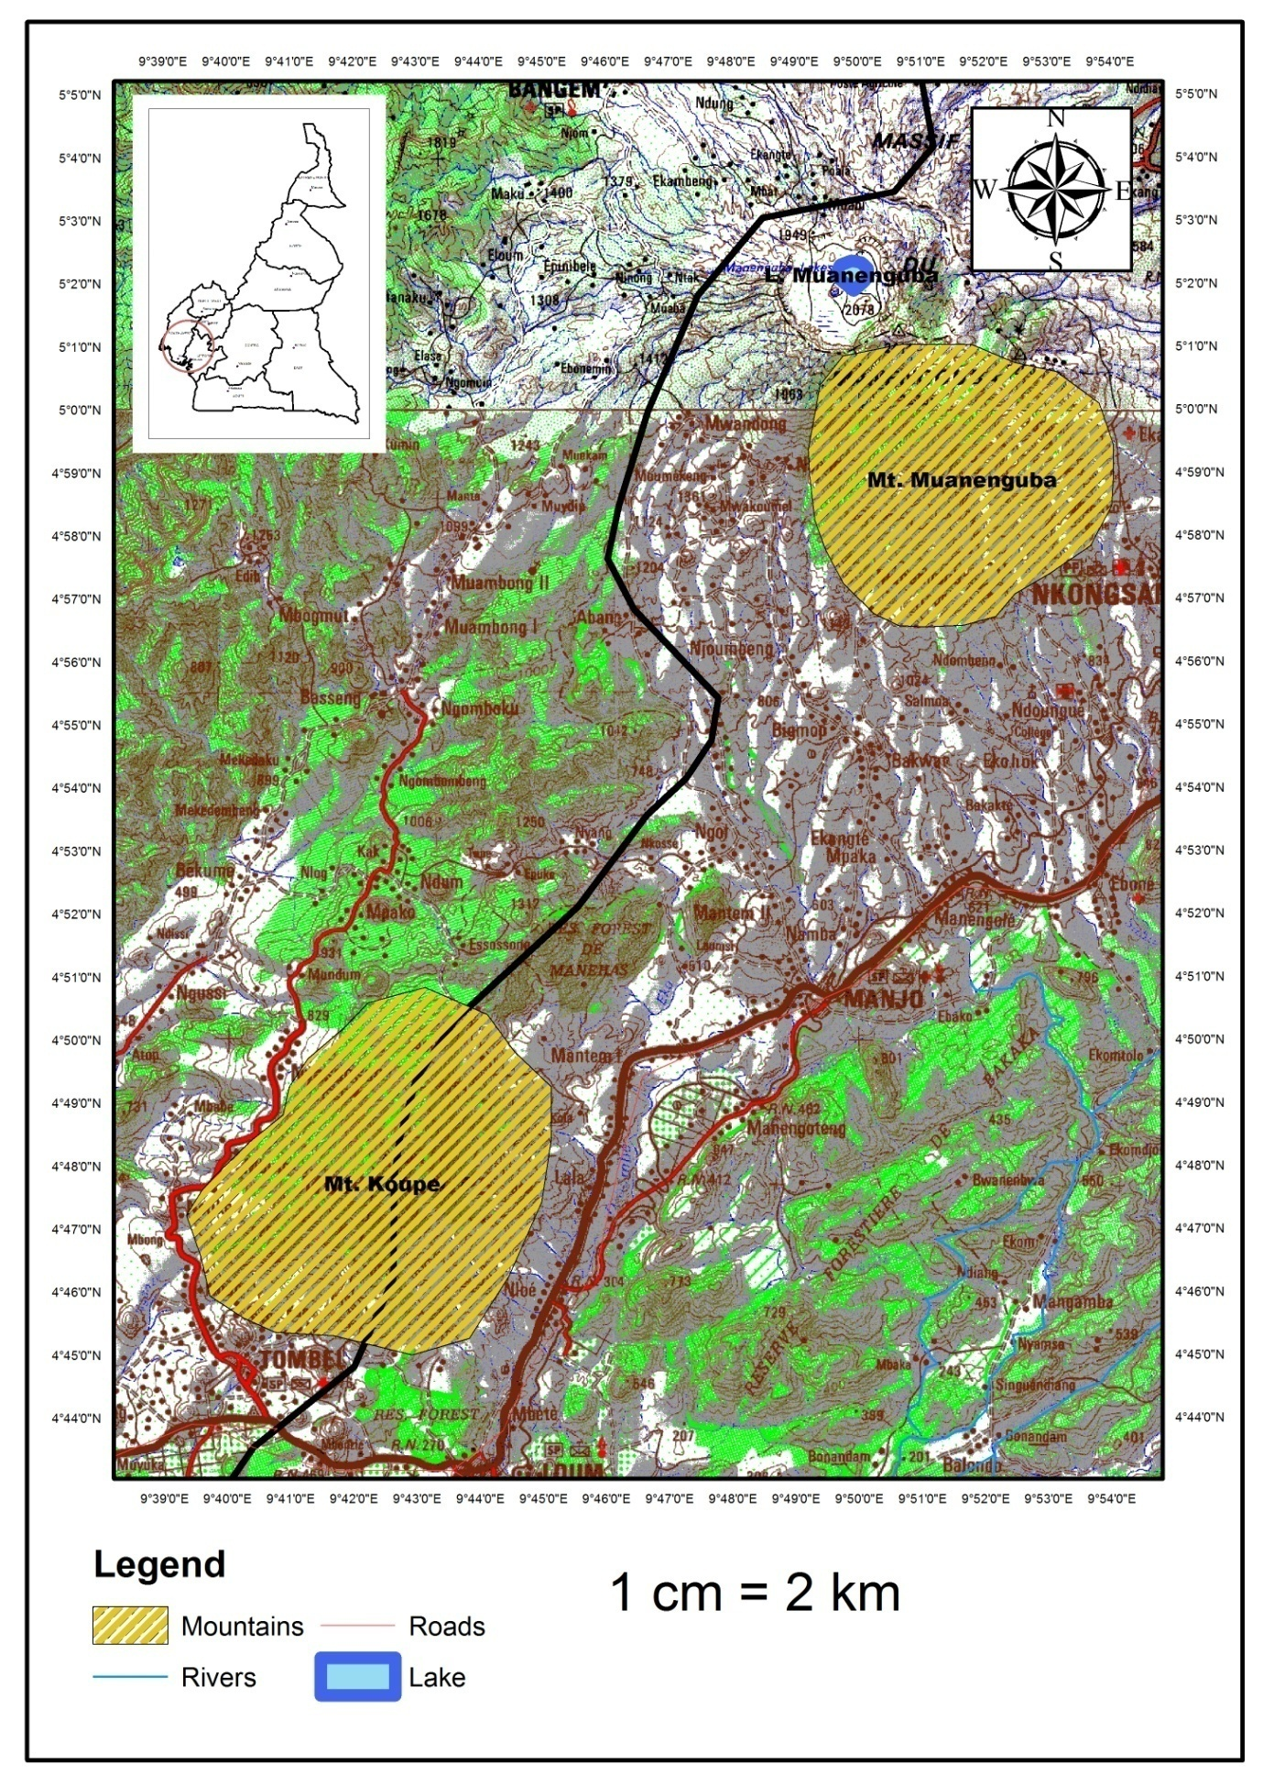

Objective 2: To restore degraded landscape through tree planting in Muanenguba Mountain area.
Growing fast timber trees for forest and water catchment restoration.
One of the greatest problem plaguing communities today is the indiscriminate cutting down of trees in the forest surrounded by these communities. This act has led to the disappearance of primary forest and its content including water resources. The disappearance of forests and water catchments is the leading cause of climate change, lost of wildlife, food and water crises. It is in this light that the Association of Biodiversity and Sustainable Development (ABiRSD) is putting up this project to protect our wildlife and water resources through the propagation of fast growing timber trees such as Cindrella, Terminalia superba (Frake) and Mahogany will be used to restore degraded lands in Kupe Muanenguba area and other degraded areas in South West and Littoral Region.
The trees are nursed in ABiRSD’s research center by the staff of ABiRSD. The objectives for growing these fast growing trees include:
- To protect and conserve wildlife in South West and Littoral Region of Cameroon.
- To mitigate climate change action in South West and Littoral Region of Cameroon.
- To ensure continuous flow of water through catchment protect in South West and Littoral Region of Cameroon.
The trees will be utilize by government officials, councils, farmers and researchers on reserves, protected areas, water catchments and farm lands.
A big multi-purpose nursery established on a level land for easy management, accessibility, that is, the nursery is located near the house for easy monitoring. This center is closer to a water source such that water is always available for watering the nursery. A shed is first constructed on the site before nursery establishment. This is to prevent direct sun or heavy rains from destroying the young seedlings and also to prevent the nursery from being destroy by stray animals and strong winds. Nursery establishment was carried out during the month of February. Four main seed varieties were used for the nursery such as: Frake, Cindrella, Tephriosia and Mahogany. Frake and Cindrella, were collected in Yaounde in the centre Region while Tephriosia and Mahogany were collected in Buea South West Region.
Seed beds were prepared by tilling the soil. The soil is mixed with saw dust and fowl droppings to enrich the soil. The soils are raised to form a ridge. The bed is flatten using a stick to form a flat bed. The width of the bed should not be more than 1.5 meters while the length can take any length. The seeds are nursed directly on the bed on straight line at a distance of three centi-meters and cover lightly with saw dust to prevent them from carried away by wind.
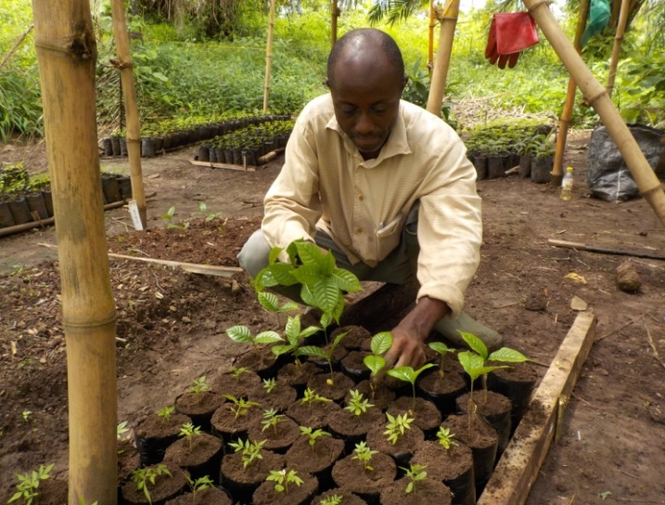
The seedlings are transplanted directly on polythene bags filled with soil. The seedlings are transfer when they attain a height of 10 cm. The seedlings should be pulled from the ground without damaging the roots. A sharp stick is used to make a hole of about 10cm deep in the polythene bag. Watering, weeding, prevention and control of pest and diseases are ensured.
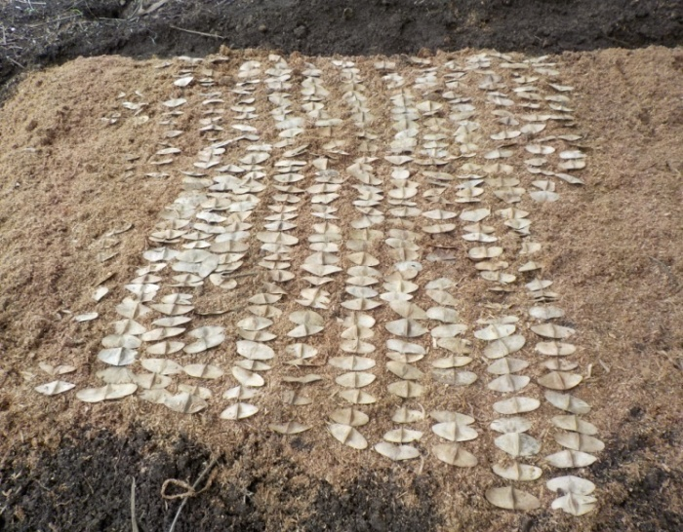
Nursing of seeds Transferring seedlings to polythene bags
Tree Planting
Tree planting is an important aspect that we must practice, this is because of its importance to man. Trees have a critical role to play in addressing climate change issues. It fights against soil erosion, deforestation and can also be use as scenery especially along the road to beautify the streets. Tree planting at Muanenguba landscape started on the 25/05/2017 at 10:00am and ended on the 27/05/2017. We began by clearing and preparing the area for the planting exercise. This planting activity was carried out by the team of Association for Biodiversity Research and Sustainable Development (ABiRSD) and villagers found around Muanenguba. The objectives of the tree planting were:
- To fight climate change in the south west region of Cameroon and the world as a whole since climate change is said to be a universal issue.
- To fight against deforestation and desertification.
- To restore degraded habitat in South West Region.
We use materials like cutlasses, holes, shovel, diggers, measuring tape and wheelbarrow. We use cutlasses to clear grasses; holes to prepare the ground work for planting, diggers are use in digging holes for planting of these trees.
The planting was done on farms and water sources. Ringing of 30 cm is ensured at the planting site. A hole of 25 cm deep and 30 cm in diameter is dug. The top soil is separated from the subsoil, this is to ensure that the top soil goes at the bottom of the hole while the subsoil occupies the top. Mature plants of Acacia spp. was planted at a distance of 4 meters apart. GPS was used to geo-reference major areas where trees are planted.
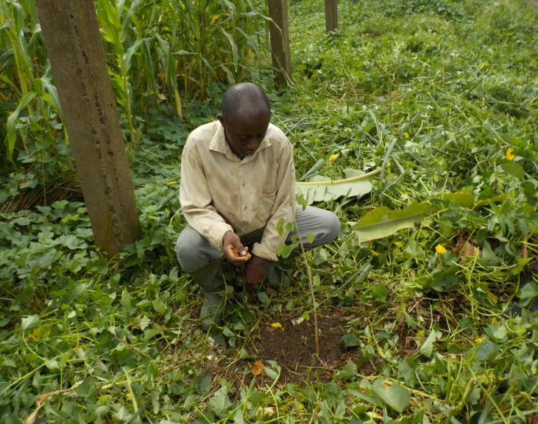
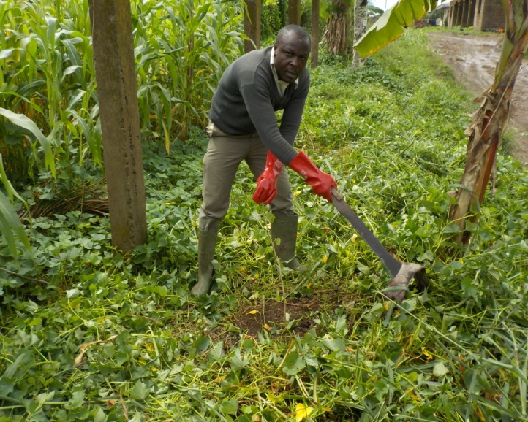
Tree planting exercise
Objective 3: To sensitize communities on the importance of frog species, sustainable farming practices and promotes alternatives to unsustainable income generating activities such as poultry, fish farming, piggery, snail farming, mush room farming etc.
Fruit Seedlings production to improve livelihood and food security
The main objective was to produce viable and disease resistance fruit seedlings to increase food security, income, and livelihood opportunities for rural communities in South West and Littoral Region so as to enhance environmental protection. The specific objectives of the project were:
- Engage farmers in developing and applying strategies for sustainable supply and delivery systems of quality tree germplasm to meet potential massive demand by smallholder farmers.
- Improve strategies for accessing functional and efficient input that increase prices paid to farmers for their outputs and reduce costs incurred by farmers for needed inputs.
- Strengthen and mobilize the capacity of national and local institutions and development agencies in scaling up agro-forestry and develop strategies for institutionalizing agroforestry research.
The activities took place in ABiRSD project site in South west and Littoral Region of Cameroon. Fruits tree seeds of pear, mango and orange were gathered around the communities. The seeds were prepared and nursed using the bed nursery method. Materials used were: seeds, knives, polythene bags, fowl dropping, saw dust, watering cane, hoe and cutlass. The cotyledons were removed from the hard coat of the seeds to increase the germination rate. A raise flatten bed of 1.5 m width and a length of 2.5 m is produce near a water source protected by a well constructed shade. After digging the bed, the soil is mixed with fowl droppings, saw dust to increase fertility of the soil and warm for seeds to sprawl faster. Intensive modular training for the farmers is to: In tree nursery care, and planting and management of trees in appropriate niches in cropping systems, to empower them to produce fruit, fuel wood. The reasons for producing fruit seedlings include:
1. Very expensive for poor peasant farmer to purchase.
3. To produce large number of fruit seedlings to be distributed to the farmers to plant.
4. These fruit seedlings take a shorter time to produce fruit than others.
5. Will produce income within short period of time.
6. Will enable us to train the farmers on nursing methods and established their own farms to produce more planting materials.

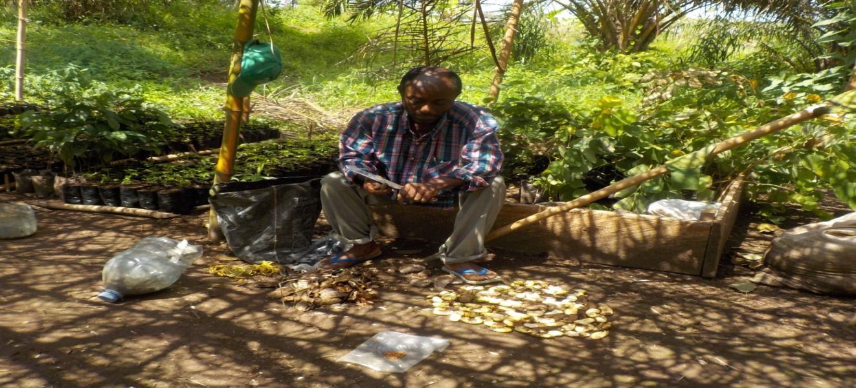
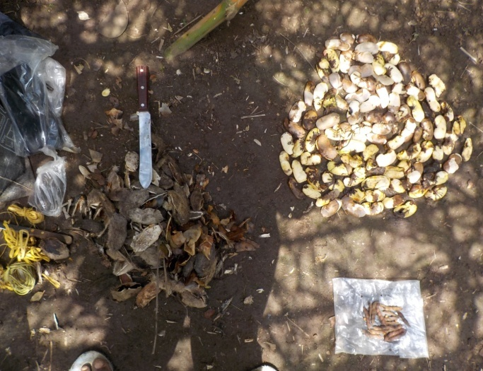
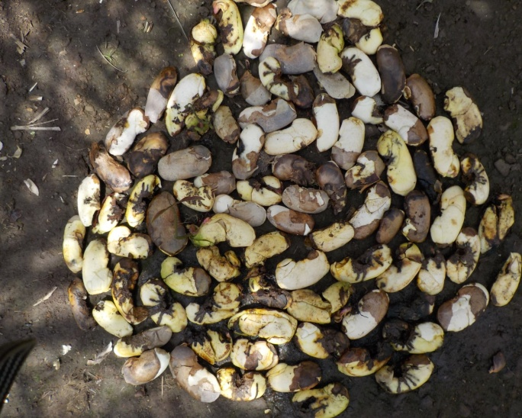
Preparing mango seeds for nursing
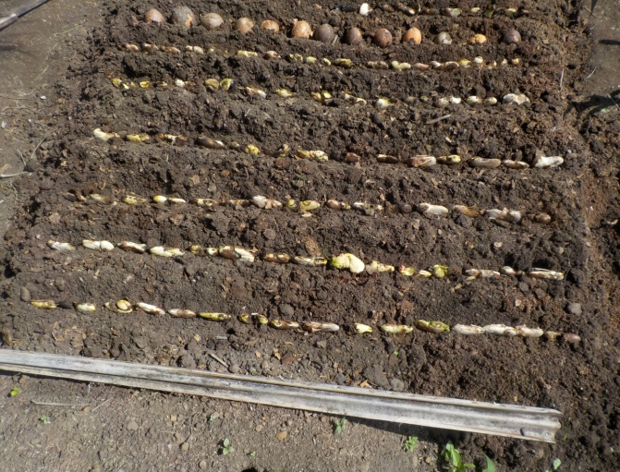
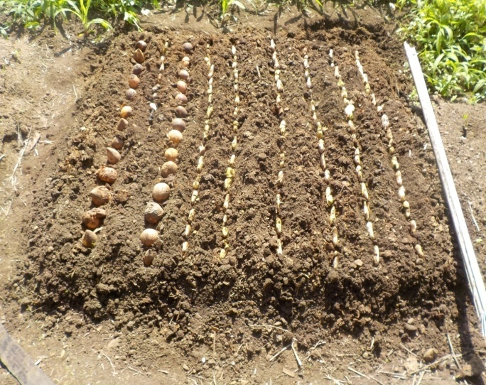
Nursing of mango seeds
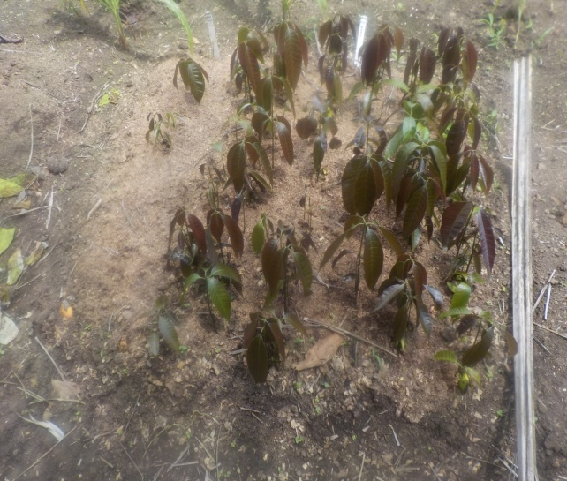
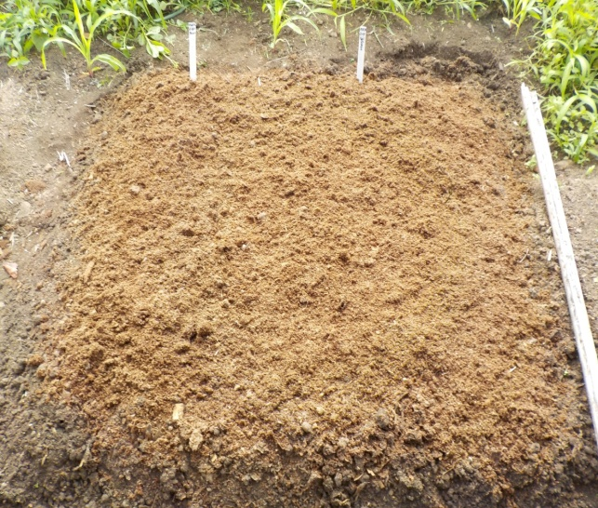
Nursed mango seeds Germinated mango seeds
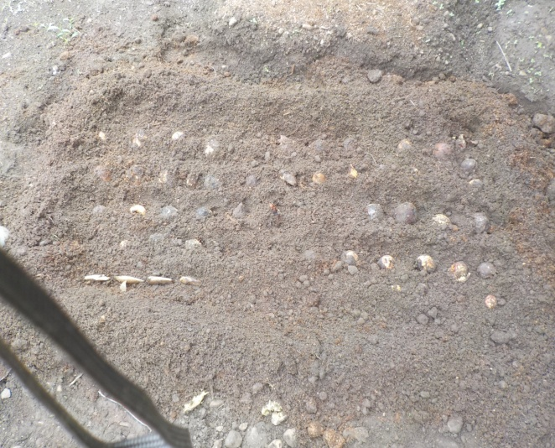
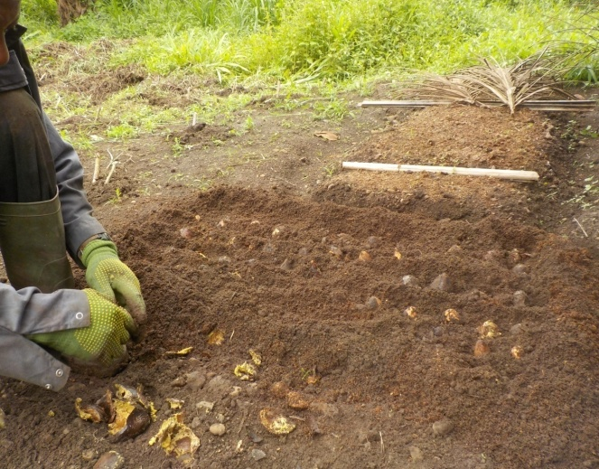
Nursing pear seeds
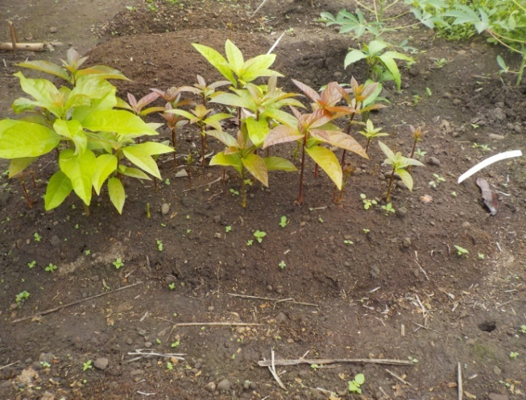
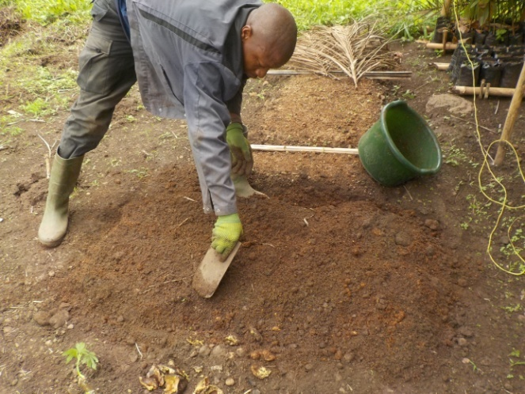
Pear seedlings

Plantain production in the South West and Littoral Region of Cameroon
The demand and the price for plantains are continuously increasing; many farmers want to grow more plantains in order to raise income and to produce enough to feed the population. However, backyards cannot be readily extended since they are enclosed by houses or fences. The only way, therefore, to expand production is to grow plantains in fields at some distance from the village. Different methods of cultivation should accompany the change in site to achieve and sustain high-level yields for several years. Cameroon with its 20 million people, 8 million of the population live in rural areas and involved mainly in agricultural activities.
It is in this light that the Association for Biodiversity Research and Sustainable Development (ABiRSD) is engaged in establishing a demonstration farm to enhance plantain production through the development of widely adapted high yielding multiple disease /pest resistance varieties and transformation to increase market opportunities. The reasons for establishing demonstration farms:
1. Plantain suckers are expensive for poor peasant farmer to purchase and most often infected with plantain diseases.
2. To produce large number of improved, fast growing, disease resistant plantain seedling to be distribute to the farmers to plant.
3. Will be use to allow the farmer appreciation and choose their own varieties to be planted.
4. To train the farmers on planting methods and established their own farms to produce more planting materials.
This strategy will go a long way to boost income generating activities and food security while conserving wildlife species in South West and Littoral Region of Cameroon. The overall goal is to improve food sufficiency and income of poor farmers and communities in the South West and Littoral Region of Cameroon. The objective is to establish a propagator for produce fast growing and disease resistant high yielding plantains seedlings of different varieties.
Activities
Selecting the Site
The site should be easily accessible, especially if the establishment of a large field is being planned. It should be well drained but not too steep slopes. Plantain cultivation is impossible if the land becomes flooded from time to time, or has a water table at a depth of only 50 cm or less. The soil should be rich in organic matter (black soil).
Preparing the Field
Fields are to be prepared with minimum disturbance to the soil (no-tillage farming). In consequence, manual clearing should be preferred to mechanical deforestation because bulldozers always remove topsoil with important organic matter and compact the remaining soil. When an old natural fallow is cleared, the debris from the forest should be use for compost. Some trees could be cut but the stumps are not to be removed, and the trees should be left to grow again. They can be pruned only when they start to obstruct field activities or shade the plantains. A propagator and acclimatization unit is constructed using ply wood, saw dust, nylon, nails, bamboo stick.
Preparing Suckers
Suckers are separated from their mother plant with a spade or machete. The sucker corm must not be damaged or chipped. Consequently the corm should be carefully peeled with a machete or knife. The pseudo stem of the suckers should be cut off above the corm. Peeling of the corm reduces the development of nematode infestation, while cutting of the pseudo stem reduces bulkiness and improves early growth of the newly planted sucker. A freshly peeled healthy corm ought to look white, but corms infected by stem borers and nematodes show brown and black spots which have to be removed until only white tissue remains. If the infestation is severe, with many brown and black spots, the sucker should be destroyed. Sucker preparation (peeling) is carried out of the field where the planting material is collected. This is to avoid contamination of the new field with roots infested with nematodes or corms with stem borers. Prepared corms are transported to their destination where they are left to dry for a few days (not in the sun). The pearled suckers are treated with insecticide in a basin for 30 minutes. This is to kill and destroy any traces of nematodes on suckers. After 30 minutes the suckers are removed from the basin and placed on nylon for it to get dry. The suckers of different varieties are nursed in the propagator. The varieties are: Ebange, Batard, Enyale, Big Ebange and Brock Caca.

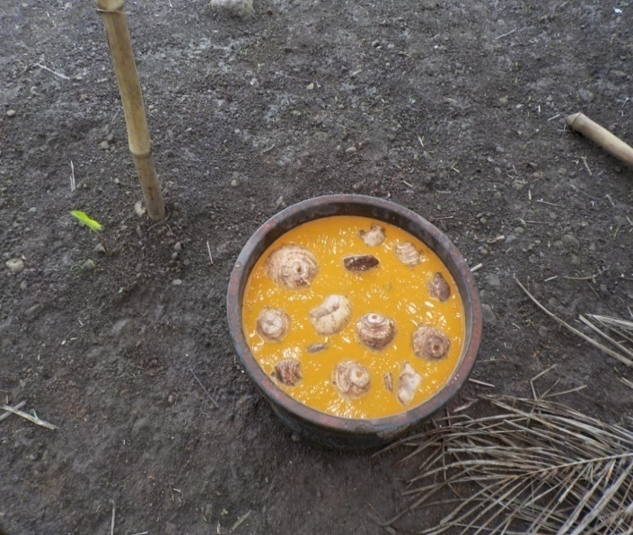
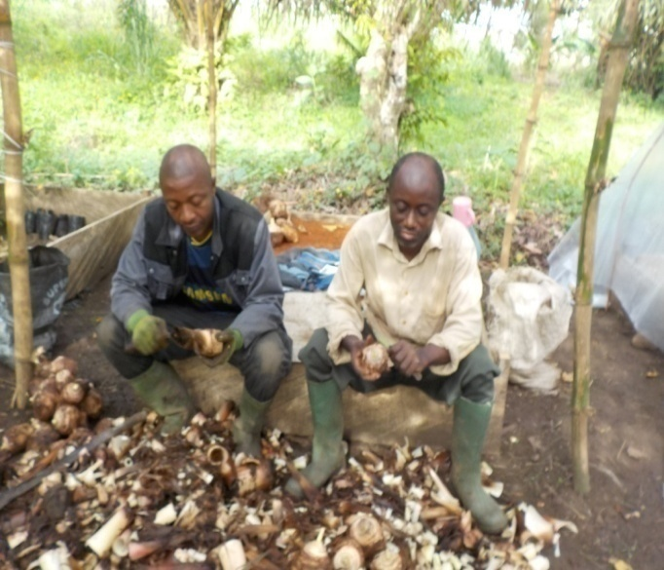

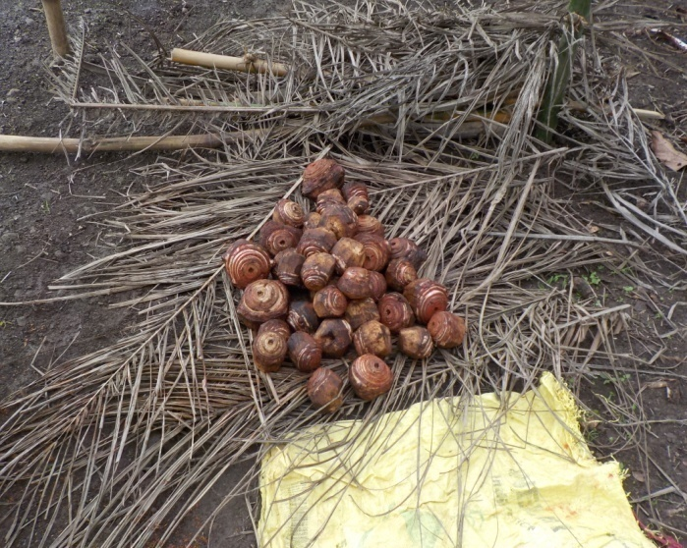
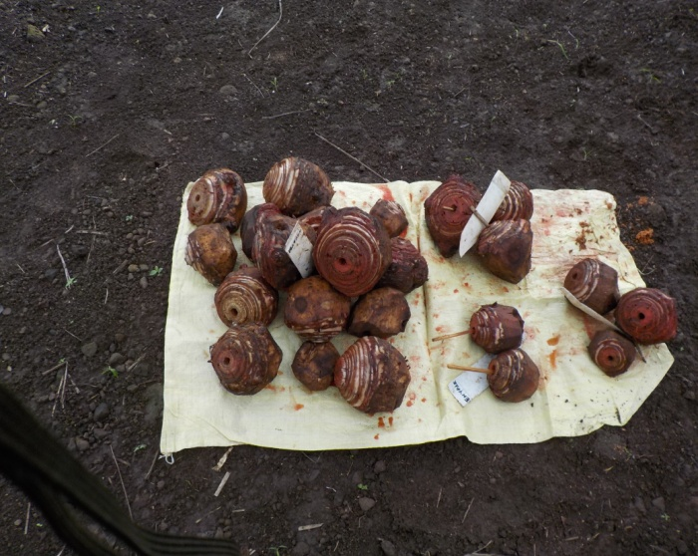
Preparing plantain suckers for nursing
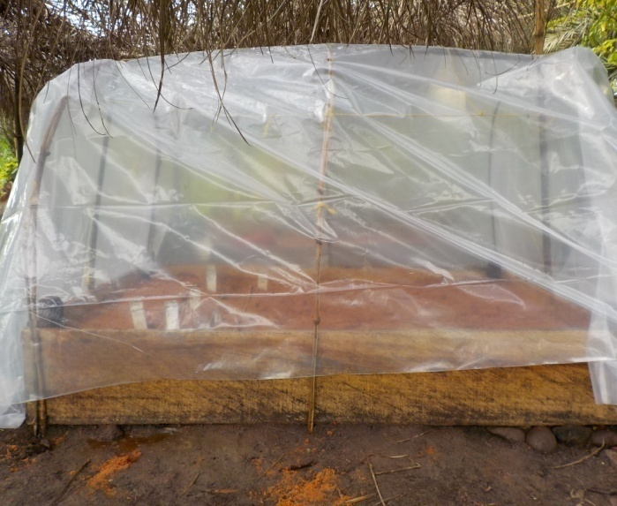
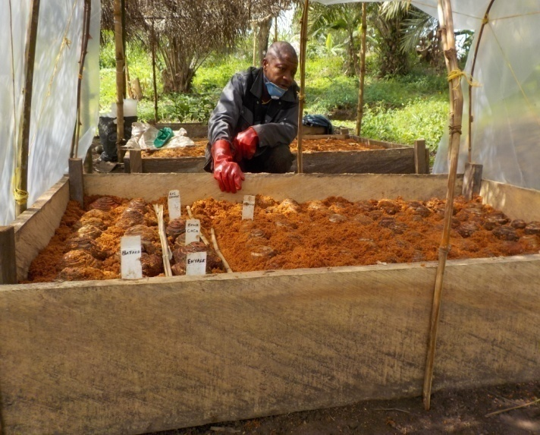

Nursing of prepared plantain suckers in a propagator
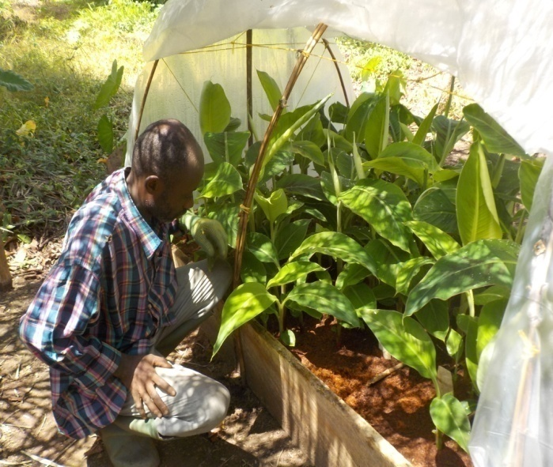
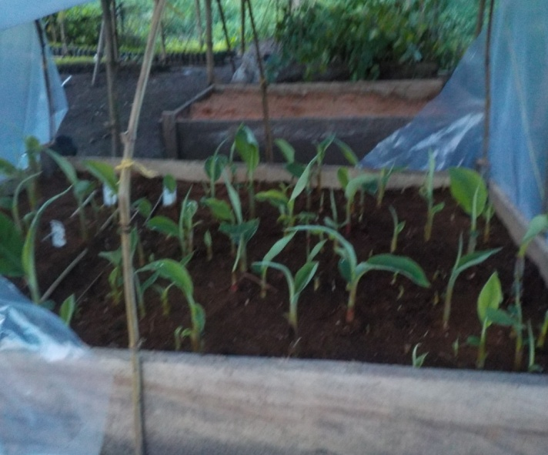
Plantain seedlings in a propagator

After three week of nursing the sucker corm the propagator is full with young plantain seedlings. The plantain seedlings are carefully removed in the propagator and transferred in acclimatization unit through the process called winning, after which it ready for transplanting. Winning cold be done for about 8 times to produce a large quantity of plantain seedlings before it fade out.
The reasons for establishing demonstration farms that will be use by the communities to make their choice on their own preferred plantain varieties to be cultivated and to provide planting materials for communities and to established more demonstration plots for the communities.

Cassava production in the South West and Littoral Region of Cameroon
The goal is to improve food sufficiency and income of poor farmers and communities in the South West and Littoral Region of Cameroon. The objective is to establish a demonstration farm of high yielding improve cassava of different varieties
Activities
Generally smallholders relies on root and tuber production, especially cassava, whose farms are mostly less than 2 ha (cassava plots). It can also be average-size farms (2-4 ha) and larger producers (over 4 ha).
Cassava represents a staple food source in Cameroon and in many other tropical countries, as it is effectively able to combat hunger. This work is carried out to: (i) determine the productivity/growth characteristics of improved and local cassava varieties in Cameroon under repeated cultivation, (ii) assess the effects of different soils on cassava growth, (iii) examine and manage cassava diseases and (iv) disseminate the improved varieties throughout the Regions. Cassava (Manihot esculenta Crantz) is traditionally grown by smallholder women farmers for household consumption. In Cameroon, the cultivation of this crop is recently gaining interest among a larger community as it appears to be a source of income generation. This activity is carried out in the South West and Littoral Region of Cameroon to use efficient improving methods for cassava production. ABiRSD is working on eight internationally recognized, improved and vulgarized varieties of cassava. These varieties are: 0023, 0057, TME 419, 0067, 001/0040-27, 92/0326, 96/1414 and 8034.
The land is identified and cleared using cutlasses, hoe to remove un-wanted vegetation and grass to keep the site clean. Burning is completely avoided to ensure the presence of micro organisms that increases soil fertility. Immediately this is done the land is pecked using a measuring tape and a rope. This is to have the exact surface area of the site of activities. The land is leveled using a spade to have a uniform landscape. Fresh and healthy cassava stem of improved and vulgarized varieties are used as planting materials. This is to ensure quality production and disease resistant of the planting materials. A sharp knife or scissor is use to cut the cassava stems into uniform sizes of 15 to 20 cm. The cassava cuttings are planted in conformity with basic norms (planting distance or spacing, pattern of planting). The following improved cassava varieties were planted; 0023, 0057, TME 419, 0067, 001/0040-27, 92/0326, 96/1414 and 8034.
Constant weeding in the plots is carried out to ensure proper growth of the crops. Disease and pests are also checked through regular control. Boiling, Gari and waterfufu production are some of the usage of cassava. Those products constitute the base of the local population’s nutrition, which explains why weekly village or communal markets are of crucial importance.
The reasons for establishing demonstration farms:
1. These eight improved vulgarized varieties are difficult to have them.
2. Very expensive for poor peasant farmer to purchase.
3. Enable us to produce large number of cassava cuttings to be distribute to the farmers to plant.
4. To allow the farmer appreciation and choose their own varieties to be planted.
5. Will enable us to train the farmers on planting methods and established their own farms to produce more planting materials.

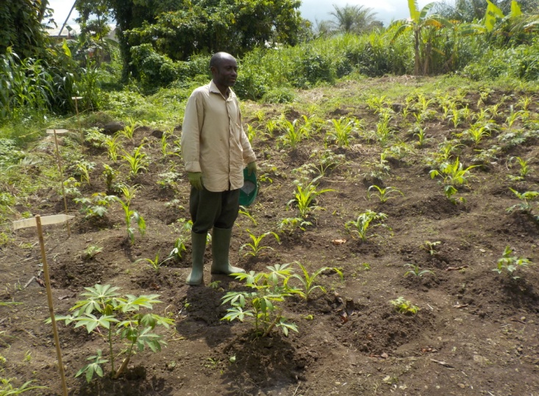
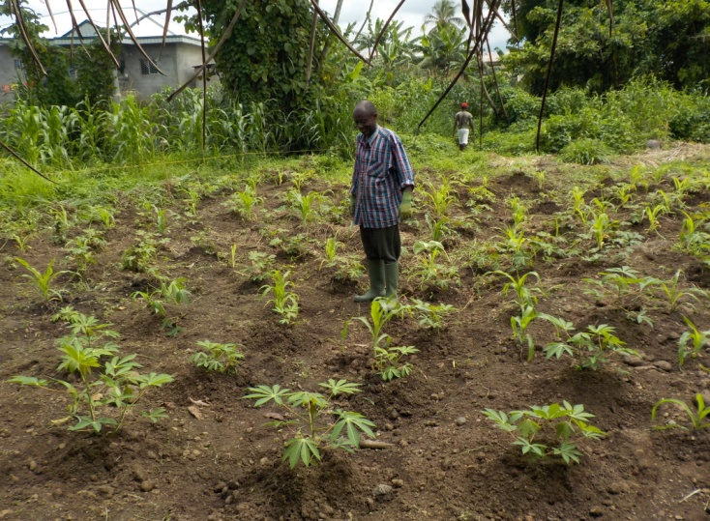
Cassava varieties demonstration farms, ABiRSD2017

Results obtained
Table showing areas visited Kupe area
Name of the area | Latitude | Longitude | Altitude in meter
Kupe I | N04º45.304´ | E009º40.872´ | 557
Kupe II | N04º45.394´ | E009º41.088´ | 561
Water source in Kupe | N04º45. 226´ | E009º40.481´ | 535
Forest in Kupe | N04º45.497 | E009º41.212 | 960

Table showing data collected during biological survey
Name of the area | Start point  In UTM coordinates | Altitude in m | Endpoint  In UTM coordinates | Altitude in m | Orientation in degrees
Muanenguba female lake | 0591798  0556905 | 1919 | 0591031  0556278 | 1980 | 215
Swamps near male lake | 0599463  0561398 | 1915 | 0589611  0564165 | 1969 | 233
Mbue river near Mbat village | 0588291  0559711 | 1546 | 0587342  0560475 | 1392 | 337
Source: Field trip 2017
Field survey and investigation shows that apart of the female lake having Cardioglosa manengouba which is critically endangered and threatened species, other areas found around Muanenguba have these threatened species. Farmlands around Muanenguba are also potential areas for other species of amphibians. From our field survey and investigation, Cardioglosa manengouba was seen at the female lake at an altitude of 1920 meters which is critically endangered and threatened species, while farmlands around Muabi and Mbat 1724 and 1543 meters respectively are also major areas to other species of amphibians.
This project has been appreciated by IDEA WILD to ensure it continuity by donated specialized survey equipment including nocturnal equipment at the end of November 2016. The equipment are sleeping tents, high resolution binoculars and recording cameras to capture sounds and images of nocturnal amphibians.
Result on fast growing trees
Frake, Cindrella and Tephriosia have the highest germination percentage (G) of 94, 95 and 95 respectively while Mahogany has 70. Frake, Cindrella and Tephriosia with the germination percentage (G) of 94, 95 and 95 have the time of germination (T) in days 11, 04 and 03. Mahogany with the germination percentage (G) 70 has the highest time of germination of 21 days.
Table 1: Information on nursing of seeds
Source of seeds | Species | Q’ty nursed | Date nursed | Date of germination | HQG* | Time(Day)* | G(%)* | Viability
Yaounde | Frake | 2500 | 24/3/17 | 04/04/17 | 2350 | 11 | 94 | Excellent
Yaounde | Cindrella | 1900 | 28/03/17 | 02/04/17 | 1800 | 04 | 95 | Excellent
Buea | Tephriosia | 3000 | 22/04/17 | 25/04/17 | 2850 | 03 | 95 | Excellent
Buea | Mahogany | 500 | 03/04/17 | 24/04/17 | 350 | 21 | 70 | Very Good
HQG*: Highest Quantity of seed Germinated, G (%)*: Highest Total of Germination percentage. Time (Day)*

Table 2: Transfer of seedlings to polythene bags
Location | Species | Q’ty transferred | Date of transferred | % of survival | Remark
Buea | Frake | 2350 | 08/05/17 | 100 | Excellent
Buea | Cindrella | 1800 | 19/05/17 | 100 | Excellent
Buea | Tephriosia | 2850 | 26/05/17 | 100 | Excellent
Buea | Mahogany | 350 | 26/05/17 | 100 | Very Good
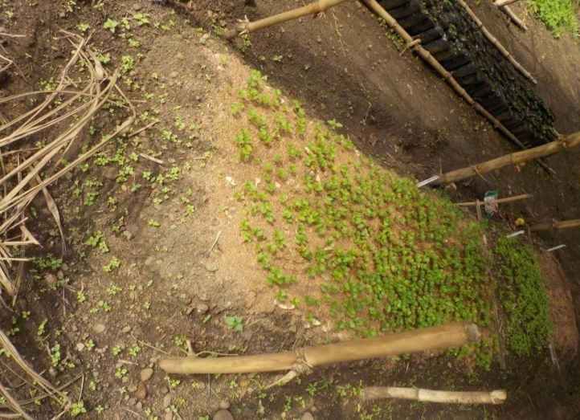
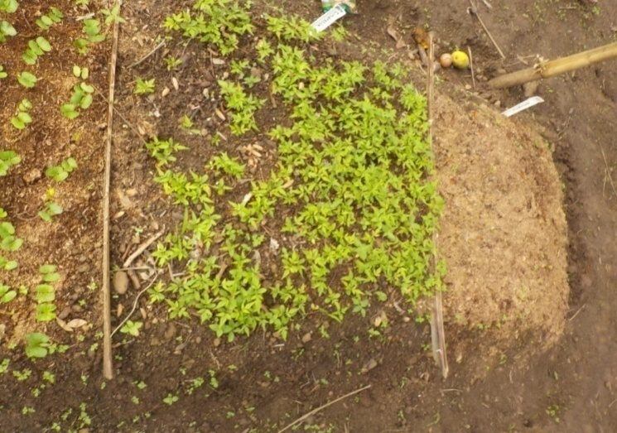

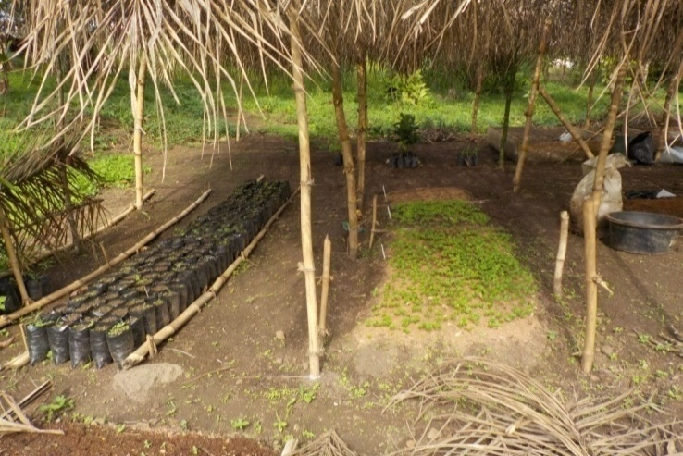
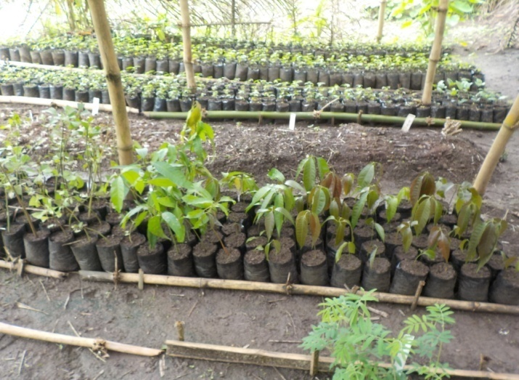
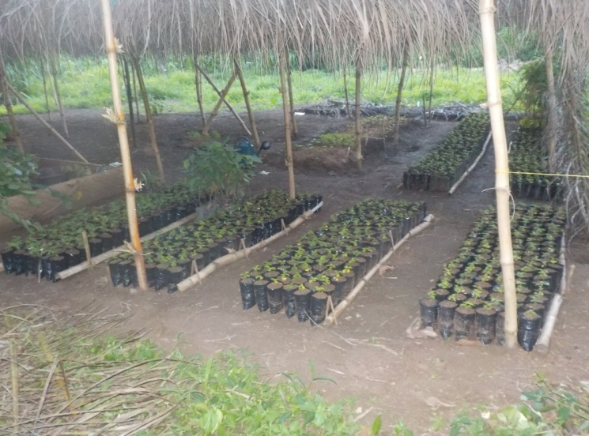
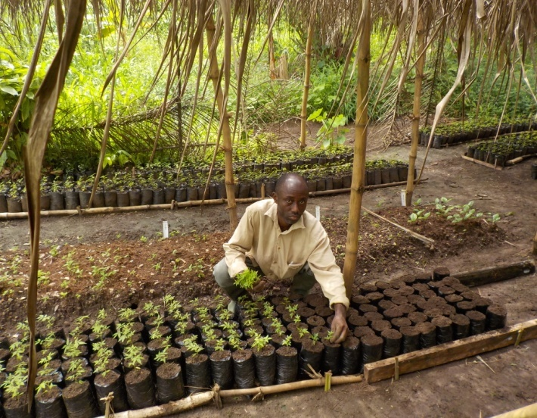

Multi-purpose nursery
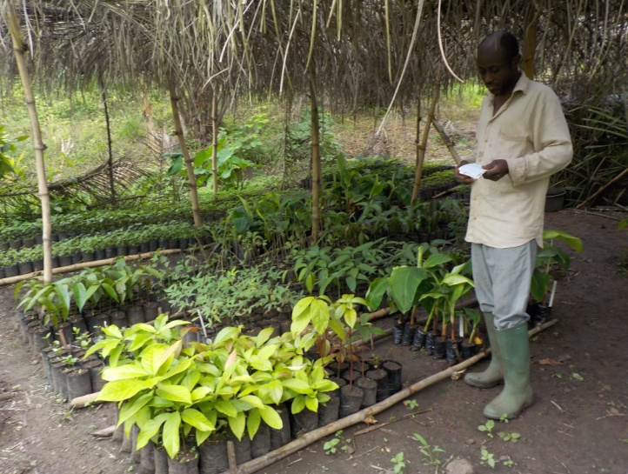
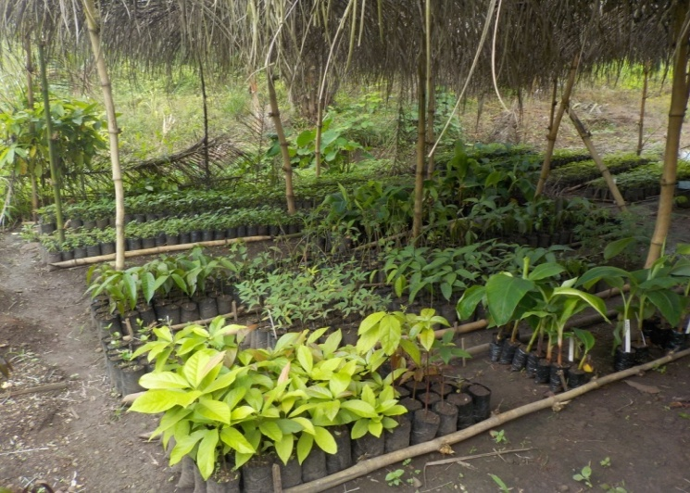
Multi-purpose nursery
Results on Tree planting
The result of tree planting in the Muanenguba was quiet successful. The trees were planted without any major resistant. We were encouraged by the chiefs of the villages of Muabi, Mualong, Mbat Ekambeng and Muasum. The villagers were also very happy to see their community moving forward as other communities. Some people appreciated the tree planting and said it was good because it is going to be use as shed during the dry season and to restore water catchments in the areas. Some individuals were also sensitized on the importance of tree planting in the community. A total of 1000 trees were planted in five villages in the Muanenguba area. The reference points collected with the use of GPS will be used to monitor the growth of these trees planted. The tree planting exercise was quiet a success despite some few challenges which were finally overcome.
Result on fruit production
Table 1: Information on nursing of Mango
Location | Nursery Bed | Q’ty nursed | Date nursed | Date of germination | HQG* | Time(Day)* | Viability
Buea | 1 | 350 | 20/04/17 | 27/04/17 | 1050 | 07 | Excellent
Buea | 2 | 300 | 19/05/17 | 27/05/17 | 900 | 08 | Excellent
Buea | 3 | 200 | 02/06/17 | 10/06/17 | 600 | 08 | Excellent
Buea | 4 | 100 | 09/06/17 | 15/06/17 | 300 | 06 | Excellent
Total |  | 850 |  |  | 2800
HQG*: Highest Quantity of seed Germinated, Time (Day)*

Table 2: Transfer of seedlings to polythene bags
Location | Nursery Bed | Q’ty transferred | Date of transferred | % of survival | Remark
Buea | 1 | 1050 | 28/05/17 | 100 | Excellent
Buea | 2 | 900 | 02/06/17 | 100 | Excellent
Buea | 3 | 600 | 08/06/17 | 100 | Excellent
Buea | 4 | 300 | 14/06/17 | 100 | Excellent

From table 1 and 2 above, mango seeds were nursed in four nursery beds at different time intervals. Highest Quantity of seed Germinated 2800 seedlings was produced from the nursing of 850 mango seeds in four nursery beds. The seeds took an average of seven days to germinate. The viability of the seeds was excellence. All 2800 seedlings survived and transplanted, with 100 % survival rate.
Table 3: Information on nursing of Pear
Location | Nursery Bed | Q’ty nursed | Date nursed | Date of germination | HQG* | Time(Day)* | Viability
Buea | 1 | 250 | 20/04/17 | 02/05/17 | 300 | 12 | Excellent
Buea | 2 | 200 | 10/05/17 | 20/05/17 | 240 | 10 | Excellent
Buea | 3 | 100 | 19/05/17 | 31/05/17 | 145 | 12 | Excellent
Buea | 4 | 50 | 21/05/17 | 01/06/17 | 85 | 11 | Excellent
 |  | 600 |  |  | 770
HQG*: Highest Quantity of seed Germinated, Time (Day)*
Table 4: Transfer of seedlings to polythene bags
Location | Nursery Bed | Q’ty transferred | Date of transferred | % of survival | Remark
Buea | 1 | 300 | 12/05/17 | 100 | Excellent
Buea | 2 | 240 | 05/06/17 | 100 | Excellent
Buea | 3 | 145 | 09/06/17 | 100 | Excellent
Buea | 4 | 84 | 14/06/17 | 100 | Excellent

From table 3 and 4 above, Pear seeds were nursed in four nursery beds at different time intervals. Highest Quantity of seed Germinated 770 seedlings was produced from the nursing of 600 pear seeds in four nursery beds. The seeds took an average of 11days to germinate. The viability of the seeds was excellent. All 770 seedlings survived and transplanted, with 100 % survival rate.
The nursing of fruit trees such as mango and pear using this method is very efficient and reliable because it doubles or triple the number of seedlings produced. One mango seed produces three to five seedlings when nursed using the above method as compared to the local method that will produce one seedling. The above method will produce great quantity of seedlings within short period of time that will satisfy the desire of farmers to plant good number of seedlings to solve the problem of food insecurity, improve income and to fight against climate change.
Results on plantain production
A propagator for the production of improved plantain seedlings of different varieties was established to be used for seed farms in our project sites.
A propagator of two thousand capacity of improved seedlings of plantains of different varieties was established. Amore bigger propagator with a capacity of producing 10,000 seedlings needs to be constructed to carter for the needs of the farmers and communities.
Five improved varieties of plantain seedlings were produced to be used for seed farms in our project sites.
Result on cassava
Demonstration farms for the production of improved vulgarized cassava cuttings of different varieties were established to be used in our project sites.
One hectare of improved vulgarized cassava farms of different varieties were established in our project site.
Eight improved vulgarized varieties of cassava were planted to be used in our project sites.
Working groups in the Muanenguba project site (participant farmer)
Division | Group name | Village | Participant farmers | Lead farmer
Kupe Muanenguba | Seven Able Men | Muelong | Epie Livinus Ekute  Elime Cyrille Epoge  Ekeh Nelson  Elunge Raymond Sone  Samelle Rene Ehoh  Ngome RobertNgande  Ndunge Elvis Awasume | Epie Livinus
 | Young Workers Group | Muabi | Sone Ebenezer  Ngando Ivo  Evane Elvis  Evane Roland  Njabe Ngwese  Sah Esong  Etiba Kingsly | Sone Ebenezer
 | Fisher Group | Muasum | Sumelong Mathias  Ejume Ashille Sume  Ngwese Ivo Epoge  Ngwese Elvis Sah  Ndunge napoleon  Ndunge Kenedy | Sumelong Mathias
 | Dynamic Youth | Mbat | Epoma Divine  Akame Cliford Ebong  Atabe Bazil  Mesombe Geoffrey  Epoma Clovis  Sone Clovis  Nwene Valery  Metuge Becliff  Esambe Elvis Ngolle  Esambe Elvis | Epoma Divine
 | Dynamic Young Farmers | Ekambeng | Enongene Thomas  Ngabe Dangusta  Ekahnjume Nelemia  Njume Samuel  Mbeh Godlove  Ekahnjume Cardine  Sume Roland  Ngwese Edison  Elage Frankline  Ebuelle Roland  Abi Enies  Etape Divine  Etoke Elah Jame  Egeh Elvis  Njabe Mirabel  Ekah Yvone  Ntube Rita  Akame Pascaline | Enongene Thomas
Source: Field trip

Challenges
- Farmers need more farming inputs to enable them carry out their activities.
- The communities need more information on sustainable farming methods.
- Communities requested for alternative sources of animal protein.
- Communities requested for training on production, processing and commercialization of cassava.
- Communities requested for training on plantain production, processing and commercialization.
- Villagers have little knowledge on the conservation of frogs’ species.
- Public transportation of tree seedlings, staff, farming inputs is not reliable.

Recommendation
- Alternative sources of animal protein should be encourage
- Farmers should be provided with farming inputs to enable them carry out their activities
- More sensitization is necessary especially with the new groups.
- Training on production, processing and commercialization of cassava is necessary with different farming groups within the project sites.
- Training on production, processing and commercialization of plantain is necessary with different farming groups within the project sites.

Conclusion
The various areas in the project site are: Muanenguba twin lakes (male and female), Muabi, Mualong, Muasum, Mbat and Ekambeng. The main objective of the field visits was to carry out amphibian Survey and to restore degraded lands in the Muanenguba Mountain area. However, other activities were also programmed during the trips. Data collection on amphibians (frogs especially Cardioglosa manengouba) were carried out in March to June. Income generating activities and food security while conserving wildlife species in South West and Littoral Region of Cameroon, such as nursing of fast growing trees, fruit seedlings production, plantain seedlings production, cassava cuttings production to be used in our project sites were carried out. Tree planting involved in the restoration of degraded amphibian habitat were also part of the project activities.
During field activities, it was realized that apart from the critically endangered Cardioglosa manengouba there also exist two critically endangered species namely; Cardioglosa trifasciata and Leptodactylodon erythrogaster. It was found out that these three species have declined drastically over the last years. Reasons being these species is edible and are rich in protein. The people use them for their protein in-take and even sell them in their local markets. From field investigation it was found that these three critically endangered species are also found elsewhere out of the project site. These sites are; Makim, Ekanjok, Mboko, Nyam, Ndung, Nkiko, Kupe, Nyassoso, and Tombel all found in Kupe-Muanenguba in West Cameroon. Also in Mbaossoum, Ndokou, Mouanguel, Mboango, Mbouroukou which are found towards Melong and Nkongsamba East Cameroon.
From field investigation we are soliciting to MBZ to extend the timeline of this project for another one year. This will enable us intensify livelihood activities such as snail farming, bee keeping, pig rearing, poultry farming, food production and to extend survey to neighboring suspected areas in the Kupe-Muanenguba landscape where Cardioglosa manengouba and other two endangered species (Cardioglosa trifasciata and Leptodactylodon erythrogaster) are believed to be found. This project has been supported with specialized survey equipment from IDEA WILD to enable it move forward.
Presently we are working on improving food production (fruit production, plantain and cassava improved and vulgarized varieties), fruit production, production of fast growing timber trees in all our project sites in South West and Littoral Region. All these projects will go along way reducing pressure on amphibians in particular and wildlife in general and to improve livelihood.

Villages and proposed activities for one year extension
Division | Village/Town | Activities
Kupe-Muanenguba | Makim | Survey, snail farming, bee keeping, pig rearing, poultry farming, fruit, plantain, cassava, production, fast growing timber trees
 | Ekanjok | Survey, snail farming, bee keeping, pig rearing, poultry farming, fruit, plantain, cassava, production, fast growing timber trees
 | Mboko | Survey, snail farming, bee keeping, pig rearing, poultry farming, fruit, plantain, cassava, production, fast growing timber trees
 | Nyam | Survey, snail farming, bee keeping, pig rearing, poultry farming, fruit, plantain, cassava, production, fast growing timber trees
 | Ndung | Survey, snail farming, bee keeping, pig rearing, poultry farming, fruit, plantain, cassava, production, fast growing timber trees
 | Nkiko | Survey, snail farming, bee keeping, pig rearing, poultry farming, fruit, plantain, cassava, production, fast growing timber trees
 | Kupe | Survey, snail farming, bee keeping, pig rearing, poultry farming, fruit, plantain, cassava, production, fast growing timber trees
 | Nyassoso | Survey, snail farming, bee keeping, pig rearing, poultry farming, fruit, plantain, cassava, production, fast growing timber trees
 | Tombel | Survey, snail farming, bee keeping, pig rearing, poultry farming, fruit, plantain, cassava, production, fast growing timber trees
 | Mbaossoum | Survey, snail farming, bee keeping, pig rearing, poultry farming, fruit, plantain, cassava, production, fast growing timber trees
 | Ndokou, | Survey, snail farming, bee keeping, pig rearing, poultry farming, fruit, plantain, cassava, production, fast growing timber trees
 | Mouanguel, | Survey, snail farming, bee keeping, pig rearing, poultry farming, fruit, plantain, cassava, production, fast growing timber trees
 | Mboango, | Survey, snail farming, bee keeping, pig rearing, poultry farming, fruit, plantain, cassava, production, fast growing timber trees
 | Mbouroukou | Survey, snail farming, bee keeping, pig rearing, poultry farming, fruit, plantain, cassava, production, fast growing timber trees
 | Nkongsamba | Survey, snail farming, bee keeping, pig rearing, poultry farming, fruit, plantain, cassava, production, fast growing timber trees
 | Muabi | Survey, snail farming, bee keeping, pig rearing, poultry farming, fruit, plantain, cassava, production, fast growing timber trees
 | Muasum | Survey, snail farming, bee keeping, pig rearing, poultry farming, fruit, plantain, cassava, production, fast growing timber trees
 | Mualong | Survey, snail farming, bee keeping, pig rearing, poultry farming, fruit, plantain, cassava, production, fast growing timber trees
 | Mbat | Survey, snail farming, bee keeping, pig rearing, poultry farming, fruit, plantain, cassava, production, fast growing timber trees

Appendix
Sample of data sheet for Amphibians inventory in the Muanenguba area
OBSERVER(S): _____________________________________________________________ Date: _____________________ Distance: _________
GPS
Start Point: ______________/____________ End Point: ______________/_____________
Altitude: --------------
Species | Sign/human activity | Location |  | Type of Vegetation, | Remarks
Species | Sign/human activity | Long. | Lat. | Type of Vegetation, | Remarks

Common Name | Vernacular Name | Where found | Village | Eatable (Yes/No) | Period (Rain/Dry season)
Sample of data sheet for Amphibians survey in the Muanenguba area

