Enhancing Survival prospect of Critically Endangered Victoria tilapia (Oreochromis variabilis) in Lake Nawampasa, Uganda
Introduction
Victoria tilapia (Oreochromis variabilis) is critically endangered cichlid fish species (IUCN Red List, 2006) endemic to lakes Victoria and Kyoga basins. This fish species has disappeared from these main lakes majorly due to environmental degradation, aggressive competition for food, space and mates from introduced tilapias such Nile tilapia and predatory actions of Nile perch. However, remnant populations of this fish species are found in satellite lakes including Lake Nawampasa. This project was aimed at fostering the survival of critically endangered Victoria tilapia (Oreochromis variabilis) in Lake Nawampasa through working with fishing communities to address threats to this fish species and its habitats.
During the last 6 months, a series of conservation activities listed below were carried out to achieve project goal;
- Victoria Tilapia Conservation Committee (VTCC) consisting of young fishermen and local leaders was established, trained and engaged in (a) identifying and mapping, monitoring and protection critical fish habitats of Victoria tilapia.
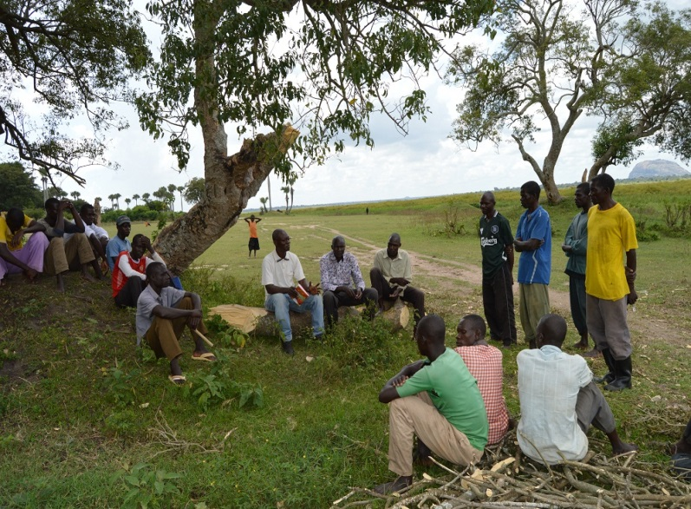
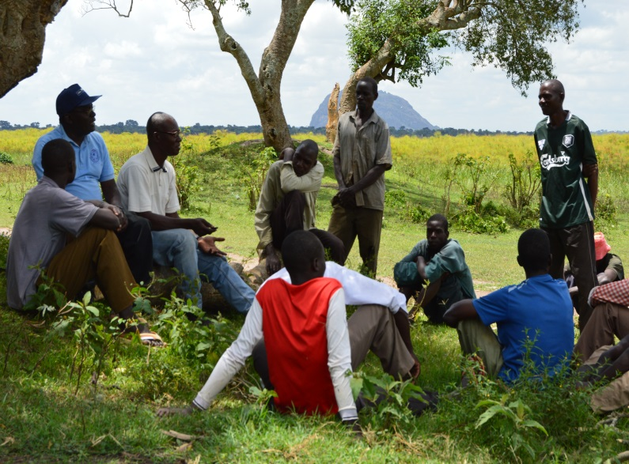

Local community engagements during selection of Victoria Tilapia Committees (VTCC)

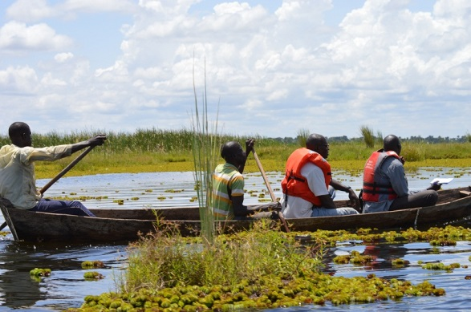
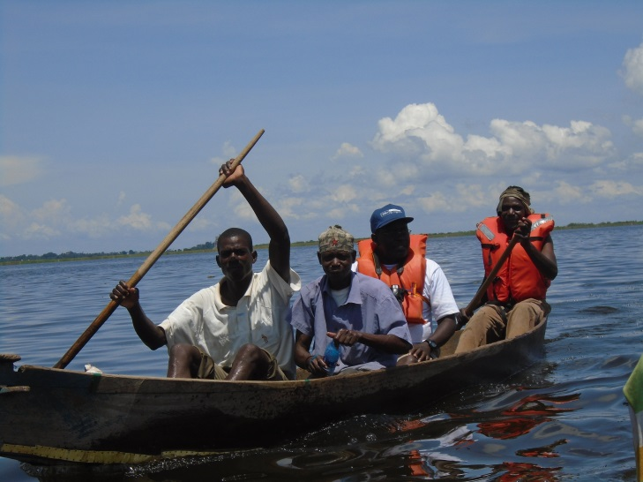
- Fishing communities, Victoria Tilapia Conservation Committee (VTCC) were engaged in various activities including landing site talk, direct involvement in mapping of breeding and nursery sites of Victoria tilapia to raise the level of their awareness about the need to conserve Victoria tilapia, threats to its habitats.

VTCC involvements in mapping of breeding and nursery areas of Victoria tilapia as part of awareness creation
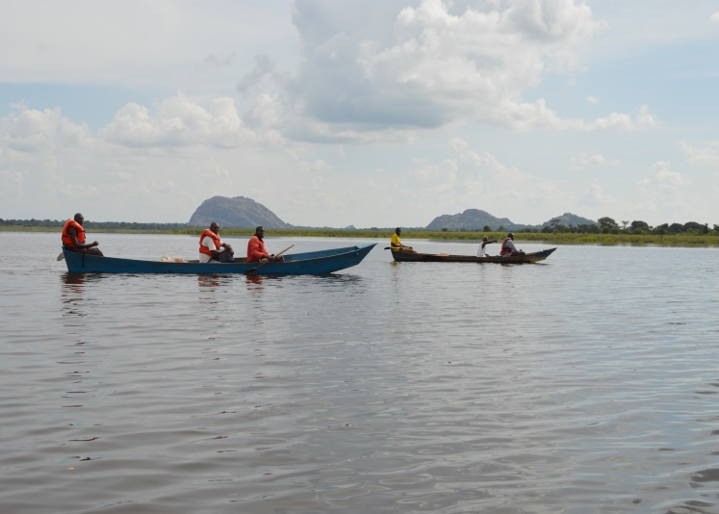
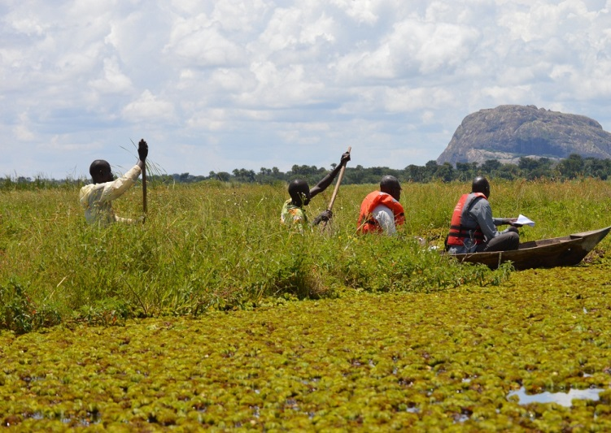
- VTCC were engaged in mapping of the breeding and nursery areas of critically endangered Victoria tilapia

VTCC team mapping breeding and nursery areas of Victoria tilapia

Major project outputs and outcomes
During awareness creation, the knowledge and understanding of local communities particularly fishermen (young and old) and local leaders were raised about the key threats namely; habitat destruction, fragmentation and loss due to poor agricultural practices, presence of invasive species particularly weeds like water hyacinth that could jeopardized ecological integrity of this Lake to continue supporting survival of threatened aquatic wildlife. The awareness creation also resulted into increased commitments and enthusiasm of local communities especially fishermen in conserving fish fauna and their habitats. This was witnessed by their active participation in implementing project activities such as mapping of critical habitats of Victoria tilapia and willingness to form Victoria Tilapia Conservation Committee (VTCC). They were impressed by the efforts being undertaken to revive fish populations which are declining drastically, and this could in turn help them to improve on their livelihoods and wellbeing.
During mapping of the critical habitats (Breeding and Nursery sites) of Victoria tilapia, we noticed that the catchment areas of this lake is also playing a big role in the conservation of other threatened birds such as Shoebill, one of the key bird species for tourist attraction not only in Uganda but globally.
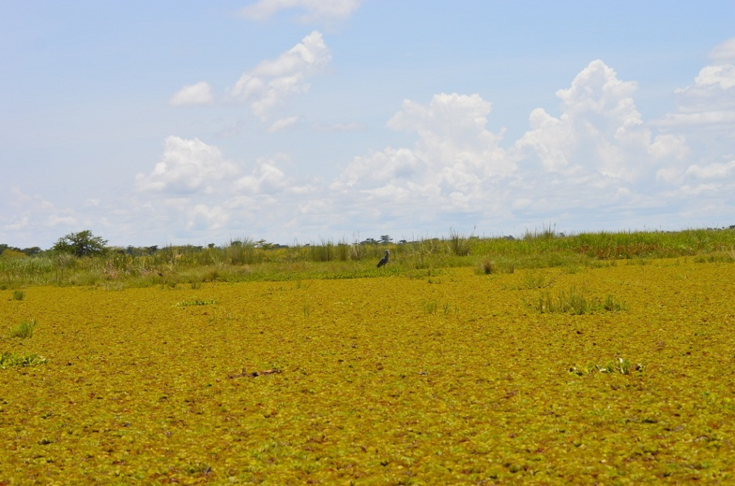
Shoebill (Balaeniceps rex)

Additionally, there are beautiful features, such as mountainous rock within the vicinity of the Lake, and according to the locals, this feature is serving as tourist attraction, thus boosting their livelihoods and wellbeing. A total of eight (8) breeding and nursery sites were mapped based on both the indigenous knowledge and scientific knowledge of the VTCC and research teams respectively. The criteria used for mapping of these sites was based on but not limited to habitat characteristics like presence of breeding substrates like waterweeds, shallow muddy bottoms and rocky areas which are majorly preferred by Victoria tilapia. These sites were name according to the local names and these includes; Namalogue- Ngagga Bay, Butooli, Nkodokodo, Buyumba-Nakatye, Kyanzile, Bupioko and Nadiope-Naika. These are the critical sites vital for the survival of Victoria tilapia and other threatened fish and birds. The sites shall be monitored and protected by VTCC team to enhance the survival of threatened fish fauna
Challenges encountered during the last six months of project tenure.
a) It was somewhat challenging to make local communities especially fishermen, local leaders and government representatives to understand the essence of the whole project particularly mapping of the breeding and nursery sites and how these sites will be protected by the committees without compromising on their daily fishing activities which form the primary components of their livelihoods and wellbeing. However through awareness creation and engagements of local communities and other stakeholders, they welcomed and appreciated the since it will help in reviving the populations of the fish that supports their livelihoods and wellbeing.

b) Presence of floating vegetation and (Invasive plant) on the lake made navigation and accessibility of some sites critical sites of Victoria tilapia very difficult, however with the help experienced fishermen, we managed to navigate and mapped these sites.
Look ahead
- Continue with mapping of the remaining breeding and nursery areas on the Lake Nawampasa
- Continue to work with VTCC to create awareness among all relevant stakeholders particularly fishing communities about the need to conserve Victoria tilapia and its habitats
- Continue to empower VTCC team, fishing communities and other stakeholders to protect Victoria tilapia and its habitats

