Photo collage relating to amphibian surveys at Ambohitantely
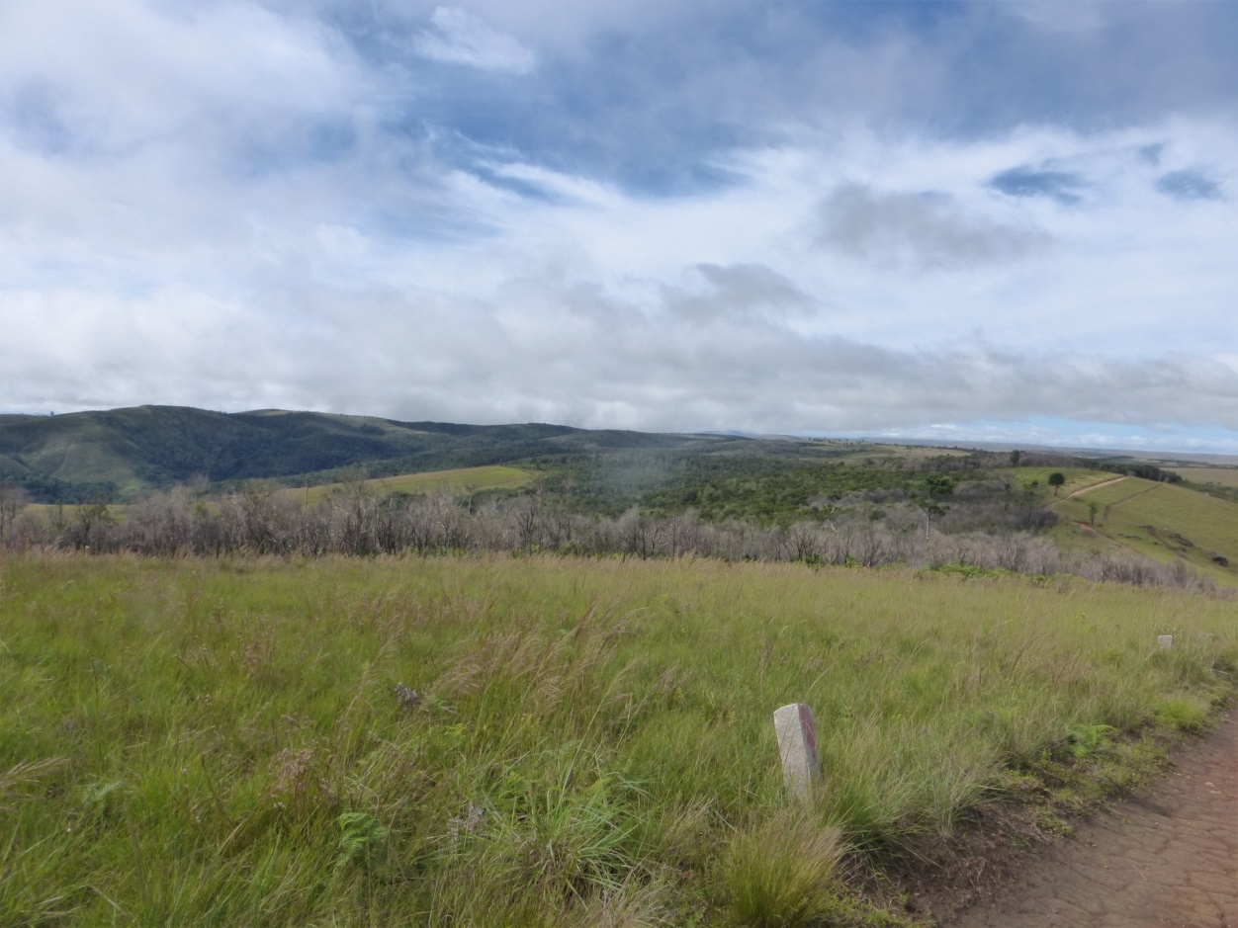
Ambohitantely core forest surrounded by anthropogenic grassland and Protected Area boundary marker in foreground (Photo: Jeff Dawson/Durrell)
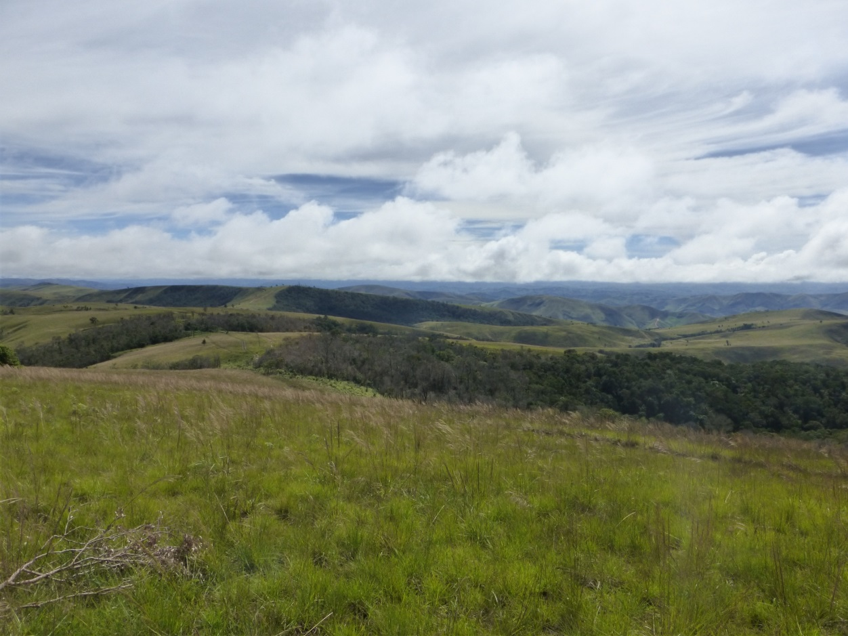
Northern tip of core forest zone (foreground) and northern forest patches (behind) (Photo: Jeff Dawson/Durrell)

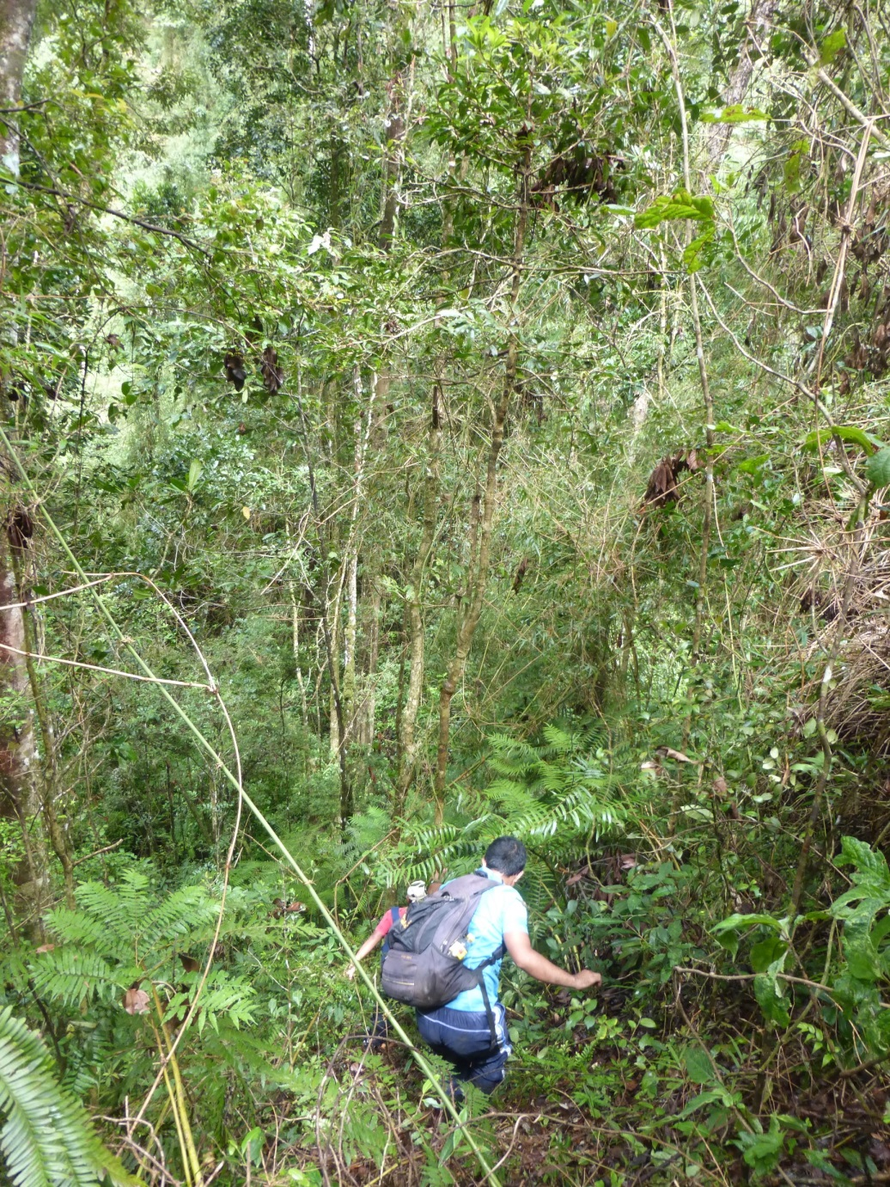
Southern forest patch topography (Photo: Jeff Dawson/Durrell)

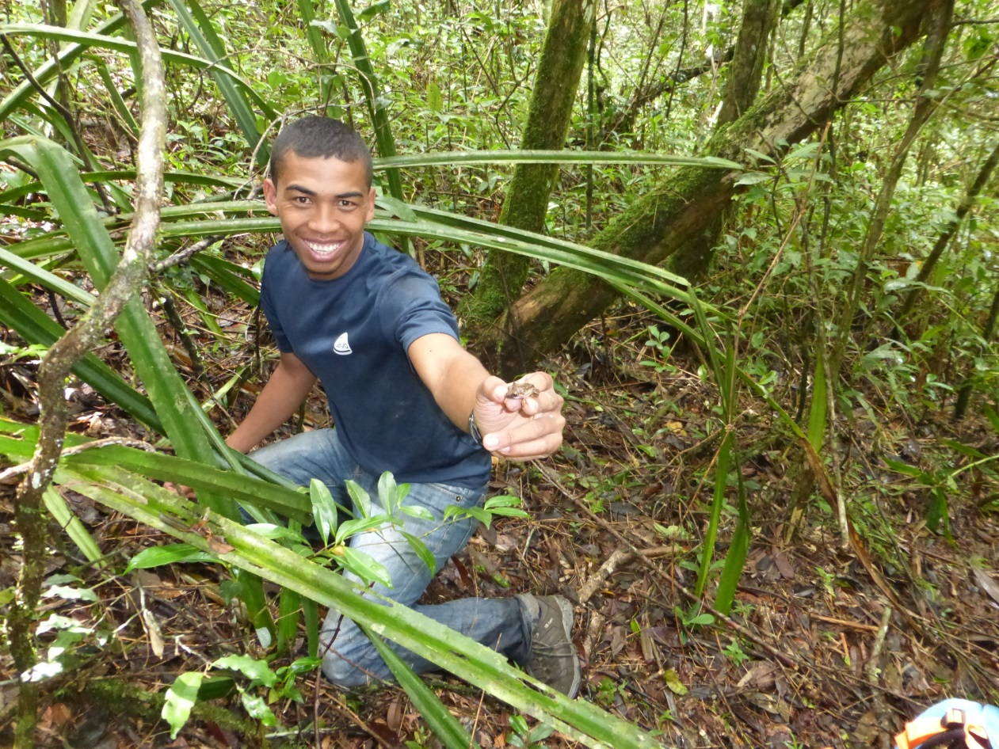
Lead surveyor Jary Razafindraibe in Ambohitantely (Photo: Jeff Dawson/Durrell)
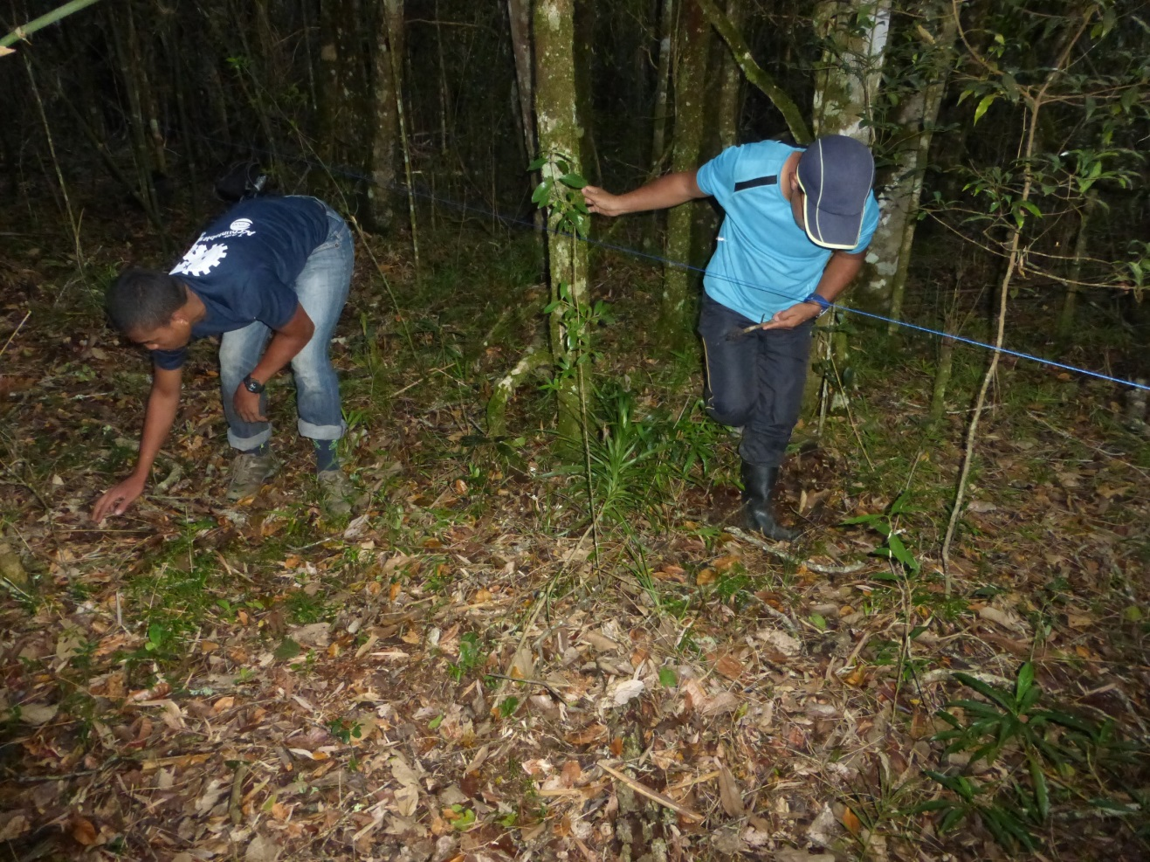
Practicing transect surveys for frogs. Initial survey method but changed due to near zero individuals detected during scoping trip (Photo: jeff Dawson/Durrell)

