Pristimantis telefericus
By Enrique La Marca, PhD
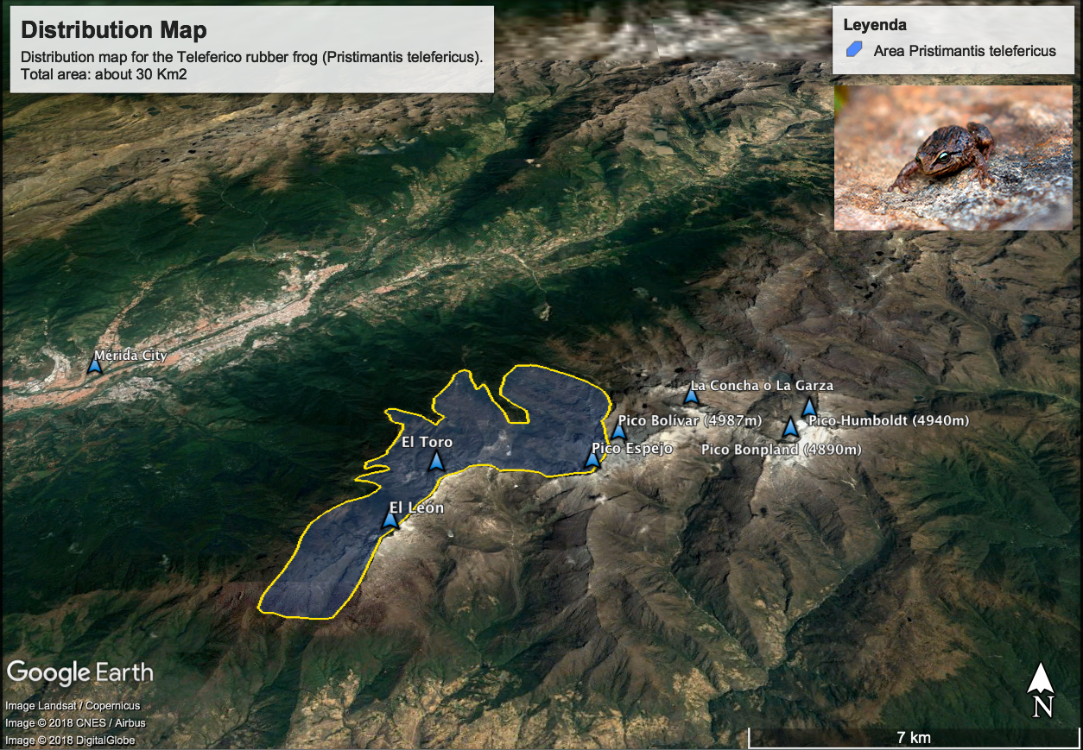

Biogeography
- The Teleferico rubber frog (Pristimantis telefericus) is an amphibian endemic to the Sierra Nevada de Mérida, the highest mountain range in Venezuela.
- The frog species occupies an area of approximately 30 Km² in the slopes of the Sierra Nevada facing the city of Mérida. The area is surrounded by high altitude cliffs and exposed rocky environments above 4000 m.asl in its upper parts, and by cloud forests in its lower parts. The frog was not found to occur in or beyond those extreme limits.
- The species prefers the transitional zone between the upper Andean cloud forest and the paramo environment. This transitional zone is a shrub-land dominated by small shrubs, grasses and paramo plant rosettes known as ‘frailejones’ (Espeletia spp.).

Red List assignment
Upon this research sponsored by the Mohamed bin Zayed Species Conservation Fund, the Teleferico rubber frog (Pristimantis telefericus) is proposed to the IUCN category of Endangered, based on the following criteria.
The best available evidence indicates that this frog species meets the following criteria indicating that it is facing a very high risk of extinction in the wild:
- A reduction in population size based on direct observation by visual encounters.
- An observed population size reduction of ≥50% over the last 20 years, based on direct observation, where the reduction or its causes are suspected to be linked to climate change and/or the presence of a pathogen fungus (Batrachochytrium dendrobatidis), but whose real cause is not well understood.
- Geographic range in the form of B1 (extent of occurrence) where the extent of occurrence is estimated to be less than 5,000 km², and estimates indicating that the species is known to exist at no more than four locations, and that there is an inferred continued decline in the extent of occurrence.
Accordingly, in this work I propose that Pristimantis telefericus be considered an Endangered frog with the following Red List Category: (EN) A2a; B1a.

