- Title of the project: Assessment of Conservation Status and Development of the Red list for Western Ghats Usioned Lichens
- Principal Investigator: Dr. Vinayaka K.S. DB: 23/02/1985
3. Implementing Institution: Dept of Botany, Kumadvathi First Grade College,
Sikaripura-577427, Shimoga, Karnataka

4. Date of commencement: 23/11/2017
5. Planned date of completion: 23/11/2018
INTRODUCTION
India’s plant resources are well known with rich diversity distributed in different ecological habitats. These plant resources has tremendous value as they are used in diverse applications like food, feed, medicines, industrially important products obtained from higher plants, microorganisms, mosses, lichens and other plant communities. Lichens form an important floral community playing a major role in ecological indication and succession. Lichens are unique group of plants, comprising of two groups of organism algae and fungi living together in a symbiotic association. Forests support vascular plants and also provide a suitable niche for non vascular plants such as, liverworts, mosses and lichens. Among these, lichens have attracted much attention recently as indicators of air quality, biodiversity and climate change (McCune et al. 1997). Lichens are among the most widely distributed and dominant groups of organisms in the world, and cover as much as eight per cent of the earth’s surface (Ahmadjian, 1995). There are about 20, 000 species of lichens so far known from the world and India represents about 2050 species (Awasthi, 2000). Lichens are most common bioindicators of air pollution. They are utilized commercially for enzymes, acids and pigments. The Western Ghats harbor valuable plant resource including lichens, microbes, mosses and other lower plants. The status of the lichen communities are severely threatened due to manmade activities that include deforestation, denudation and over exploitation of forest produce. While more than five decades of systematic studies have accumulated taxonomic information of the 2150 species of lichen flora of India, only very recently have ecologists begun to investigate their community ecology.
Earlier works in Western Ghats
The crustose lichen dominates in Western Ghats represented by 618 taxa followed by foliose and fruticose lichens, which are represented by 269 and 62 taxa respectively. The highest number of endemic lichens 253 species (26.7%) is present; of which 210 are found only in Western Ghats while remaining 43 occur in other licheno-geographical region. Lichens are self-supporting symbiotic associations of a fungus and one or several algal or cyanobacterial components. Lichens and lichen products have been used in traditional medicines for centuries and still hold considerable interest as alternative treatments in various parts of the world. In various systems of traditional medicine worldwide, including the Indian system of medicine, these lichen species are said to effectively cure dyspepsia, bleeding piles, bronchitis, scabies, stomach disorders, and many disorders of blood and heart (Saklani and Upreti, 1992; Lal and Upreti, 1995; Negi and Kareem, 1996). They produce characteristic secondary metabolites that are unique with respect to those of higher plants (Lawrey, 1986). Lichen metabolites exert a wide variety of biological actions including antibiotic, antimycobacterial, antiviral, anti-inflammatory, analgesic, antipyretic, antiproliferative and cytotoxic effects (Muller, 2002). The utility of lichens is due of range of secondary compounds produced by them. A wide range of secondary metabolites of lichens were characterized. According to their chemical structure, most lichen substances are phenolic compounds, dibenzofuranes, usnic acids, depsidones, depsones, lactones, quinines and pulvunic acid derivatives (Boustie and Grube, 2005). About 320 tons of lichens are annually utilized for different purpose in Nepal and adjoining regions of India (Moxham, 1986). Approximately 750 metric tons of lichens are brought in annually from Uttaranchal hill and 200 metric tons from other regions of India, including Himachal Pradesh, Sikkim and Assam of this about 50-80 metric tons are exported (Shah, 1997). A survey on lichen samples available in local markets of Maharashtra, Karnataka and Tamil Nadu found 11 species of lichens (Upreti et al., 2005). Quantitative studies have not been carried out in Western Ghats to assess the amount of lichen collected, utilized, exported and its effect on particular lichen species or whole lichen diversity of the region.
Woolseley and Aguirre-Hudson (1997) studied the ecology and distribution of lichens in tropical deciduous and evergreen forests of Thailand. They argue that the high diversity, combined with the presence of species and genera associated with a cool temperate forest are evidence that these forests are relicts of the extensive temperate flora of the cretaceous and early tertiary prior to the breakup of Gondwana land. Lucking (2003) distinguished three tropical and three extra tropical lichen-geographical regions in the world.
National status
India harbors around 2200 species of lichens (Negi, 2000). There are 949 lichen taxa in Western Ghats belonging to 929 species, 20 varieties, 150 genera and 54 families. Parmeliaceae representing 137 species belonging to 22 genera is the dominant family in the Western Ghats while Graphisis the dominant genus with 49 species. Tamil Nadu has the highest number of lichens with 657 taxa followed by Karnataka, Kerala and Maharashtra with 336, 288 and 91 taxa respectively (http://www.ces.iisc.ernet.in / biodiversity, 2000).
Approximately 750 metric tons of lichens are brought in annually from Uttaranchal hill and 200 metric tons from other regions of India, including Himachal Pradesh, Sikkim and Assam of this about 50-80 metric tons are exported (Shah, 1997). A survey on lichen samples available in local markets of Maharashtra, Karnataka and Tamil Nadu found 11 species of lichens (Upreti et al., 2005). Upreti et al. (2005) enumerated lichens from Madhya Pradesh reporting 179 species belongs to 51 genera placed in 26 families and from Chhattisgarh 6 species belongs to 5 genera and 3 families. They analyzed as crustose lichens has been dominated and represented 104 species and foliose represent 74 species. Physciaceae was the dominant family represent 49 species and Pertusaria is the largest genera with 19 species.
About Usnea:
The genus Usnea is regarded as one of the taxonomically most difficult genera of macrolichens. Most of the species are widespread and highly variable in morphology. Lichens are diverse in tropical rain forests and some studies have focused on ecological questions such as vertical distribution and habitat preference (Cornelissen & Steege 1989; Cornelissen & Gradstein 1990; Wolf 1993; Komposch & Hafellner 2000; Herrera- Campos et al. 2004; Peroz et al. 2008). Several authors have discussed parameters influencing the distribution of epiphytic lichens, including rainfall, temperature, light, shade, humidity, age of the tree and substrate factors such as texture, water relation and chemistry (Brodo 1973; Dettki 1998; Brodo et al. 2001). The proportion of foliose and fruticose lichen increases with altitude, where as crustose are the main component of epiphytic community in the lowland rain forests (Sipman & Harris 1989).
Usnea Adans. is a large genus in the family Parmeliaceae, with more than 350 species (Clerc 1998) that are widely distributed in polar, temperate and tropical regions. The Genus is recognized based on the fruticose thallus, branches with a cartilaginous central axis and the presence of Usnic acid in the cortex. At the species level, the extensive plasticity of morphological characters, in response to environmental parameters, greatly challenges the delimitation of species (Clerc 1998).
Works on lichens genus Usnea in India is not fully completed. So far there are only 45 species reported in India. The information on distribution of Lichens in Western Ghats is poorly known. Hence, this project is aimed at cataloguing the diversity and conservation studies of lichens genus Usnea in Western Ghats of India.

OBJECTIVES:
The main objective of this project is to assess current status, threats and establish conservation measures for Western Ghats lichens
- To map the distribution and identify the ecological niche of Usenoid lichens
- To assess the current status and distribution of Usenoid lichens in natural habitats.
- To identify the influence of disturbed habitats on the distribution of lichens
- To assess conservation status of the Usenoid lichen species in WGs
- To create Red list data for Usenoid lichen Species
- To assess the knowledge of local people on lichen species and their habitats
MATERIALS AND METHODS
Study area: Study was conducted in the areas focus on Maharashtra, Karnataka, Tamil Nadu, Kerala and Goa parts of Western Ghats of India. We mainly focus on trees which are distributed in evergreen, semi evergreen, Deciduous and montane forests.
Forest types:
The general pattern of vegetation in study area broadly falls into six types. Dry deciduous and grassy downs with moist deciduous forests, semi-evergreen, evergreen with shola forest cover the inner slopes and inner hill range in the trough and scrubby forests (Plate-I). Apart from these forest study region contains monoculture plantations and agricultural plantations crop fields.
Collection of lichens: Survey was done regularly in the Western Ghats in different habitats and particularly timing and location of observation. Survey was carried out by using line transect method. The representative lichen specimens were collected along with their substratum irrespectively of their growth form. The three major substrates rock, soil and wood were considered as the microhabitats. The woody substrates included tree trunks, branches, twigs, wood logs and stumps. Only the lichens that were very loosely attached to substratum was scraped out and collected. The corticolous lichens growing on tree trunk at reachable height usually collected and canopy lichens found fallen on ground was collected. Light exposure, humidity, rainfall, temperature data was also collected in the sampled areas.
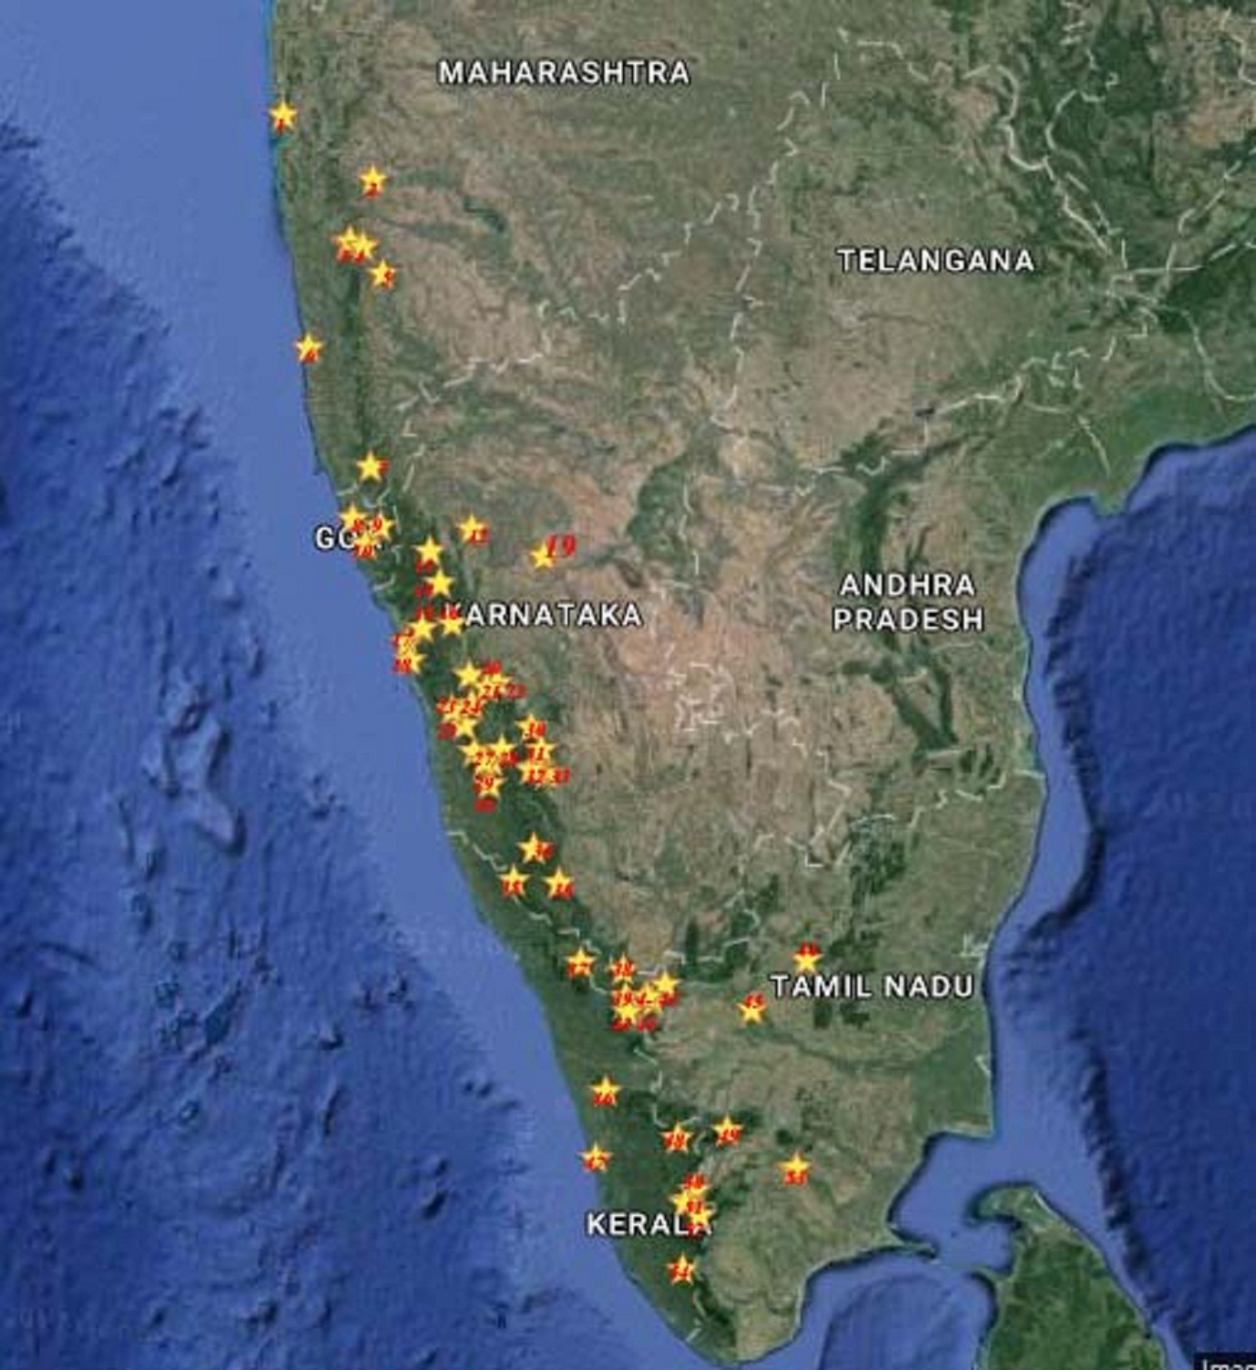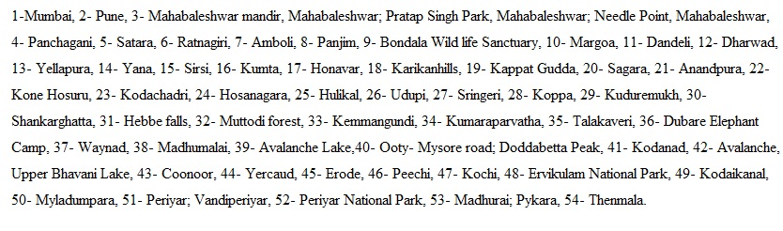
Fig 1: Map showing different study sites in Western Ghats region of Southern India.
Identification of lichens: The collected specimens were made to dry under the Sun. During winter and rainy season, the material was dried with the help of a hot air oven. The lichen herbarium packets were made with a thick white or brown handmade acid free paper. The herbarium packet dimension is maintained at 13.5 x 11.5 cm. The process of identification of lichens was done on the basis of the morphology, anatomy, chemical test (Colour and TLC test). All lichen specimens were preserved in the herbarium. The collected lichen specimens were packed in paper bags, dried, identified by using standard manual (Awasthi, 2000, G. Awasthi, 2002). The colour tests will be performed with the usual reagent, i.e., K test (5% Potassium hydroxide), C (aqueous solution of Calcium hypochlorite), I (Iodine) and PD (Paraphenylenediamine). Also Thin Layer Chromatography (TLC) in solvent A (180ml tolune: 60ml dioxine: 8ml Acetic acid) using technique of Culberson (1972) and Walker & James (1980) was performed for the confirmation of identification.

Pattern of distribution and community ecology: The distribution pattern of lichens on substrates were divided into different categories based on the nature of the substrates such as corticolous (bark/ main stem), ramicolous (twig), lignicolous (wood), saxicolous (rock). Host specificity and altitudinal and environmental gradients for their distribution were identified. Relationship between tree communities and other lichen communities with lichens will be studied by community ecological methods. The details of colonizing lichens were surveyed.

Statistical analysis
The data recorded from the every field survey was maintained in the data sheet, after that they were entered into Microsoft excel data sheets. Finally, the data used to calculate the density, frequency and abundance, the relative frequency, relative density index were calculated by referring Cottam and Curtis (1956) and Importance Value (IVI) was calculated by summing the relative values for species (Species Importance Value- SIV) (Ganesh et al., 1996). To understand the diversity and distribution patterns of lichen in the different forest types correlation, multiple regressions, Chi-square test and P test was performed. All the statistical test procedures were followed (Zar, 2004; Gomazie and Gomiz, 1996).

RESULTS AND DISCUSSION
According to our objectives we have done the literature survey and study site selection in different states of India. The study is based primarily on specimens collected from different places of Western Ghats in the first year of project. Field trips were made to various locations in Maharashtra, Karnataka, Tamil Nadu and Kerala. In Karnataka we visited different location like Kemmangundi, Kuduremukh, Sringeri, Hebbe, Koppa, Kigga, Sigdal, Mulyannagiri of Chikmagaluru Dist., Suliya, Subramanya, Udupi in Dakshina Kannada Dist., Bhagmandala, Mugilpete, Talkaveri, Kushalnagar, Elephant Camp, Madikeri in Coorg Dist., Kodachadri, Anandapura, Konehosur, Jog, Sagara, Shankaraghatta, Hosanagara in Shimoga Dist. Kappdagudda in Gadag Dist., Sirisi, Yellapura, Kumta, Yana, Honavar, Dandeli, Karikan hills in Uttarakannada Dist. Also collections are made from few areas of Mysore, Chamarajanagar & Belgam Dist. In Maharashtra collections are made from Mahabaleshwar and Panchagani of Satara Dist., In Kerala collections are made from Different spots in Munnar, Kochi, Waynad, Iddaki, Palgat, Chittur, Palkadu, Ksaragodu and Rajamala. In Tamil Nadu specimens are collected from Nilgiri hills of Ooty, Madumallai, Eroad, Erakadu, Kodekenal, Dodabetta and Coonur. But there are no specimens find in Goa. Apart from the field collections we also studied the herbarium specimen from the Agarkar Research Institute (ARI), Pune, Maharashtra and National Botanical Research Institute (NBRI), Lucknow, Uttar Pradesh, Botanical Survey of India (BSI) Allahabad and Kerala Forest Research Institute (KFRI). The specimens were stored in the Herbarium of the Dept. of Botany, Kumadvathi First Grade College, Shikaripura.

Table 1: Showing Usnea species collected with their locality, altitude, habitat along the WGs
Sl. No. | Species name | Locality | Altitude | Habitat
1 | Usnea aciculifera | Tamil nadu , Kodaikanal hills | 2264m | Citrus tree
2 | Usnea austro indica | T.N, udakamandalam Dist. Sholar at 8-9 miles Ooty-Mysore road Botanical garden Ooty | 2134m | On tree twig
3 | Usnea baileyi | Pykara forest range shoal near pykara | 2134m | Tree trunk
4 | Usnea bismolliscula | Kerala, Idukki dist, Munnar, Rajamallay, Along the borders of tee plantation, | 1500-1600m | Bark of tree
5 | Usnea complanata | TN, Palni Hills, Kodaikanal | 2134m | Tree
6 | Usnea compressa | T.N, udakamandalam Dist. On the way to doddabetta peak | 1828m | On trees
7 | Usnea corallina | T.N, udakamandalam Dist. On the way to doddabetta peak | 2500-2633m | Twig
8 | Usnea dasaea | T.N, udakamandalam Dist. Sholar at 8-9 miles Ooty-Mysore road | 2134m | On tree
9 | Usnea eumitriodes | Kerala, Idukki Dist. Thenmallay, Tea-estate area near Munnar along road side. | 1800m | Bark of tree
10 | Usnea fragailis | Kerala, Kottayam, way to Vandiperiyar | 1200 | Bark
11 | Usnea ghattensis | Karnataka, Dakshina kannada dist. Sullia, Maharashtra, Satara Dist. Mahabaleshwar, Pratap Singh Park | 1900 | tree
12 | Usnea gigas | Kerala, Munnar, Rajamala | 1520m | Bark
13 | Usnea galbinifera | Karnataka | 1300m | Bark
14 | Usnea hirta | India, TN,Salem Dist.Yevcaud, Shevory Hills,Sanyasi Hills | 1400-1500m | Rocks
15 | Usnea himalayana | T.N, Udakamandalam Dist. On the way to doddabetta peak | 2633m | On trees
16 | Usnea himantodes | TN, Madhurai Dist. Kodaikanal Piller rocks | 2500m | tree
17 | Usnea cf. inermis | TN, Nilgiri Hills, Ooty, below Doddabetta Peak in Eucalyptus plantation | 2250-2400m | Bark of Eucalyptus tree
18 | Usnea lucea | TN, Nilgiri hills, Emerald Beat, opposite & south of Mukurti Lake & Nilgiri peak | 2286m | Tree
19 | Usnea leucospilodea | Karnataka, Shimoga, Sagar, Sharavati River basin, Mattikoppa | 603m | Fallen twig
20 | Usnea luridorufa | Karnataka, Dakshina Kannada, Sulllia, Subramanya  Kumaraparvata | 1200m | Bark
21 | Usnea maculata | T.N, udakamandalam Dist. Shoals at 8-9 miles ooty- Mysore road | 2134m | Twigs
22 | Usnea nilgirica | Kerala, Idukki Dist. Thekkady, Sankunthala Kadu PTR | 980m | Santalum album
23 | Usnea nidifica | Kerala, Idukki Dist. Thekkady, Sankunthala Kadu PTR | 980m | Santalum album
24 | Usnea orientalis | Karnataka, Chikkamagaluru Dist.  Kemmangundi, Kerala, Idukki Dist. Munnar, Rajamala | 1000m,1670m | Bark
25 | Usnea pangiana | Kerala, Idukki Dist. Way to Myladumpara to Munnar Chinnakanal area | 1350m | Bark
26 | Usnea picta | TN, Nilgiri hills, Udakamandalam, Dodda betta Peak | 2438-2621m | Rhododendron
27 | Usnea pictoides | Kerala, Idukki Dist. Thenmallay tea estate area near Munnar, along road side | 1800m | Cinnamum
28 | Usnea pseudosinensis | Kerala, Munnar, Rajamala | 1670m | Bark
29 | Usnea rigidula | T.N, udakamandalam Dist. Road side Shoals at 8-9 miles ooty- Mysore road Karnataka, Dakshina kannada dist. Subramanya, Kumaraparvata | 2134m,1500m | On stones/ bark
30 | Usnea rubicunda | T.N, udakamandalam Dist. Coonoor near Sim’s Park. | 1750m | Bark
31 | Usnea sinensis | TN, Nilgiri hills, Udakamandalam, Dodda betta Peak | 2500-2633m | Twig
32 | Usnea spinosula | Tamil nadu , Kodaikanal hills | 2340m | Twig
33 | Usnea splendens | TN, Nilgiri Hills, Kodanad, in Shola near forest rest house. | 2042m | Bark
34 | Usnea stigmata | TN, Nilgiri hills, Udakamandalam Karnataka, Chikamagalore Dist. Way to Kemmangundi | 1842m,1400m | Rock
35 | Usnea stigmatoides | TN, Nilgiri Hills, Ooty-Kotagiri roadnway to Mayani from Doddabetta road | 2134-2286m | Eucalyptus tree trunk at base
36 | Usnea subflorida | TN, Nilgiri hills, Avalanche Emerald road, along road side, Kerala, Idukki Dist. Munnar towards Anajirangal dam | 2134m,1550m | Ground/bark
37 | Usnea subfloridana | Kerala, Idukki Dist. Tekkady Periyar Tiger Reserve | 950m | tree
38 | Usnea thomsonii | TN, Nilgiri hills, Ooty, on the way to Doddabetta Kerala, Idukki Dist. Munnar, Rajamala | 2500-2633m,1530m | Bark
39 | Usnea undulata | Tamil nadu , Kodaikanal hills | 2340m | Twig
40 | Usnea vulneraria | TN, Nilgiri hills, Ooty, on the way to Doddabetta | 2500-2633m | tree

All together a total of 40 Usnea species recorded from different localities of the study area. Comparative account on the lichen species of different forest types in study area has resulted in different Usnea species composition. We have got Usnea nidifica & Usnea galbinifera which forms the new report from Karnataka. The corticolous Usnea species were dominated in study area representing about 27 species, ramicolous 7 species, saxicolous 3 species and terricolous were one species and two species found as both corticolous/saxicolous (Table-1). In the present study it has been observed that higher level of species diversity existed in relation to the areas sampled when compared to other studies reported from the country (Awasthi and Joshi, 1977; Singh and Sinha, 1994; Krishnamurthy and Hariharan, 1995; Negi and Gadgil 1996; Kumar and Stphen, 1996, 2002). Among different forest types in Karnataka the montane (shoal) forests supported more number of 25 species occurred it is followed by moist and dry deciduous forests. The lichens growth is influenced by substrates and microclimate. In the study area distribution pattern of Usnea species varies with the availability of substrates like bark, wood, rock, twig and soil. Most species of Usnea were dominated on the main stem (71%) followed by twig (18%) and soil supported for less number of lichens (Fig-3).
We have carried out the TLC and colour test for collected lichen species. Usnic acid is found in majority of the species followed by stictic acid, slazinic acid, norstictic acid (Fig-1; Table-2). Results of the colour test showed that P and K test shown by some of the Usnea species (Table-3). The secondary metabolites of all species are identified, which resulted in 17 different chemical compounds. Among them Usnic acid is common in all specimens and strictic acid and salazinic acid is present in most of the species. (Table- 2). The lichens which are collected in large quantity (U. undulata U. ghattensis) are subjected for extraction in three successive solvents such as Acetone, Methanol and Water.
Table 2: Showing Usnea species with their chemical substance and colour test reaction
Sl. No. | Species name | Chemical substances
1 | Usnea aciculifera | Usnic acid, Stictic acid, constictic acid, cryptostictic acid
2 | Usnea austro indica | Usnic acid, barbatic acid, unknown spot
3 | Usnea baileyi | Usnic acid, norstictic acid, unknown spot
4 | Usnea bismolliscula | Usnic acid, stictic acid complex, unknown spot
5 | Usnea complanata | Usnic acid, Galbinic, norstictic and salazinic acid
6 | Usnea compressa | Usnic acid, stictic acid complex and norstictic (Trace)
7 | Usnea corallina | Usnic acid, Salazinic acid
8 | Usnea dasaea | Usnic acid, Protocetraric acid
9 | Usnea eumitriodes | Usnic acid, Stictic acid complex, unknown spot
10 | Usnea fragailis | Usnic acid, Barbatic acid and salazinic acid
11 | Usnea galbinifera | Usnic acid
12 | Usnea ghattensis | Unknown substance, Usnic acid
13 | Usnea gigas | Usnic acid, Stictic acid complex
14 | Usnea hirta | Usnic acid, Norstictic acid
15 | Usnea himalayana | Usnic acid, Salazinic acid
16 | Usnea himantodes | Stictic acid complexUsnic acid
17 | Usnea cf. inermis | Usnic acid
18 | Usnea leucospilodea | Usnic acid, Stictic acid complex, iso usnic acid
19 | Usnea lucea | Usnic acid, Stictic acid complex
20 | Usnea luridorufa | Usnic acid, iso usnic acid
21 | Usnea maculata | Usnic acid, unknown spot
22 | Usnea nilgirica | Usnic acid, stictic acid complex, unknown copound
23 | Usnea nidifica
24 | Usnea orientalis | Usnic acid, psoromic acid and unknown spot
25 | Usnea pangiana | Usnic acid, Salazinic , barbatic acid, diffractic.
26 | Usnea picta | Usnic acid, stictic acid complex
27 | Usnea pictoides | Usnic acid, psoromic acid unknown spot
28 | Usnea pseudosinensis | Usnic acid, unknown spot
29 | Usnea rigidula | Usnic acid, stictic acid complex, norstictic (trace)
30 | Usnea rubicunda | Usnic acid, stictic acid complex, norstictic (trace)
31 | Usnea sinensis | Usnic acid, stictic acid complex
32 | Usnea spinosula | Usnic acid, Stictic acid complex, norstictic (trace)
33 | Usnea splendens | Usnic acid, salazinic accid
34 | Usnea stigmata | Usnic acid, salazinic accid
35 | Usnea stigmatoides | Usnic acid, stictic acid complex, norstictic (trace)
36 | Usnea subflorida | Usnic acid, unknown spot
37 | Usnea subfloridana | Usnic acid, stictic acid complex, norstictic (trace)
38 | Usnea thomsonii | Usnic acid, psoromic acid unknown spot
39 | Usnea undulata | Usnic acid, galbinic, norstictic & salazinic acid. Stictic acid complex
40 | Usnea vulneraria | Usnic acid, Norstictic, stictic acid and salazinic acids

Fig 2: Pi Chart showing distribution of different lichenic acid in Usnea
Table 3: Showing the results of various colour tests conducted on thallus of Usnea species
Sl.  No. | Species name | Colour test
Sl.  No. | Species name | K test | P test | I test
1 | Usnea aciculifera | + | + | -
2 | Usnea austro indica | - | - | -
3 | Usnea baileyi | + | + | -
4 | Usnea bismolliscula | + | + | -
5 | Usnea complanata | - | - | -
6 | Usnea compressa | + | + | -
7 | Usnea corallina | + | + | -
8 | Usnea dasaea | - | - | -
9 | Usnea eumitriodes | + | + | -
10 | Usnea fragailis | - | - | -
11 | Usnea galbinifera | + | + | -
12 | Usnea ghattensis | - | - | -
13 | Usnea gigas | - | - | -
14 | Usnea hirta | - | - | -
15 | Usnea himalayana | + | + | -
16 | Usnea himantodes | + | + | -
17 | Usnea cf. inermis | - | - | -
18 | Usnea leucospilodea | + | + | -
19 | Usnea lucea | + | + | -
20 | Usnea luridorufa | + | + | -
21 | Usnea maculata | - | - | -
22 | Usnea nilgirica | - | + | -
23 | Usnea nidifica
24 | Usnea orientalis | + | + | -
25 | Usnea pangiana | + | + | -
26 | Usnea picta | - | - | -
27 | Usnea pictoides | - | - | -
28 | Usnea pseudosinensis | - | + | -
29 | Usnea rigidula | + | + | -
30 | Usnea rubicunda | + | + | -
31 | Usnea sinensis | - | - | -
32 | Usnea spinosula | + | + | -
33 | Usnea splendens | + | + | -
34 | Usnea stigmata | - | - | -
35 | Usnea stigmatoides | + | + | -
36 | Usnea subflorida | + | + | -
37 | Usnea subfloridana | + | + | -
38 | Usnea thomsonii | - | - | -
39 | Usnea undulata | - | - | -
40 | Usnea vulneraria | + | + | -

Colour tests are performed for all the Usnea species identified. Most of the species shows the colour change for the Potassium hydroxide (K test) and few species shows the colour change for Paraphenylenediamine (P test). In case of Usnea aciculifera yellow colour is shown for K test in Medulla region and in Usnea baileyi K test turns the medulla region to yellowish red colour and yellow then to red for P test. The colour change in Usnea baileyi is due to the presence of Norstictic and salazinic acid respectively. These colour change is because of the presence of stictic acid which belongs to the chemic class despidones like that in No species shows any colour change for Iodine solution (I test). The reason for colour change in Usnea for K test is because of the presence of the chemical class Depsidone and in P test colour change is due to the presence of the chemical class didepsides. Yellow colour for K-test is due to the presence of stictic acid, as in case of U. eumitriodes & U. rigidula. U. himalayana & U.corallina shows yellow then orange to red colour which is because of the presence of the depsidone, salazinic acid.

Microclimate and altitude are playing key role in the distribution of Usnea species along the Western Ghats. An altitude of 2000m-2500m supported for more number of Usnea species (Fig-3). A large number of Usnea lichens are collected from an altitudinal range between 1500- 2000. Usnea are also collected from the lower altitude, that is Usnea leucospilodea is collected from an altitudinal range of 603m on Karnataka and Usnea subfloridana is collected from an altitude of 950m in Kerala. Based on the substrates majority of Usnea species were growing as corticolous form (Fig-4) Among the corticolous and ramicolous species of Usnea lichens the host plants are identified. The major host plants were Gnidia glauca, Syzygium cumini, Hypericum mysurense, Glochidiom spp, Memecylon spp, Pinus spp, Thea sinensis, Eucalyptus spp, Grevillea robusta etc.,.

Fig 3: Graph showing distribution of Usnea in different altitude.

Fig 4: Graph showing Growth form of Usnea in different substrates

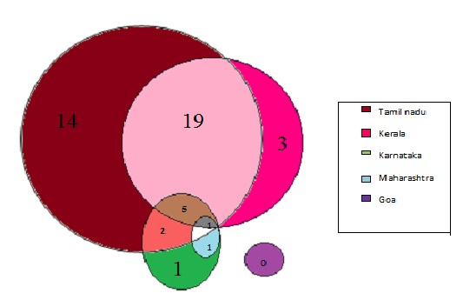
Fig 5: Venn diagram showing distribution of Usnea genus in different states of Western Ghats

Preliminary phytochemical analysis of acetone extract of lichen species was determined by chemical tests. Phytoconstituents viz., alkaloids, saponins, tannins and terpenoids were detected in the Genus Usnea. The extract showed presence of Tannin, Tetradepside, Depsidone, Dibenzofurane. Most of the Usnea extract showed the presence of Dibenzofurane and Depsidone followed by Tannin and Tetradepside (Table-4).

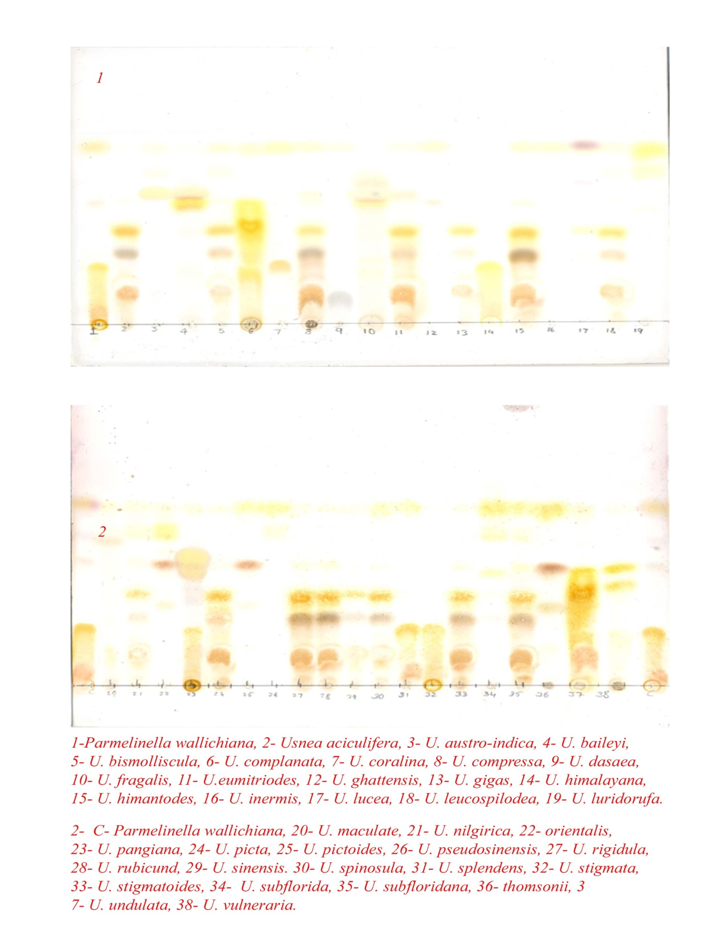

Fig 6: TLC plate showing distribution of chemical substances in Usnea genus

We studied anatomy of all the 40 species. The anatomy of all the species shows three different regions, cortex, medulla and axis. Most of the species contain a small portion of cortex, middle large portion of medulla and central solid axis is present. In most of the species the medulla region is spongy and in some cortex is coloured (Fig-6).
The specimens are also subjected for micro crystallization in the solvent system, GAW (Glycerol ethanol water- 1:1:1). Different types of crystals are found arranged in different shapes based on the presence of different acids.
Table 5: Status of Usnea in Western Ghats
Sl. No. | Species name | Growth Form | Status*
1 | Usnea aciculifera | Corticolous | Rare
2 | Usnea austro-indica | Ramicolous | Endemic
3 | Usnea baileyi | Corti/Saxi | Common
4 | Usnea bismolliscula | Corticolous | NE
5 | Usnea complanata | Corticolous | Rare
6 | Usnea compressa | Corticolous | Rare
7 | Usnea corallina | Ramicolous | Endemic
8 | Usnea dasaea | Corticolous | Rare
9 | Usnea eumitriodes | Corticolous | Common
10 | Usnea fragailis | Corticolous | Rare
11 | Usnea ghattensis | Ramicolous | Endemic
12 | Usnea gigas | Corticolous | Rare
13 | Usnea galbinifera | Corticolous | Common
14 | Usnea hirta | Saxicolous | Rare
15 | Usnea himalayana | Ramicolous | Common
16 | Usnea himantodes | Corticolous | Rare
17 | Usnea cf. inermis | Corticolous | NE
18 | Usnea lucea | Corticolous | Rare
19 | Usnea leucospilodea | Ramicolous | NE
20 | Usnea luridorufa | Corticolous | Rare
21 | Usnea maculata | Ramicolous | Rare
22 | Usnea nilgirica | Corticolous | Endemic
23 | Usnea nidifica | Corticolous | Rare
24 | Usnea orientalis | Corticolous | Rare
25 | Usnea pangiana | Corticolous | Common
26 | Usnea picta | Corticolous | Common
27 | Usnea pictoides | Corticolous | Endemic
28 | Usnea pseudosinensis | Corticolous | Rare
29 | Usnea rigidula | Saxicolous | Rare
30 | Usnea rubicunda | Corticolous | Common
31 | Usnea sinensis | Ramicolous | Rare
32 | Usnea spinosula | Ramicolous | Endemic
33 | Usnea splendens | Corticolous | Common
34 | Usnea stigmata | Saxicolous | Endemic
35 | Usnea stigmatoides | Corticolous | Endemic
36 | Usnea subflorida | Terricolous | Rare
37 | Usnea subfloridana | Corticolous | Rare
38 | Usnea thomsonii | Corticolous | NE
39 | Usnea undulata | Ramicolous | Common
40 | Usnea vulneraria | Corticolous | Endemic

NE- Not Evaluated, * status given based on earlier literature and current study
and status only specific to Western Ghats of India.

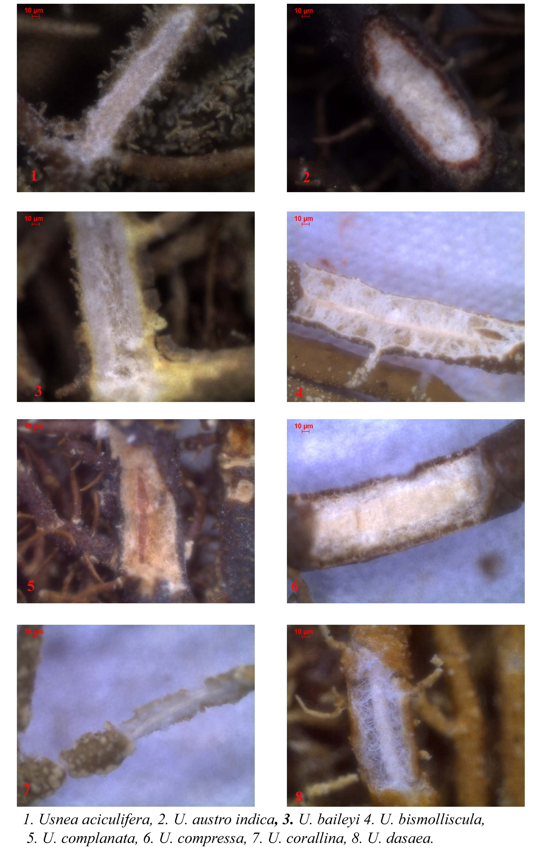
Fig 7: Plate showing the anatomy of some Usnea genus
Usnea Adans. is a large genus in the family Parmeliaceae, with more than 350 species (Clerc 1998) that are widely distributed in polar, temperate and tropical regions. Lichen genus Usnea is represented by occurrence ca. 300 species in the world (Ohmura 2012) and India represents 60 species (Singh & Sinha 2010). Earlier studies reported that Usnea with 30 species from Western Ghats. In our study we have come across 40 Species of Usnea from Western Ghats. 28 species of Usnea are reported from Uttarakhand (Shukla P et al 2014). Usnea are found growing in tropical regions. We collected Usnea species from an altitudinal variation of 600- 3500m. The study (Truong & Clerc, 2012) on lichen genus Usnea in South America also shows that the Usnea species are distributed across 600- 3500m.
Most of the Species of Usnea (79%) are corticolous, growing on bark of trees or twigs of the branches. Only few species grow on rocks (Table 1). Majority of Usnea species prefer lower temperate to upper temperate regions. Moist conditions favour the growth of Usnea species (Halonen 2000) therefore majority of species are found abundantly in old–humid forest types. Corticolous species of Usnea grow luxuriantly on Syzigium, Rhododendron spp. and Eucalyptus spp. The trees twig harbour number of Usnea species. Owing to the presence of old–moist forests that provide ideal conditions for growth of Usnea species, the each state has wide diversity of Usnea species.
Conclusion
Lichen genus Usnea has natural products, which remain as an untapped reservoir of potentially useful chemical compounds not only as drugs but also as unique templates that could serve as a starting point for synthetic analogues. We have reported a 40 Usnea species from Western Ghats and we have assessed the current status of all the species mention in the report. Based on our filed survey Usnea species are restricted to mainly unpolluted areas of Western Ghats and more preferably high altitude places. Most of the Species of Usnea (79%) are corticolous, growing on bark of trees or twigs of the branches. Only few species grow on rocks. Majority of Usnea species prefer lower temperate to upper temperate regions. Moist conditions favour the growth of Usnea species (Halonen 2000) therefore majority of species are found abundantly in old–humid forest types. Corticolous species of Usnea grow luxuriantly on Syzigium, Rhododendron spp. and Eucalyptus spp. The trees twig harbour number of Usnea species. Owing to the presence of old–moist forests that provide ideal conditions for growth of Usnea species, the each state has wide diversity of Usnea species. Assessing the current conservation status we found that majority of the species are found to be occurs Rare in status because of the specific ecological condition and they are mainly threaten by pollution, habitat degradation, illegal harvesting and unmanaged tourism in some high altitude regions. Around 15 species are endemic to Western Ghats and about 5 species are critically endangered and some of the species present statuses we still not get properly because of poor accessibility of the species. Majority of Usnea species required more conservation efforts to improve their current status in the wild and need more conservation study to improve their habitat.

