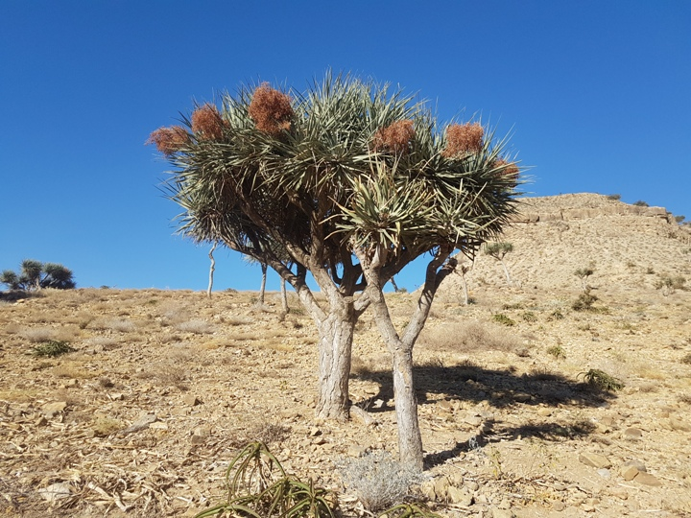
Ecology and conservation status of the endangered Dracaena ombet in the degraded Arid Afromontane of Eastern Africa

First progress report to our MBZ project
Dracaena ombet is a globally endangered tree, and known as a flagship species for north-east African arid Afromontane eco-regions. In Ethiopia, it is only sparsely found at Desa’a protected forest, which is one of the dry Afromontane biodiversity hotspots of Eastern Africa. Several factors have been mentioned to affect its regeneration and populations in the Desa’a relic forest of Ethiopia, including over-exploitation, habitat degradation and fragmentation. Our project was therefore focused in this eco-region to study the tree’s ecology, conservation threats and its future conservation intervention actions in collaboration with international conservation foundations and local and national stakeholders. To date, we provided training for 15 representative key stakeholders, comprising local community, local experts, conservation NGOs to improve their awareness and skills on values of the tree, its conservation threats and future conservation interventions.

In the training, we presented for the representative stakeholders about the tree diverse values and its conservation threats and future interventions, and then the stakeholders were freely exchange their views on the presented issues. The stakeholders have listed the tree has different uses at local level such as fodder, utensil making, house making and shading for livestock and others. The stakeholders also agreed that populations of the tree species is diminishing time to time due various threating factors including over-exploitation, free grazing, settlement, agricultural expansion, erosion, charcoal making and others.

During the training, we also asked the stakeholders to list future conservation interventions for the tree species. They replied the intervention actions as introduction of area enclosure, introduction of soil and water conservation activities into the habitats of the tree, enrichment planting (artificial planting) of the seedlings of tree, continues training for stakeholders; diversify livelihoods of the local community, enhancing cooperation and collaboration among different government and NGOs actors on conservation of the tree and its degraded Desa’a forest.

In the next six months, we will plan to accomplish all objectives of the project including assessment of the current conservation status of D.ombet in the field through collecting its data such as regeneration, population structures and threats. We will also prepare a map for the tree’s distribution; developing conservation action plans; and train the stakeholders by different awareness creation activities; and some others.

Some photos during training of the stakeholders

