Conservation of Ashy Red Colobus Monkeys (Piliocolobus tephrosceles) in Tanzania through Habitat monitoring
Introduction
This is the six month report of the project of a 10 month life span (project duration). The aim of the project is to promote, sustain, support and aid the conservation initiatives of the Ashy Red Colobus (Piliocolobus tephrosceles) in Mbuzi and Mbizi forests (Ufipa plateau) in Rukwa region, southern highlands of Tanzania. The initiatives that have been already established by Wildlife Conservation Society (WCS) through the survey on the population status of the target species conducted in 2007 and Mohamed Kibaja (University of Dar Es Salaam) through studying the feeding habit of the target species (2012; 2014). To enhance the conservation of Ashy Red Colobus in the Ufipa plateau, this project focused on evaluating the quality of habitat (through vegetation survey) where these primate species are found.in relation to their population status (number of groups and composition).
The focus on evaluating habitat quality in relation to population status was due to the fact that Ashy red Colobus stands as globally endangered species with rapid population decline due to habitat loss (IUCN, Davenport, 2007; Kibaja, 2012). Mbuzi and Mbizi forests being the only habitat that support at least a small known population of Ashy Red Colobus, conservation of these forests as important habitat to this monkey is crucial, given the fact that there are insufficient data to establish the status of their population in other previously known localities in Tanzania. Thus, it was evidently to the project that, more information on the abundance, distribution, habitat use and threats to the survival of Ashy Red Colobus in the area are needed so as to build up ecological information necessary for their sustainable conservation.
To achieve the overall project goal/focus, a number of objectives are put forward including; implementation of low-cost monitoring scheme for Ashy red Colobus population and its habitat; reduce anthropogenic pressure and interference to the forests from adjacent communities through; collaboration with other stakeholders to promote the use of alternative source of fuel and energy and promote and assists in establishing environmental friendly projects.
Achievements so far
The successes of the targeted objectives were planned through completion of number of activities which were set to achieve a specific objective. These activities included: vegetation surveys (for habitat quality assessment and conservation threats); animal census and species monitoring (for assessment of population status); establishment of environmental friendly projects (for alternative source of income and source of alternative fuel and energy) as well as workshops for raising conservation awareness.

Habitat quality assessment and conservation threats
In November 2018 after receiving the funds, the project team visited the two study sites in the Ufipa Plateau. The purpose of the visitation was to conduct a random assessment on the quality of the two forests as habitats for the Ashy red Colobus. The team conducted two days random surveys in each forest to assess for forest cover, vegetation types and level of anthropogenic disturbances in the areas.
Mbuzi Forest
The team discovered that there was a lot of human disturbance in the Mbuzi forest in Nkasi district, there was a lot of forest clearance, large part of the forest was cleared and there were only patchy remains of what was forest before (Picture 1a, 1b, 1c). Apart from that, there were also begins of establishment of human settlements in the area (Picture 2) as well as other human activities such as agriculture and livestock keeping (Picture 3).
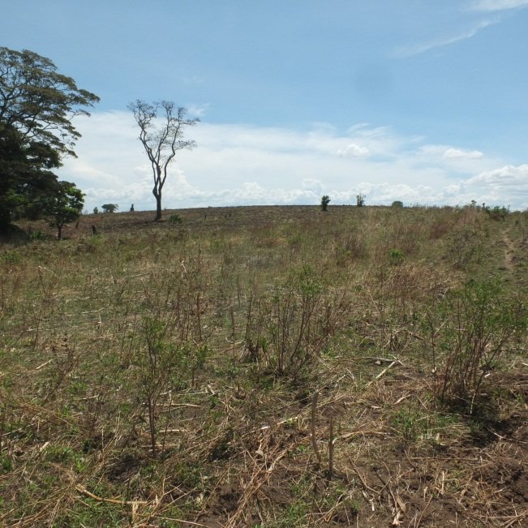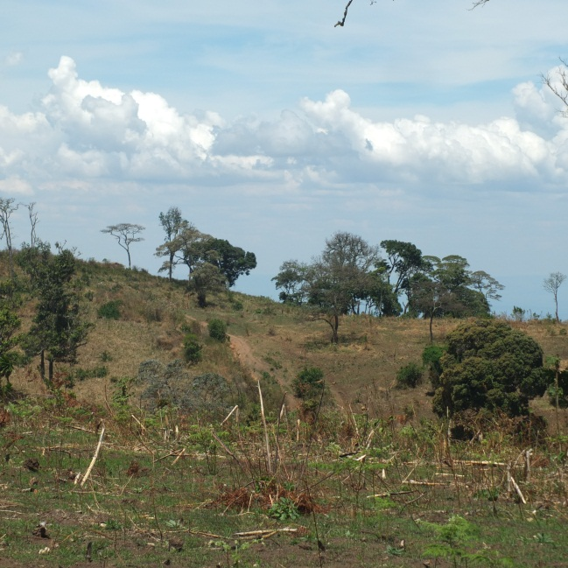
- (b)
Pic 1: Forest clearance as observed in Mbuzi Forest in November, 2018 at Nkasi District

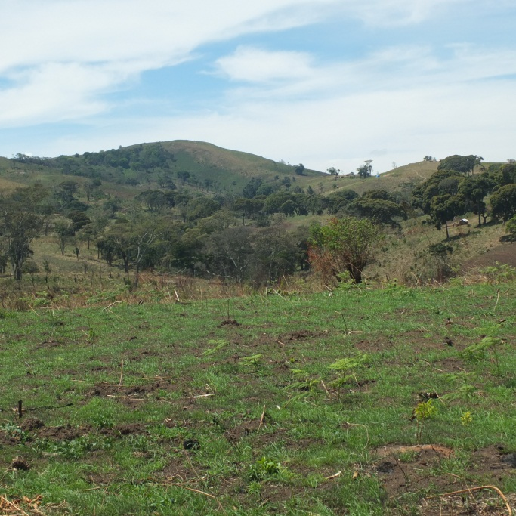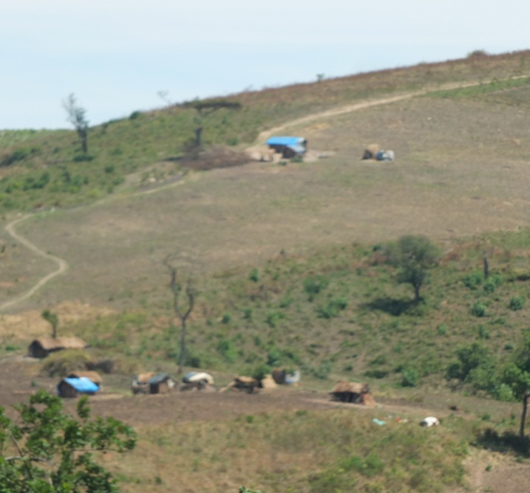
1c: Forest remnant in Mbuzi forests Pic 2: Human settlements inside the forest

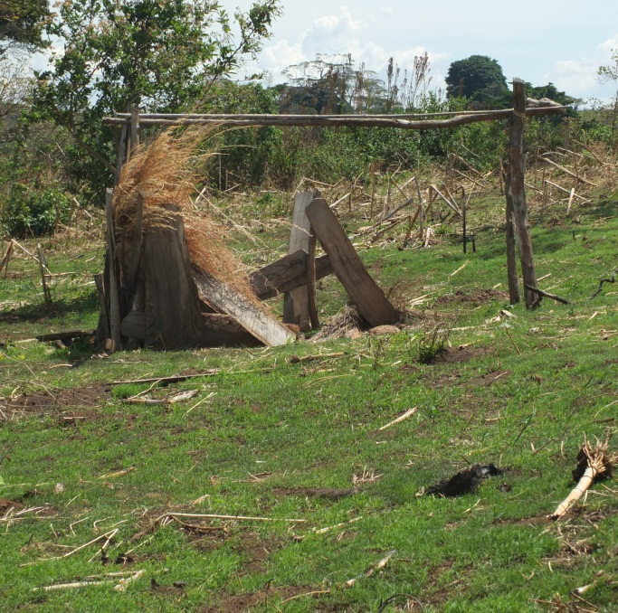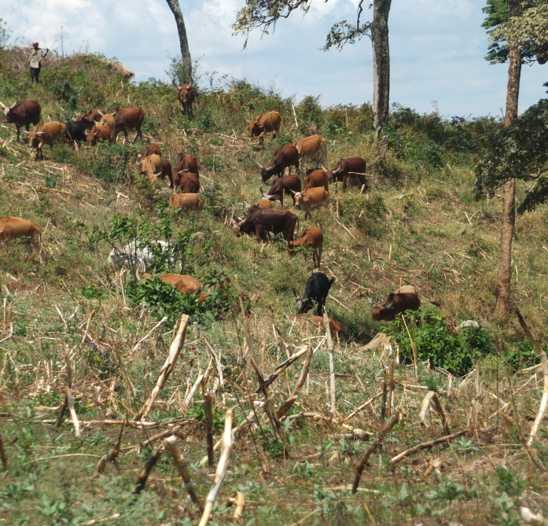
3a: Pit sawing inside the forest 3b: Livestock keeping inside the forest
Pic 3: Some human activities conducted inside Mbuzi Forest, Nkasi District

Mbizi Forest
The team discovered that a program has been put forward by the government through the Tanzania Forest Services (TFS) in collaboration with local communities around the forest to recover the disturbed part of the Mbizi forest. While the remained part of the natural forest has been left to recover and regenerate, parts of the forest that were disturbed and cleared, the government is involving in recovery program in those areas through replantation. However, the team observed that the replantation project involve planting pine trees in the disturbed areas. Pine trees are not indigenous to the areas and by far they are used as commercial trees; this made the team believe the recovery program is not sole for conservation rather for business purposes. While there was no Ashy Colobus seen in Mbuzi forest in Nkasi District, at least two groups of Ashy red Colobus were seen in the natural forest at Mbizi forest.
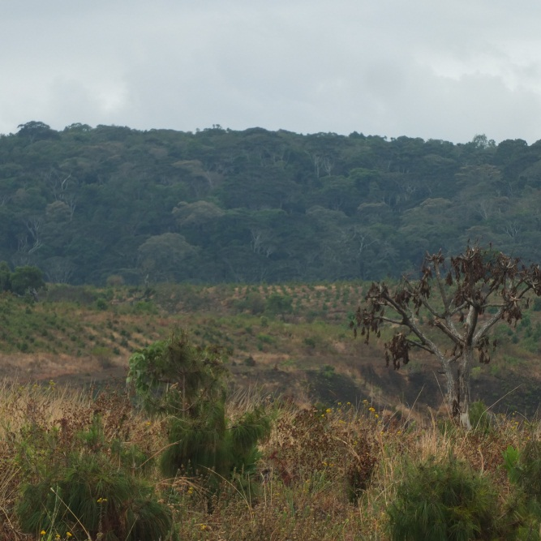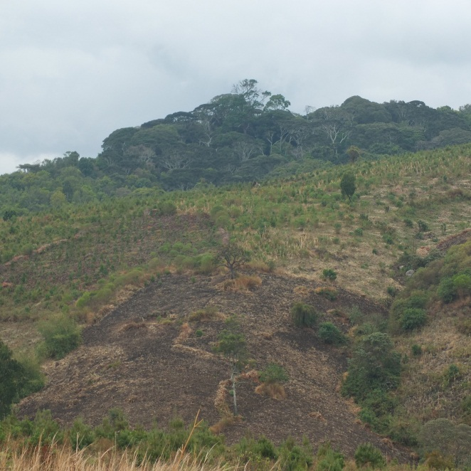
Pic 5a: Mbizi forest, background the natural forest Pic 5b: Mbizi forest, the front is pine plantation

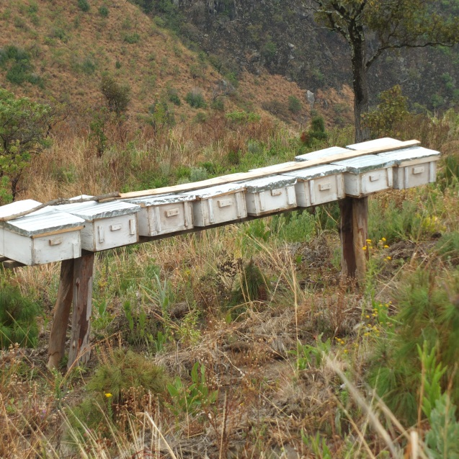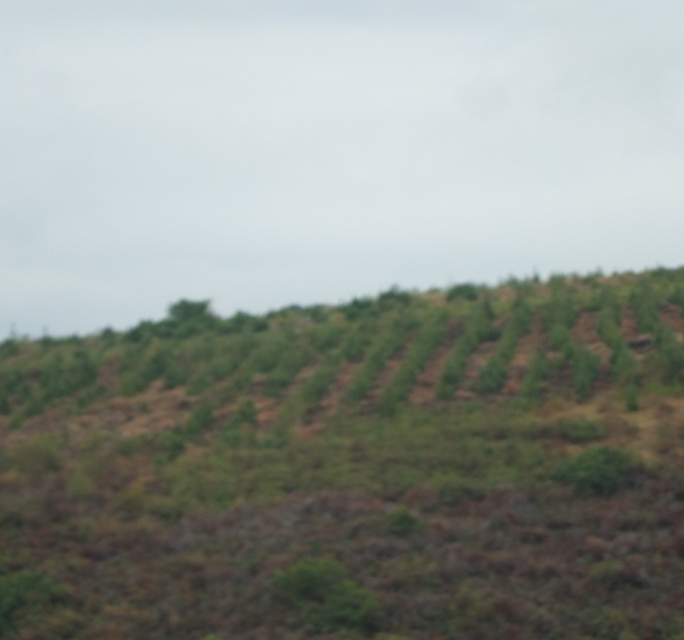
Pic 6: Beekeeping, environmental friendly project carried out inside the disturbed part of Mbizi forest (left) and pine plantation grown as recovery program inside the forest (right).

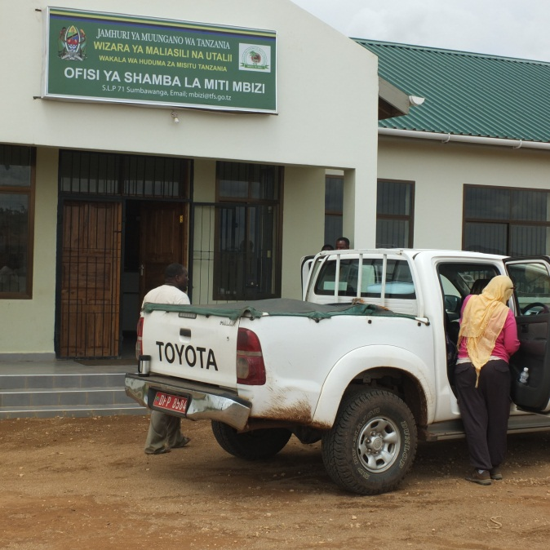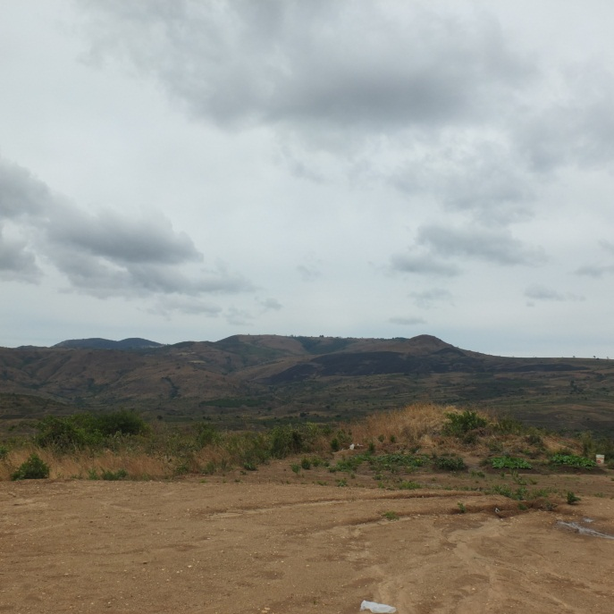
Pic 7: Researchers at the government office which manage the Mbizi forest (left); on the right is Mbizi forest (mountains) as seen from the government office

Animal census
Surveys for census on Ashy red Colobus monkeys were conducted in Mbizi forest in February, 2019 for six (6) days. A line transect using GPS was used for the survey, three teams of three people ( two experienced researchers one local assistants) each simultaneously search for ashy monkey using line transects (following Peres, 1999). When a group is encountered, information such as the number of individuals, sex and age composition, habitat type, major group activity and GPS position of the areas where the group was observed were recorded. Because this method can leave out some groups (Ferrari et al., 2010), especially in very large areas, it was complemented with complete counts (sensu Davenport et al., 2007). The surveys were conducted into from early in the morning around 7:00 am to early evening around 5:00pm in two different areas of the forest, in the south west part of the forest (starting point) and in the south east part of the forest-Mponda camp (Fig 1). Total population size (number of individuals and groups), encounter rate, population density estimates and group composition were assessed.
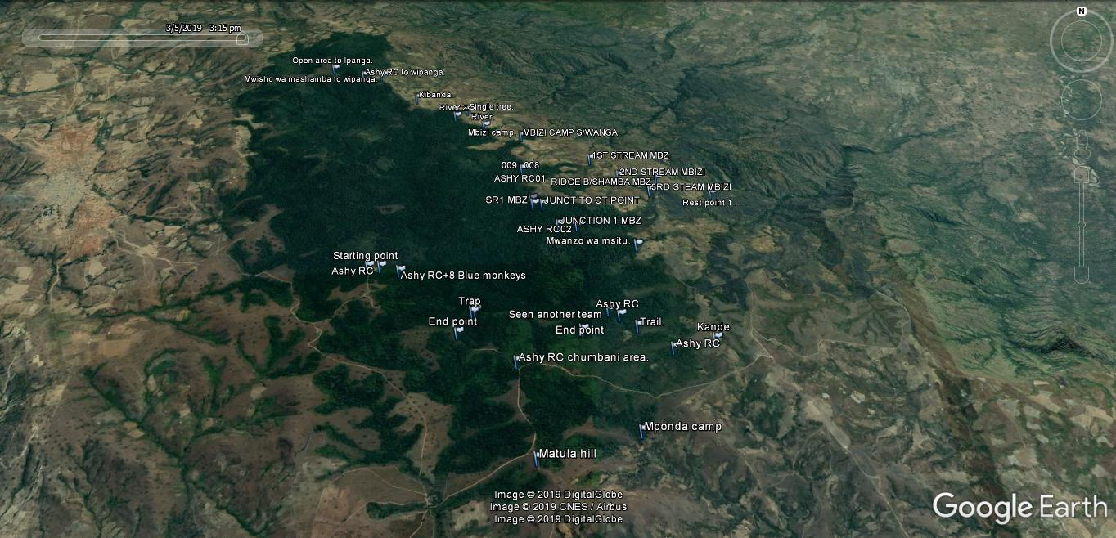
Fig 1: A Google indicating the survey area within Mbizi forest for the census of Ashy red Colobus

Population size
Within six days of field work, a total of 20 groups were counted by the three teams in the two surveyed areas (Mponda camp and first camp). Generally, this averaged into encounter rate of 6 groups per day (Figure 2). However, there was site difference in the number of group encounters; many groups were encountered in the south western part (Mponda camp) of the surveyed area than in the south eastern part (first camp) of the surveyed area (Figure 2).

There was no definite pattern on the number of group encountered and day in the first, but the number decreases in the second and third day of the survey. However, more groups were encountered again in the 4 to six day of field survey (Figure 3).
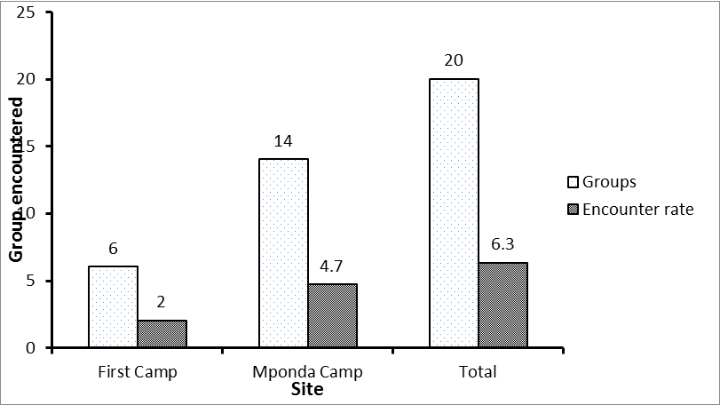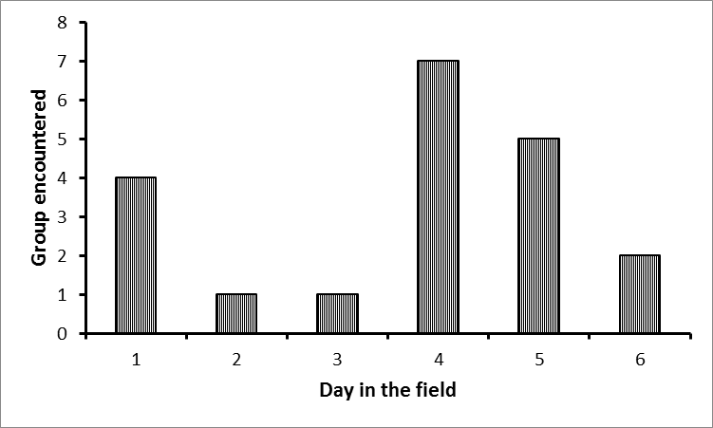
Fig 2: Group encounter rate per site Fig 3: Group encounter rate per field day

Generally a total of 518 individuals were estimated to be counted in all twenty groups encountered, this is an average of 30 individuals per group. However, because of the nature of habitat which these animals were found (i.e. open canopy forest with closed under canopies), and steeply terrain of the forest edge where the group were also encountered, the good estimate of group composition was not possible. However, it was noticed by all three teams that, most of the encountered group were composed with more juveniles and sub adult individuals than adults. For instant, one group in which a total count estimated to be 33 individuals was composed of 6 adults (2 males and 4 females), and 8 infants most of which were clinging on their mother, the rest of the group were juveniles and sub adult individuals. Apart from Ashy Red Colobus monkey other primates such as blue monkeys were also observed and recorded.

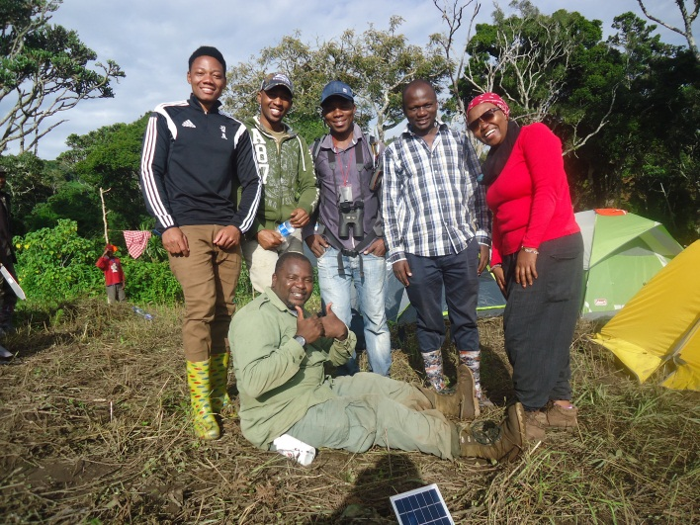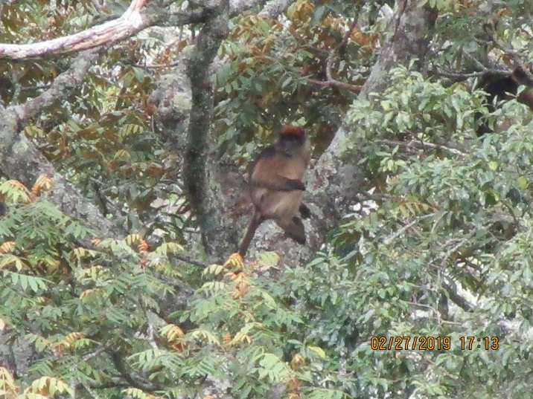
Pic 8: The research team at the first camp Pic 9: Ashy red Colobus at the first camp
Pending activities
As it is indicated in the introduction, this document aim into reporting project activities within six months of its life; the project is designed to be complete in August 2019 (10 months project). Apart from what have been done so far the project was scheduled to conduct a number of activities when comes to its completion. In that regards, a number of activities are still waiting for implementation as follows:
- Field survey for animal census in the Mbuzi forest Nkasi districts, this will be conducted in the mid of May because there were some protocol issues needed to be solved between research team and the University Authorities
- Establishment of environmental friendly project, due to shortage of funds provided to this project contrary to was requested, the project is still seeking for some supplementary funds to curter for this activity together with awareness raising workshop to local communities especially around Mbuzi Forest were the destruction level to the forest is high and continuing.
- Dissemination of finding through conferences and publication, two of the research team members (Kitegile Amani and Arafat Mtui) are planning to attend and present some preliminary finding on the coming African Primatological Society Conference in Entebbe, Uganda in September 2019.
- Vegetation assessment in both forests will be conducted in the next field survey when the team visits Mbuzi forest in May. The exercise was not conducted simultaneously with animal census in Mbizi forest as was planned before due to shortage of time the team stayed in the forest this time.

