1.0 Introduction
1.1 Background

Mount Bamboutos’ forest is being altered by various anthropogenic activities with adverse effect on amphibians. This due to the increasing human population and increasing land demand for agriculture and settlement. This is the main threat to the Egg Frog Leptodactylodon axillaris, which is endemic to the mountain and dependent on forest. Mount Bamboutos has no official protection, therefore engagement with local farmers is crucial for the survival of this species.

Project Activities
This 14-month project seeks to initiate the assessment of the population and habitat of the Bamboutos Egg Frog Leptodactylodon axillaris to create a conservation action plan for this species and its ecosystem. The project activities included training of youths, development of community leadership, research, information dissemination and support building. The desired outcomes include increased population of the population of L. axillaris, sustained improvement in local knowledge, attitudes and behavior and greater support for, and involvement in, the management process of the amphibians. The activities began in December 2018 with the holding of a planning meeting in Fido, a small locality close to mount Bamboutos. During the meeting, the activities were planned and prioritized. The Mount Bamboutos Conservation Action Plan, identifies the chain of mountains as a prime focus for immediate conservation attention. Unfortunately, the population continues to decline at an alarming rate due to habitat loss and human land conflicts. These land conflicts have been identified as one of the main menace of L. axillaris population through agricultural encroachment. We also aim to help farmers and other community inhabitants plan alternative economic livelihood enterprises. Community education and awareness was also raised in fringing communities on the need to protect the amphibian’s population.

1.2 Description of the Study sites

Mount Bamboutos is situated between longitudes 09°57'E and 10°15'E and latitudes 05 °27'N and 05°48'N (Gountié Dedzo et al., 2012). Also known as the Bamboutos mountains, is a set of massifs situated between the towns of Mbouda and Santa and includes about 230 km² ha of montane area. The massif is not too abrupt, isolated mountain with montane savanna grassland mixed with large patches of gallery forest on the plateau and the slopes, where they line the numerous streams, some of which are seasonal and some permanent. The surrounding populations are mainly farmers and cattle breeders.
The region is shown in Figure 1 below.

Key Project Activities
The following key project activities were conducted during the project execution period.
- Raise local awareness on the species’ conservation needs, and build capacity to improve Leptodactylodon axillaris’ future population assessments.

- Re-evaluate the severity of known threats (e.g. deforestation, degradation, and overgrazing) and identify any new threats on the new site; and also assess local attitudes and perceptions toward the species.

- Monitor the potential for amphibian chytrid fungus to be a threat.
- Estimate breeding population size of Leptodactylodon axillaris.
- Develop model for the predicted distribution of the Leptodactylodon axillaris.
- Identify priority areas for the species’ conservation in the study area.
- Produce a conservation action plan for this species.

  - Field Methods
Surveys
The reconnaissance survey method (visual and acoustic encounter survey (VES & AES method) are used. We surveyed several sites across Mount Bamboutos. A total of twelve sites have already been surveyed.
Visual Encounter Surveys

This method of survey involves searching a given area systematically, day and night time surveys were conducted in these designated sample sites using visual and acoustic encounter surveys. This involved searching of microhabitats, such as lifting rocks and logs, peeling away bark from trees, moving fallen debris and inspecting tree stems at daytime (07:00-12:00 h) nighttime (19:00–00:00 h) along streams, ponds and the surrounding vegetation (Crump & Scott, 1994; Rödel & Ernst 2004).

Audio Surveys
Audio surveys were undertaken using appropriate equipment. However, the past two years of fieldwork have enabled the learning of calls of the target species and this helped with noting the presence of the species without capturing them.
Community meetings

Meetings are being held in each of the key settlements of the mountain. The main approaches used included community meetings, interviews granted to key informants (shepherds, farmers) and forest surveys. Prior to surveys at each site, community meetings were organized involving members of the traditional councils and community representatives to inform and solicit their support.
School education sessions
Formal lectures on environmental education were held in the secondary institutions throughout the Highlands.
Training workshops
A number of training workshops have already been held both for youths/students and for representatives of community-based forest management institutions. These formed part of institutional and capacity building. The project facilitates the formation of community-based networks of conservation leaders across the highlands.

Conservation output
Since the beginning of the project we contacted and worked very closely with the local community on Bamboutos.
The project has so far engaged a total of 169 local farmers and other inhabitants in four different communities (Fido, Toumakah, Mvoh and Kombouh). We trained the farmers on how to maximize efficiency of crop productions by reducing using of chemical products. Farmers who implemented this made compost from cow dung.
A three day training workshop has already been organized for government wildlife ecoguards working in the forest block to build their capacity in resolving incidents of agricultural encroachment. The ecoguards were given brochures and leaflets to guide them in giving technical support and providing future assistance to local farmers.
We conducted community conservation campaigns to educate stakeholders, students, pupils and communities on the need for sustainable conservation of amphibians and their habitats. The education activities included conservation talks, presentations, showing of local cultural drama on amphibian-related topics in schools and communities. Community meetings were also conducted in the local language to further educate the communities on amphibians Conservation issues.

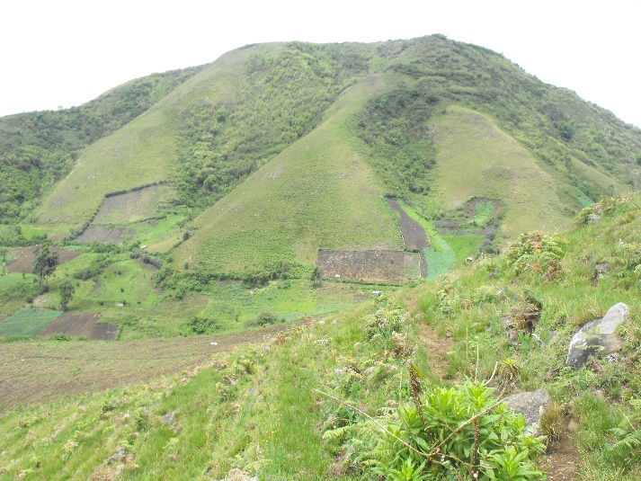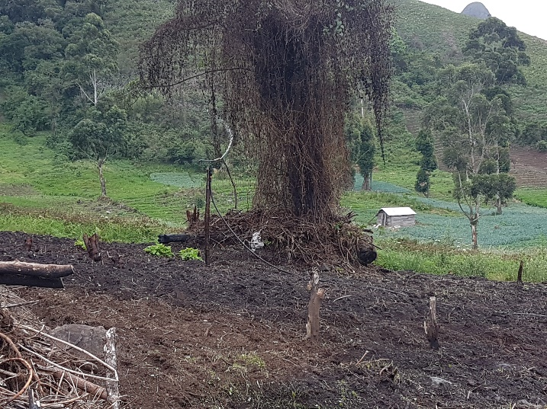
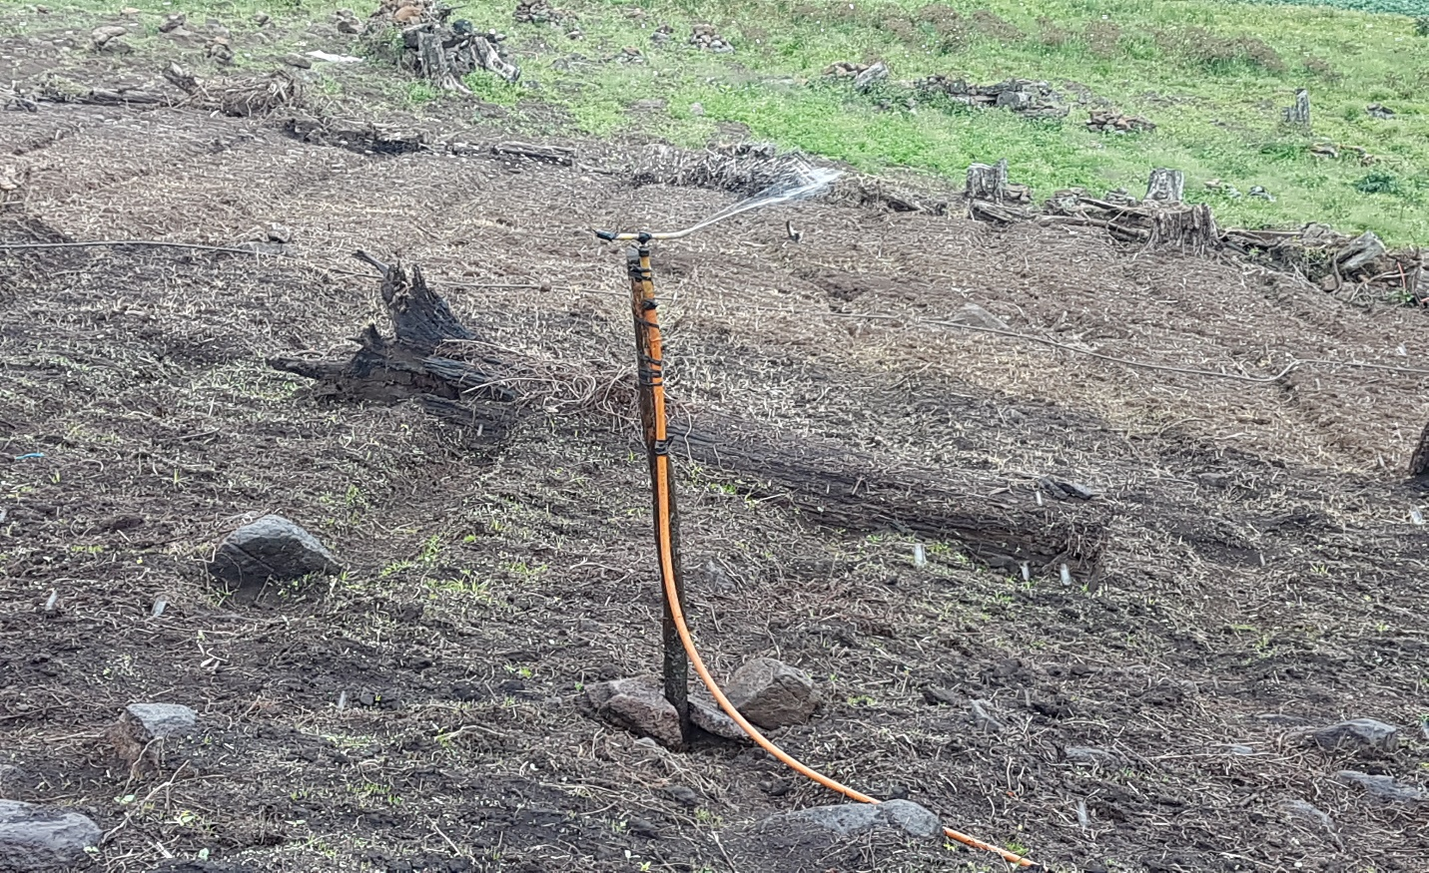
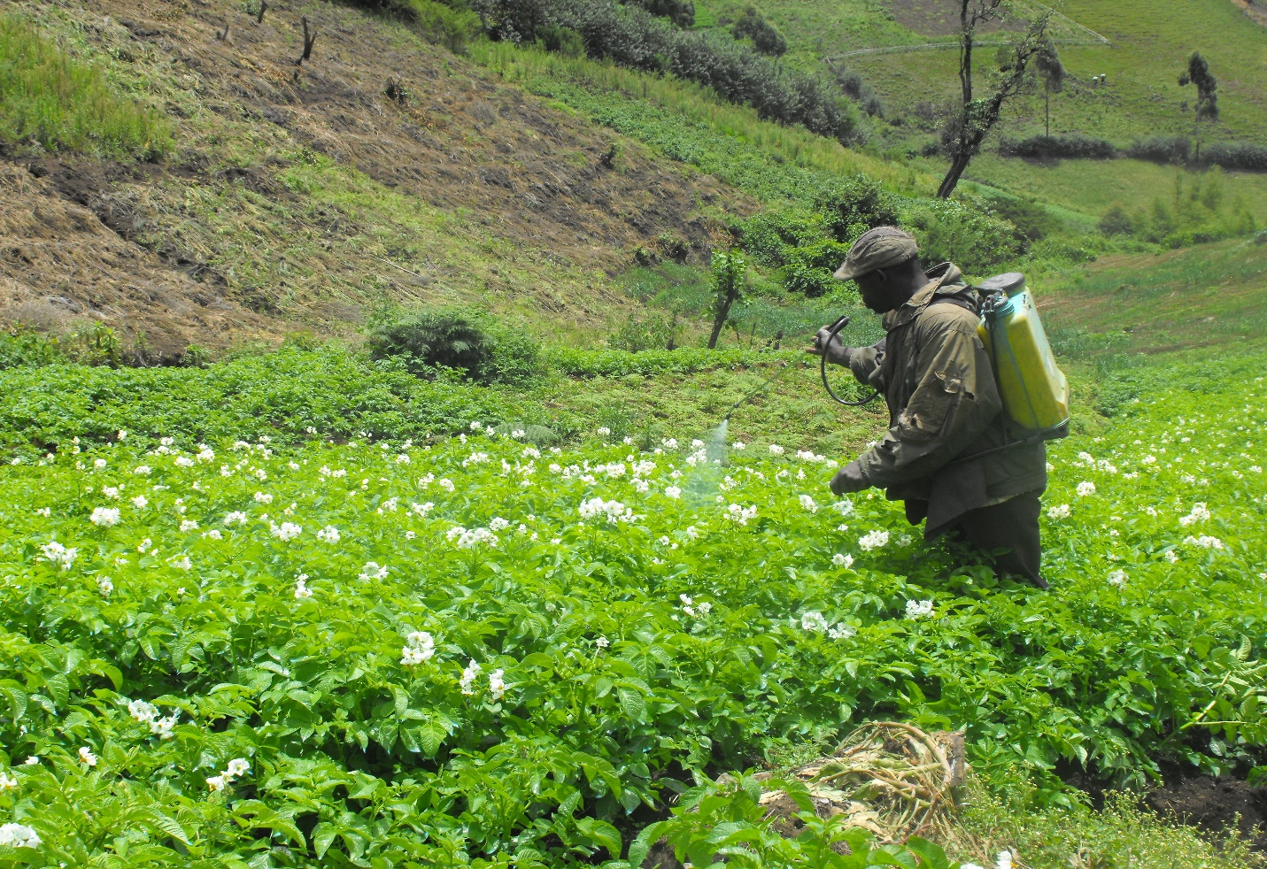
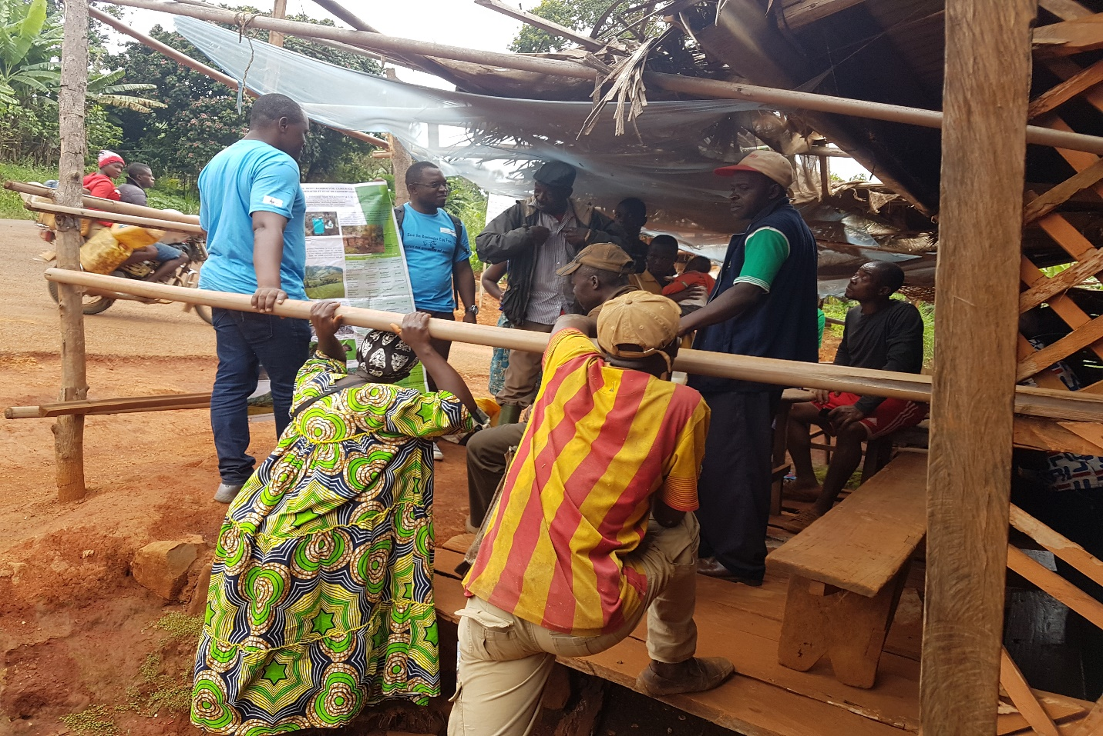
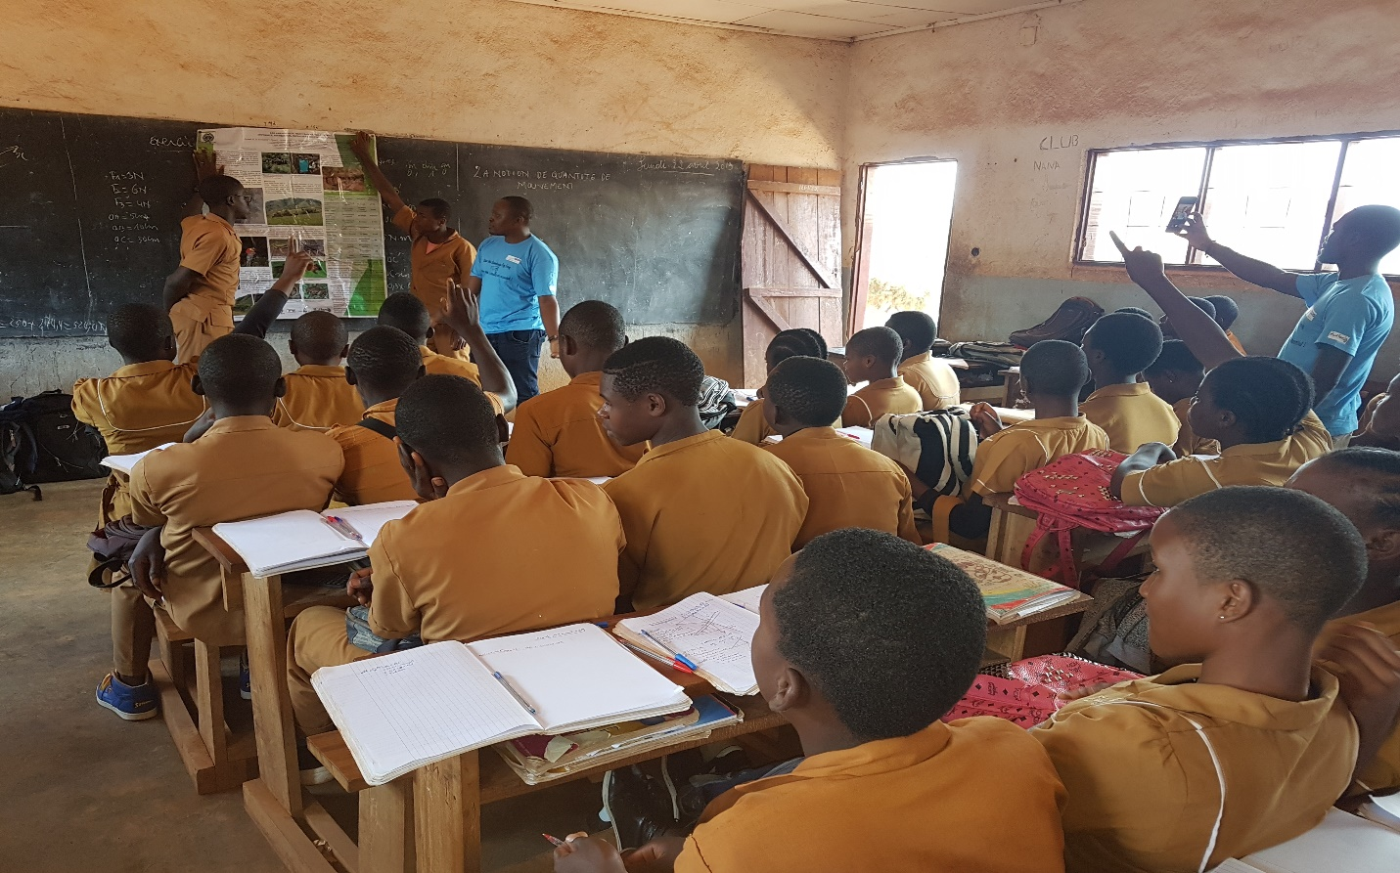
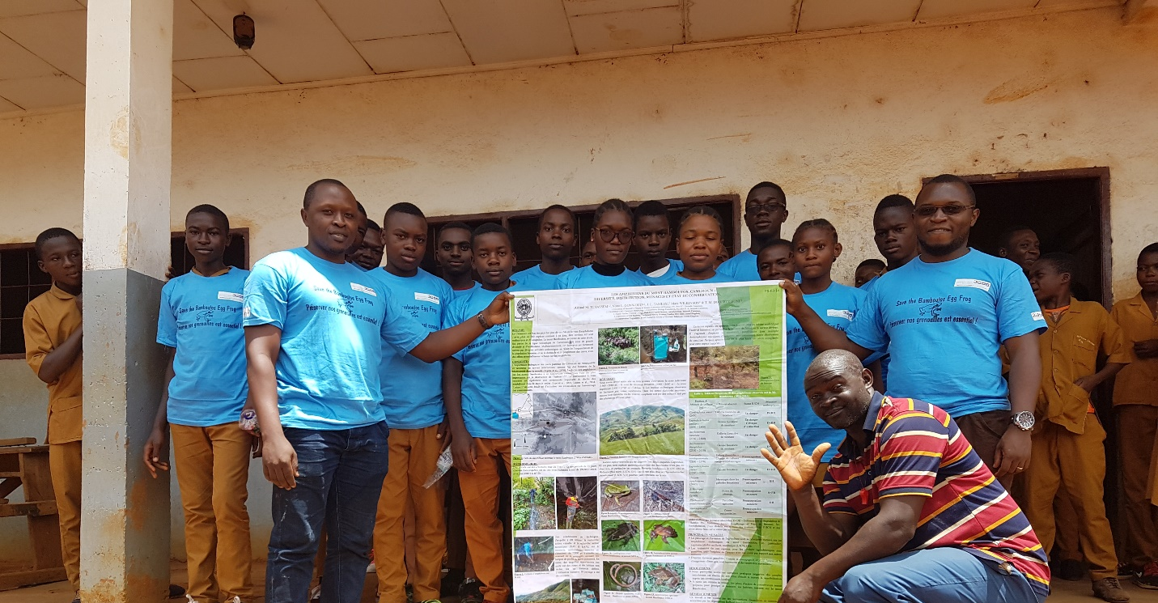


Conservation achievement

The community outreach component of this project made local people aware of the plight of the amphibians, their natal forest habitats, and take practical steps to protecting them. Until now, there is a wrong perception amongst communities that, amphibians are venomous and infinite. Such perception leads to unwarranted public persecution. Through the community outreach, we try to demystify such beliefs and win community’s love for these species.
Apart from the short term financial benefits local people receive from the project in the form of employment as guides, it is clear that they are predisposed to assist with projects relevant to conservation.
The discovery during this study of the critically endangered Leptodactylodon axillaris on new localities or sites since its description updates information on the species. The surveyed habitat types varied in size, in altitude with the sub-montane area covering a larger surface area followed by the lowland area and montane habitats. Leptodactylodon axillaris is recorded on mount Bamboutos with high population concentration around 2200 and 2400m a.s.l.. Formally known from the eastern flank between 2200-2650 m.a.s.l., the species was recorded. These records extend the known range of the species to the summit and western flank of the mountain. It seems that the species does not live outside of forest, and would be probably a forest-dependent species.
GPS records of the breeding areas, the migration paths and the highly degraded habitats have been recorded at our site. Breeding sites are along the small streams all over the mountain at different periods of the year and especially at the beginning of the rainy season for tadpoles of Leptodactylodon axillaris and Leptodactylodon perreti, two sympatric species. Adults are found from the end of June on Mount Bamboutos, potential disperal corridors between these streamsare unfortunately impacted by pasture and bush fires.

Development of model for the predicted distribution of the Leptodactylodon axillaris.

Field surveys were directed to localities that have high probability of presence of L.axillarisThe data will comprise amphibian presence and environmental data. Environmental variables in each land use are also measured, though is necessary for understanding distribution of L. axillaris, and follow up work should take this into account. GIS is being used to facilitate the mapping of the future distribution following climate change of L. axillaris.

Conclusion
Options for the reduction of the rate of forest loss and degradation on Mount Bamboutos are being explored, such as the creation of a protected area consolidating the forest, possibly with help of the government Ministry of Forestry & Wildlife, or a community forest management committee. Other work is needed on this species, their environment and how they can be preserved to the benefit of the local community. In addition, this project's report and additional publications will provide more awareness to this region of Cameroon, its unique biodiversity and culture. Strong involvement of local stakeholders is needed to secure success of these conservation interventions. In the absence of official protection, strategies are in development to involve local communities in the process of conserving remnant forest, and restoration of degraded habitats.

