Distribution and Population Status of Arthroleptides dutoiti - Du Toit's Torrent Frog, Critically Endangered in Mt. Elgon, Uganda

Progress Report

February 2020

- INTRODUCTION
Du Toit's Torrent Frog - Arthroleptides dutoiti (Loveridge, 1935), also known as the Kenya Rocky River Frog, is a species of frog in the Petropedetidae family endemic to Mt Elgon area in Kenya, and has not been found on the Ugandan part of the mountain. It is currently assessed as Critically Endangered (CR C2aii) according to the IUCN 2020 species red listing.
This species is known from its type locality on the Kooitobos River in the northeast of Mount Elgon in Kenya; and a site along the Suam River which divides Kenya and Uganda at the northeast base of Mount Elgon. Its known elevational range is 2,100-2,200 masl. It is expected to occur along other drainage basins on both the Kenyan and Ugandan sides of Mount Elgon.
A single specimen of species was last recorded along the Suam River in 1962 and earlier on in 1934 during the rainy season by Loveridge (1935). There have been extensive surveys to locate Du Toit’s torrent frog since its last record in 1962, targeted in the locality of origin in Kenya but all attempts have failed to find the species (Ngwava et al, 2015; Lötters et al, 2003, Lötters et al, 2006).
Between 2001 and 2006 five attempts to locate the species at the type locality along the Koitobos River (in wet and dry seasons) were unsuccessful (P.K. Malonza and V. Wasonga pers. comm. June 2012). Four targeted surveys (two wet season and two dry season, each 15 days long) from February 2013 to December 2014 at the type locality and adjacent farmland also failed to record the species (Ngwava 2015a). The preferred microhabitat - rapids, fast moving water and waterfalls - means that it can be hard to sample (P.K. Malonza and V. Wasonga pers. comm. June 2012). However, congeners are relatively easily sampled and in high abundance at known localities, so it would be fair to assume the same would be true for this species (S. Loader pers. comm. November 2015).
However surveys on the Ugandan side had never taken place. Its range map has been slightly revised to include the Suam River sites which were missing from the previous map. As such, its extent of occurrence and these two sites are considered a single threat-defined location.
Du Toit's Torrent Frog is listed as Critically Endangered, and possibly Extinct because repeated, unsuccessful surveys of the small type locality and several other sites in the area have failed to record the species. There is only a small chance that it is still extant within its historic range, but information is lacking to declare it Extinct. The surveys on the Ugandan side could provide the only remaining and hence important habitats of this species.

- AIMS AND OBJECTIVES
The main aim of the project is to provide updated information on the distribution, population status and preferred habitats of Arthroleptides dutoiti in Mt Elgon area. The specific objectives are:
- Identify and map critical habitats vital for the survival of Arthroleptides dutoiti,
- Assess and document threats to Arthroleptides dutoiti and its habitats,
- Determine the population size and abundance of Arthroleptides dutoiti,
- Document any other herpetofauna species encountered in the surveyed area.
New: Ecological assessment and spatial distribution of herpetofauna in habitats preferred by Arthroleptides dutoiti
- STUDY AREA AND METHODS
3.1 Study Area
Sampling locations were at the edge of the Mount Elgon National Park along River Suam and its tributaries, comprising of edges of farmlands and and disturbed vegetation near the park. These sites were sampled from 17–23 August and 15-22 November 2019 (Fig. 1).

Mount Elgon is a 112,100 hectares protected area located in eastern Uganda (N01.33513, E34.41092) along the Kenyan border. This site is one of the largest solitary volcanoes in the world, and reaches an altitude of 4,321 m. Mean rainfall reaches over 1,270 mm per year, and rainfall ranges from 1,500 mm on the eastern/northern slopes, to 2000 mm in the southern/western slopes. The park’s two dry seasons extend from June–August, and December–March. Thus the park’s rainy season is bimodal, and the wettest period occurs from April–October. Mt. Elgon’s vegetation reflects an altitudinal gradient associated with large mountains. Mixed montane forest extends up to 2,500 m elevation, low canopy montane forest from 2,500–3,500 m elevation, and bamboo / moorland above 3,500 m elevation. The park is a UNESCO Man and Biosphere Reserve.
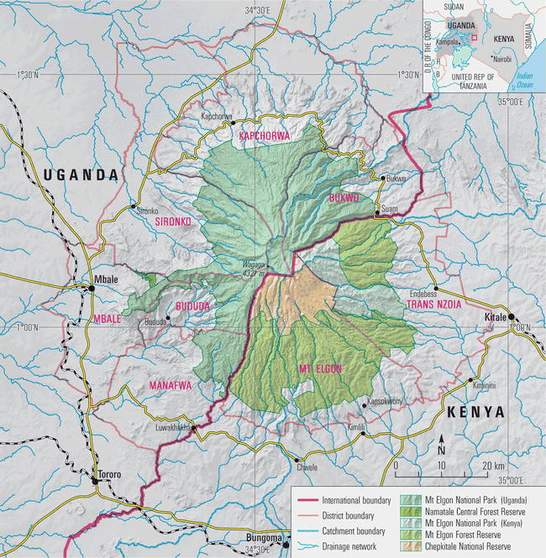
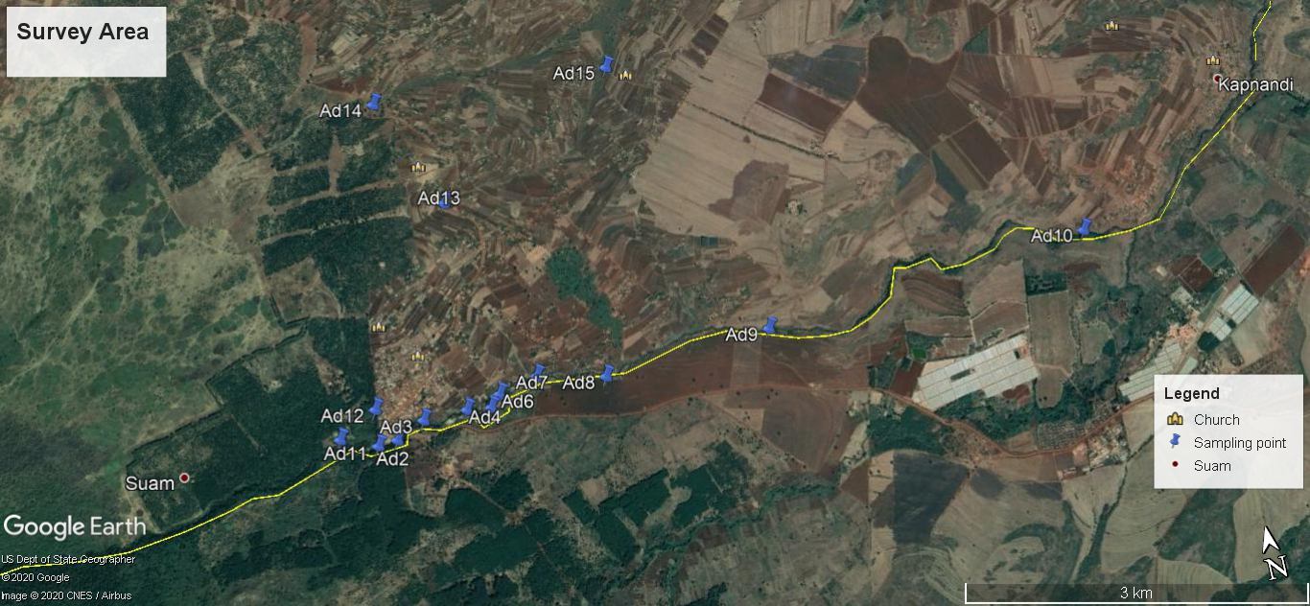

Figure 1: Map showing the location of sampling sites in Mt Elgon Area - Uganda

3.2 Methods
Visual Encounter Surveys, opportunistic records and consultations were the key methods used in monitoring herpetofauna

Visual Encounter Surveys
Visual Encounter Surveys (VES) are a time-honoured technique. VES is similar to the Timed Constrained Count (TCC) method described by Heyer et al., (1994). Visual encounter surveys are used to document presence of amphibians and are effective in most habitats and for most species that tend to breed in lentic habitats. They generate encounter rates of species in their habitats in a unit hour. The method involves moving through a habitat, turning logs or stones, inspecting retreats and watching out for surface-active species. The data gathered using this procedure provides information on species richness of the habitat.

Opportunistic Records
Opportunistic records are those made outside the sampling points but occur in the surrounding area to be impacted by the project. It helps complete the checklist of the animals as much as possible. Amphibians and reptiles are mobile and can therefore be encountered outside their preferred habitats both spatially and temporally. Several individual specimens were recorded outside the sampling time in the survey area. The species encountered this way were used in completing the checklists of sites surveyed but not be used in the analyses.

Consultations
Local people were also interviewed to establish the amphibian and reptilian species known to be present in the sites surveyed. This was treated as secondary data.
Species Identification
Identification of herpetofauna followed (Schiøtz, (1999), Spawls et al., (2002) and Channing & Howell (2006). The AmphibiaWeb (2015) and The Reptile Database (Uetz, P. & Jirí Hošek (eds.) 2015) were also used. The conservation status of the herpetofauna is reported using the IUCN Red Listing (IUCN 2020) and the Ugandan Red List (WCS 2016).
Statistical analyses
The data was sorted according to the surveyed sites and herpetofauna group using excel spread sheet. The cleaned data was exported to Microsoft access to perform more robust data filtering techniques of determine the species number in each group and survey site. Biodiversity pro software was used to predict species occurrence and generating species accumulation curve for each herpetofauna group.

- RESULTS
Fourteen sites in Uganda were surveyed for the herpetofauna with a focus while searching for Du Toit's Torrent Frog - Arthroleptides dutoiti (Tab. 1), River Suam point being the fifteenth and reference point for this project. Most of the sites were along River Suam, which is highly degraded of natural landscape due to crop farming being extended to the edges of the river.
Table 1. – Location of the sites surveyed in Mt Elgon Area - Uganda
Locality Name | Northing | Easting | Altitude (metres above sea level -masl) | Description
A.dutoiti1 | 36 N 692360 | 134557 | 2,160 | River Suam, edge of forest
Ad2 | 36 N 692840 | 134446 | 2,153 | Farmland at edge of River Suam
Ad3 | 36 N 693093 | 134562 | 2,151 | Farmland at edge of River Suam
Ad4 | 36 N 693476 | 134566 | 2,150 | Farmland at edge of River Suam
Ad5 | 36 N 693683 | 134539 | 2,149 | Farmland at edge of River Suam
Ad6 | 36 N 693779 | 134636 | 2,150 | Farmland at edge of River Suam
Ad7 | 36 N 694126 | 134718 | 2,145 | Farmland at edge of River Suam
Ad8 | 36 N 694715 | 134579 | 2,142 | Farmland at edge of River Suam
Ad9 | 36 N 696202 | 134670 | 2,135 | Farmland at edge of River Suam
Ad10 | 36 N 699158 | 134902 | 2,129 | Edge of farmland near Campnamdi
Ad11 | 36 N 692670 | 134432 | 2,155 | Farmland at edge of River Suam
Ad12 | 36 N 692707 | 134743 | 2,158 | Tributary of River Suam, near Suam Full Gospel Church
Ad13 | 36 N 693665 | 136361 | 2,166 | Swam Parish Church of Uganda
Ad14 | 36 N 693232 | 137364 | 2,170 | Farmland at edge of tributary to River Suam with forest
Ad15 | 36 N 695318 | 137264 | 2,163 | Near Matimbe Roman Catholic church

  - Amphibian richness, diversity, distribution and status
A total of eight amphibian species from the 44 individuals sighted, belonging to one order Anura, four families and four genera were recorded from 14 sites during the study (Tab. 2). The richest sites were sites Ad2 with four species, followed by Ad3 and Ad12 each with three species. The rest of the sites were poor each with two or one species recorded. Ptychadena nilotica – the Nile Grassland Frog was the most common species recorded in 10 out of 14 sites surveyed, followed by Phrynobatrachus cf. natalensis -Natal Dwarf Puddle Frog (6/14 sites), Schlerophrys regularis - Common African Toad (4/14 sites) and Schlerophrys kisoloensis - Kisolo Toad (3/14 sites). The rest of the species were recorded each in one or two sites of the surveyed area.
All the amphibian species recorded were of Least Concern (LC) conservation status both globally and nationally according to the red listing (IUCN, 2020; WCS, 2016) except Amietia cf. wittei - De Witte's River Frog which is listed as Data Deficient (DD) both globally and at national levels.
Table 2. – List of amphibian species recorded in Mt. Elgon area - Uganda – Range of A.dutoiti
Family | Species | Common name | IUCN Global | IUCN Country
Bufonidae | Schlerophrys regularis | Common African Toad | Least Concern (LC) | Least Concern (LC)
Bufonidae | Schlerophrys kisoloensis | Kisolo Toad | Least Concern (LC) | Least Concern (LC)
Phyxicephalidae | Amietia cf. nutti | Nutt’s River Frog | Least Concern (LC) | Least Concern (LC)
Phyxicephalidae | Amietia cf. wittei | De Witte's River Frog | Data Deficient | Data Deficient
Phrynobatrachidae | Phrynobatrachus cf. natalensis | Natal Dwarf Puddle Frog | Least Concern (LC) | Least Concern (LC)
Phrynobatrachidae | Phrynobatrachus petropedetoides | Ruwenzori Puddle Frog | Least Concern (LC) | Least Concern (LC)
Phrynobatrachidae | Phrynobatrachus sp
Ptychadenidae | Ptychadena nilotica | Nile Grassland Frog | Least Concern (LC) | Least Concern (LC)

  - Reptilian richness, diversity, distribution and status
A total of five reptilian species from 12 individuals sighted, belonging to two orders Sauria and Serpentes, four families and four genera were recorded from seven sites during the study (Tab. 3). All sites in which reptiles were encountered were species poor with only one reptilian species recorded in each site except site Ad10 which had two species recorded. The commonest species were Trachylepis striata - Common Striped Skink recorded in four out of the seven sites in which reptiles were recorded and Agama lionotus - Kenyan Rock Agama (3/7 sites). Each of the rest of the reptile species were recorded in only one site.
All the reptilian species recorded were Not Evaluated (NE) globally (IUCN, 2020) but their conservation status nationally is of Least Concern (LC) (WCS, 2016)) except Trachylepis varia - Variable Skink which is listed as Data Deficient (DD) at national level.

Table 3. List of reptile species recorded in Mt. Elgon area - Uganda – Range of A.dutoiti
Order | Family | Species | Common name | IUCN Global/Country Status
Sauria | Agamidae | Agama lionotus | Kenyan Rock Agama | Not Evaluated (NE) / Least Concern (LC)
Sauria | Lacertidae | Adolfus jacksoni | Jackson’s Forest Lizard | Not Evaluated (NE) / Least Concern (LC)
Sauria | Scincidae | Trachylepis striata | Common Striped Skink | Not Evaluated (NE) / Least Concern (LC)
Sauria | Scincidae | Trachylepis varia | Variable Skink | Not Evaluated (NE) / Data Deficient (DD)
Serpentes | Colubridae | Philothamnus battersbyi | Battersby's Green Snake | Not Evaluated (NE) / Least Concern (LC)

- DISCUSSION
Up to 90 amphibian species have been documented for Uganda (Channing, 2006, WCS, 2016, Amphibiaweb, 2018, Goodman, 1996, pers observ), while up to 190 reptilian species have been recorded (WCS, 2016, Spawls et al, 2002). The taxonomy of herperofauna continuously changes and with more modern identification methods such as molecular techniques, and with more surveys in more localities across the ecosystems. Appendix1 shows photographs of some of the amphibian and reptilian species encountered in the surveyed sites.
Arthroleptides is a small genus of frogs in the family Petropedetidae, have distinct tympana and no external vocal sacs. They are known to inhabit the spray zone of streams and waterfalls in Africa (Barej et. al, 2010). Du Toit's Torrent Frog - Arthroleptides dutoiti itself is associated with seeps and fast-flowing streams in montane forest.
However, it was not encountered this time of the survey. The genus is probably associated with Phrynobatrachus. The one Phrynobatrachid specimen that was not identified to its specific level will be sent the museum abroad for further identification as well as the two specimens identified as Phrynobatrachus petropedetoides. Some of the Phrynobatrachus cf. natalensis specimens will also be sent to the museum abroad for further analysis.
The main threats to the species recorded in the survey area was extensive cultivation up to the river banks. The key amphibian habitats that usually consists of wetland vegetation that surround rivers, was generally removed or where it occurs, highly disturbed, thus inhabited by fewer species than expected. The area surveyed was mostly farmland with gardens up to the river banks. The other threats were agro-chemicals for use on crops, these agrochemical seep into the river, possibly making the water more contaminated and not liked by amphibian species.
Further survey work will be repeated again in March and April 2020 to determine the status of this species for the dry season. Sites inside Mt. Elgon National Park will be visited to determine whether the less disturbed areas still contain this amphibian species and whether the species is not yet extinct.

REFERENCES
AmphibiaWeb (2018) Information on amphibian biology and conservation. Berkeley, California: http://amphibiaweb.org
Barej MF, M-O, Rodel, LN, OSG, Gonwouo Pauwels, W, Bohme and A Schmitz (2010) Review of the genus Petropedetes Reichenow, 1974 in Central Africa with the description of three new species (Amphibia: Anura: Petropedetidae). Zootaxa 2340:1-49
Channing, A. and Howell, K.M. (2006) Amphibians of East Africa. Edition Chimaira, Frankfurt am Main
Goodman, J. (1996) Draft Checklist of East African Amphibians. Unpublished Report
Heyer, W.R., Donnely, M.A., Mc Diarmid, R.W., Hayek L.C., and Foster M.S. (Eds.). (1994) Measuring and Monitoring Biological Diversity: Standard Methods for Reptiles and Amphibians. Smithsonian Institution Press, Washington.
IUCN (2020) The IUCN Red List of Threatened Species. Version 2019-3. <https://www.iucnredlist.org>
Ngwava, J.T (2015a). EDGE Fellowship Final Report on: Conservation Assessment of the Critically Endangered Du Toit’s Torrent frog (Arthroleptides dutoiti) in Kenya. Zoological Society of London.
Lötters, S., D. Rotich, and M. Veith (2003) Non-finding of the Kenyan endemic frog Artholeptides dutoiti. FrogLog 60: 3-4.
Lötters, S., D., Rotich, T.E., Koester, J., Kosuch, V., Muchai, K., Scheelke, S., Schick, P., Teege, V.D Watonga, and M. Veith (2006) What do we know about the amphibians from the Kenyan central and western highlands? A faunistic and taxonomic review. Salamandra 42(2/3): 165-179.
Loverage, A. (1935) Scientific results of an expedition to rain forest regions in eastern Africa. I. New reptiles and amphibians from East Africa. Bulletin of the Museum of Comparative Zoology 79: 3-19
Ngwava, J.M., P.K. Malonza, and A.B. Bwong (2014) A Survival Blueprint for Du Toit’s Torrent frog (Arthroleptides dutoiti Loveridge 1937). Zoological Society of London.
Schiøtz, A. (1999). Treefrogs of Africa. Edition Chimaira, Frankfurt am Main, Germany.
Spawls, S., K. Howell, and R. C. Drewes (2006) Reptiles and Amphibians of East Africa. Princeton University Press, New Jersey, USA.
Spawls, S., K. Howell, R. C. Drewes and J. Ashe (2002) A Field Guide to the Reptiles of East Africa: Kenya, Tanzania, Rwanda and Burundi. Academic Press, London, UK.
Uetz, P., and J. Hošek (Eds.) (2016) The Reptile Database. Available at: http://www.reptile-database.org.
WCS, (2016) Nationally Threatened Species for Uganda. National Red List for Uganda for the following taxa: Mammals, Birds, Reptiles, Amphibians, Butterflies, Dragonflies and Vascular Plants. Prepared by WCS, the Government of Uganda, the Uganda Wildlife Authority.

Appendix1: Amphibian and Reptile photos
Species name | Geo references | Photo
Schlerophrys regularis  (Common African Toad) | 36 N 699158  UTM 134902 | 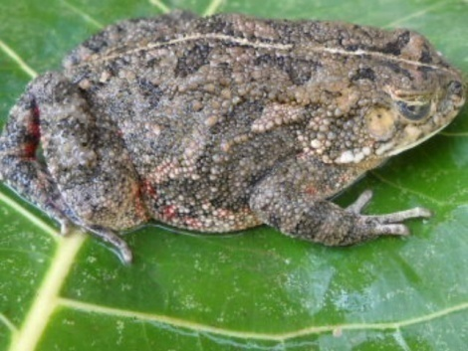
Schlerophrys kisoloensis  (Kisolo Toad) | 36 N 693093  UTM 134562 | 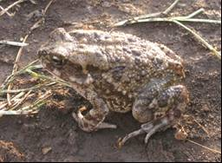
Ptychadena nilotica  (Nile Grassland Frog) | 36 N 699158  UTM 134902 | 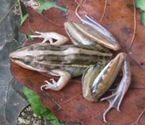
Ametia cf. nutti  (Nutt’s River Frog) | 36 N 692840  UTM 134446 | 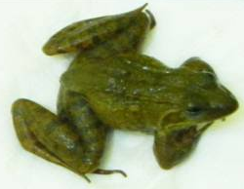
Phrynobatrachus cf. natalensis  (Natal Dwarf Puddle Frog) | 36 N 692707  UTM 134743 | 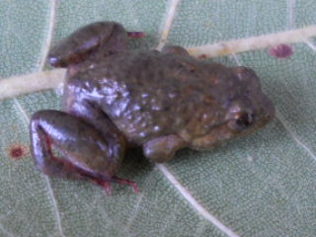
Agama lionotus  (Kenyan Rock Agama) | 36 N 695318  UTM 137264 | 