
Species Action Plan for Aromobates leopardalis

Author(s) Enrique La Marca

Date of completion 7 May 2021

Coordinator and contact details

Enrique La Marca
REVA (Rescue of Endangered Venezuelan Amphibians) Conservation Center
enrique.lamarca@gmail.com

Acknowledgements

Special thanks to the Rescue of Endangered Venezuelan Amphibians Conservation Center (REVA, a program of the Fundación BIOGEOS), The Mohamed bin Zayed Fund provided mayor funding for an in situ conservation program with the species. Additional funding to the project, mainly addressed to conservation education and community work provided by Chessington Conservation Fund.

BACKGROUND

Species

English common names: Mucubaji skunk frog, Leopard skunk frog
Spanish common name: Rana mapurite de Mucubají
Scientific name: Aromobates leopardalis

Photo
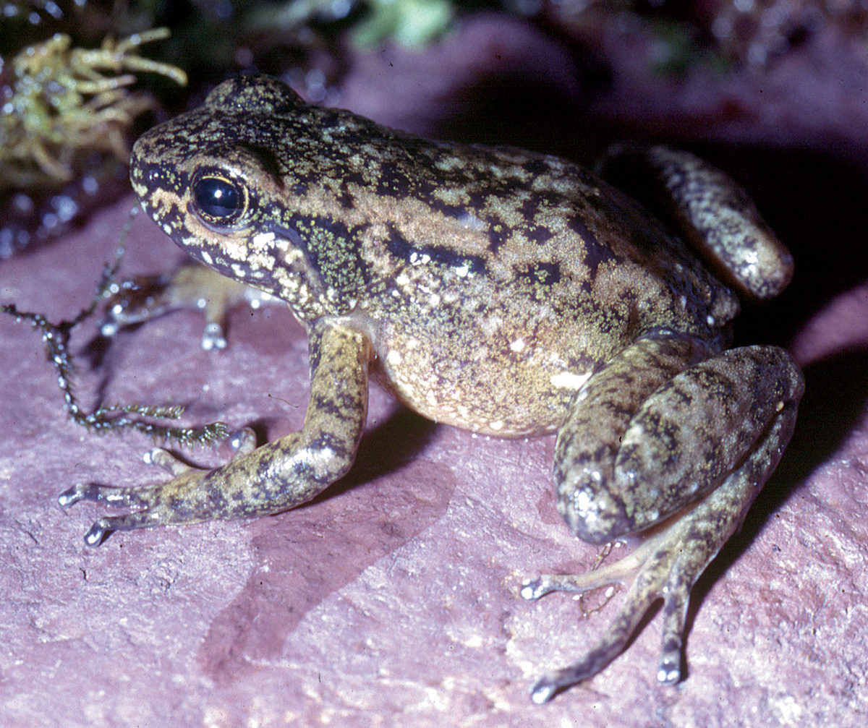
Aromobates leopardalis. Photograph by Enrique La Marca

Conservation status

The species is currently listed as Critically Endangered (Possibly Extinct) D (IUCN 2020). The rationale for the assesstment is that this frog has not recuperated from a documented drastic population decline during the end of the last century. The species has not appeared in spite of repeated searches during several years in this century. Given these exhaustive survey efforts and lack of records, it is inferred that it is either possibly extinct or if there is still an extant population, that it is very small (<50 mature individuals).The conservation status as a Critically Endangered frog has not changed since the IUCN evaluations of 2004 and 2010 (La Marca and Garcia Perez 2010).

Distribution, population size and trends

The historically associated localities for the species occur at the Mucubají region, between the Páramo de Mucubají and the locality of El Baho, in the Sierra de Santo Domingo, estado Mérida, at altitudes purportedly between 2435 and 3300 m.asl. Search for the frog at the type locality and vicinities failed to reveal any specimens (La Marca 2005, Gross 2009).
There are no extant populations known to occur in the historical range of the species, with a population trend indicating declines in the last 3 decades. All of them where within the Sierra Nevada National Park, one of the largest protected areas in the Venezuelan Andean region.
The species was previously common at the type locality during the 1970s and 80s, but was last seen in 1995 (IUCN 2020). Many searches in the area by different teams of herpetologists and students failed to reveal further specimens (IUCN 2020). Gross (2009) did not find any specimens during monthly field trips carried out at the type locality from April 2005 to July 2006.

Habitat and ecology

The Mucubají skunk frog inhabits high altitude paramo and sub-paramo environments, ecosystems dominated by grasses, shrubs and rosette plants known as frailejones (Espeletia spp.). Specimens hide below rocks or stay below plants by the stream banks and escape into the water when disturbed. Adults possess a smelly exudate of unknown function, which reminds of the odor condition also exhibited by Aromobates nocturnus. Extreme daily fluctuation in temperatures in their places where the species is present makes us think that the animals stay out of the water during the freezing hours of the day, usually at night and very early and late hours. This is the only Aromobates found in paramo and sub-paramo habitats. It is probably that the species only occurs there marginally, being its more common habitat the upper cloud forest. Recent searches for the frog in this kind of high altitude environments failed to reveal its presence there.

Primary threats

Traditionally, the drastic population decline in this frog led to think that it might be attributable to the chytrid fungus Bd. However, thirty specimens sampled for histological purposes showed no signs of the fungal infection (unpubl. data). Chytrid fungus affected several other species, including Atelopus mucubajiensis, which lives in the same habitats as Aromobates leopardalis, supporting the content that the later species is also affected (Lampo et al. 2006). Previous work on climate change (Santiago-Paredes and La Marca, Herpetotropicos 2007) suggests that warm temperatures and pronounced dry seasons might have affected the species.
Rainbow trout (Oncorhynchus mykiss), known to be a voracious predator, could have a great influence on the survival of tadpoles and metamorphs, and perhaps some adults. Another potential problem is the soil and water contamination by extensive cattle ranching (an activity not controlled by environmental authorities) or by the use of a large quantity of chemical products for the agricultural production. Introduced conifers (Pinus spp.) planted in the Mucubají region, through their decaying material, contributes to soil and water acidification, which may affect pH of water where the frog reproduces. Some deforestation and sporadic burning episodes add to the loss of suitable habitats for the species.

Conservation measures required.

There is a need to reinforce measures to protect the remaining habitat for the species, because even when it is present in a protected area, some deforestation and fires still occur. We recommend to continue the education program already started and to initiate an in situ captive breeding program if specimens reappear.

Current protection

The habitat of the species has current protection under the legal figure of a protected area: the Sierra Nevada National Park. It also has the highest level of concern within the IUCN Red List, as being classified as Critically Endangered.

Current and previous conservation actions

There are no current actions underway to conserve this species in ex situ programs. In situ education conservation work and monitoring in field is currently under way by Enrique La Marca through the REVA (Rescue of Endangered Venezuelan Amphibians) Conservation Center, with the support of the Mohamed bin Zayed Conservation Fund and the Chessington Conservation Fund.

Knowledge gaps

Field work is necessary to determine whether the species still exists in the wild. Research is still required to establish the reasons why the species experienced such drastic decline in the apparently suitable habitats.

PRIORITY ACTIONS

Ex situ
Include this section if there is an ex situ component to the recovery plan.

Captive management
No specimens have been found to initiate an ex situ conservation program for the species. Nonetheless, if found, a parental stock should be initiated as soon as possible. The organization to be held responsible for the ex situ program is REVA (Rescue of Endangered Venezuelan Amphibians) Conservation Center.

Capacity building for ex situ management
There are enough skilled people in the country to manage a captive amphibian conservation program with the species, with the REVA (Rescue of Endangered Venezuelan Amphibians) Conservation Center taking care of it.

Develop husbandry guidelines
Husbandry guidelines or protocols do not exist for this species, but there are captive husbandry protocols for closely related species (in the genus Aromobates) developed at the REVA Conservation Center.

Education and awareness

Public education and raising awareness
There is a plan underway by the REVA Conservation Center to help provide education to local communities and the general population. Such plan includes social media and videos dealing with the species and conservation education material.

Community and stakeholder engagement
The regional ecotourism organization Selva y Niebla, based in the town of Mucuchíes, has been involved with the development of the plan. REVA established an alliance with this organization to keep them involved in the conservation education campaign and the monitoring of the species to find individuals.

REFERENCES

Gross, J. (2009). Decline in populations of six species of anuran amphibians from the Mucubají páramo, Mérida State, Venezuela. Herpetotropicos 5:9-20.
IUCN SSC Amphibian Specialist Group. 2020. Aromobates leopardalis. The IUCN Red List of Threatened Species 2020: e.T55104A89759273. https://dx.doi.org/10.2305/IUCN.UK.2020-3.RLTS.T55104A89759273.en.
La Marca, E. & García-Pérez, JE. 2010. Aromobates leopardalis. The IUCN Red List of Threatened Species 2010: e.T55104A11250110.https://dx.doi.org/10.2305/IUCN.UK.2010-2.RLTS.T55104A11250110.en .Downloaded on 28 July 2020 (https://dx.doi.org/10.2305/IUCN.UK.2010-2.RLTS.T55104A11250110.en)
La Marca, E. (2005). Population status of frogs of the Dendrobatidae family (Amphibia: Anura) in their type localities in the Andes of Venezuela. Herpetotropicos , 2 (2).
Lampo, M., Rodriguez-Contreras, A., La Marca, E., & Daszak, P. (2006). A chytridiomycosis epidemic and a severe dry season precedes the disappearance of Atelopus species from the Venezuelan Andes. The Herpetological Journal, 16 (4), 395-402.

