BIOGEOGRAPHY AND CONSERVATION OF AROMOBATES LEOPARDALIS
By: Enrique La Marca
Rescue of Endangered Venezuelan Amphibians (REVA) Conservation Center, Mérida, Venezuela.

INTRODUCTION
The leopard skunk frog or Mucubají mapurite frog (Aromobates leopardalis, Fig. 1) easily stands out from other congeners by being the only one that lives in paramo habitat (well above the cloud forest where most of the other species inhabit) and by its unique coloration. It is also noticeable by being the second largest species and for being lost for a much longer time than its congeners.
The leopard skunk frog or Mucubají mapurite frog (Aromobates leopardalis, Fig. 1) was in the decade of the 70s and 80s of the last century, according to the records in zoological collections, one of the most common species in the streams that run in the high mountains of the Sierra de Santo Domingo, in the Andean state of Mérida. In recent decades, there has been a notable decrease in its populations. The latter is coincident with a worldwide phenomenon of amphibian declines evidenced in many taxa.
Aromobates leopardalis is a "Critically Endangered" species, according to the IUCN (2020). Very little is known about the species; therefore, the data provided in this project is directed to enlarge our scarce knowledge on this unique animal.

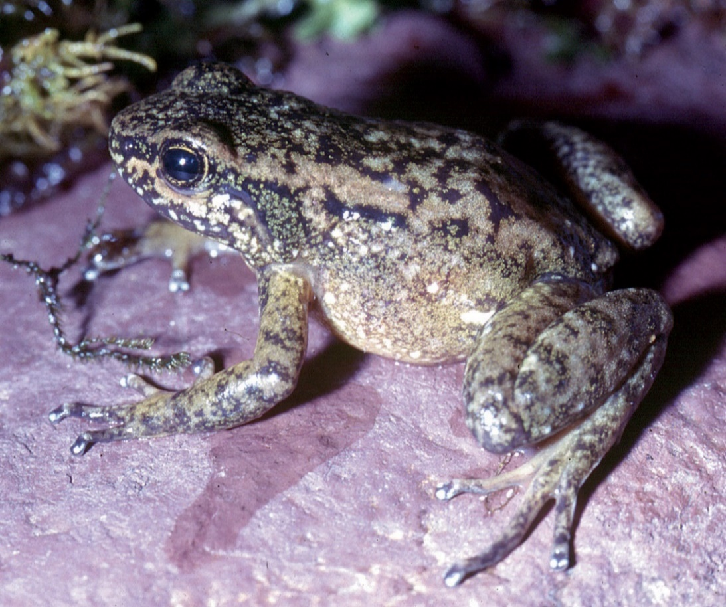
Fig. 1. Adult female of Aromobates leopardalis form La Corcovada region, Paramo Mucubají, estado Mérida, Venezuela. Photography: Enrique La Marca.
We aimed our initial efforts in searching the frogs in previously known localities. For this, we first revised the literature on the species and gathered data from museum specimens.
Traveling to the field sites was difficult at the beginning due to the pandemic COVID-19 local restrictions. But we finally managed to get this over by fixing our field activities to weeks that we were allowed to travel (usually one intercalated week, on schedule), or making alliances with local conservation organizations to cover some field activities. Developing a conservation education program was nearly impossible due to the closing of the educational centers in the pandemic, reason why we shifted our goals to give direct one-to-one talks to local people and interact with individual representatives of local NGOs. We succeeded in making a working alliance with the NGO "Selva y Niebla", located in the town of Mucuchíes, close to the type locality of Aromobates leopardalis. We trained their personnel to search for frogs, and gave scientific instructions aimed to give information on the endangered frog plus the environment it inhabits. Additionally, we provided information on the global and the regional amphibian declines, as well as discussing some local environmental issues.
GEOGRAPHIC DISTRIBUTION
The Leopard skunk frog (A. leopardalis) is an endemic amphibian to the Venezuelan Cordillera de Merida mountain range, in the northern Andes. Its common name derives from its color pattern and its strong odor when manipulated. It was known to occur only in the Sierra Nevada mountain range, in the Andes at western Venezuela.
Our past knowledge on the species come from few specimens collected last century. All samples come from a few localities near the Mucubají Lagoon, in Merida State, western Venezuela. Those came mainly from the road from Laguna Mucubají to the town of Santo Domingo. These localities are located in an area of roughly 4 Km². With the in situ program for this project, we became aware of other localities in the adjacent Serranía de Timotes, which augment the known frog´s distribution area to nearly 120 Km². This is by far the largest area occupied by any Aromobates species (Fig. 2).
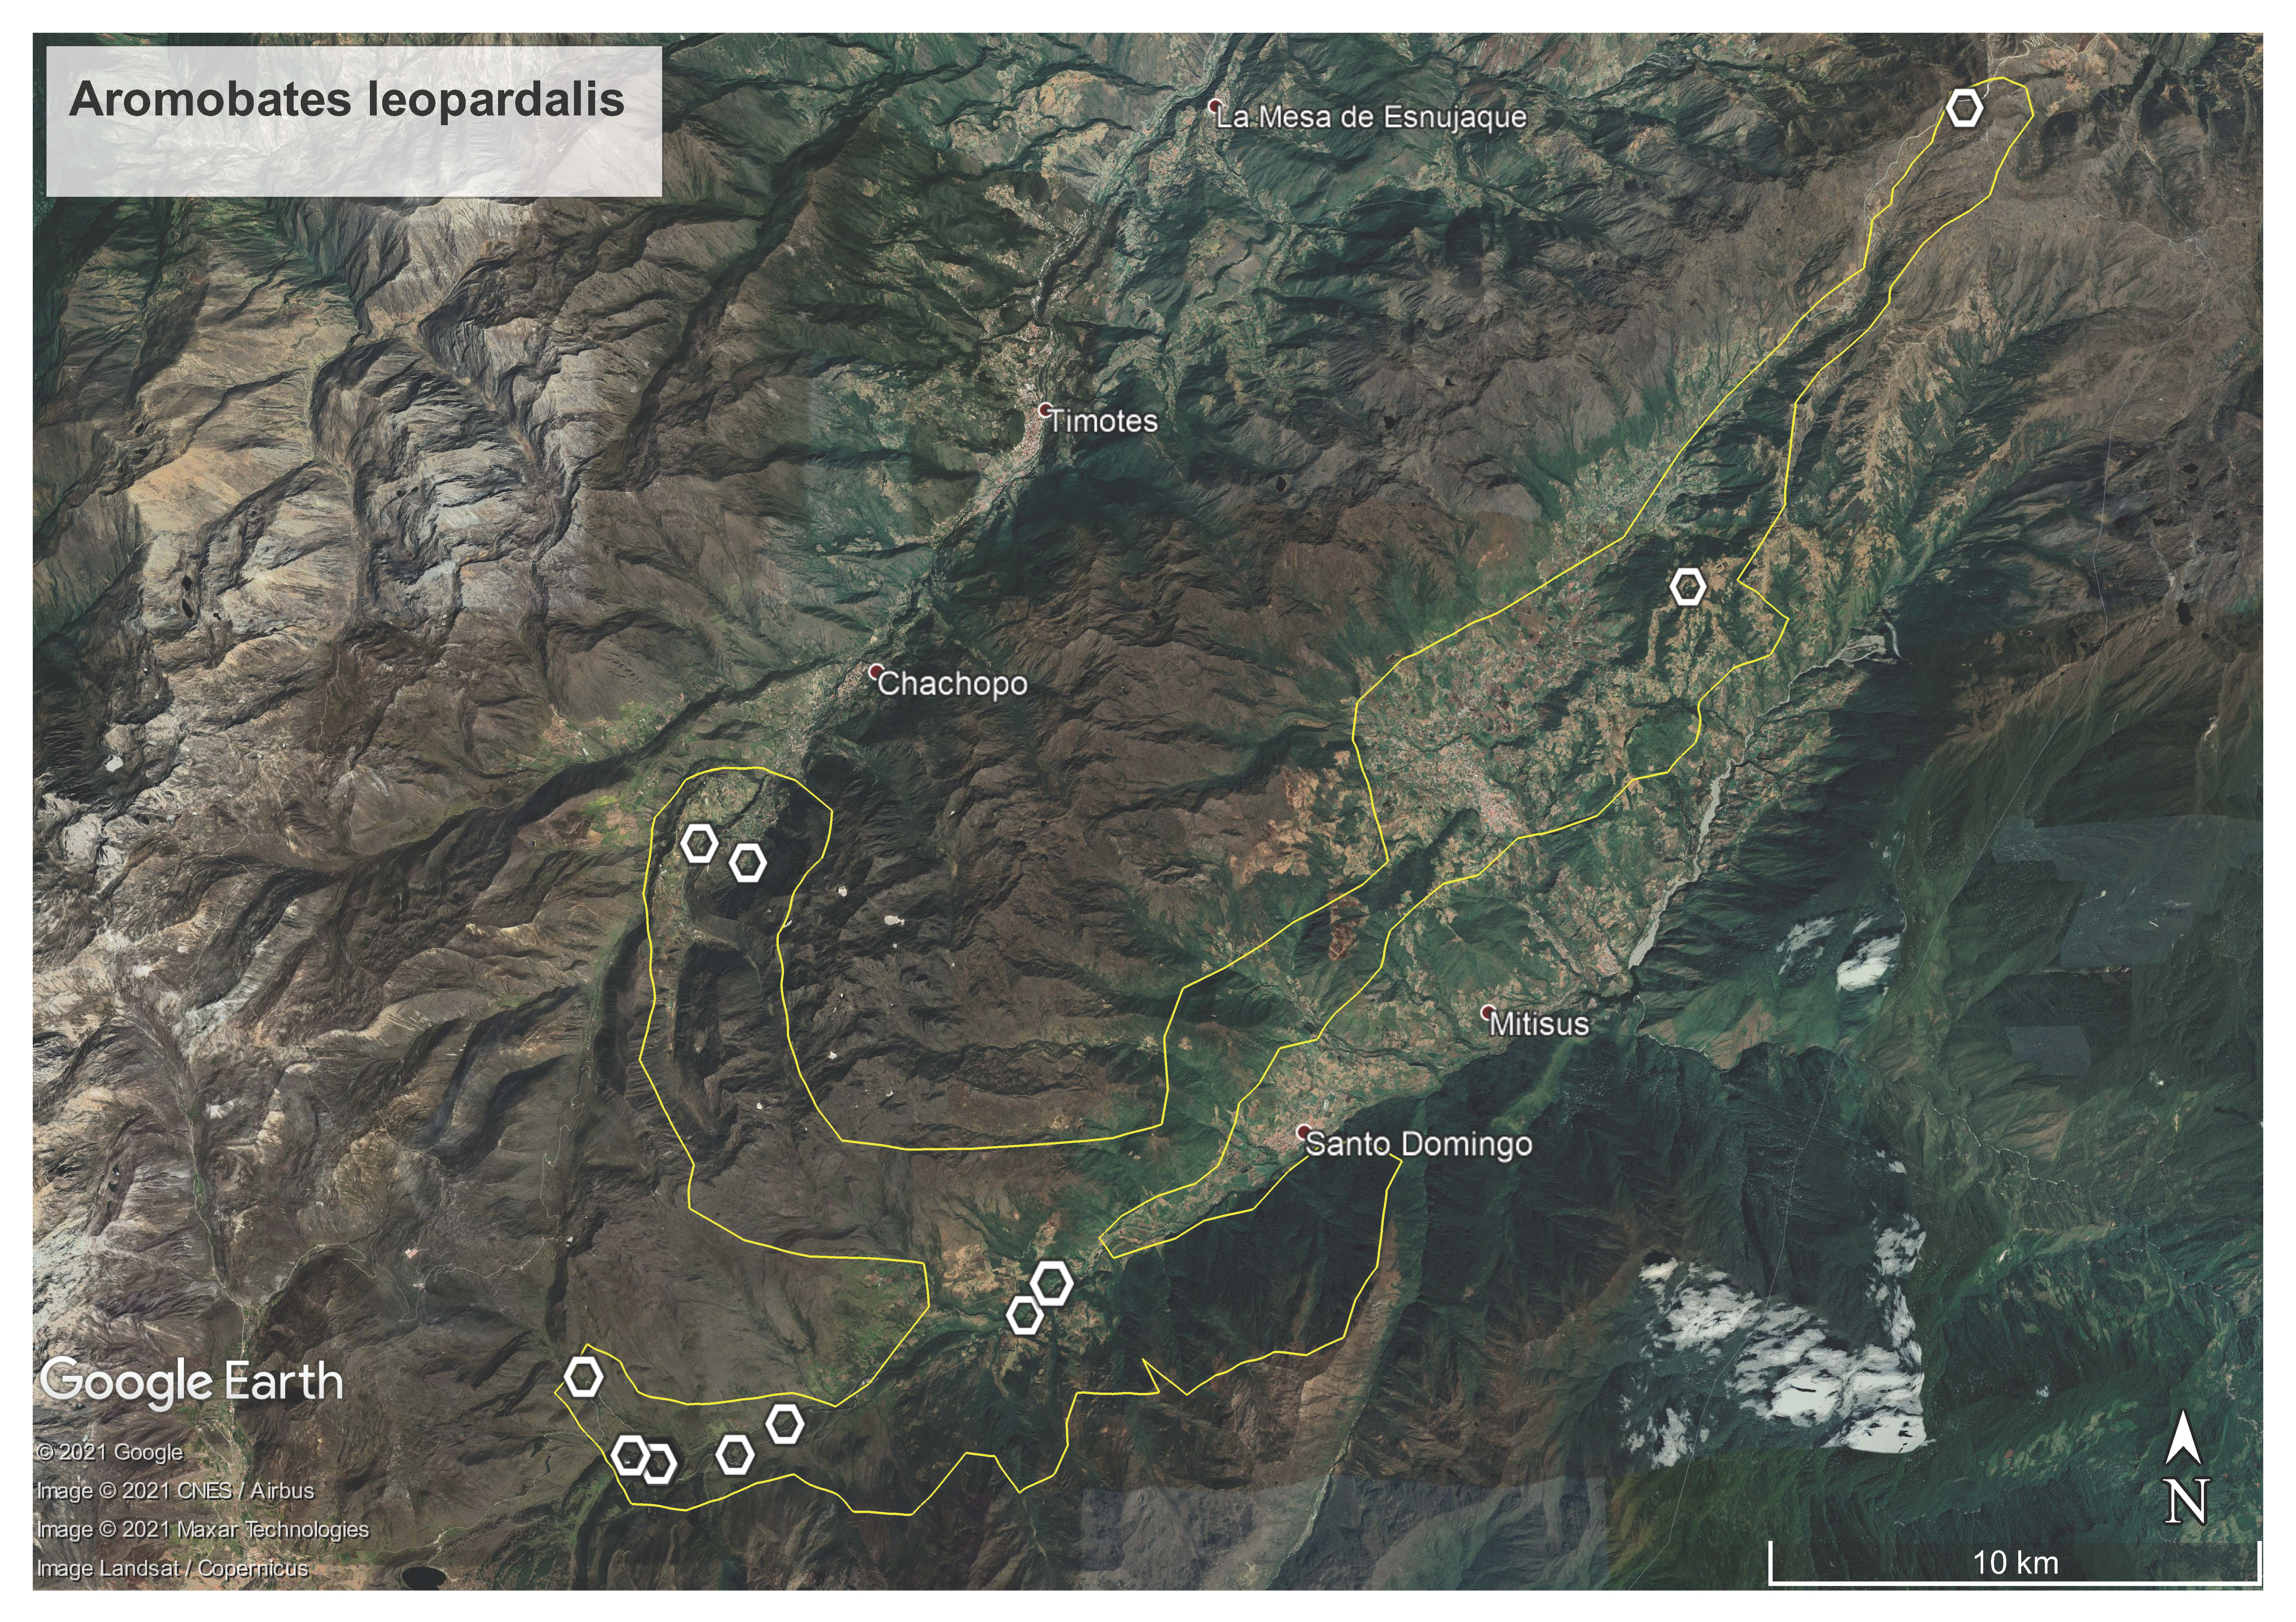
Fig. 2. Distribution Map for Aromobates leopardalis in the Venezuelan central Andes. White polygons are presence records, while polygon with yellow perimeter is the total area for the species.

According to the literature, the species altitudinal range is from 2435 m to 3300 m. asl. With data gathered for this project, we set this range to be from 2250 m to 3350 m. asl., with these extremes being the lowest and highest records ever recorded, respectively. There is an unpublished museum record indicating an elevation of 3500 m, but since the place where they come from (Laguna Victoria) is hardly over 3200 m, it is highly likely that this is a non-precise measurement, reason why we do not take it into account and recommend its removal.

Geographic distribution data for Aromobates leopardalis from museum specimens:
Adults:

CVULA IV 3085-3087 Laguna La Victoria, Páramo de Mucubají, 3500 m.asl (probably in error).
CVULA IV 768, 774, 776/779, 1861-1862, 1987, 5855 Páramo de Mucubají, La Corcovada, 3300 to 3350 m. asl
CVULA IV 1370;1374 Entre Santo Domingo y Páramo de Mucubají, 2720 m. asl
CVULA IV 2286-2292, 2297, 2299 Km 18 entre Apartaderos y Barinas, 2560 m. asl
ULABG 381 La Corcovada, Páramo de Mucubají, 9.700 pies
ULABG 389. Páramo de Mucubají
ULABG 747 Región de La Corcovada, a pocos km de Laguna Mucubají
ULABG 964 Entre La Venta y Valera
ULABG 1052 Tuñame cerca del Paramo del Pajarito, Edo. Trujillo
ULABG 1083-1087 Paramo de Mucubaji, La Corcovada
ULABG 1539-1543 A 17 Km del Pico del Aguila, entre la Venta... 3100 m
ULABG 1977-1980 La Corcovada, cerca del Páramo de Mucubají y la Laguna Victoria, 3000 m
ULABG 2630-2637 Páramo La Corcovada, cerca de La Laguna de Mucubají, 3050 m
ULABG 2665 Páramo La Estrella arriba de la Culata, 2850 m
ULABG 3119-3120 La Corcovada
ULABG 3352 Páramo de Mucubají, Quebrada La Corcovada, 3000 m
ULABG 3377-3378 Quebrada La Corcovada aprox. 8 Km Laguna de Mucubají, 3000 m

Tadpoles:

CVULA IV 4661 Hacienda El Baho, 14 Km al NE de Laguna Mucubají (Páramo de Mucubají), 2250 m.
CVULA IV 4662 La Corcovada, Páramo de Mucubají, 2956 m
MCNG 1897 Hacienda El Baho, 14 Km al NE de Laguna Mucubají (Páramo de Mucubají), 2250 m.

Taxonomic note: During the course of this investigation, we also examined museum specimens resembling Aromobates leopardalis and coming from a different mountain range in Trujillo State. They revealed to be an undescribed Aromobates species that is under study by us at this moment. We are not releasing sensitive locality data at this moment.
Last known record: The species is absent from the region (no visual encounters or captured animals) for almost three decades (since December 1992), despite intense searches carried out by different researchers on various occasions (IUCN 2020). This resembles the case exhibited by other sympatric species, such as those belonging to the genera Atelopus and Pristimantis.
ECOLOGY
The activity schedule of this species, its role in food chains and the resources it consumes, as well as its reproductive aspects, among many others ecological aspects, remain not-well known. In general, we can state that this is a diurnal and semiaquatic species. This frog species is associated with paramo and cloud forest streams, with adult and juveniles usually found mostly among rocks in the watercourse. They take refuge in grasslands and among the typical high Andean paramo vegetation, such as the frailejones (Espeletia spp.) that are found alongside bodies of running water. In addition, it is possible to record them within streams and under rocks on their banks (IUCN 2020, pers. obs.). The tadpoles are free-living in fast fluent cascading streams, where they attach to the rocks with their mouthparts and can even swim against the current making use of its strong caudal musculature (Mijares-Urrutia, 1991; pers. obs.).
Like other representatives of the genus Aromobates, A. leopardalis apparently exhibits parental care. The female would lay a small number of relatively large eggs probably attended by a male, which will carry the hatched tadpole on its back to a close waterway to ensure their survival after release.
These frogs, as well as most others belonging to the Aromobatidae family, do not possess aposematic coloration. Aromobates leopardalis has a rather cryptic coloration with its environment, with a marbled dorsal pattern (Fig. 1) putatively helping the frog to pass unnoticed to potential predators.
The paramo habitat, from which most of the specimens come from, is a harsh environment, with temperatures dropping below zero at night and high (up to 30 degrees Celsius) temperature during midday. The humidity is relatively high, as well at the solar radiation. The precipitation is mostly associated with the Venezuelan lowland’s climatic pattern, with a single rainy season at the middle of the year, starting in May and ending in October, with a peak of precipitation during June-July (Santiago and La Marca, 2007).
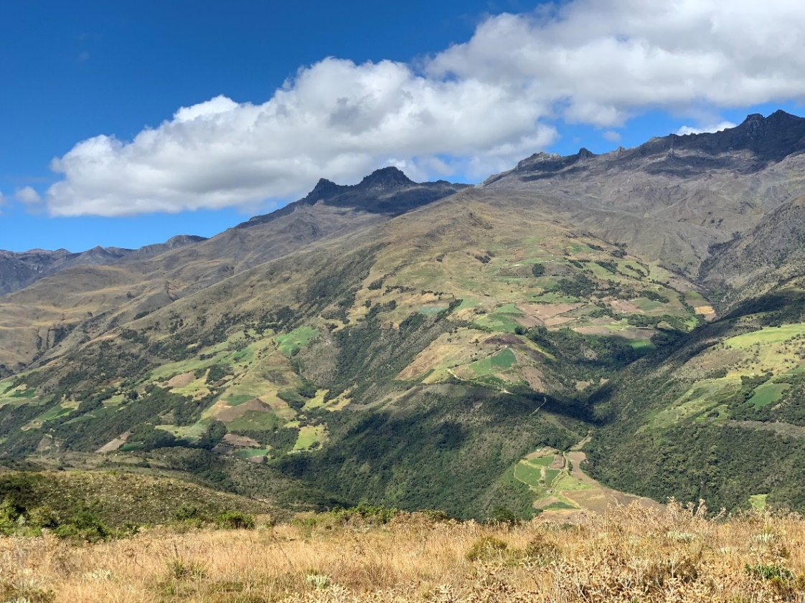
Fig. 3. Mosaic of vegetation (cloud forests, páramos, cultivated lands) at the Mucubají region, where most of the known specimens of Aromobates leopardalis come from.
CONSERVATION
The Mucubají skunk frog is a Critically Endangered species suspected to be extinct (IUCN 2020), reason why it is necessary to understand the threats this amphibian is facing as well as to implement actions to counteract them.
Legal protection
Most of the documented populations of the Mucubají skunk frog lie within the Sierra Nevada National Park< however, a large proportion of its area of distribution (Fig. 2) lies outside of protected areas.
Threats
Climate change: Previous work on climate change (Santiago-Paredes and La Marca, 2007) suggests that warm temperatures and pronounced dry seasons might have affected the species, especially by the end of the last century. The species is absent from recent searches (La Marca, 2005; Stuart et al., 2008; Gross, 2009; Barrio-Amoros and Santos, 2012; La Marca and García-Pérez, 2010). Documented regional changes in the precipitation regime, some of them associated with planetary phenomena such as the El Niño Southern Oscillation (ENSO), seems to account for declines I the species, as has been stated for the harlequin frog of Mucubají, Atelopus mucubajiensis, by Santiago-Paredes and La Marca (2007).
Agrochemicals: chemical products used for agriculture have not been associated with the species declines, but there is a high possibility that it may have been so. All sorts of pesticides are causing much harm to soil invertebrates such as beetles, springtails and earthworms (Gunstone et al. 2021). In return, the impoverished invertebrate fauna would mean less available prey items for the frogs.
Introduced species: The introduction of exotic species such as rainbow trout (Oncorhynchus mykiss), known to be a voracious predator, could have a great influence on the survival of tadpoles and metamorphs, and perhaps some adults of the leopard skunk frog. The plantation of coniferous plants (Pinus spp.) in the Mucubají region may pose an ecological problem, since this type of forest has been shown of having higher evapotranspiration rates compared to cloud forests; additionally, coniferous plantations have lower pH values in the soil, which affects plants and soil fauna and thus, indirectly, the frog food-chain. Concomitant water acidification may affect pH values of the water where the frog reproduces (La Marca and Reinthaler, 1991).
Bd: The incidence of the disease caused by the chytrid fungus (Batrachochytrium dendrobatidis) may account for as one of the factors causing the frog population declines; however, histological analyzes carried out on collection animals did not show positive for the fungus in A. leopardalis. A study carried out by Argelia Rodríguez in the Laboratory of Biogeography of the University of Los Andes, under my direction, did not find evidence of chytridiomycosis in histological samplings of thirty specimens of Aromobates leopardalis coming from five localities in the Mucubají region. Nonetheless, its presence in Atelopus mucubajiensis, a frog inhabiting in sympatry with the leopard skunk frog, suggest that the latter may have suffered too from this disease documented to cause dramatic frog declines worldwide.
Fires: We have documented a few burning episodes in the Mucubají region. As seen, their occurrence have greatly diminished the quality of habitat used by the amphibians.
Deforestation: Some of the populations of the species reside within a protected area that is under the figure of National Park. In most part of this range, there is little to virtually non-intervention. However, outside the protected areas there is still some deforestation; this adds to the loss of suitable habitats for the species. Due to repeated and prolonged electricity shortages in the country, people is nowadays cutting trees to have wood. The harvesting of falling and decaying trees affects the invertebrate communities that depends on them for its ecological requirements. Since they are also in the frogs food web, their lacking in the environment will also means a direct impact on the amphibians’ populations that rely partially on them.
Pollution: The contamination of the moors by extensive cattle ranching, uncontrolled by environmental authorities, or the use of a large quantity of chemical products to maintain large areas of cultivation, is directly affecting the frog populations.

Education Conservation
For a proper placement of attention in the focus frog for this project, we started to implement a community approach to contribute to preserve the species. We have started to talk to the local people to implement plans with the local communities to preserve the species and the habitat where it occurs. One of the first actions was to produce audiovisual material to teach the people about the species; in this sense, we produced a short video and printed material showing regional frog species and providing information on their threats (Fig. 4).

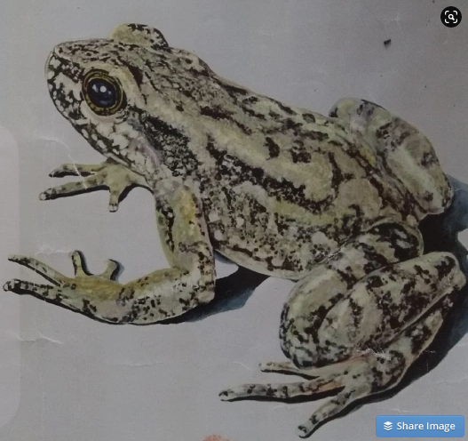
Fig. 4. Artistic rendering of the Leopard Skunk Frog, by artist Angel Ulloa, to help to spread knowledge for conservation education purposes.

Acknowledgements
This assessment has been possible through a research grant from the Mohamed bin Zayed Conservation Fund, which is a significant philanthropic endowment established to provide targeted grants to individual species conservation initiatives, recognize leaders in the field of species conservation, and elevate the importance of species in the broader conservation debate.

Cited Literature
Barrio Amoros, C.L. and J.C. Santos. 2012. A phylogeny for Aromobates (Anura: Dendrobatidae) with description of three new species from the Andes of Venezuela, taxonomic comments on Aromobates saltuensis, A. inflexus, and notes on the conservation status of the genus. Zootaxa 3422:1-31.
Gross, J. (2009). Decline in populations of six species of anuran amphibians from the Mucubají páramo, Mérida State, Venezuela. Herpetotropics , 5 , 9-20.
Gunstone, T., T. Cornelisse, K. Kleine, A. Dubey and N. Donley. 2021. Pesticides and soil invertebrates: a hazard assessment. Frontiers in Environmental Science, 04 may 2021. https://doi.org/10.3389/fenvs.2021.643847.
IUCN SSC Amphibian Specialist Group. 2020. Aromobates leopardalis. The IUCN Red List of Threatened Species 2020: e.T55104A89759273. https://dx.doi.org/10.2305/IUCN.UK.2020-3.RLTS.T55104A89759273.en
La Marca, E. 2005. Population status of frogs of the Dendrobatidae family (Amphibia: Anura) in their type localities in the Andes of Venezuela. Herpetotropicos , 2 (2).
La Marca, E. And J.E. García-Pérez. 2010. Aromobates leopardalis. The IUCN Red List of Threatened Species 2010: e.T55104A11250110.https://dx.doi.org/10.2305/IUCN.UK.2010-2.RLTS.T55104A11250110.en
La Marca, E. & H.P. Reinthaler. 1991. Population changes in Atelopus species of the Cordillera de Mérida, Venezuela. Herpetological Review 22(4):125-128.
Lampo, M., Rodriguez-Contreras, A., La Marca, E., & Daszak, P. 2006. A chytridiomycosis epidemic and a severe dry season precedes the disappearance of Atelopus species from the Venezuelan Andes. The Herpetological Journal, 16 (4), 395-402.
Mijares-Urrutia, A. 1991. Descripción del renacuajo de Colostethus leopardalis Rivero con algunos comentarios sobre su historia natural. Amphibia-Reptilia 12: 145-152.
Santiago-Paredes, S., E. La Marca. 2007 (“2006”). Comportamiento del clima a finales del siglo XX en los altos Andes venezolanos y el declive de Atelopus mucubajiensis. Herpetotropicos 3(1):7-20.
Stuart, S. N., M. Hoffmann, J. Chanson, N. Cox, R. Berridge, P. Ramani, and B. Young (eds.). 2008. Threatened Amphibians of the World. Barcelona, Spain; Lynx Editions.

