Preliminary report : Project N°212528367

Distribution, threats, extinction-risk assessment and conservation of the giant green endemic millipede Spirostreptus crenulatus Porat, 1894, in the Dja-Biosphere-Reserve, Cameroon

By : NZOKO FIEMAPONG Armand Richard, PhD
(Principal investigator : armandnzoko@gmail.com)

July 2022

Summary of the proposal
The ongoing biodiversity crisis, characterized by high extinction rates, requires well-planned conservation efforts. This is specially true for soil invertebrates such as the giant African millipedes, which are generally given very little consideration in conservation projects. Yet, assessing the conservation status of these species has been recognized as a key tool for determining the threshold of threat and thus guiding conservation objectives. Given the level of land use and rate of forest destruction in Cameroon, it is important to assess the extinction risk and conservation status of rare, site-specific, and threatened taxa such as Spirostreptus crenulatus and to identify habitats that require conservation action in order to propose mitigation measures. This ongoing project aims to (1) assess the occurrence, distribution, habitat preference and conservation status of Spirostreptus crenulatus using the IUCN criteria, (2) assess the perception of the target species by local population, (3) raise awareness among the local population through a sensitization and education campaign on the place and importance of the target species in forest ecosystem functioning,(4) assess the human pressures and threats that face the the target millipede species and (5) design plans to protect the target species and its habitats in the Dja Biosphere Reserve.
Background and project activities.
Millipedes are one of the most important components of tropical forest ecosystem functioning in. Despite increasing awareness of their importance to global conservation planning, little attention has been given to inventorying and monitoring of this group. Millipedes are a very important, mega-diverse group of terrestrial arthropods, especially in tropical forest biomes. They are sensitive to habitat changes resulting from forest disturbance, changes in light regimes, microclimates, dead wood availability and soil compaction, making them important indicators of habitat disturbance. Studying their diversity, abundance, and distribution can provide useful and rich baseline information that can assist in biodiversity conservation decisions and management planning for protected areas such as the Dja Biosphere Reserve, an important key biodiversity hotspot in Cameroon with the largest remaining tract of primary lowland rainforest and with a high conservation priority due to its species richness with many endemic and threatened species.
This 12-month project aims to determine the distribution, threats, extinction risk assessment of the endemic green giant millipede Spirostreptus crenulatus Porat, 1894, in the Dja-Biosphere-Reserve to create a conservation action plan for this species and its ecosystem. Project activities includa household survey to assess the local population’s perception and knowledge of the African green Giant millipede, an awareness campaign using a combination entertainment and environmental education on the ecological and cultural importance of the target millipede species, assessment of the range and occurrence of the target species in the study site, documentation of anthropogenic threats affecting the target millipede species, characterization of habitat and population parameters and planning of conservation actions. Desired outcomes include mapping the distribution of S. crenulatus, sustained improvement in local knowledge, attitudes and behavior and greater support, and involvement in the millipedes species management process.
Material and methods
Materials and methods
Study site
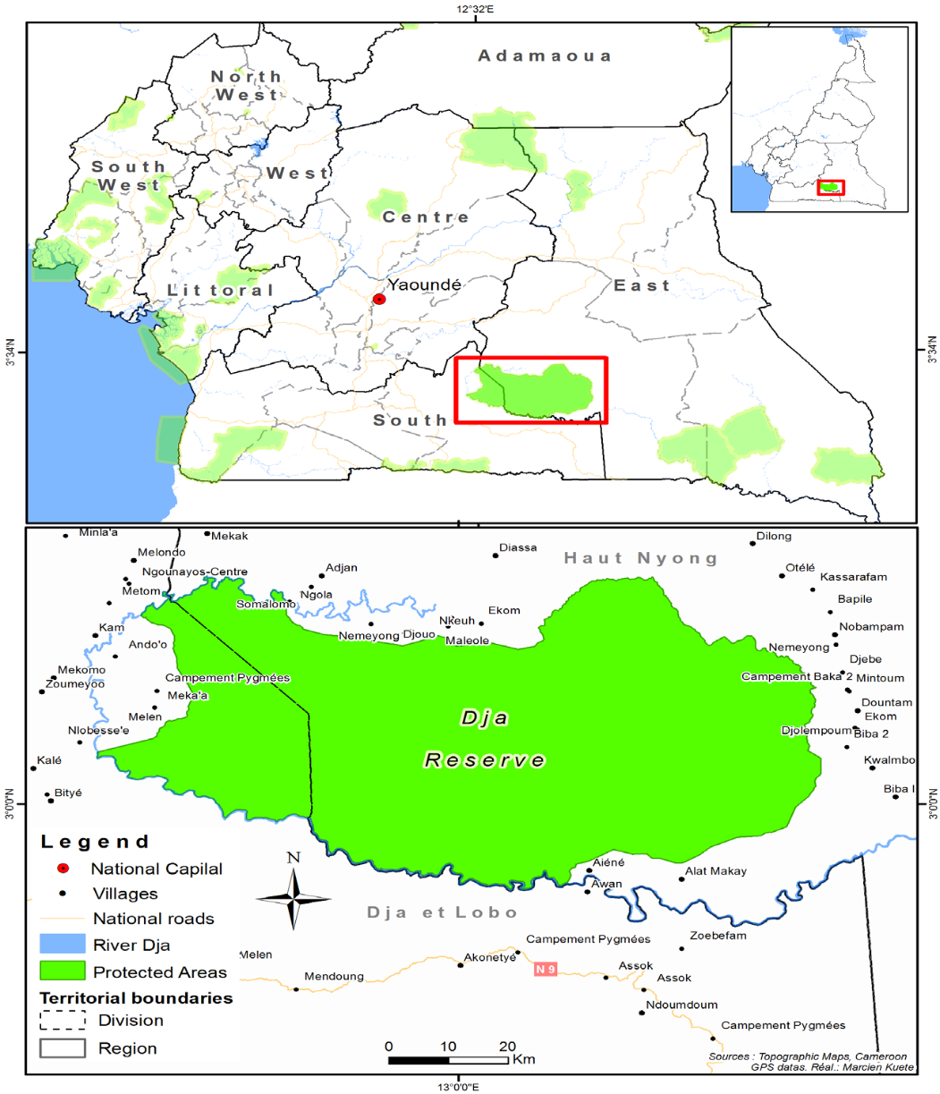
The Dja Biosphere Reserve, which constitutes the Dja Wildlife Reserve and surrounding buﬀer zones, is located in southern Cameroon (Figure 1). This protected area covers approximately 5,260 km² and extends between latitudes 2 ° 49’-3 ° 23’N and longitudes 12 ° 25-13 ° 35’E. The protected area was established in 1950 and was reclassiﬁed as a Biosphere Reserve in 1981 and further upgraded to a World Heritage Site in 1987 (Muchaal & Ngandjui 1999). It covers six subdivisions : Lomié (east cluster), Somalomo (north cluster), Bengbis and Meyomessala (west cluster), Djoum and Mintom (south cluster). The Dja River forms a natural border of the reserve, protecting it to the south, west and north. The climate is of the equatorial type, with four seasons: the rainy season from mid-September to December followed by a three-month dry season and then a small rainy season between mid-March and June followed by a short dry season from July to September. The average monthly temperature is between 23.5 ̊C and 24.5 ̊C and the annual rainfall of 1600 mm (Sonke & Couvreur, 2014). The east and part of the western cluster are red ferallitic soils while the south and part of the western cluster are yellow ferrallitic (lateritic) sesquioxide soils, good for growing crops such as cocoa and coffee. The vegetation of the Dja Reserve is Congolese type with evergreen forest belonging to the Guineo-Congolese domain and consists of large trees up to 60 m tall (Tabue et al., 2018). The Dja Faunal Reserve is home to rich and threatened taxa. While vertebrates in these areas have received considerable conservation attention, the invertebrate fauna in general, and millipede in particular, remain understudied with no data yet for provide a basis for making conservation decisions.
Figure 1 : The Dja Biosphere Reserve and its peripheral zones.

Methods
Perception and Knowledge of S. crenulatus by local population
The community interview (figure 2) in this study is follows a protocol adapted from Nash et al. (2016). Bio-ecological knowledge of the target giant African millipede species, Spirostreptus crenulatus Porat, 1894, is being recorded in villages around Dja Biosphere reserve. Participants are selected using a snowball sampling method. A questionnaire consisting of open-ended and closed questions on knowledge of the target giant African millipede species, its ecology and conservation.

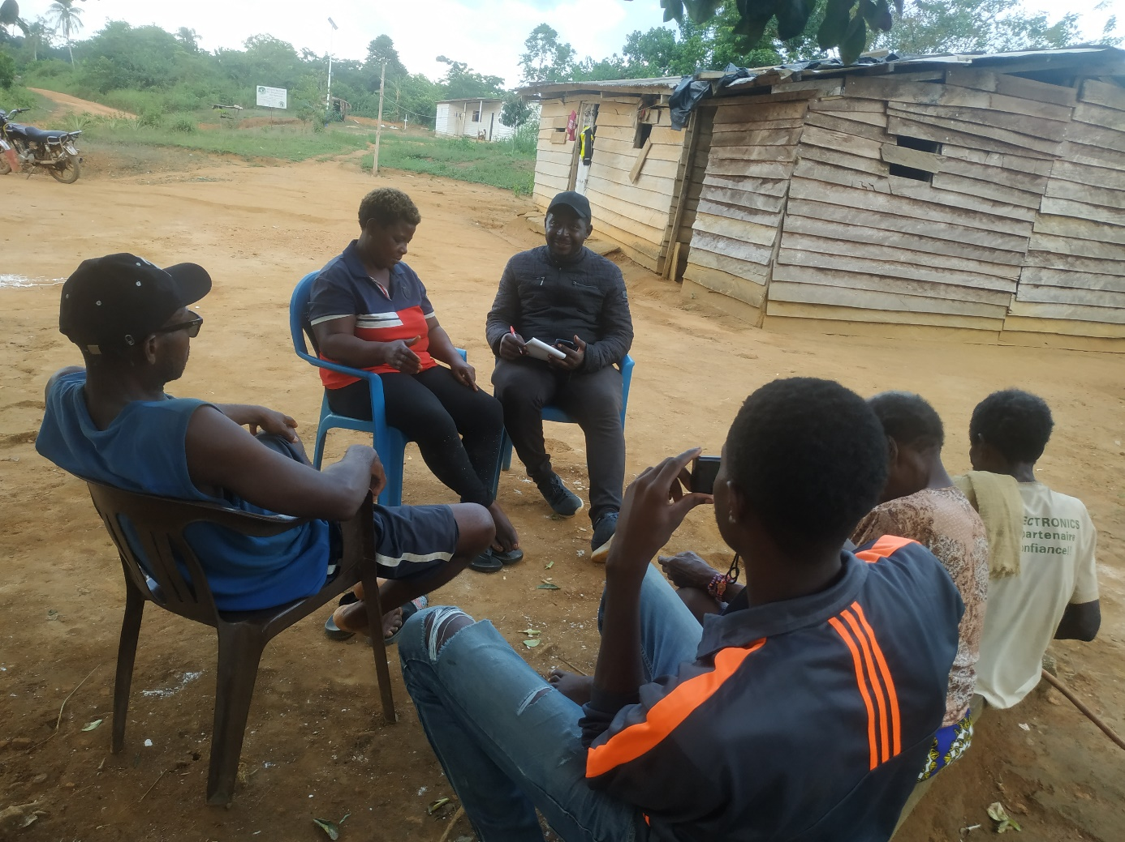

Figure 2: community-based interview of some villagers

Sampling of S. crenulatus
Assessment of the occurrence and distribution of the target species, as well as its habitat preference is conducted using a combination of two soil invertebrate survey methods (Quadrat, traps, and sixty-minute active searching). This activity is conducted to record and estimate the population size, abundance fluctuations, and population dynamics of the target species at study sites. In the different vegetation types identified in the Dja biosphere reserve and for each field trip, 40 quadrats of 9 sq. m are regularly placed on 4 transects of 200 m in length, with 10 quadrats per transect 20 m apart. Each transect is 10 m apart from the other. An active search (figure 3a) of approximately 1 hour along other transects (200m and 2m wide) is conducted in combination with the first method to increase the chances of collecting the target species but also to have the possibility to sample in the majority of micro-habitats. All shelters and habitats suitable for millipedes including under rocks, tree barks, fallen branches, leaf litter, or directly in soil monoliths/cores 25 cm x 25 cm x 30 cm deep are typically surveyed.
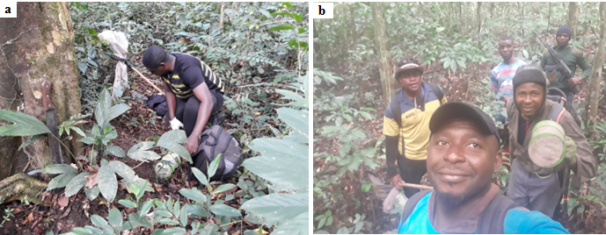
Figure 3: Field survey in the Dja Biosphere Reserve (a) active searching by principal investigator, (b) research time.

Habitat characterization and threats to the target giant African millipede species
During field activities we take the time to characterize the basal vegetation on all survey transects using to collected S. crenulatus. Assessment of human pressures and threats to forests and target millipede species are determined in each ecosystem. The following parameters are recorded: number of culls and stripes, track marks, the number of live bases and internal road network of the reserve as well as all human activities that can potentially affect our target species.
Preliminary results
Perception and Knowledge of S. crenulatus by local population
Protect activities began in February 2022 with a planning meeting in Somalomo, a small community in the Dja Biosphere Reserve. During this meeting, activities were planned and prioritized. Overall, to date, 150 people have been interviewed in the study area. The respondents are between 18 and 75 years old, the average age of the population being 39 years, suggesting its youthfulness. More than half of the respondents (59%) are women. The main activities of the people in the study area are hunting and slash-and-burn agriculture. Hunting is mainly practiced by men (90%), while agricultural activities are primarily carried out by women (100%), generally assisted by children. With regard to the knowledge and use of millipedes by the local populations of the Dja Biosphere Reserve, it appears that almost all of the people interviewed know about this taxon and identify them by their shape, coloration and especially by their large number of legs. More than half (55%) of the respondents recognized the usefulness of millipedes in fertilizing the soil and in degrading forest litter. No medicinal or culinary use has been reported so far in the study area. Culturally, it appears from the analysis of the applied questionnaires that some millipede’s species are myths and that chance encounters with some of them could be a harbinger of bad or good news. The target species Spirostreptus crenulatus has been identified by 1/3 of the people interviewed to date. However, about 90% of those who identified the species recognize that it is very rare and state that they did not encounter it several years ago in the locality of study. This suggests that the species, although present, is very rare. Respondents who recognized the species report that this species of giant African millipede is a typical forest species and is most often found on tree trunks in the rainy season and in forest litter during the dry season. In terms of cultural knowledge, our respondents indicated that this species is mystical and that it generally heralds misfortune, including the death of people close to the person who encountered it. The consequence of this state of affairs is that the species is systematically killed by the populations when the it is encountered in the forest. The information collected to date from populations living near the Dja biosphere reserve provides sufficient information on the level of threat to our target species. All respondents know the target species, but none of them know the importance of conserving this species.
Distribution, occurrence and habitat preférence of Spirostreptus crenulatus in the Dja Biosphere Reserve
From February to July 2022, we conducted 6 field trips of 7 days each in the Dja Biosphere Reserve. In total, we have identified 5 vegetation types to date as shown on figure 4 (primary forests, secondary forests, fallow land, crop fields and cocoa-based agroforests).
The target giant African millipede species Spirostreptus crenulatus has so far only been observed in primary forest. Despite considerable sampling effort and a combination of collection methods, we were only able to collect two specimens (02), all female (figure 5). The two specimens found at this stage of the study were collected during the month of July and this with the active search method which seems to be very effective for rare species. The specimens of S. crenulatus collected were associated with decaying forest litter.

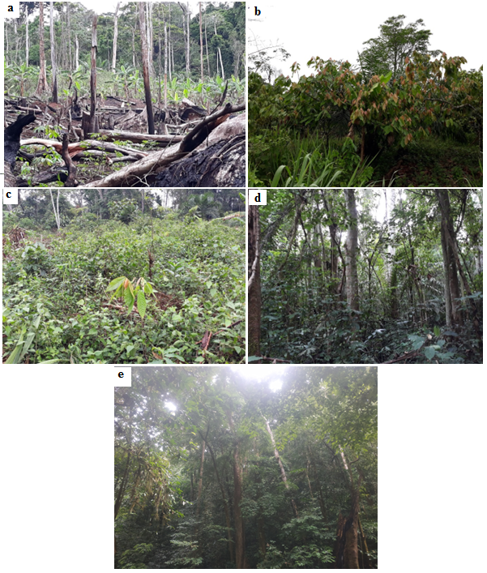
Figure 4 : Prospected vegetations in the Dja Biosphere Reserve : a-Farm land, b- Cacao-base plantation, c-fellow, d-secondary forest, e-Primary forest.
This giant African millipede appears to be a site-specific species with a very low dispersal ability and a restricted range. With the low number of specimens of our target species collected to date, it appears that despite the fact that the study area is a protected area under Cameroonian law, populations of this species in this site appear to continue to decline at an alarming rate probably due to the land use system and habitat loss.
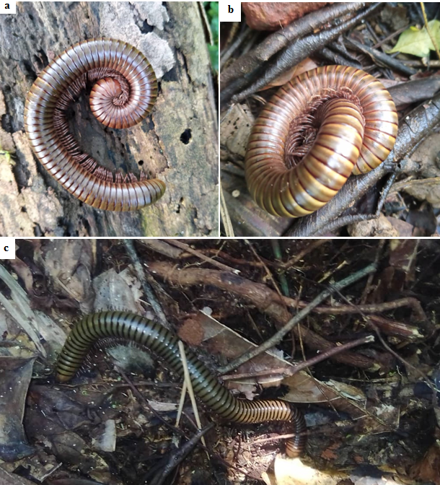
Figure 5: Spirostreptus crenulatus in natural environment a and b specimen recorded in mouth of May, c specimen recorded in July.
Anthropogenic practices and threats to target species in the project areas
During the six-month field survey, we noted several types of anthropogenic practices and threats to target species in the Dja Biosphere Reserve. Hunting, harvesting of tree products, and slash-and-burn agriculture are the major activities that lead to the degradation of the forest cover in this reserve and could have a significant negative effect on the millipede population found there. The majority of the population of the Dja Biosphere Reserve depends on hunting for food and income. When they go into the forest to hunt, they usually cut down trees to establish temporary dwellings, and the young stems are also used to prepare traps for animals, all of which has a negative effect on the regeneration of plants in the reserve and thus on soil invertebrates such as millipedes. Slash-and-burn agriculture is a common practice in this area; most of the population depends solely on this practice. They cut down all the trees and set them on fire to establish plots of cassava, groundnuts, and plantains. The use of fire results in the destruction of soil organic matter, consequently, a decrease in the productivity of the vegetation and the crops planted on the burnt plot. In addition, all invertebrate species with low dispersal capacity and a high level of endemicity, such as millipedes, are usually lost during these activities. The harvesting of tree products (20.3%) mainly tree for medicinal purposes is also a cause of canopy degradation due to the use of unsustainable harvesting techniques.
Estimation of the size of population of S. crenulatus
The only two individuals observed and marked during this initial six-month survey have not been recaptured to date. This observation suggests a very low population size of this millipede species in the study locality. Moreover, this observation sufficiently demonstrates the vulnerability of this species and the need to preserve it as well as its natural habitat.
Conservation output
Since the beginning of the project, we have contacted and worked closely with the local people in the study area. In addition to the short-term financial benefits that some local people receive from the project in the form of guiding jobs, it is clear that they are predisposed to participate in other conservation projects. This is mainly due to the training received during our field activities, but also to the interest that some have in the group, such as the millipedes, which are a curiosity for them. By preserving their environment, the local people will gain more from the research that will be conducted in their localities in the future.
Upcoming activities
Over the next six months, we will continue to assess the distribution and occurrence of the target millipede species and map its range based on our data and data from literature. The Area of Occupancy (AOO) and Exten of Occurrence (EOO) of the target species, both parameters of the IUCN extinction risk criteria B, will be estimated to establish its conservation status. Awareness campaigns will be conducted to help increase the knowledge of local populations on the importance of the conservation of the Giant African millipede in general and Spirostreptus cernulatus in particular. A training workshop is planned for government wildlife ecoguards working in the Dja Biosphere reserve to build their capacity to resolve incidents of anthropogenic pressure that could be harmful to wildlife in general and millipedes in particular to forest ecosystem. We also plan to conducted community-based conservation campaigns to educate stakeholders, students, and communities on the need for sustainable conservation of millipede and their habitats. Educational activities will include conservation talkshows, presentations, showing of local cultural plays on millipede related topics in schools and communities.
References
Sonke, B., & Couvreur, T.L.P. (2014). Tree Diversity of the Dja Faunal Reserve, South- east Cameroon. Biodiversity Data Journal, 2, e1049. https://doi.org/10.3897/BDJ.2.e1049
Tabue, B. R. M., Louis, Z,, Valery, N. N., Forbi, P. F., Jules, C. Z., Louis, R. N., Louis, R. K., Nadège, M. T., Amandine, F. N., Mireil, C. T., Nyeck, B., & Cedric, C. D. (2018). Diversity, Structure and Carbon Storage Potential of the Dja Reserve Vegetation Cover. Journal of Biodiversity and Environmental Sciences, 13, 180-199.
Muchaal P.K., Ngandjui G. (1999). Impact of village hunting on wildlife populations in the Western Dja Reserve (Cameroon). Conserv. Biol., 13 (2): 385-396.
Nash P., Schlösser A. & Scarr T. (2016). Teachers’ perceptions of disruptive behavior in schools: a psychological perspective, Emotional and Behavioral Difficulties, 21:2, 167-180, doi:10.1080/13632752.2015.1054670

