Mohamed Bin Zayed Species Conservation Fund
Project number : 212528367
Distribution, threats, extinction risk assessment and conservation of the giant green endemic millipede Spirostreptus crenulatus Porat, 1894, in the Dja-Biosphere-Reserve, Cameroon

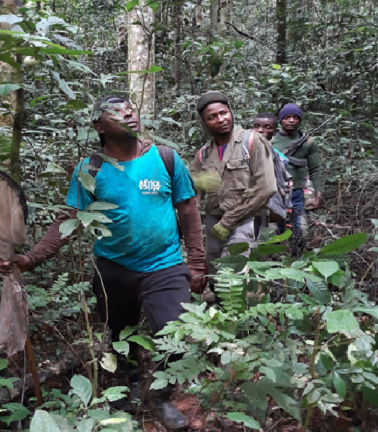
Final report (February 2023)
Compiled by NZOKO FIEMAPONG Armand Richard, PhD
(Principal investigator: armandnzoko@gmail.com)

ACKNOWLEDGEMENTS
We acknowledge the Mohamed Bin Zayed Species Conservation Fund (MBZCF) for their financial support of this project. We thank the Cameroon Ministries of Scientific Research and Innovation (MINRESI) and of forest and wildlife (MINFOF) for have delivered the necessary research permits for the implementation of this project (Permit n°1835 and Permit n°000009 respectively). We are indebted to the conservator of the Dja Biosphere Reserve M. Gilbert Oum Ndjock and his collaborators for the facilitation provided during fieldwork activities. We express gratitude to our field team members for their help and assistance on the field and to all the local guides of our different study sites for their collaboration and assistance during field activities. Finally, we are grateful to the local populations of the Dja Biosphere Reserve for their fruitful collaboration without which this project would not have been successfully implemented.
Abstract
The ongoing biodiversity crisis, characterized by high extinction rates, requires well-planned conservation efforts. Assessing key ecological parameters of species whose populations are in decline is the first step to improve their conservation strategies. This is especially true for soil invertebrates such as giant African millipedes, which generally retain very little attention in conservation projects. We aimed to assess the extinction risk and conservation status of the threatened endemic giant green African millipede Spirostreptus crenulatus and identify habitats that require conservation actions in order to propose threat mitigation measures. We did one year field survey from February 2022 to January 2023 in the Dja biosphere reserve using a combination of sampling methods usually used for soil drawling invertebrates. In addition, during the same period, we investigated the local ecological knowledge and use of millipedes through semi-structured questionnaires and conducted education and awareness campaigns on the role and importance of millipedes in the functioning of natural ecosystems. We recorded 13 occurrences of the giant green African millipede, including 8 specimens (3 males and 5 females) in the Dja Reserve and the other occurrences were opportunistic collections made in other localities in the Cameroonian forest region. Of the five types of habitats identified and surveyed during this study, S. crenulatus was mostly collected in primary forests where it was associated with leaf litter and fallen dead trees. The period of maximum activity of S. crenulatus is the wet season as most of its occurrences were recorded during this this season. The capture mark-and-recapture method permitted us to evaluate the population size of the target species to 4 individuals at the scale of the study site. Concerning the perception and knowledge of the importance of the target species by the local population, it appeared that the majority of respondents knew the target species, but none of them knew its conservation importance. This species is particularly negatively perceived by the local population living in and around the Dja Biosphere Reserve who believe its occurrence is an indicator of bad news. The target species is severely threatened in its distribution range and the most commonly observed threats are the cutting of trees for traditional medicine, deforestation for the production of charcoal as well as firewood, and the clear-cut practices for the installation of Cocoa, palm oil, rubber, and Cassava plantations. The extinction risk of the target species was evaluated as Endangered under IUCN Criterion B2ab (ii, iii, iv), AOO = 52.00km2 with a cell width of 2 Km. This project enables us to understand factors influencing S. crenulatus occurrence and distribution, which are crucial for appropriate and useful conservation action plans. In the light of all these results and findings, concrete and urgent actions must be taken by nature and wildlife conservation organizations and authorities to strengthen conservation strategies in Cameroon in order to preserve the target species.
Keywords: Giant African Millipede, distribution, threat, Extinction risk assessment, Conservation, Afrotropical region.

Introduction
The ongoing biodiversity crisis, characterized by high extinction rates, requires well-planned conservation efforts (Karam-Gemael et al, 2020). Assessment of the conservation status of species with inadequate conservation management like giant African millipedes has been acknowledged as a key tool for determining threat threshold and hence guiding conservation objectives (Karam-Gemael et al. 2020). Invertebrates, including millipedes, are the least studied animal group, accounting for just 31% of all evaluations on the IUCN Red List. Millipedes constitute one of the most important components of ecosystem functioning in tropical forests (Menta & Remelli 2020). Despite increased awareness of their importance to global conservation planning, little attention has been paid to the inventory and monitoring of this taxonomic group.

Millipedes are a very important, mega-diverse group of terrestrial arthropods, especially in tropical forest biomes (Golovatch & Liu, 2020). They are sensitive to habitat changes resulting from forest disturbance, changes in light regimes, microclimates, dead wood availability, and soil compaction, making them important indicators of habitat disturbance (Golovatch & Kime, 2009). Studying their diversity, abundance, and distribution can provide useful and rich baseline information that can assist in biodiversity conservation decisions and management planning for protected areas such as the Dja Biosphere Reserve, an important key biodiversity hotspot in Cameroon with the largest remaining primary lowland rainforest with a high conservation priority due to its species richness with many endemic and threatened species. Despite their prominent role in natural ecosystem functioning, they are underrepresented in conservation programs in Afrotropical regions including Cameroon (Reinecke & Reinecke 2018). Many millipede species have a narrow distribution range (Hamer and Slotow 2001) and they require conservation actions to ensure their survival as threats such as land transformation increase (McGeoch et al. 2011).

Habitat loss and destruction are the main causes of species extinction (IUCN 2023). The conservation status of most millipede taxa is poorly known in the Afrotropical region and only a few millipede species have been assessed according to the IUCN Red List criteria mostly in south Africa and Malgazi. To date, no millipede species from Central and West Africa has been the subject of an assessment with a view to its inclusion in the IUCN Red List. Thus, this study was carried out with the aim of assessing the conservation status of Cameroonian endemic green giant millipede Spirostreptus crenulatus Porat, 1894, in the Dja-Biosphere-Reserve to suggest a bio-monitoring plan in light of climate change and environmental degradation.

More specifically, this project aimed to (1) to assess the occurrence, distribution, habitat preference, and conservation status of S. crenulatus using the IUCN criteria, (2) to assess the perception of the target species by the local population, (3) raise awareness among the local population through a sensitization and education campaign on the role and importance of the target species in the functioning of forest ecosystem, (4) assess anthropogenic threats to the target millipede species and (5) design plans to protect the target species and its habitats in the Dja Biosphere Reserve.

Material and methods
Study site
The climate is of the equatorial type, with four seasons: the rainy season which occurs from mid-September to December followed by a three-month dry season and then a small rainy season between mid-March and June then a short dry season from July to September. The average monthly temperature is between 23.5 ̊C and 24.5 ̊C and the annual rainfall is 1600 mm (Sonke & Couvreur, 2014). The east and part of the western clusters are red ferrallitic soils while the south and part of the western clusters are yellow ferrallitic (lateritic) sesquioxide soils, good for growing crops such as cocoa and coffee.

The climate is of the equatorial type, with four seasons: the rainy season which occurs from mid-September to December followed by a three-month dry season and then a small rainy season between mid-March and June then a short dry season from July to September. The average monthly temperature is between 23.5 ̊C and 24.5 ̊C and the annual rainfall is 1600 mm (Sonke & Couvreur, 2014). The east and part of the western clusters are red ferrallitic soils while the south and part of the western clusters are yellow ferrallitic (lateritic) sesquioxide soils, good for growing crops such as cocoa and coffee. The vegetation of the Dja Reserve is of the Congolese type with evergreen forest belonging to the Guineo-Congolese domain and consists of large trees of up to 60 m tall (Tabue et al., 2018). The Dja Faunal Reserve is home to rich and threatened taxa. While vertebrates in these areas have received considerable conservation attention, the invertebrate fauna in general, and millipede in particular, remain understudied with no data that could provide a basis for making conservation decisions.
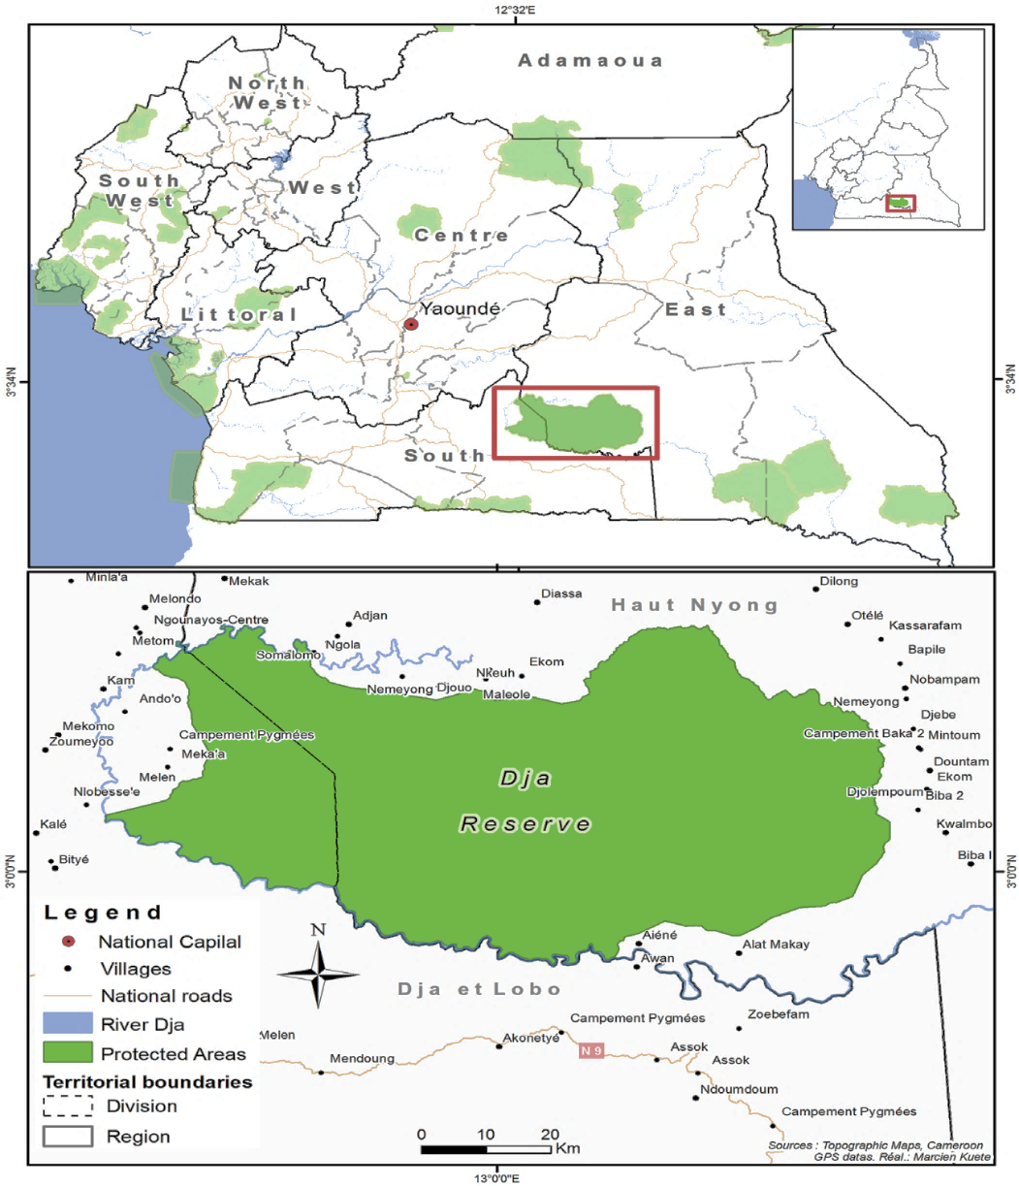
Figure 1: The Dja Biosphere Reserve and its peripheral zones.

Perception, knowledge of S. crenulatus by the local population and awareness campaigns (figure 2)

The interviews in this study followed a protocol adapted from Nash et al. (2016). Local ecological knowledge on the giant green African Millipede S. crenulatus Porat, 1894, was assessed in villages around the Dja Biosphere Reserve. Participants were selected using a snowball sampling method. A questionnaire consisting of open-ended and closed questions was administered to participants to ascertain their knowledge of the Giant African Millipede, its ecology, and conservation. Awareness campaigns in the local communities living in and around the study site were organized, in order to increase the knowledge of local populations on the conservation importance of the target species in our study localities. To better illustrate what we were talking about during awareness campaigns, printed photographs of the target species were presented to participants.
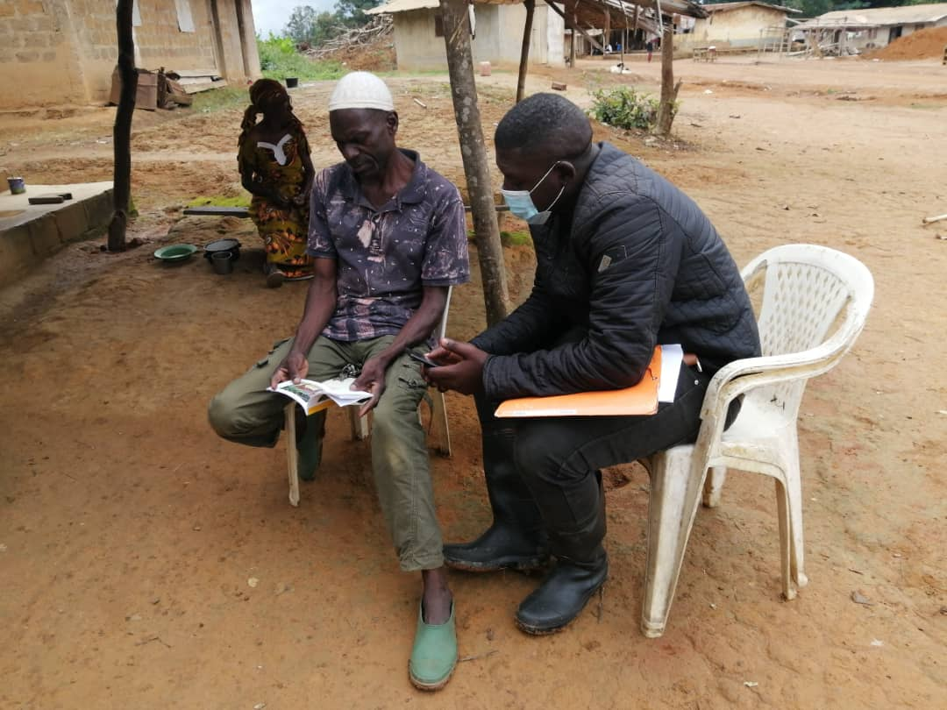
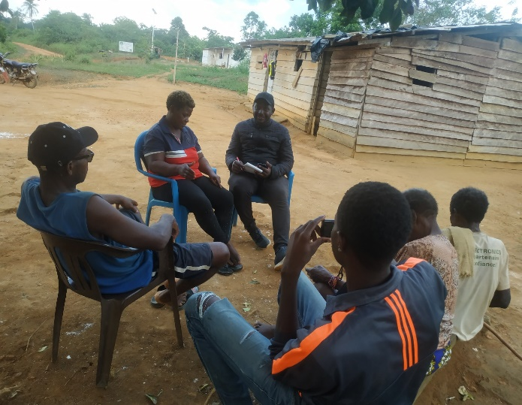
Figure 2: community-based interview of some villagers

Sampling of S. crenulatus

The assessment of the occurrence and distribution of the target species, as well as its habitat preference were conducted using a combination of two soil invertebrate survey methods (Quadrat, and sixty-minute active searching). This activity was conducted to record and estimate the population size, abundance fluctuations, and population dynamics of the target species at study sites as well as all threats that the latter face. In the different vegetation types identified in the Dja biosphere reserve and for each field trip, 40 quadrats of 9 sq. m were regularly placed on 4 transects of 200 m long, with 10 quadrats per transect, 20 m apart from each other. Each transect was placed 10 m apart from the next. In addition to this method, 1-hour active searching was carried out (figure 3) along other transects (200m and 2m wide) to increase the chances of collecting the target species and also to have the possibility of surveying the majority of micro-habitats and threats to the target species. All shelters and habitats suitable for millipedes including under rocks, tree barks, fallen branches, leaf litter, or directly in soil monoliths were typically surveyed.

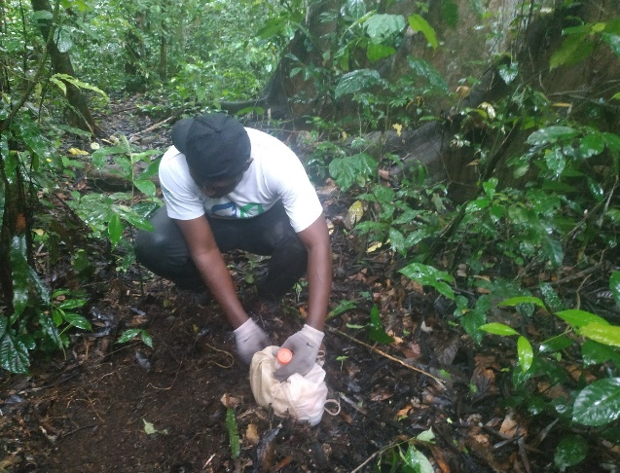
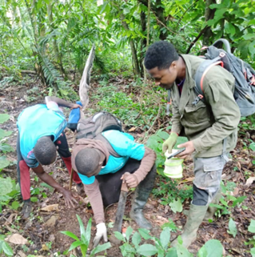
Figure 3: Field survey in the Dja Biosphere Reserve

Distribution and extinction risk assessment of S. crenulatus

For each prospected habitat, geographical coordinates were taken. The distribution map of the target species was constructed using the recorded coordinates to visualize the distribution range of the species. The potential conservation status of S. crenulatus according to IUCN criteria was addressed via the R package red - IUCN Red listing Tools (Cardoso, 2017) by computing the extent of occurrence (EOO) and area of occupancy (AOO) of the target species. This package generated automated conservation assessments according to IUCN Red List categories. As such, Criterion B which concerns the geographical range in the form of both B1 (Extent of Occurrence: EOO) and B2 (Area of Occupancy: AOO) was applied. The EOO is defined by the IUCN (2001) as “the area contained within the shortest continuous imaginary boundary that can be drawn to encompass all the known, inferred or projected sites of present occurrence of a taxon”. The AOO is defined as the area within the EOO that is actually occupied by the species, and this measurement recognizes that a species will usually be confined to a specific habitat and will not occur throughout the area where it is distributed. A location is defined as a “geographically or ecologically distinct area in which a single threatening event can rapidly affect all individuals of the taxon present in the area. The size of the location depends on the area covered by the threatening event”. A location is therefore different from a locality, which is usually a collection point, and a location can include several localities if these are relatively close together. This extinction risk assessment was done using occurrence data collected during fieldwork and data from the literature.

Table 1. Summary of the criteria B used to evaluate the target millipede species in an IUCN Red List threatened category. Reproduced from the IUCN Red List Criteria Summary Sheet (https://www.iucnredlist.org/resources/summary-sheet).
B. Geographic range in the form of either B1(Extent of Occurrence) AND / OR B2 (Area of
Occupancy)
 | Critically  Endangered | Endangered | Vulnerable
B1. Extent of occurrence (EOO) | <100km2 | <5000km2 | <20 000km2
B2. Area of occupancy (AOO) | <10km2 | <500km2 | <2 000km2
AND at least 2 of the following 3 conditions:
a) Severely fragmented OR Number of locations | =1 | <5 | <10
(b) Continuing decline observed, estimated, inferred or projected in any of: (i) extent of occurrence; (ii) area of occupancy; (iii) area, extent and/or quality of habitat; (iv) number of locations or subpopulations; (v) number of mature individuals
(c) Extreme fluctuations in any of: (i) extent of occurrence; (ii) area of occupancy; (iii) number of
locations or subpopulations; (iv) number of mature individuals
Populations size of S. crenulatus

The estimation of the population size of the target millipede species was based on the capture-mark-recapture method of Peterson-Lincoln. Monthly captures of the target species were carried out in 5 different vegetation identified in the Dja Biosphere Reserve. During the overall study period, 12 trips of 5-7 days each permitted us to investigate various habitats and vegetation in the study area. All samples were identified in situ, marked, and released at the study site.

Habitat characterization and threats to the target giant African millipede

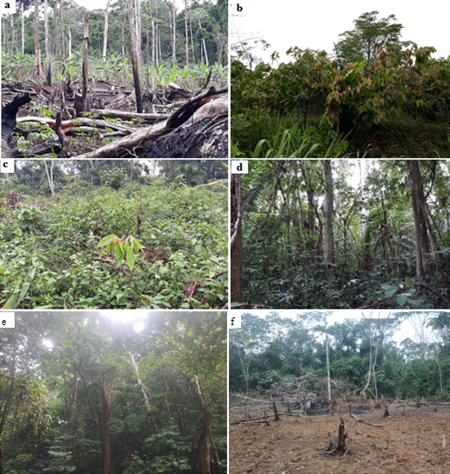
During field activities we characterized the basic vegetation (figure 4) on all survey transects in which specimens of S. crenulatus were collected. We also assessed human pressures and threats to the target millipede species within each survey habitat. The following parameters were recorded: the number of culls and stripes, track marks, the number of live bases, agricultural practice, overgrazing, wood exploitation, the internal road network in the reserve as well as all other human activities that can potentially affect the target species.
Figure 4 : Some prospected vegetation in the Dja Biosphere Reserve (a, f: : Farmland using slach and brurn agricultural practice, b- Cacao-base plantation, c-fellow, d-secondary forest, e-Primary forest).
Results

Perception, knowledge, and awareness campaign concerning S. crenulatus in the local population

Protect activities began in February 2022 with a planning meeting in Somalomo, a small community in the Dja Biosphere Reserve. During this meeting, activities were planned and prioritized. Overall, 300 people were interviewed in the study area. The respondents were between 16 and 78 years old and the average age of the population was 41 years, suggesting its youthfulness. More than half of the respondents (57%) were women. The main livelihoods of the people in the study area are hunting and slash-and-burn agriculture. Hunting is mainly practiced by men (92%), while agricultural activities are primarily carried out by women (100%), generally assisted by children. Concerning the knowledge and use of the target millipedes by the local populations of the Dja Biosphere Reserve, it appeared that almost all the interviewees knew the target species and could recognize them in their natural habitat by their shape, coloration and especially by their large number of legs. This study reveals that 63% of the respondents acknowledged the usefulness of millipedes in soil fertilization and the degradation of forest leaf litter. No medicinal or culinary use of the target millipede has been reported so far in the study area. Regarding the cultural aspect, answers from questionnaires and focus group discussions highlighted that the giant green millipede is considered a mysterious species which is generally associated with bad luck. The target species was successfully identified on images by 65% of interviewees. However, about 98% of those who identified the species acknowledged it is very rare and stated that they did not encounter the species since several years ago. This suggests that the species, although present, is very rare. Respondents that recognized the species reported that the latter is a typical forest species and is most often found on dead tree trunks and forest litter mostly during the wet season. In terms of cultural knowledge, our respondents indicated that this species is mystical and that it generally heralds misfortune, including the death of people close to the person who encounter it. The consequence of this situation is that specimens of the target species are systematically killed by local populations when they see them in the forest. Information collected from populations living in and around our study site provides sufficient data on the level of threat to the target species. In the locality of Meyomessala, S. crenulatus is called “twins’ species” because according the local people, this species is their totem and move with twins wherever they go.
All the respondents knew the target species, but none of them knew the importance of conserving this species. During awareness campaigns, we showed local populations the importance of millipedes in ecosystem functioning and the need to conserve them and their natural habitats. The populations were sensitized about the various threats to the target species and the necessity of reducing these threats for its long-term survival.

Abundance fluctuation and estimation of the population size of S. crenulatus in the Dja Biosphere reserve

During the one-year field survey in the Dja Biosphere Reserve, we recorded 8 specimens of Spirostreptus crenulatus. The collected individuals were represented by 7 adults (3 male and 4 female) and 1 sub-adults (female). All specimens were exclusively recorded in forest habitats (figure 5). Our observations reveal that S. crenulation is occurs between May and October and the maximum abundance was recorded in August (25% of the total individuals observed). All specimens were exclusively observed in the forested habitats (primary forest and floodable raffia forest, while none was observed in other vegetation types (figure 5).
Figure 5: Monthly fluctuation of abundances of Spirostreptus crenulatus per vegetation type in the Dja Biosphere Reserve.

The figure 6 below shows that the abundance of S. crenulatus varies considerably between different seasons. The small dry season (sds) and the long rainy season (lrs) exhibited the highest abundances with respectively 50% and 37.5% of the collected specimens. No specimen was observed during the long dry season (lds), which could suggest that soil desiccation is a limiting factor to the proliferation of this Diplopod species.
Figure 6: seasonal variation of the abundance of S. crenulatus in the Dja Biosphère Reserve
The Mark-Recapture Method permitted us to estimate the size of the population of our target millipede species. Of the 8 specimens captured and marked during this study, we recaptured 3 individuals over the six consecutive months (May-August) during which individuals of the target species were collected. Applying the Jolly-Seber formula for open populations allowed us to estimate the population size of S. crenulatus to 4 individuals. This observation suggests a very low population size of this millipede species in the study locality. Moreover, this observation sufficiently demonstrates the vulnerability of this species and the need to preserve it as well as its natural habitat.

Habitat preference of S. crenulatus in the Dja Biosphere Reserve

The target species occurred exclusively in two forests variants in the Dja Biosphere Reserve (primary forest and raffia forest) as presented in figure 2. These forests are mainly characterized by closed canopies and the presence of important leaf litter. The most important occurrence was recorded in the primary forest (5 occurrences over 8 recorded) where the target species was associated with the leaf litter and dead trunks. This specificity of habitat and even micro-habitat makes this species highly vulnerable to human activities. This species is site-specific with very low dispersal ability, and a very restricted distribution range. These characteristics suggest that it may easily go extinct if there is no appropriate measure to monitor and protect them in their natural habitats.

Distribution and occurrence of S. crenulatus in Cameroon

Figure 4 below shows the distribution of the target species in Cameroon. The exploration of literature as well as the data collected during our studies in the Dja Biosphere Reserve and in other localities visited sporadically permitted us to note 13 occurrences including 8 in the Dja Biosphere Reserve as stated above. The 5 other occurrence coordinates were recorded in the Deng Deng National Park (2 occurrences), in the locality of Nganha in the Adamaoua region (2 occurrences), and in the locality of Engout'Adja in the Ntem Valley division (South Cameroon Region; 1 occurrence).
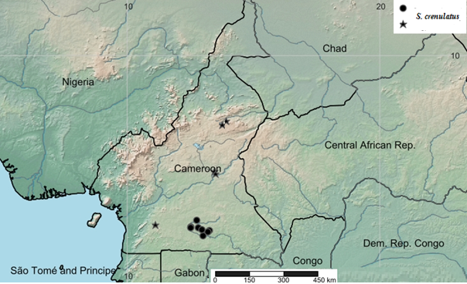

Figure 7: distribution of the target species in Cameroon (circles represent the occurrence in the Dja Reserve Forest and stars the highlight occurrence out of the aforementioned area).

Threats to target species in the Dja Biosphere Reserve

During the 12 months of implementation of our project in the Dja Biosphere Reserve, we noted several anthropogenic practices and threats to target species. Hunting, harvesting of tree products, and slash-and-burn agriculture are the major activities that lead to the degradation of the forest cover in this reserve and could have a significant negative effect on the target millipede population. The majority of the population of the Dja Biosphere Reserve rely on hunting for food and income. When they go into the forest for hunting, they usually cut down trees to establish temporary dwellings, and the young stems are also used to prepare traps for animals, all of which has a negative effect on the regeneration of plants in the reserve and thus on soil invertebrates such as millipedes. Slash-and-burn agriculture is a common practice in this area; most of the population depends solely on this practice. They cut down trees and set them on fire to establish plots of cassava, groundnuts, and plantains. The use of fire results in the destruction of soil organic matter. Consequently, there is a decrease in the productivity of the vegetation and the crops planted on the burnt plot. In addition, all invertebrate species with a low dispersal capacity and a high level of endemicity, such as our target millipede species, would likely perish during these activities. The harvesting of tree products mainly for medicinal purposes is also a cause of canopy degradation due to the use of unsustainable harvesting techniques. Although deforestation inside the Dja Biosphere Reserve is remarkably low, logging occurs at the entire periphery of this area, causing fragmentation of the forest habitat and therefore having an impact on biodiversity in general and especially on the populations of S crenulatus which are highly fragmented, with a low dispersal ability. Logging takes place within the framework of concessions granted to private operators on forest management units (FAU) or, depending on the case, directly to local communities. Its peripheral infrastructure facilitates access to the reserve and poaching (road network, vehicles, increased demand for protein). Logging, as well as the advance of agricultural exploitation in the study area, have an immediate consequence on the accentuation of deforestation. This trend towards progressive deforestation and is probably linked to an increase of the human population living in the periphery of the Dja Biosphere Reserve. The Mékin hydroelectric dam located on the Dja River, in the northwest area at a few km from the inscribed perimeter of the Dja Fauna Reserve, also constitutes a serious potential threat to our target taxon, as the waters of this dam affects in times of flood a large part of the habitats and microhabitats suitable for its proliferation. The activities of the company "Sud Cameroun Hévéa" on the outskirts of the Dja Biosphere Reserve on nearly 44,000 ha of concession (for rubber, oil palm, and cocoa plantations) have several negative impacts on the environment. The most significant of these activities are the increase in poaching, large-scale deforestation, the disappearance of certain animal and plant species, the degradation of surface water resources and soil through the overuse of chemicals. Many explorations permit for mining projects - granted in the periphery of the reserve - also constitute an eventually serious threat to the fauna in general and C. crenulatus in particular.

Conservation assessment of S. crenulatus
This giant millipede (figure 7) is an endemic species described from an unknown locality in Cameroon in 1894 by C. O. Von Porat. S. crenulatus is a rare species inhabiting two forests variants (primary forest, and raffia forest). The distribution area of this species includes two protected areas (the Dja Biosphere reserve, our primary study site, and the Deng Deng National Park) where several field study trips were conducted before and during our study period. The other localities which arbor the species are not protected and there are no conservation actions in place for the latter. The harvest of plants for medicines and timber may result in the degradation of the habitat of the target species, but this is not a major risk. Due to the small number of known range localities, this species is vulnerable to catastrophes such as bush fire, slash-and-burn agricultural practices, mining, and inundation from the hydro-electrical dams. These include the dam on the Dja river (which surrounds the Dja faunal reserve) and that of Lom pangar which considerably affects habitat and microhabitats suitable for the target millipede in the Deng Deng National Park. The extent to which forest degradation is continuing in the prospected area is alarming. Also, there are many mining projects around the study area that constitute real threats to the entire biodiversity. The most significant of these are large-scale deforestation, degradation of surface water resources, and soil through excessive use of chemicals. Despite the fact that the target species is located in two protected areas, the level of management in the areas is poor. The EOO is estimated as 288902.00 km² and AOO = 52.00 km². The number of known locations is presently equal to four (04). Considering the estimated AOO, the size of the population of the target species, the number of mature individuals, and the recorded threats, this species may be qualified as Endangered (EN) + B2ab (ii, iii, iv).

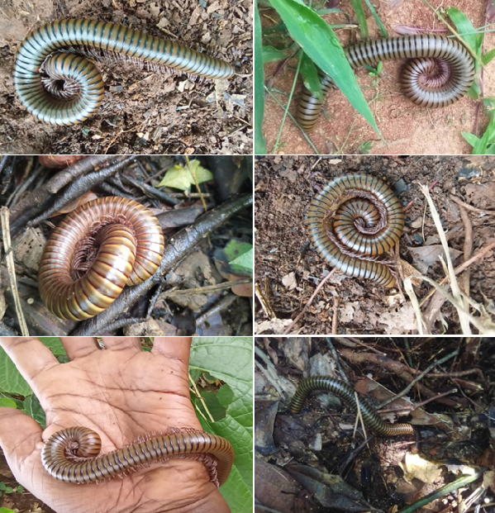
E
F
D
C
B
A
Figure 7: Spirostreptus crenulatus in natural environment

Conservation outcome

During this project, we worked closely with the local population of the study area. In addition to the short-term financial benefits that some local people (guides) benefited from the project in form of guiding jobs, it is clear that they are predisposed to participate in other conservation projects. This is mainly due to the training received during field activities, but also to the interest that some have to millipedes, which are a curiosity to them. By preserving their environment, the local people will gain more from the research that will be conducted in their localities in the future. There are currently no conservation actions in place in favor of this giant millipede in the study area. The assessment of the conservation status of this target species using IUCN Red List criteria B reveals that this endemic species is endangered and restricted to forest environments where it is associated with leaf litter and dead wood trunks. The species occurred just in four localities with very fragmented populations. The size of its population is small, with only 12 adults recorded during the study period plus and one recorded during a previous study at Engout'Adjap in 2016. The small size of the population of the target species suggests a continued decline of the latter. This is due to the fact that the species is severely threatened by continuing forest degradation, agricultural practices, mining, and Hydroelectric dams. In addition, the poor knowledge of the ecology and behavior of the target species are limitations to the implementation of conservation measures and actions. Thus, it is urgently important to develop conservation action to preserve this charismatic species in its natural habitat.

Current and upcoming activities

- Intensify the survey of the target species in the Deng Deng National Park, a locality near the Dja Biosphere Reserve, where one sporadic field trip permitted to record of the two occurrences of S. crenulatus.
- Use ecological modeling to predict the distribution and the conservation of the target species in different scenario in the future and then provide a useful conservation strategy for the species.
- Revision of the taxonomic status of Spirostreptus crenulatus which actually no longer belongs to the genus Spirostreptus since the revision of this genus by Mwabvu et al. (2009).
- • Publish these results in a peer-reviewed journal

Conclusion
This project has shown that the target species occurred in only a few locations and in very few numbers. Spirostreptus crenulatus is restricted to forest habitats and has a very low dispersal ability. This species is well known by the local population who associate it with high cultural values. This study reveals that this species is threatened by anthropogenic disturbances among which deforestation, slash and burn agricultural practices, clear cut practices for the installation of industrial plantation (Cocoa, Hevéa, and pal oil) which also require an important quantity of chemicals. Based on the IUCN Criterion B, the target species is assessed as Endangered (EN). Thus, it is urgently important that nature and wildlife conservation organizations and governmental authorities intensify conservation strategies and actions so as to preserve this giant millipede in its natural ecosystem.
References
Cardoso P (2017) red - an R package to facilitate species red list assessments according to the IUCN criteria. Biodiversity Data Journal 5: e20530. https://doi.org/10.3897/BDJ.5.e20530
Golovatch S.I. & Liu W (2020) Diversity, distribution patterns, and fauno-genesis of the millipedes (Diplopoda) of mainland China. In: Korsós Z, Dányi L (Eds) Proceedings of the 18th International Congress of Myriapodology, Budapest, Hungary. ZooKeys 930: 153-198. https://doi.org/10.3897/zookeys.930.47513
IUCN (2023). The IUCN Red List of Threatened Species. Version 2022-2. https://www.iucnredlist.org
Karam-Gemael M., Decker P., Stoev P., Marques MI., Chagas Jr.A. (2020). Conservation of
terrestrial invertebrates: a review of IUCN and regional Red Lists for Myriapoda. ZooKeys, 930:221–229
McGeoch M.A., Sithole H., Samways M.J., Simaika J.P., Pryke J.S., Picker M., et al. (2011). Conservaton and monitoring of invertebrates in terrestrial protected areas. Koedoe, 53(2), 13.
Menta, C., & Remelli, S. (2020). Soil Health and Arthropods: From Complex System to Worthwhile Investigation. Insects, 11(1), 54. doi:10.3390/insects11010054
Muchaal P.K., Ngandjui G. (1999). Impact of village hunting on wildlife populations in the Western Dja Reserve (Cameroon). Conserv. Biol., 13 (2): 385-396.
Nash H.C, Wong M.H.D.G., Turvey S.T. (2016). Using local ecological knowledge to determine status and threats of the Critically Endangered Chinese pangolin (Manis pentadactyla) in Hainan, China. Biological Conservation 196: 189–195
Nash P., Schlösser A. & Scarr T. (2016). Teachers’ perceptions of disruptive behavior in schools: a psychological perspective, Emotional and Behavioral Difficulties, 21:2, 167-180, doi:10.1080/13632752.2015.1054670
Sonke, B., & Couvreur, T.L.P. (2014). Tree Diversity of the Dja Faunal Reserve, South- east Cameroon. Biodiversity Data Journal, 2, e1049. https://doi.org/10.3897/BDJ.2.e1049
Tabue, B. R. M., Louis, Z,, Valery, N. N., Forbi, P. F., Jules, C. Z., Louis, R. N., Louis, R. K., Nadège, M. T., Amandine, F. N., Mireil, C. T., Nyeck, B., & Cedric, C. D. (2018). Diversity, Structure and Carbon Storage Potential of the Dja Reserve Vegetation Cover. Journal of Biodiversity and Environmental Sciences, 13, 180-199.

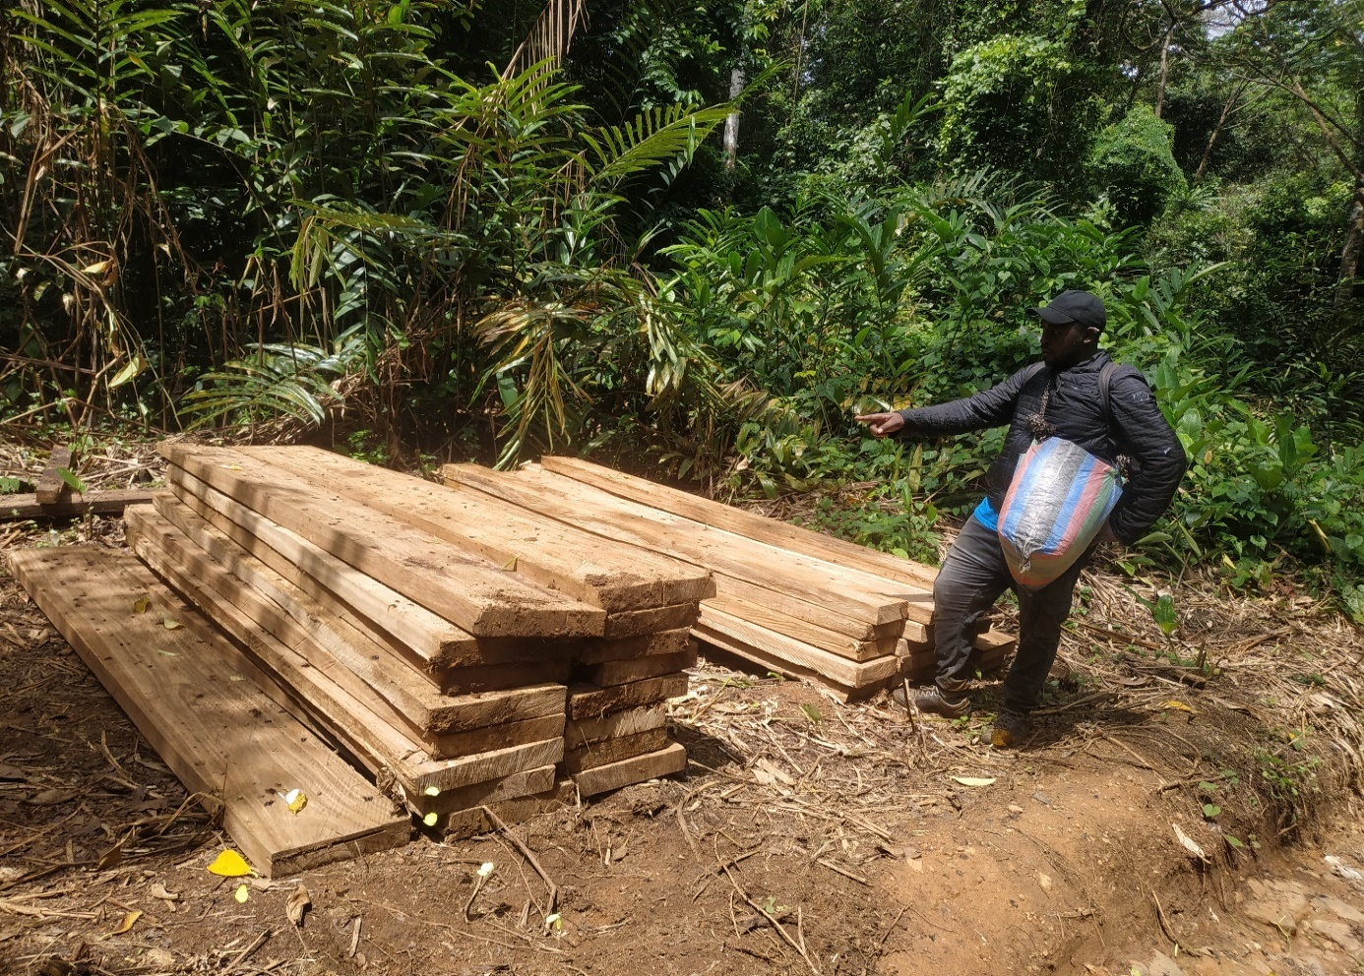
Appendix
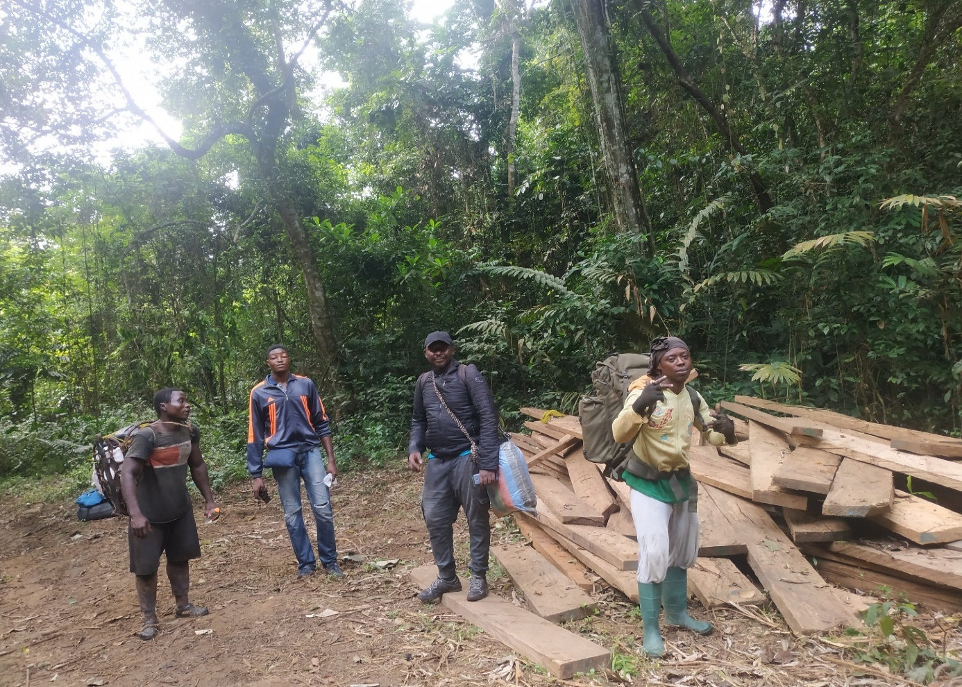
The exploitation of wood by the riparians population of the Dja Biosphere Reserve
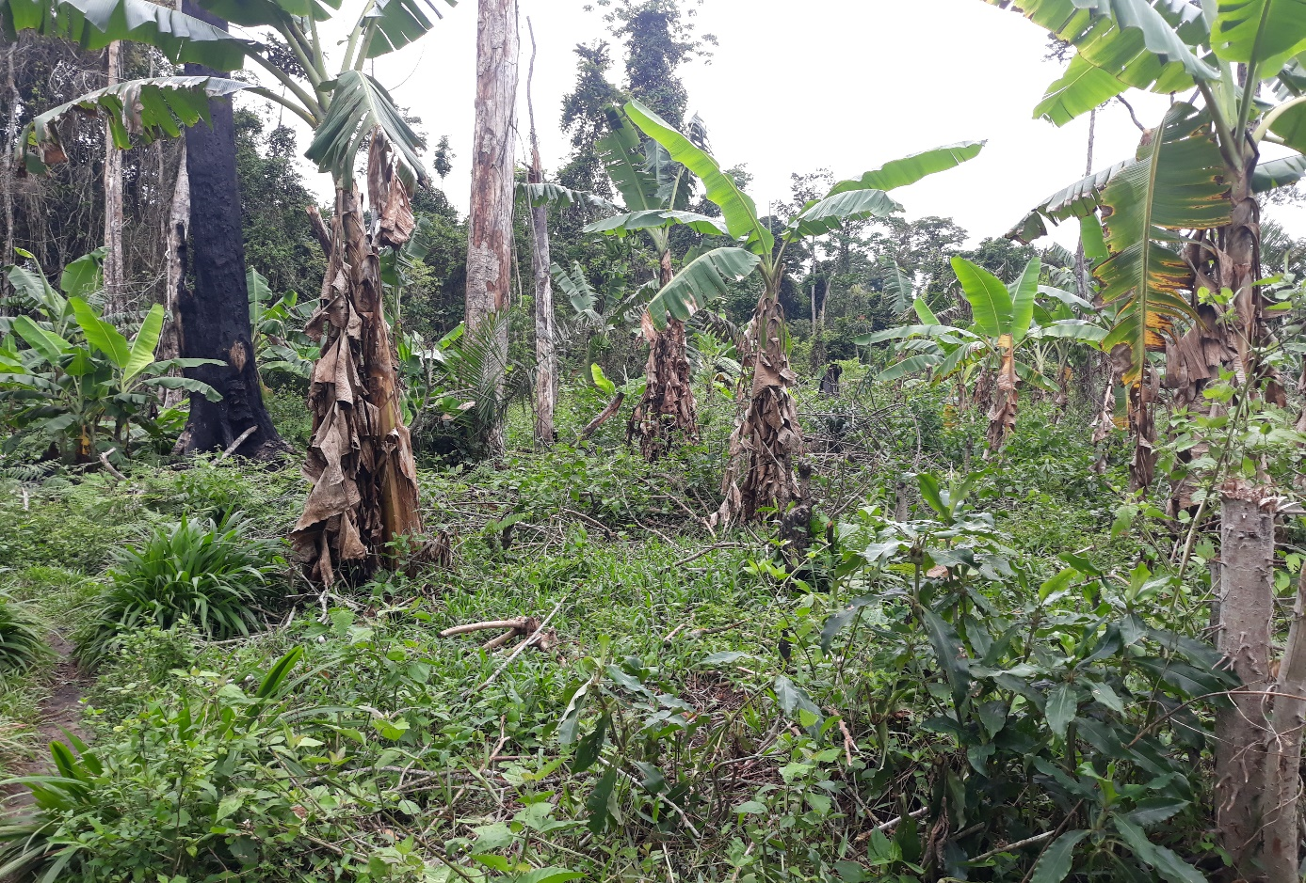
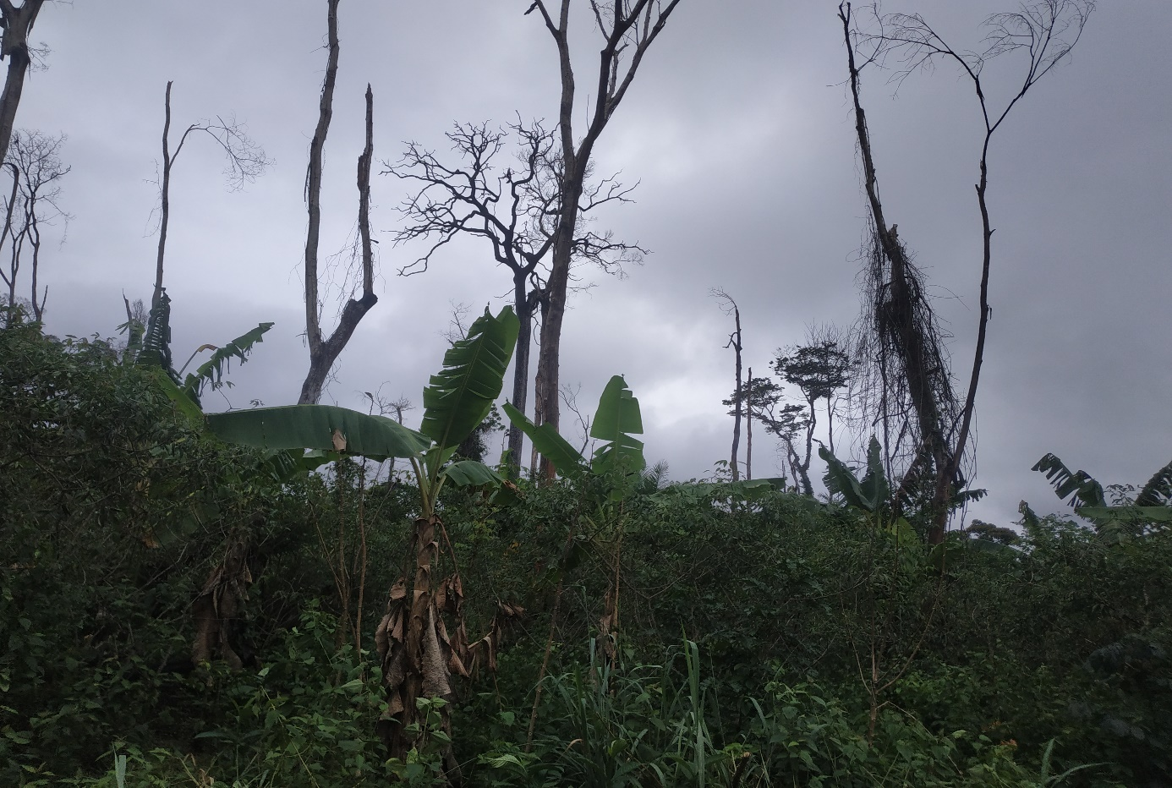
Farmland in the booffer zone of the Dja biosphere

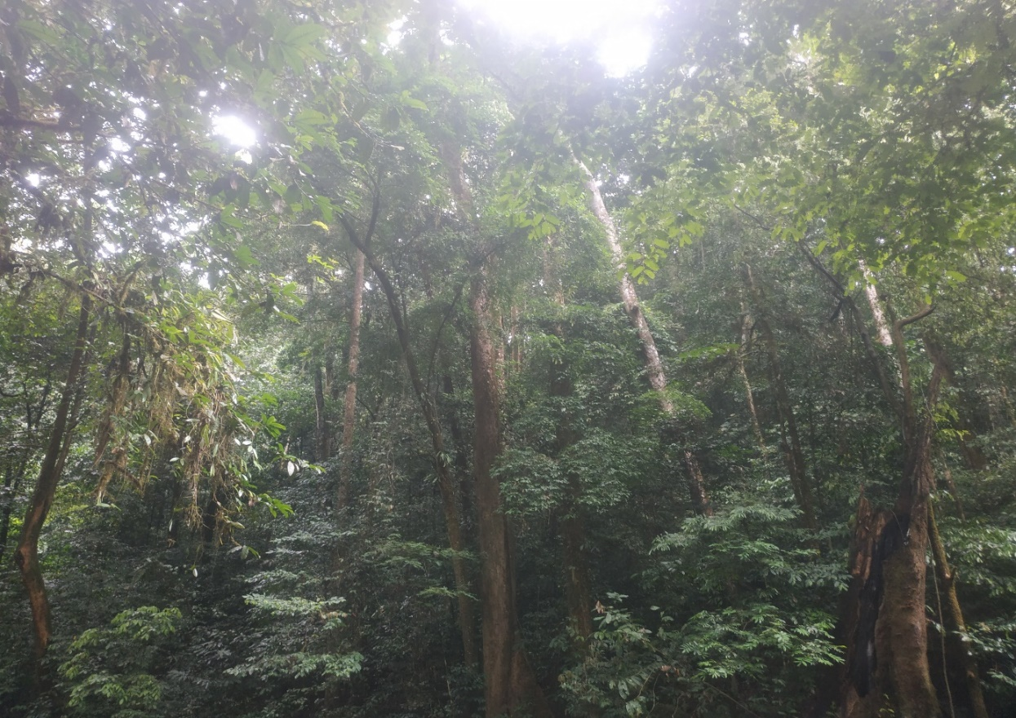
Primary forest in the Dja Biosphere Reserve
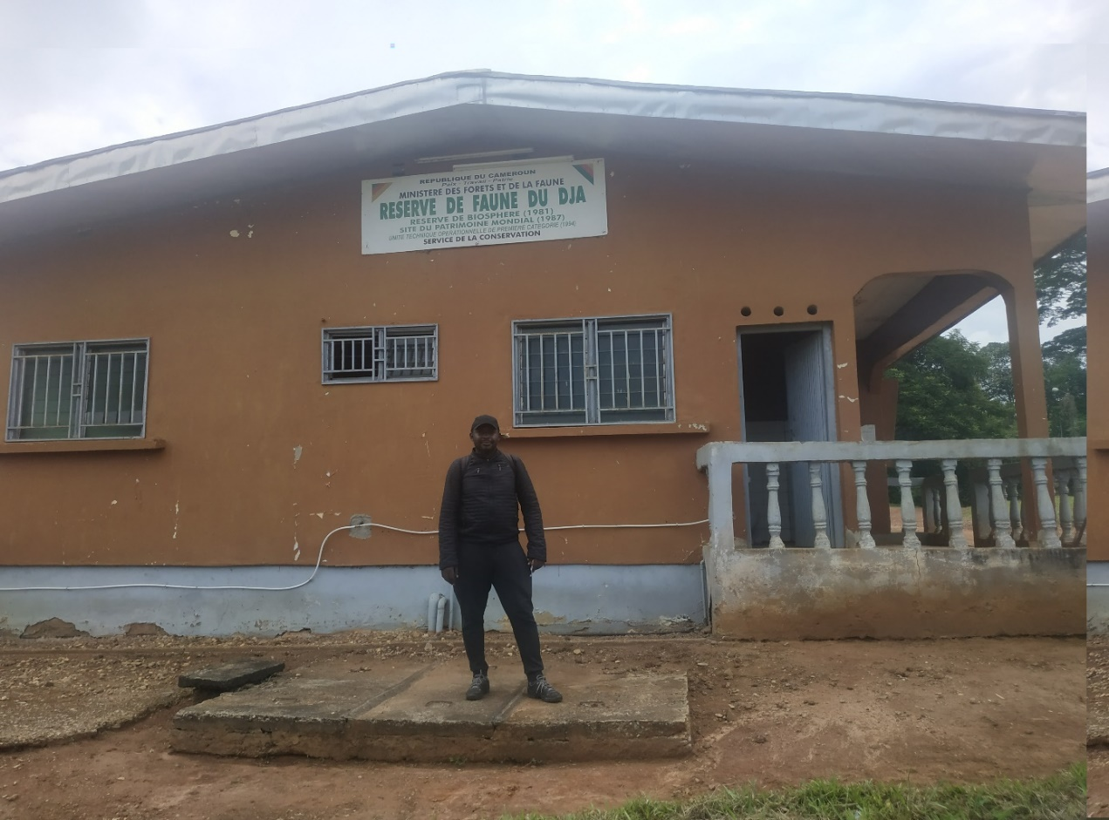

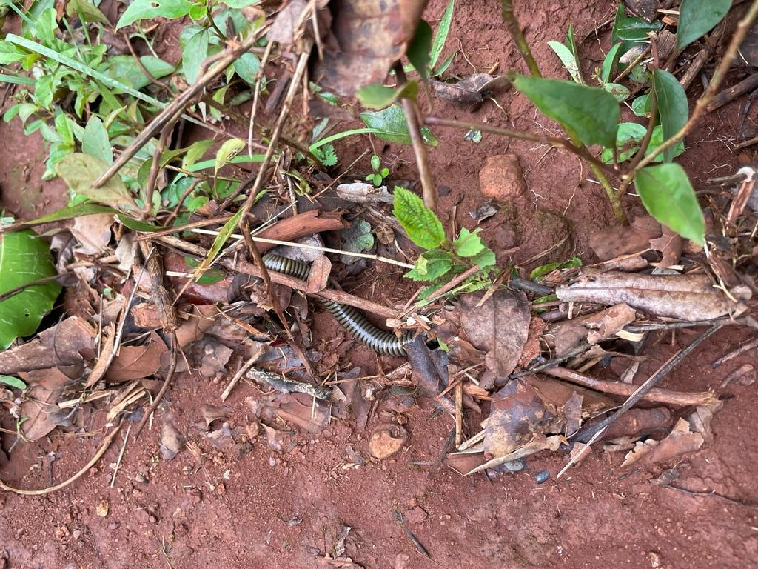
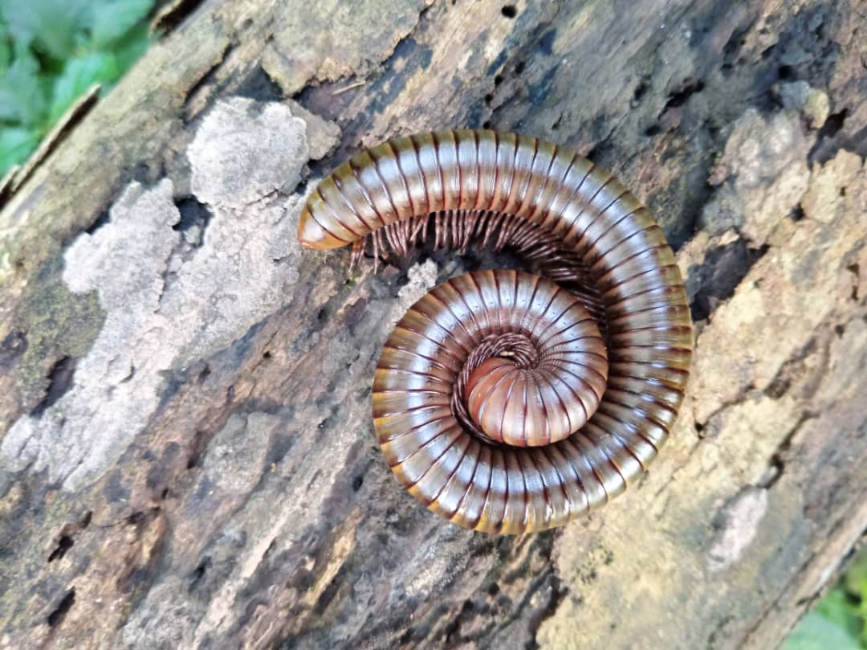
S. crenulatus in the natural environment
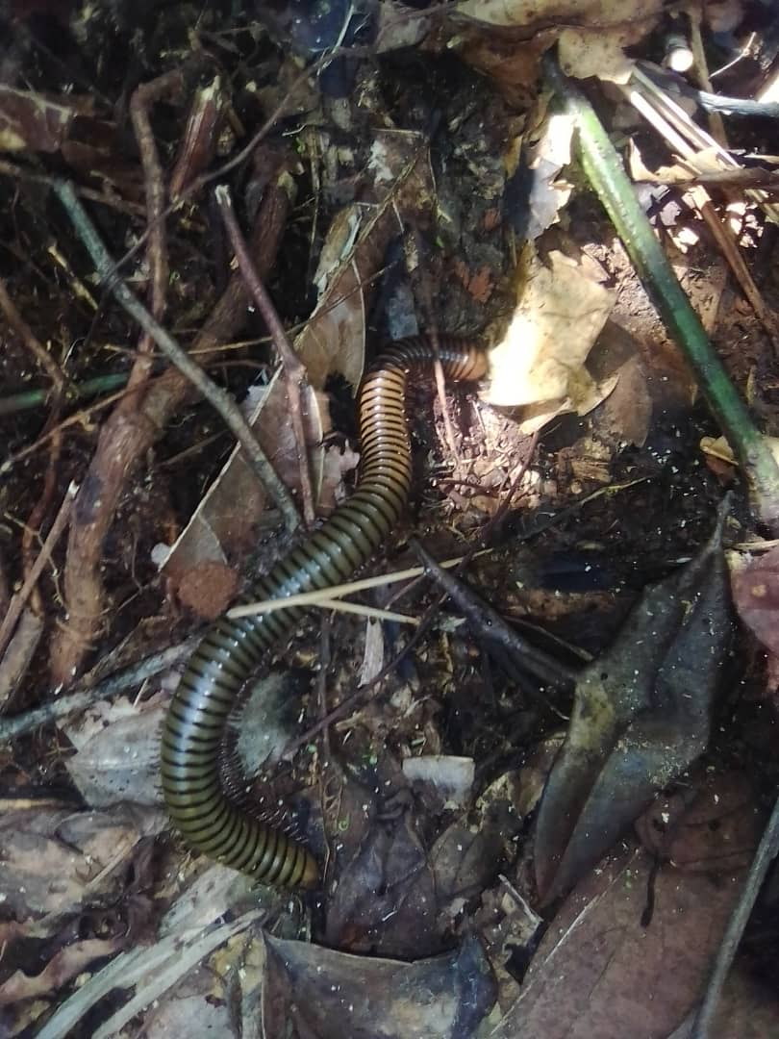

S. crenulatus in the natural environment

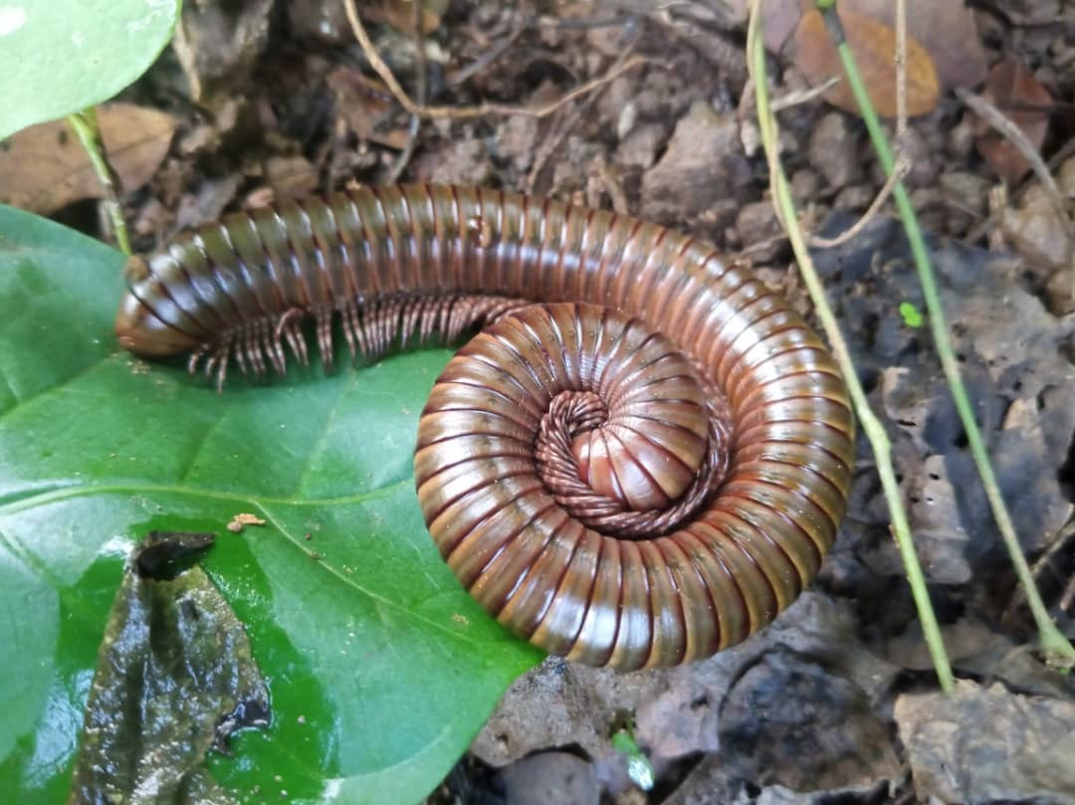
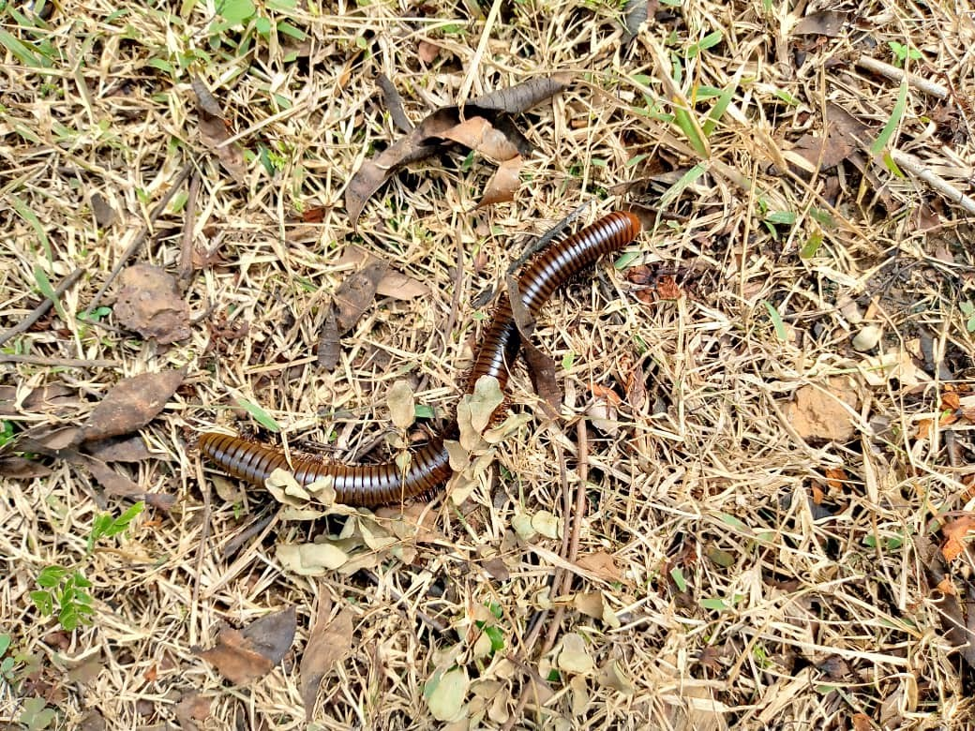
S. crenulatus in the natural environment

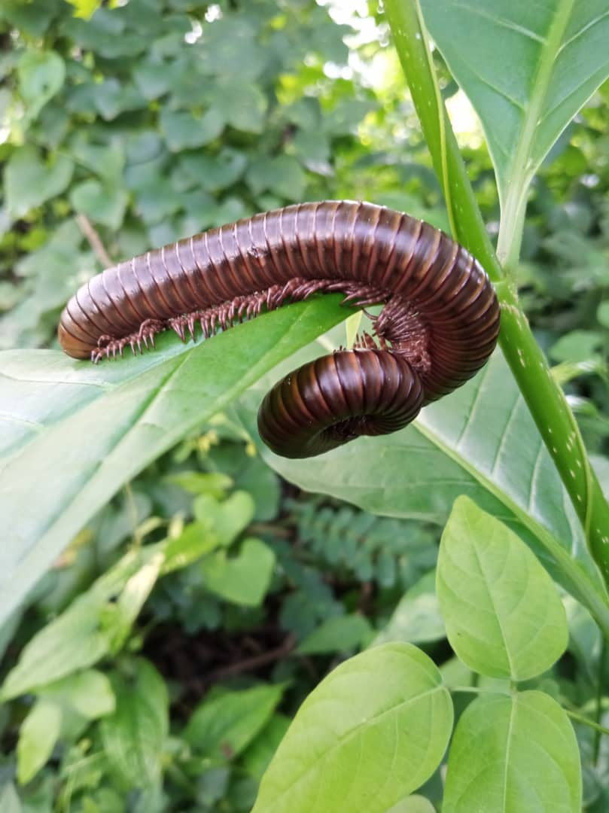
S. crenulatus in the natural environment

