New localities and extension of distribution for Lila Downs' Friar Grasshopper (Orthoptera: Acrididae) and endangered unique species from Oaxaca, Mexico
Ricardo Mariño-Pérez and Oscar Salomón Sanabria-Urbán

During 2022, we visited the current localities where Lila Downs' Friar Grasshopper was originally found and after talking with local people, we obtained information regarding new nearby localities. In the next map, we show in red the previous known localities and in yellow the new localities where we found Liladownsia fraile.
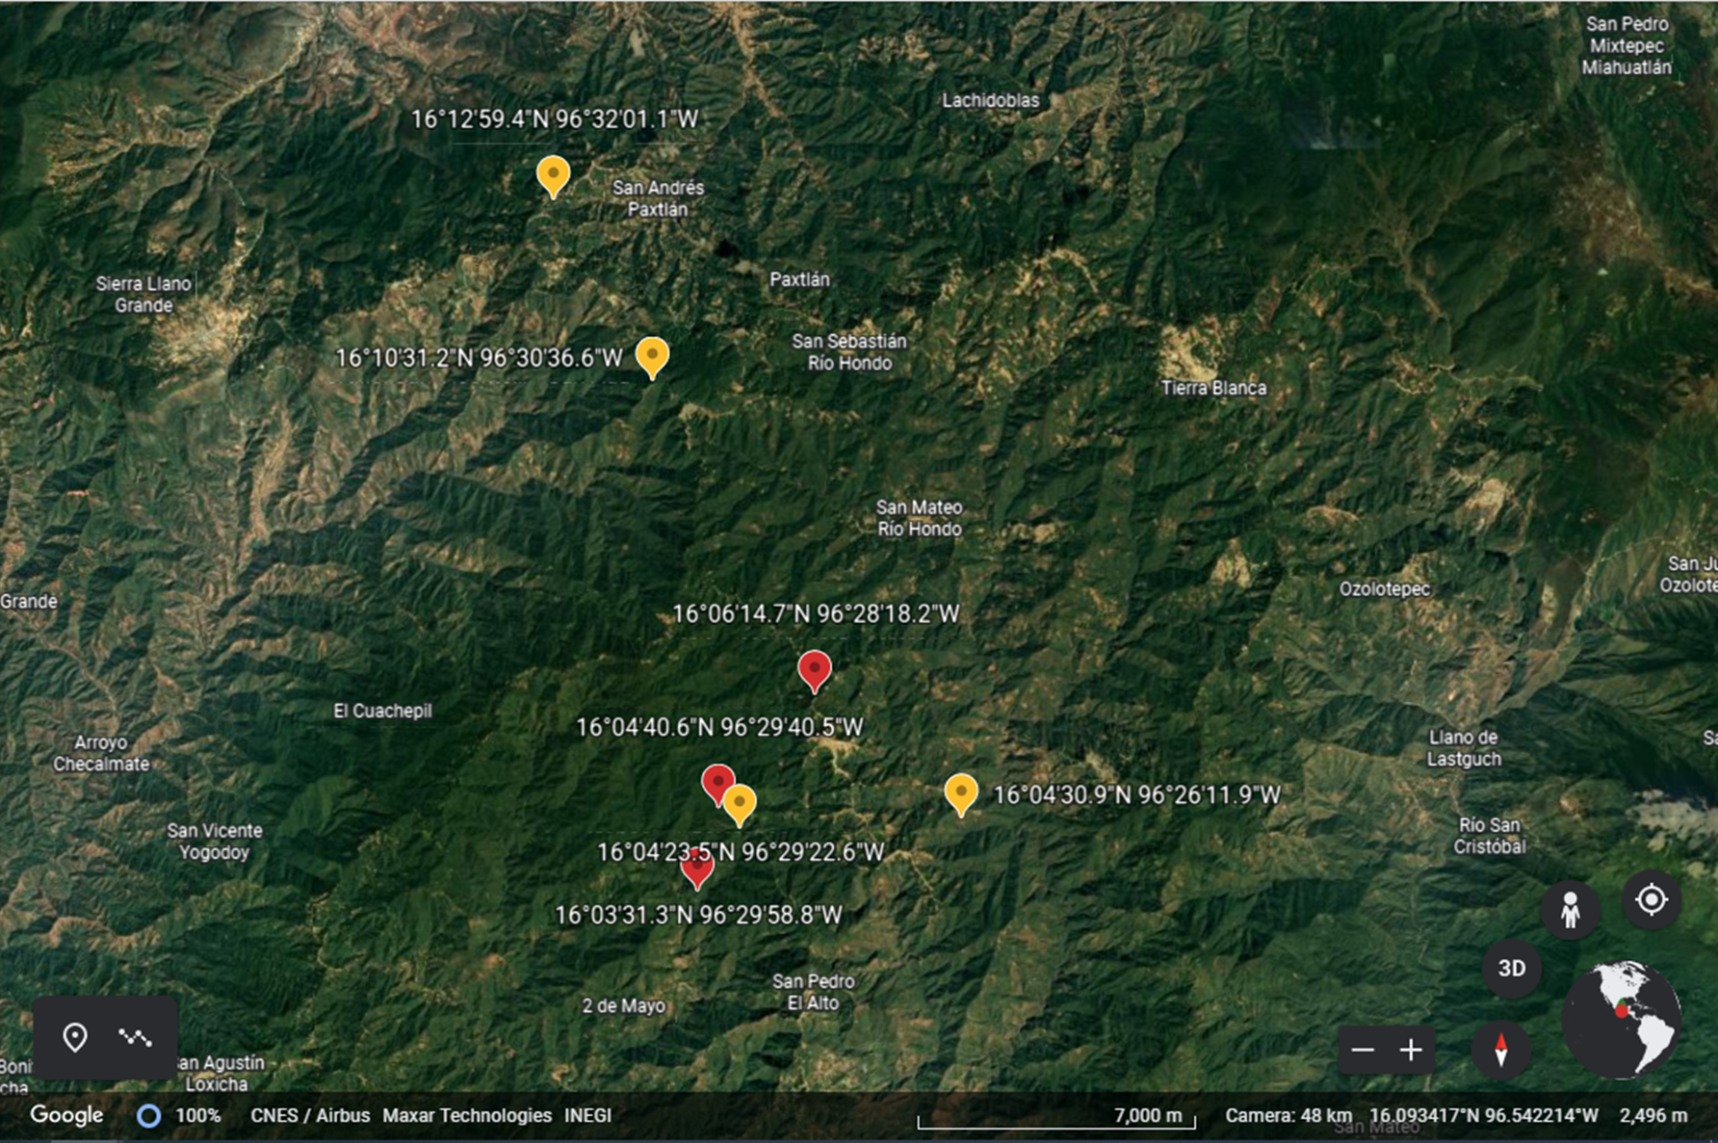

These new records (yellow marks) will increase the current Estimated Area o Occupancy (AOO) of 16 km² and the Estimated Extent of Occurrence (EOO) of 50 km² into a very much broader AOO and EOO. Certainly, with all these new information a reassessment will be conducted and the new assessment will be way more accurate and informative to the stake holders and institutions and agencies interested.

Regarding the northern records (yellow marks), there is an extension of range in straight line of 14 km from the previous known localities (red mark).
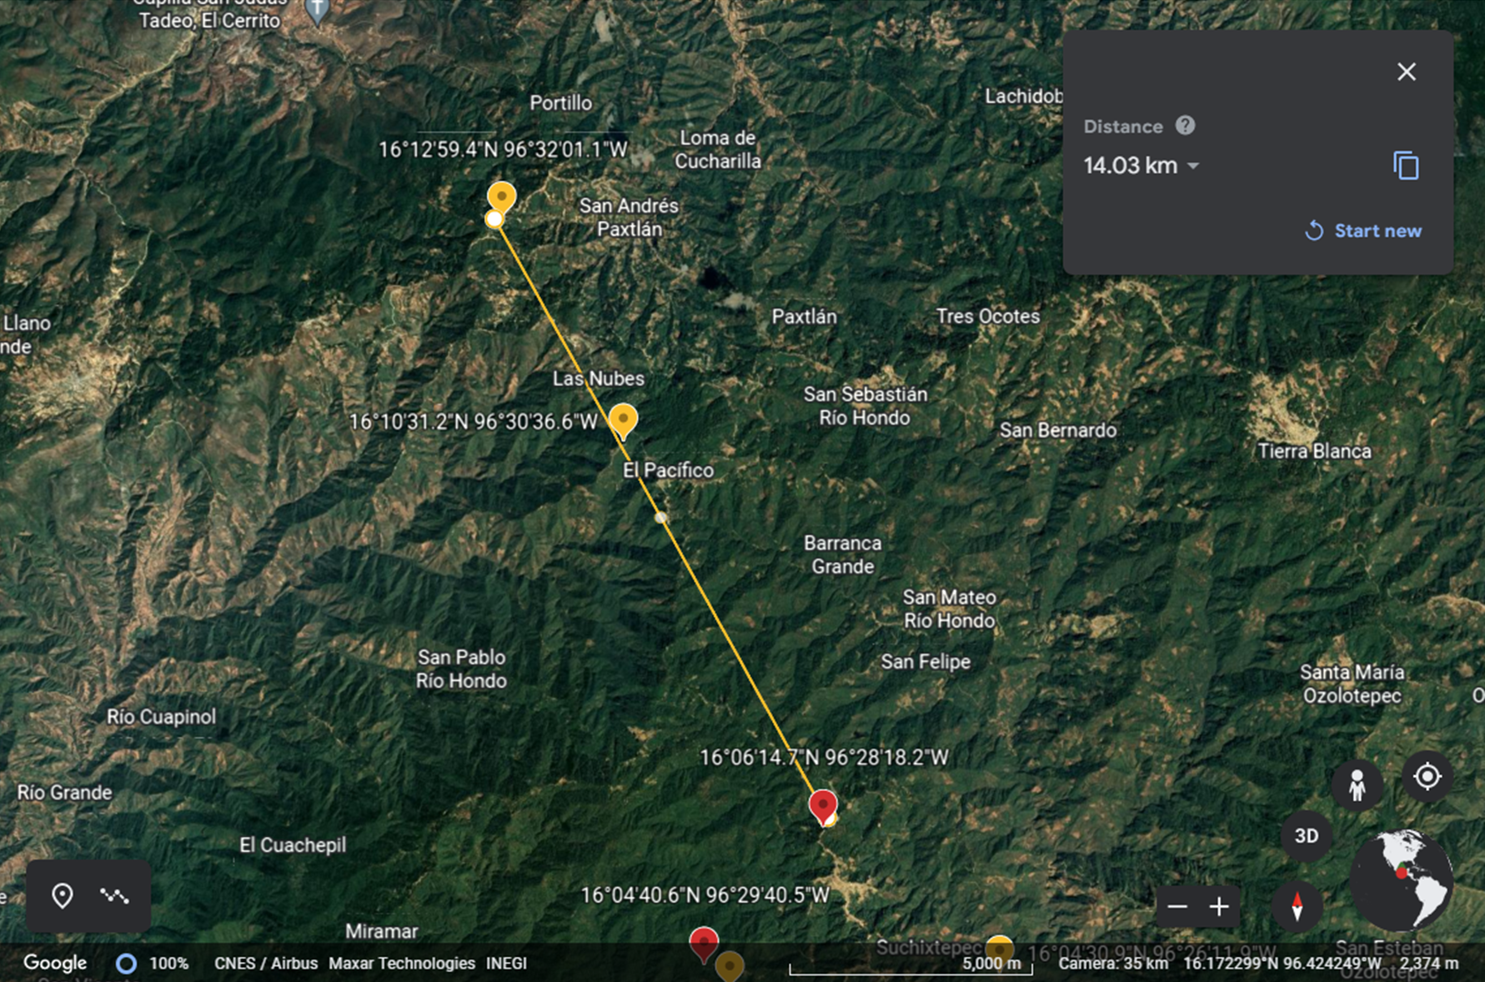
Regarding the eastern record (yellow mark), there is an extension range in straight line of 5 km from the previous known locality (red mark).
