Safeguarding Alwero wetland, Ethiopia's only existing home for the endangered Nile Lechwe.
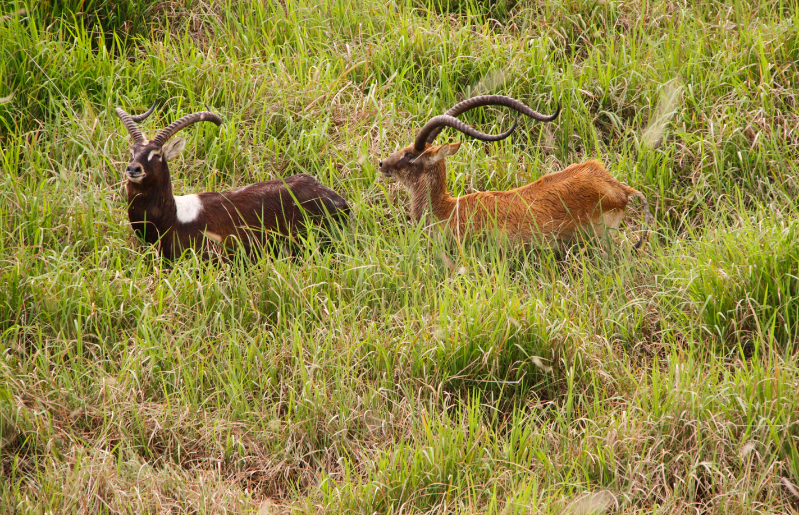

Ecology and threats of the Endangered Nile Lechwe (Kobus Megaceros) in Gambella, Ethiopia
Abstract
It is essential to understand the distribution, habitat use, as well as the attitudes and knowledge of the local community toward wildlife, in order to create and implement conservation management initiatives. This could enhance human-wildlife relationships and wildlife conservation. The rare and endangered Nile lechwe antelope is only found in Ethiopia (the Gambella region), and South Sudan (the Sudd wetlands, and the surrounding marshes). In Ethiopia, it is restricted to Alwero (Duma) wetland. We used direct field survey, questionnaires, and focal group discussions to gather data from the study sites and local households in Gambella, Southwest Ethiopia, between February and June 2023. We investigated the distribution, threats and the main elements influencing local attitudes toward the Endangered Nile Lechwe (Kobus Megaceros) by using a mixed analysis technique. We confirmed that Nile liechwe is restricted to specific sites, the Alwero wetland (49 km²) in Gambella. The estimated population of Nile lechwe in Alwero wetland was 200-300 individuals. Habitat loss and poaching were the major threats identified, the community's attitudes regarding Nile lechwe were 86% positive (40, N = 125), and 12% negative. Respondents with positive attitudes to Nile lechwe’s associated them mainly with its contribution as economical value (through tourism). Negative respondents linked them to the effects of conservation, on the direct use of Nile lechwe (for bush meat), and effect on the grazing land use. The study confirmed that the Alwero wetland is the only habitat for Nile lechwe and other species like Shoebill. Hence, it hat need special conservation attitudes of the community toward Nile lechwe were depends on age, and gender. We strongly suggest increasing awareness of the community toward Nile lechwe, and Alwero wetland conservation.
Key words: Nile lechwe, Gambella wetland, endangered species

- Introduction
The endangered Nile lechwe (Kobus megaceros), is a threatened semi-aquatic species found only in South Sudan and Ethiopia (IUCN, 2017, 2022; Rolkier, 2021; Alier et al., 2021; Fay et al., 2007). The Nile Lechwe population is listed as Endangered due to an estimated population decline of more than 50% over the last 15 years. Currently, Nile lechew’s habitat (wetlands) losses is increasing in alarming way, because the agriculture is transferring from small scale to large scale commercial investment.
Poaching, competition with domestic livestock, and habitat degradation caused by cattle grazing during the dry season all contribute to the population decline of Nile lechwe (IUCN Red list, 2022). The problem is aggravated by the fact that Nile Lechwe is only found in a few geographical areas, Gambella National Park of Ethiopia and Sudd wetland of South Sudan. In Ethiopia, during two wildlife aerial surveys in Gambella (2009 and 2010), 300 to 350 Nile lechwe were estimated. It is restricted within wetlands, mostly in the park (Alwero swamp: Rolkier, 2021). The Gambella National Park, in addition to the Nile lechwe, it is home to a variety of mammals (Such as Elephants, Giraffe, Nile Lechwe, Lelwel Hartebeest, white-eared kob, and Roan Antelope), and birds (Shoebill Stork, Black Crowned Crane, Saddle Billed Stork, African Fish Eagle, and Basra Reed Warbler) reptiles and plant species as well (EWCA GNPO, 2020). These species are segregated in different part of Gambella National Park (fig. 1).
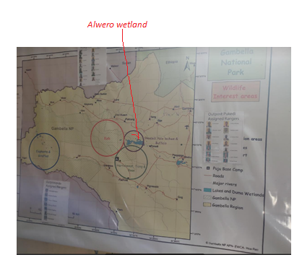
Figure 1. Distribution map of major wildlife in Gambella National Park

Nile Lechwe (fig. 2) is among the less-known endangered species, as a result it has been less considered for conservation, and most of its study were from ex-situ conservation. However, some papers have been published , for instance, the study by Legas and Mamo (2018), was used as a baseline for this project. The paper identified the major factors affecting Nile Lechwe in Gambella, these were agricultural investment, illegal hunting, overgrazing, rice cultivation in the area and habitat loss. Rolkier (2021), published a review paper on the title ‘Current Status of Nile lechwe in Gambella National Park’, where he explained, Alwero wetland as the only important habitat of Nile Lechwe. We studied the distribution, threats, human Nile lechwe conflict, perception of the community toward Nile lechwe, and method of coexistence (finding alternative livelihood). Except a general conservation program to Gambella National Park Biodiversity, there was no project focusses on the conservation of this threatened and rare species in Ethiopia.
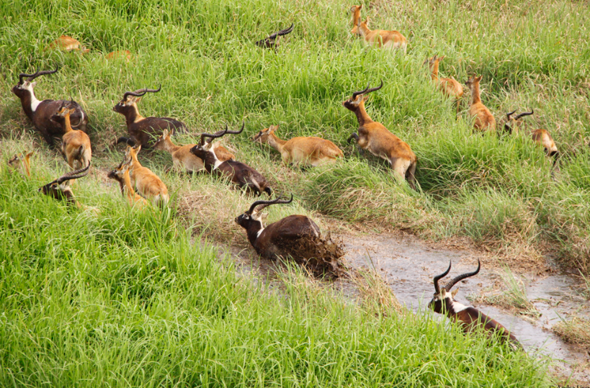
Figure 2. Nile lechwe in Alwero wetland Gambella (Photo from Gambella National park office)
The major goals of this research are to identify Nile lechwe locations for conservation, determine the underlying causes of threats to Nile lechwe, determine community attitudes toward Nile lechwe, and raise community understanding of Nile lechwe. Lastly, the project aimed to identify an alternative form of income for the locals in the vicinity of the Nile lechwe ecosystem in order to support the species' continued sustainable protection.
- Methodologies
Study area
This project was carried out in the Gambella region, with emphasis in the Alwero wetland, which is located in Gambella National Park (GNP; fig. 3), Ethiopia. GNP was established in 1973 as a protected area to protect a diverse assemblage of wildlife and unique habitats, particularly the Nile Lechwe and white-eared Kob (EWCA, 2014).

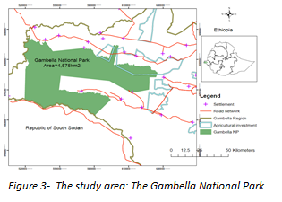
GNP is situated between the coordinates 330 45' and 340 15'E and 07030' and 08015'N.
Methods
Field observation was carried out in both wet and dry seasons in Gambella region. During field observation, equipment’s like GPS, binocular, and camera trap were used for data recording. Respondents were purposively sampled from communities living around Alwero wetland. One hundred and fifty (150) respondents were purposively selected from farmers, development agents, teachers, students, old people and religious leaders residing around the wetlands. Five focus group discussions (FGDs) each consisting 8 participants were held.
In addition to research survey, this project also conducted public outreach and education activities in order to change the attitudes, knowledge, and behaviors of the local community toward the target species. It also trained grassroots conservation leaders to reach out to large numbers of community members.
Both quantitative and qualitative techniques were used for data analysis. All Data were analyzed using R-software
- Result
This study is mainly based on interviews of 150 respondents, FGD and direct field observation
3.1 Respondent demography
150 individals from the community living around the Gambella National park, park staff, Gambella security office were participated. In the selected respondents, though males were more participated, we tried to include females in the interview. Regarding ages both young and older people were included (Table 1).
Table 1. respondents characteristics (sex, age, education status and family size)
Sex | Category | Number
 | Male | 96
 | Female | 54
Age | 18-25 | 32
Age | 26-34 | 56
Age | 35+ | 62
Educational level | Illiterate | 48
Educational level | Primary | 43
Educational level | high school
Educational level | diploma and above | 19
Family size | Lest than or equal to 5 | 54
Family size | 6-9 | 25
Family size | 10+ | 71

3.2 Ecology of Nile lechwe
Distribution
Nile lechwe is limited to Alwero wetlands in Ethiopia. In this study, 97% (n=145) confirmed that Alwero wetland is the only site for Nile lechwe in Ethiopia. This agrees with the Rolkier, 2021. These wetlands receive their water by the Alwero River. The Alwero Dam, which was constructed to assist the area's extensive agricultural production, gets its water from this river. But farming isn't done at the Dam nowadays.
The community's attitudes regarding Nile lechwe conservation were 97% positive (40, ), 9% negative, and 5% neutral. Respondents with positive attitudes to Nile lechwe’s associated them mainly with its contribution as economical value (through tourism). Negative respondents linked them to the effects of conservation, on the direct use of Nile lechwe (for bush meat), and effect on the grazing land use.
Table 2. Answers given by respondents to a few questions on Nile lechwe
Questions | Respondents
Do you think Nile lechwe is restricted to  Alwero in Ethiopia? | Frequency | % | P
- Yes | 145 | 97 | < 0.001
- No | 5 | 3.3
Do you think the population size of Nile lechwe changes with seasons?
- Yes | 150 | 100 | < 0.001
- No | 0 | 0
Do you support conservation of Nile lechwe?
- Yes | 86 | 129 | < 0.001
- No | 14 | 21
Is the population Nile lechwe increasing or decreasing
- increasing | 20 | 13 | < 0.001
- Decreasing | 91 | 61
- No change | 39 | 26
What do you think the major threats of Nile lechwe?
- Habitat loss | 71 | 47 | < 0.001
- poaching | 45 | 30
- Firing their habitat | 51 | 34
- predators | 37 | 25
- other | 5 | 3

3.3 Assessing community dependence on the Alwero wetland
The primary uses of the Alwero Wetland by the locals during the dry season are as a source of fish and bush meat, which includes Nile lechwe (Table 3). As a result, the wetland's resources are primarily what the nearby settlements rely on. This shows that maintaining the wetland requires finding alternate sources of income.

Table 3. Resources that are used by communities from Alwero wetland
Questions | Respondents

Do you use Alwero wetland for: | Yes No
- Fish | 150 | 0 | < 0.001
- Bush meat | 85 | 75
- Grazing land | 79 | 57
- others | 6 | 4

Fish are the primary resource that the communities use from the Alwero wetlands, particularly in the dry season. However, the main food sources during the wet season were bush meats, where, white-eared kob, warthog, buffalo, porcupine, and Nile lechwe are typically utilized. Discussions with the people indicate that as recently the number of wildlife is decreasing, and as a result, the number of hunting wildlife is decreasing.
Water plants and succulent grasses are the diet of nile lechwe (fig.4). When floods decrease, a greater proportion of swamp grasses are consumed, whereas wild rice is believed to be a favored food at the start of the flood season.
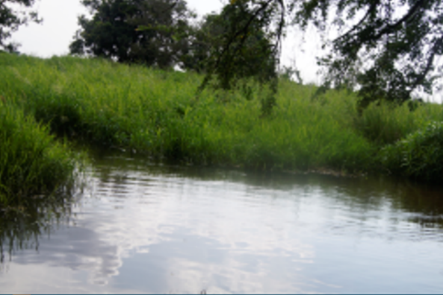
Figure 4. Alwero wetland is fully water with grasses
The Alwero (Duma) wetland
The only remaining habitat for Nile lechwe, the Alwero Wetland is around 49 km² in size. The location is still in danger from humans even though it is a national park. Due to the food source (grasses; fig 5) in the wetland and the fact that Nile lechwe utilize the water as a refuge to defend themselves from predators and people, this habitat is ideal for Nile lechwe.
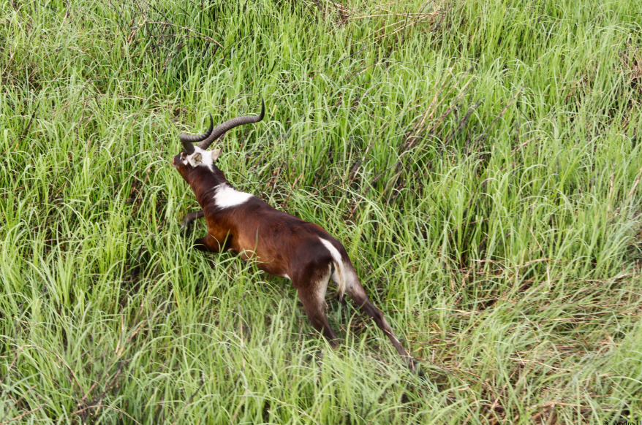

Figure 5. The Alwero wetland grasses as food for Nile lechwe

This study involved raising awareness among hunters and the people surrounding the Alwero wetland (fig. 6), as well as experts who operate in the National Park. The main topics of discussion included the need for wildlife protection, the status of the Nile lechwe and its importance for the growth of ecotourism, the usage of wetlands, and the effects of poaching.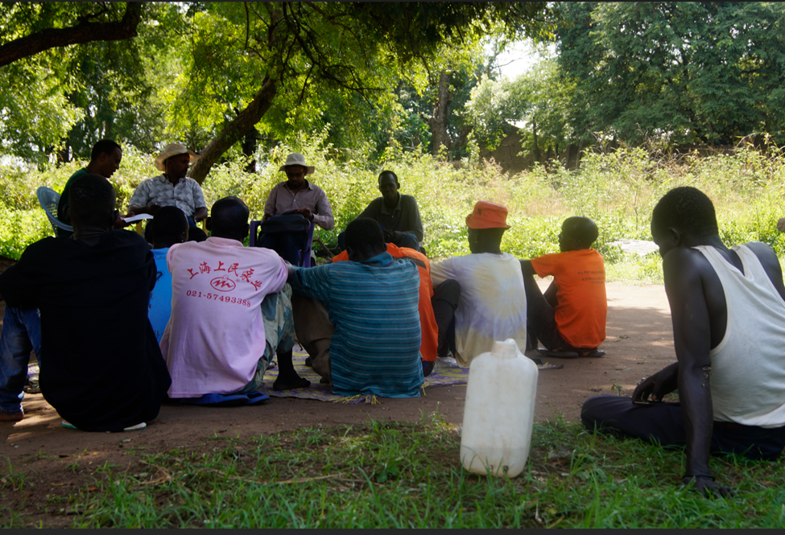
Figure 6. Discussion with local communities at Abobo-Alwero wetland
3.4 Awareness creation
This study involved raising awareness among hunters and the people surrounding the Alwero wetland, as well as experts (fig. 7). The main topics of discussion included the need for wildlife protection, the status of the Nile lechwe and its importance for the growth of ecotourism, the usage of wetlands, and the effects of poaching.
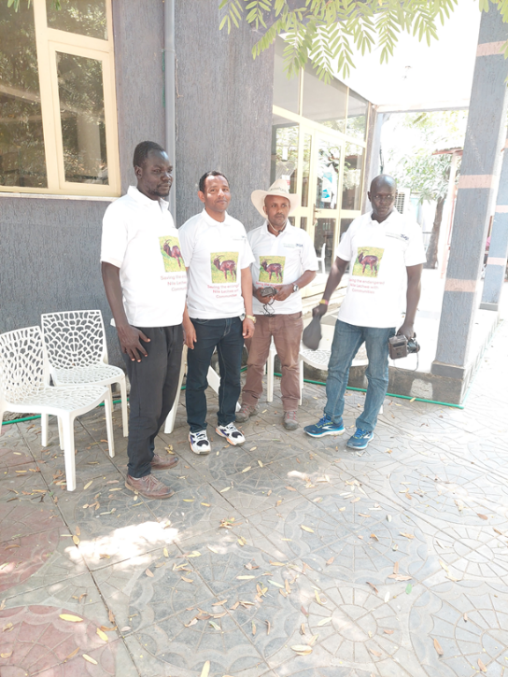
Figure 7. Training for expertise in Gambella region

3.5 Threats of Nile lechwe
The study found that poaching and habitat destruction during the dry season are the main threats to Nille lechwe (Table 4).
Table 4: Major threats of Alwero wetland according to respondents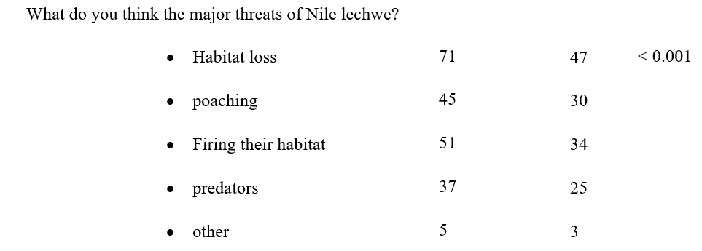

Challenges to study Nile lechwe in the study area

Heavy flood
The Alwero wetland has been survived by its intense flooding, which made it impossible for the locals to utilize the resources there, including the Nile lechwe (Fig. 7).

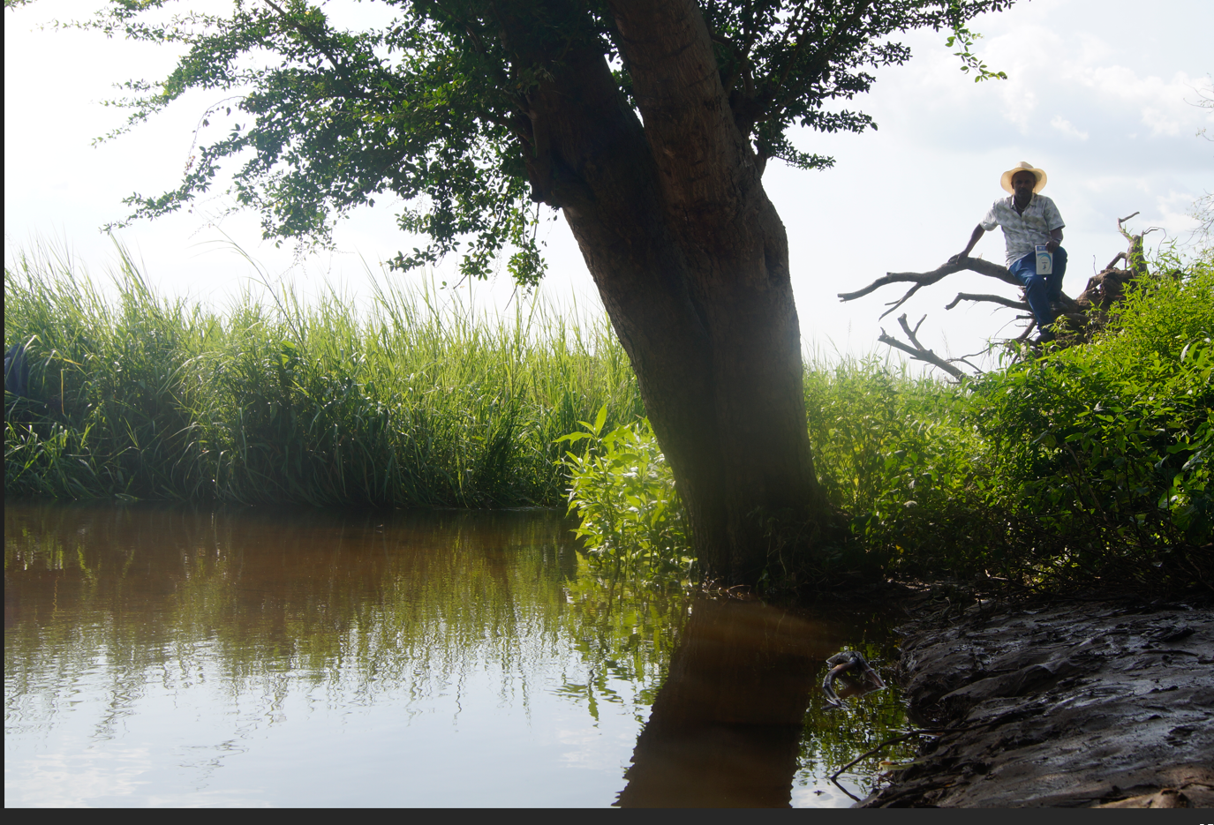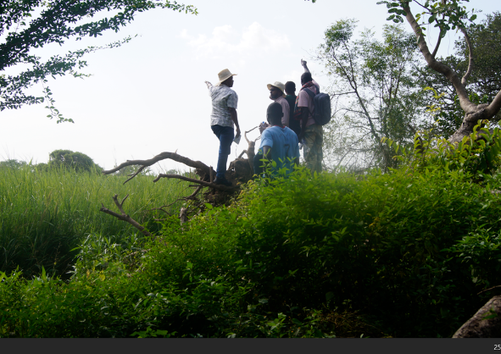
Figure 8. Looking habitat of Nile lechwe from distance (solution: arial survey)

Security
Security issues were one of the difficulties to undertake research in this area, but we overcame it by hiring people who are knowledgeable about the area and are well-trained (fig.)

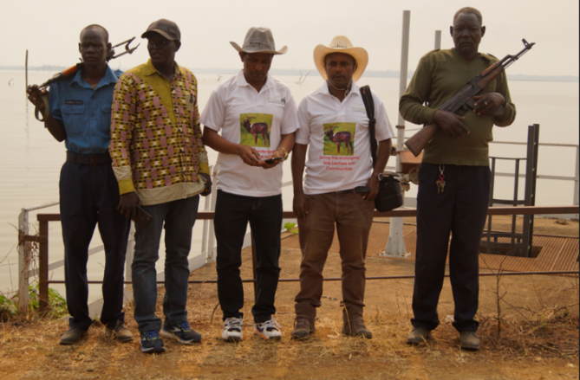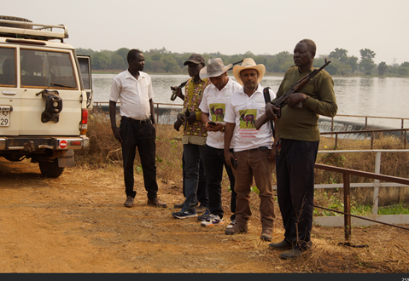
Figure 9. The researchers with the local security police on the study area

- Conclusion and Recommendation
The endangered Nile lechwe is currently limited to only two wetlands: South Sudan's Sudd wetland and Ethiopia's Alwero wetland in Gambella region (Duma wetland). These habitat are
Fish farming, apiculture, multipurpose fruits can be a potential alternative livelihood in the area.
We advise concentrating on enhancing alternative revenue streams for the nearby community that rely on the Alwero wetland and increasing public awareness. At Alwero Wetland, specific species such as Shoebill storks and Nile lechwe require special attention.
The communities surrounding the wetland may benefit economically from the Alwero dam (fig 8) if it is used carefully. But, to preserve the habitat of the Nile Lechwe, this dam needs to be used responsibly.
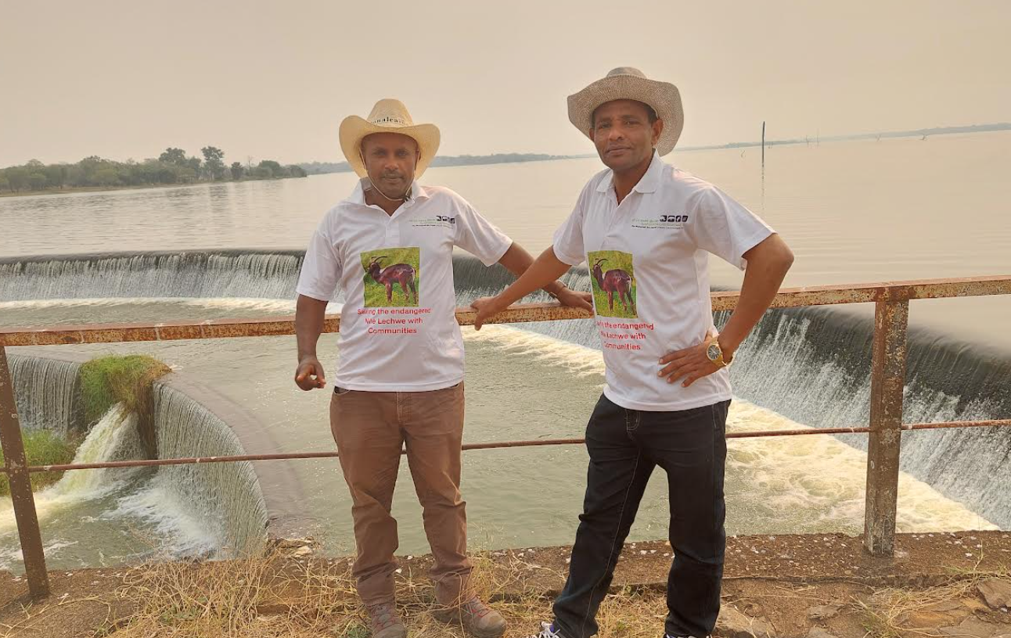
- Acknowledgement
We thank Mohamed Bin Zayed Species Conservation Fund, for financial support and Threatened Species Conservation Organization for s
haring their field equipment and expertise. We thank EWCA for research permission.

- References
Rolkier, G., 2021. Current Status of Nile lechwe in Gambella National Park. Scientific Reports in Life Sciences, 2(3), pp.18-24.
Alier, G., Idohou, R., Hounsou-Dindin, G. and Glèlè Kakaï, R., 2023. Assessing the potential impact of climate change on Kobus megaceros in South Sudan: a combination of geostatistical and species distribution modelling. Modeling Earth Systems and Environment, pp.1-12.Groves,
Colin; Peter Grubbs (2011). Ungulate Taxonomy. USA: The Johns Hopkins University Press. p. 191. ISBN 978-1-4214-0093-8.
Falchetti, E.; Ceccarelli, A.1993. "A peculiar behaviour of the dominant males of Nile lechwes (Kobus megaceros, Bovidae Reduncinae): urination on the neck". Ethology Ecology & Evolution. 5 (3): 392–393.
Falchetti, E. 1998. General issues in the conservation biology of Nile Lechwe (Kobus megaceros) and preliminary guidelines for an action plan. Part 2. IUCN/SSC Antelope
Fay, M., Elkan, P., Marjan, M. and Grossman, F. 2007. Aerial Surveys of Wildlife, Livestock, and Human Activity in and around Existing and Proposed Protected Areas of Southern Sudan, Dry Season 2007. WCS – Southern Sudan Technical Report.
IUCN. 2017. The IUCN Red List of Threatened Species. Version 2017-2. Available at: www.iucnredlist.org. (Accessed: 14 September 2017).
Legas, M.S. and Mamo, B.T., 2018. Impact of human activities on wildlife: the case of Nile Lechwe in Gambella National Park Southwest Ethiopia. International Journal of Conservation Science, 9(4).

