Project Update

Title: Search for the Rocky Glider: Assessing the distribution of Eupetaurus cinereus in the Uttarakhand Himalaya, India

Period: July 2023- Jan 2024

Project supported by:



Submitted by: Hiranmoy Chetia
PhD Research Scholar,
Amity University, Noida,
Uttar Pradesh, India
Materials and Methods
Questionnaire surveys:
We started our study in Uttarkashi district (Figure 1), which is in the northern part of the Indian state of Uttarakhand. The study period was from July 2023 to January 2024. We covered four villages: Agoda, Gangnani, Dharali, and Mukhba. Dharali, Mukhba and Gangnani are located in the buffer of Gangotri National Park. Agoda is in the buffer of the Barahat Range of the Uttarkashi Forest Division. The basis of the selection of the villages is the record of the Wolly Flying Squirrel (WFS) from the Bhagirathi basin (Pal et al. 2019, 2020). We interviewed total of 65 people belonging to Pahadi and Nepali communities. These included people who live in villages (Villagers), herders (Bakarwhals), people who organize tours (Tour Operators), guides who help people explore the mountains (Trekking guides), and people who work manual jobs (labourers). We chose to talk to people who regularly venture to high altitudes as part of their work or daily life. The interviews were based on a semi-structured questionnaire about the information on the WFS.
Deployment of Camera Traps:
To investigate the presence of the Woolly Flying Squirrel (WFS) in the Bhagirathi Basin of Harsil Valley, six camera traps for three months (October-December 2023) were strategically deployed at the base of the Srikant Mountain range. This specific location was chosen based on documented evidence of WFS presence in the region, as reported by Pal et al. (2019, 2020). Their prior research provided valuable insights into the potential habitat range of the WFS within the basin.

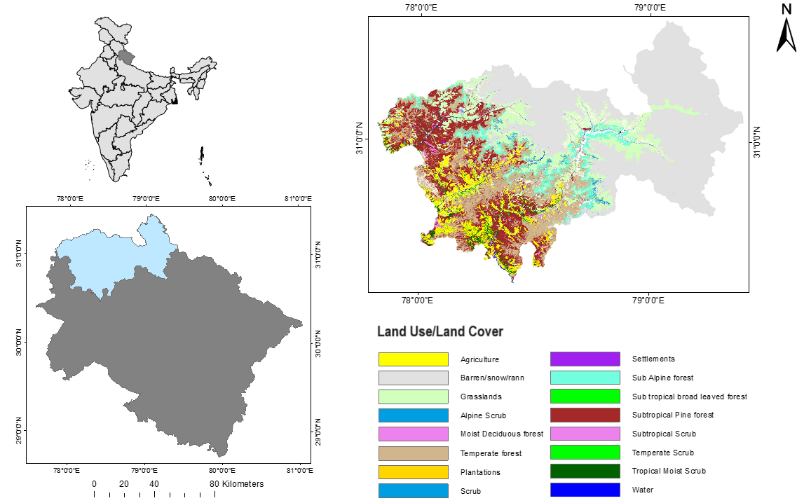
Figure 1. Location of Uttarkashi district in India
Results
Questionnaire Survey:
Our survey revealed a significant knowledge gap regarding the Woolly Flying Squirrel (WFS) among the general public. A large majority (96%) of participants had no prior knowledge of this unique species. Even when presented with an image, many individuals (65%) confused the WFS with more familiar animals, primarily the Yellow-throated Marten and Mountain Weasel. This confusion is likely due to the similar size of these creatures, along with the higher visibility of Martens and Weasels in the local area.
However, there were a few exceptions. Two respondents from Dharali, a tour operator and a mountaineer, mentioned potentially encountering the WFS during high-altitude treks. However, their identifications remained uncertain.
Camera traps result:
Despite deploying six camera traps at the base of the Srikant Mountain range for three months, the elusive Woolly Flying Squirrel was only captured once during our survey and the quality of the image is also not good (malfunctioning because of snow) (Figure 2, Zoomed image in Figure 3). This raises significant concerns. Climate change is rapidly altering the landscape of these high-altitude environments. Rising temperatures, changes in precipitation patterns, and increased frequency of extreme weather events are all contributing factors. These alterations have the potential to significantly impact the habitat suitability of the WFS.
Limitations of the study:
This study serves as a valuable initial exploration of public awareness regarding the WFS and offers valuable insights into the knowledge gaps that exist. However, acknowledging the limitations of the research strengthens the overall presentation and paves the way for future investigations.
Sample Size: The study relied on a sample size of 65 individuals. While this initial data provides a helpful starting point, a larger sample size would be necessary to ensure the generalizability of the findings to the broader population within the region. Expanding the participant pool in subsequent studies would allow for a more comprehensive understanding of community awareness and perspectives on the WFS.
Camera trap duration of the study: Owing to bad weather conditions we were only able to conduct the camera trap survey for three months. This time duration may not have been sufficient to capture potential seasonal variations in sightings. Extending the duration of the study in future efforts could provide a more detailed insight into the WFS.
Next Steps:
Recognising these limitations emphasizes the need for further research. Employing larger sample sizes and extending the study duration will enable researchers to comprehensively understand the dynamics surrounding the WFS.
Acknowledgement:
We express our heartfelt gratitude to the Principal Chief Conservator of Forest, Uttarakhand, for graciously granting permission for this vital study to take place. In addition, our sincerest appreciation goes out to the warm-hearted residents of Dharali, Mukhba, Gangnani, and Agoda villages, whose unwavering support was instrumental throughout the duration of our study. Furthermore, we express our deepest thanks to Anil Bisht, Jaydev Panwar, Lokesh (Lucky) Panwar of Dharali, and Sajan Rawat of Agoda for their guidance during our field expeditions.

References:
Pal, R., Bhattacharya, T., & Sathyakumar, S. (2020). Woolly Flying Squirrel Eupetaurus cinereus: A New Addition to the Diet of Snow Leopard Panthera uncia. Journal of the Bombay Natural History Society (JBNHS), 117.
Pal, R., Thakur, S., Bhattacharya, T., & Sathyakumar, S. (2019). Range extension and high elevation record for the endangered woolly flying squirrel Eupetaurus cinereus in western Himalaya, India. Mammalia, 83(4), 410-414.
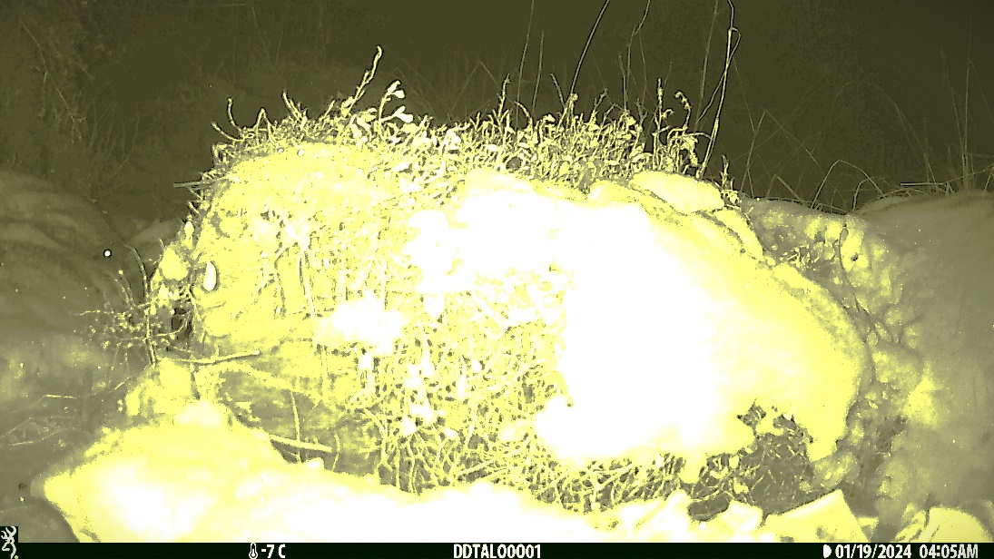
Figure 2: A hazy camera trap image of WFS

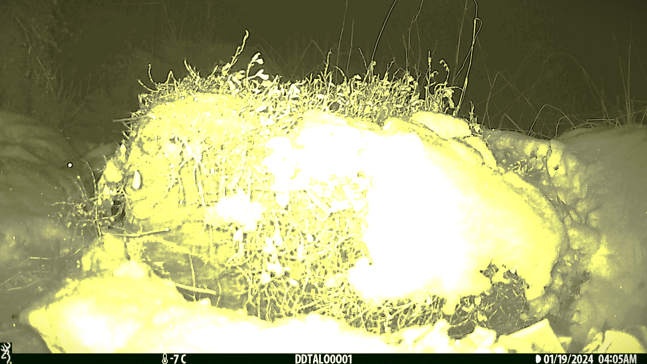

Figure 3: Zoomed-out image of Figure 2, which shows the head of the WFS
Photos of some important wildlife from the study area:
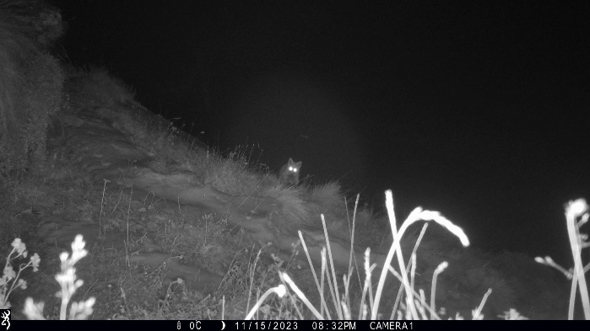  Himalayan Red Fox  (Vulpes vulpes montana) | 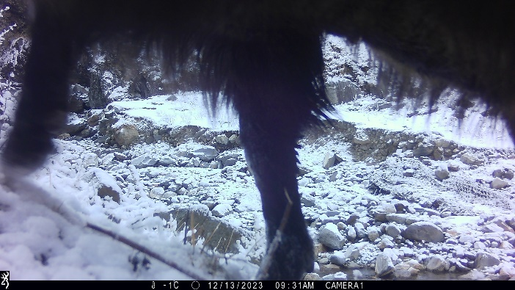  Himalayan tahr  (Hemitragus jemlahicus)
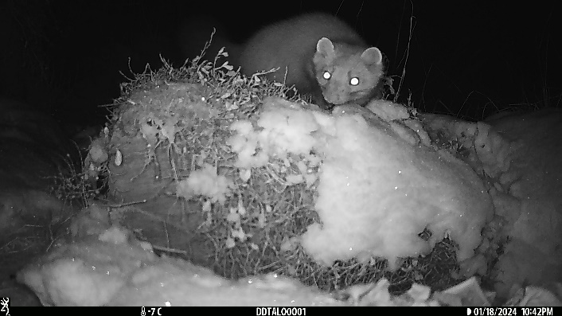  Mountain weasel  (Mustela altaica) | 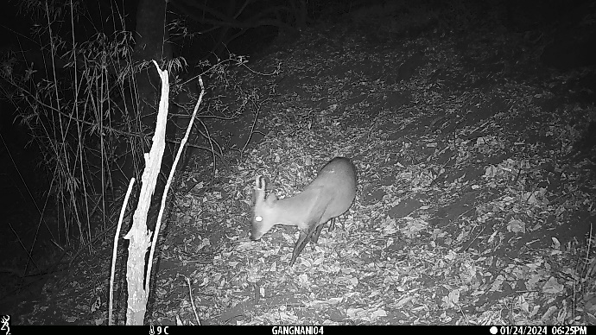  Muntjak/Barking deer  (Muntiacus muntjak)
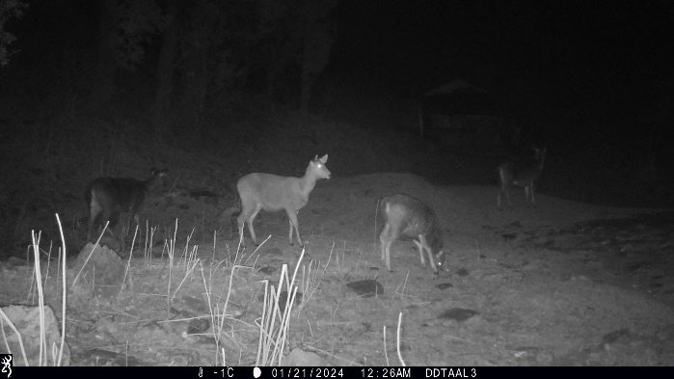  Sambar deer  (Rusa unicolor) | 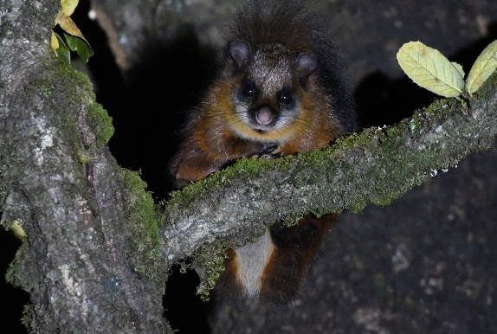  Red Giant Gliding Squirrel  (Petaurista petaurista)

