In-situ assessment of the current status of endemic Aloe species of Tanzania
Tanzania has more than 52 known species of Aloe recorded in the Floral of Tropical East Africa (Aloaceae, 1994) that have restricted distribution. Eight (8) species are known from their type location only. These are A. babatiensis, A brandhamii, A. bullockii, A. congdonii A. dorotheae, A.flexilifolia, A. leptosiphon and A. leedalii. Three (3) species are recorded in two locations (A. leachii, A. brachystachys and A.sobolifera) while only two (2) species are recorded in three locations (A.bussei and A. richardsiae).

For this project Endemic Aloe species to Tanzania were given the priority. The aim is to assess field status of the species and the quality of their locations. However, during the application of the fund, 3 species were given the priority. These were Aloe dorotheae, A. leptosiphon and A. flexilifolia
During the first 2 months (July – August) of the grant we were able to assess the populations and habitats of critically endangered (CR) Aloe dorotheae.
Aloe dorotheae is threatened at its single location in Tanzania in Tanga Region, Handeni district in Kang’ata Ward, Madebe village. It grows on rocky grounds with only shallow soils resulting from decomposing leaves biomass brought on the rock by wind. The rocky ground is surrounded by banana and vegetable gardens because the rocky ground has some holes which keep rain water which is used during drier periods for domestic, livestock and irrigation. A. dorotheae plant (Kikori in Zigua) is used for treatment of human and livestock various diseases and seasoning of local brew due to its bitter taste. Before our visit the Madebe villagers were not aware that the plant is endemic to their area and that unsustainable harvesting is threatening the continued existence of the plant. A. dorotheae is in 6 patches of an area of ca. 1.4 km^{2,} each patch with about 200 or less mature individuals.
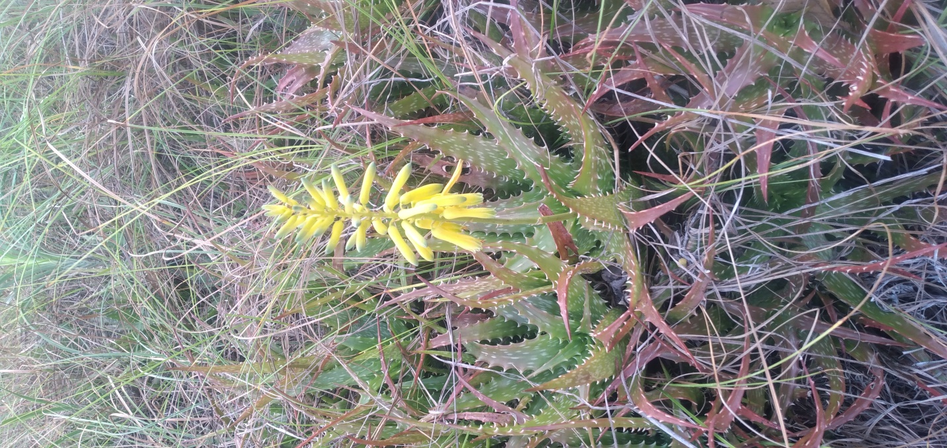
Figure 1: Aloe dorotheae

During September to December 2022 and January – April 2023, the assessment was done for the other five (5) endemic Tanzania Aloe species. These are Aloe babatiensis, A. bussei, Aloe leptosiphon, A. flexilifolia and A.leedalii
Aloe flexilifolia – The type location for A. flexilifolia is Tanga Region in Lushoto district along Mombo – Soni road (4.88254S; 38.33620E; 929m asl.). A. flexilifolia is always hanging on about 10 – 20 m high rocky cliffs faces with very shallow soils and due to shallow soils their self-propagation is difficult. The species is also harvested for medicinal use. The habitats around the rocks are highly used for agriculture and grazing an indication that the cliffs might as well be affected at a greater extent.

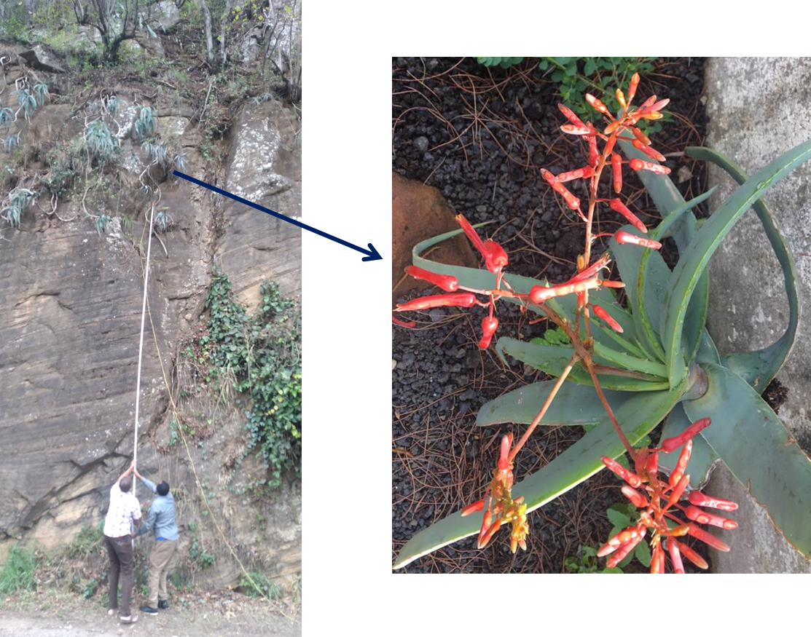
Figure 2: Aloe flexilifolia

Aloe leptosiphon – The type location was visited in Tanga region, Lushoto district near Maweni camp in Sony village. The rocky cliff where the plant is hanging is surrounded by maize and banana farms whereby the farm owners confessed to have cleared A. leptosiphon for more farms. During the visit into this area, goats and cows were found grazing on the rock cliffs, thus facilitating the erosion of the thin top soil which holds the plants. The villagers use the leaves of the plant for treatment of human and chicken and livestock diseases. Human influence threatens the existence of the species. The 200m² area has about 70 individuals of A. leptosiphon.

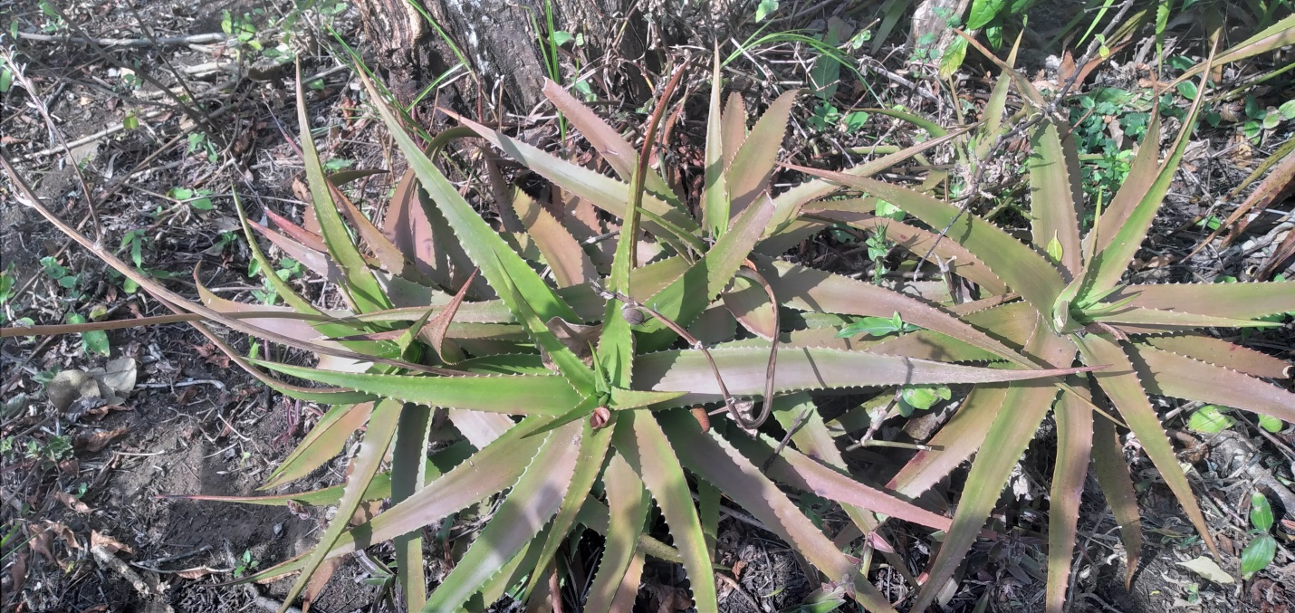
Figure 3: Aloe leptosiphon

Moreover all Aloe species encountered during field surveys are planted in a Botanical Garden at the premises of Tanzania Plant Health and Pesticides Authority (TPHPA), the Garden is managed and cared by the staff of National Herbarium of Tanzania (NHT). Specimens are curated and managed at the NHT as well. The established Aloe species in the Botanical garden will be used for training and awareness creation on their in-situ status, threats and endemism. It is also important as it serves as an ex-situ back-up population of the threatened in-situ populations.
Aloe leedalii – This species is endemic in the southern highlands of Tanzania. The type locality is Kipengere Mountains at Fulaningi ridge above Wangama village. It couldn’t be found at this locality. However the plant was found at Mtorwi hill slopes (9.080598⁰; 34.017732⁰; 2842.87 m asl.) in association with Aloe nutii; at the edges of Mwakipembo swamp inside Kitulo National Park (9.05582⁰; 33.91858⁰; 2587 m asl). This species is within the National park, therefore its habitat is protected from any harvest or human influence that may lead to land use change. Other Aloes species found in the southern highlands of Tanzania during the surveys were A. chaubadii, A. myriacantha and A. lateritia in Kipengere Game reserve. All these are under the Game Authority, thus safely protected.
Aloe babatiensis is threatened more than is known before. This species is known from the type location in Manyara region in a populated village at water catchment points in Bashnet Village. One point is Masakta sub village (04.24681⁰S; 035.42688⁰E; Alt. 2085 m asl.), where we counted 53 standing individuals while in the second point Ayayae sub village (04.25392⁰S; 035.42882⁰E; 2061 m asl.), we counted 2 standing individuals on a rock surface and in another point same sub village (04.26986⁰S; 035.4282⁰4E; 1985 m asl.) they were 73 individuals. We observed human activities in these locations that threaten the continued existence of the Aloe babatiensis. Major activity in water points is the mud bricks making at the water catchment points which depleted all of the surface soils and leave big pits resulting into removal of vegetation including Aloe babatiensis in the habitat.
Aloe bussei – The type location (1908) was visited in Dodoma Region, Mpwapwa District Pembamoto village (6.2656⁰S; 36.8014⁰E; 1268 m asl.). The locality now is a highly populated village with maize and sunflower farms with small patch remains of used natural woodland. Individuals of Aloe bussei are within a stretch of ca. (500 x 200) m² between the farms. We predict that due to ever increasing human population which lead to land use change, A. bussei will extinct from the type location in the near future as human may clear the whole woodland for cultivation. Another patch in Dodoma along the Dodoma Iringa road, 85 km away from Dodoma at Fufu village (6.71553⁰; 34.01840⁰; 750 m asl) in a stretch of ca. 200 x 20 m had about 100 individuals of A. bussei. This patch is natural woodland surrounded by maize, beans and sunflower farms. The patch seems to be continually shrinking for expansion of farms and pathways.
During the survey we found other Aloe species which couldn’t be identified immediately without flowers/inflorescences. One Aloe species in Kilosa District, Magubike village (06.25702⁰S; 037.15643⁰E; Alt. 800 m asl. The other two Aloe species in Babati District, Bashent village and one more Aloe species in Handeni District, Madebe Village (05.63073⁰S; 038.01789⁰E; Alt. 625m asl.).

