Mainland Metro News | Obudu Montane ecosystem needs protection…Conservation group warns of endangered species | All the news you need...
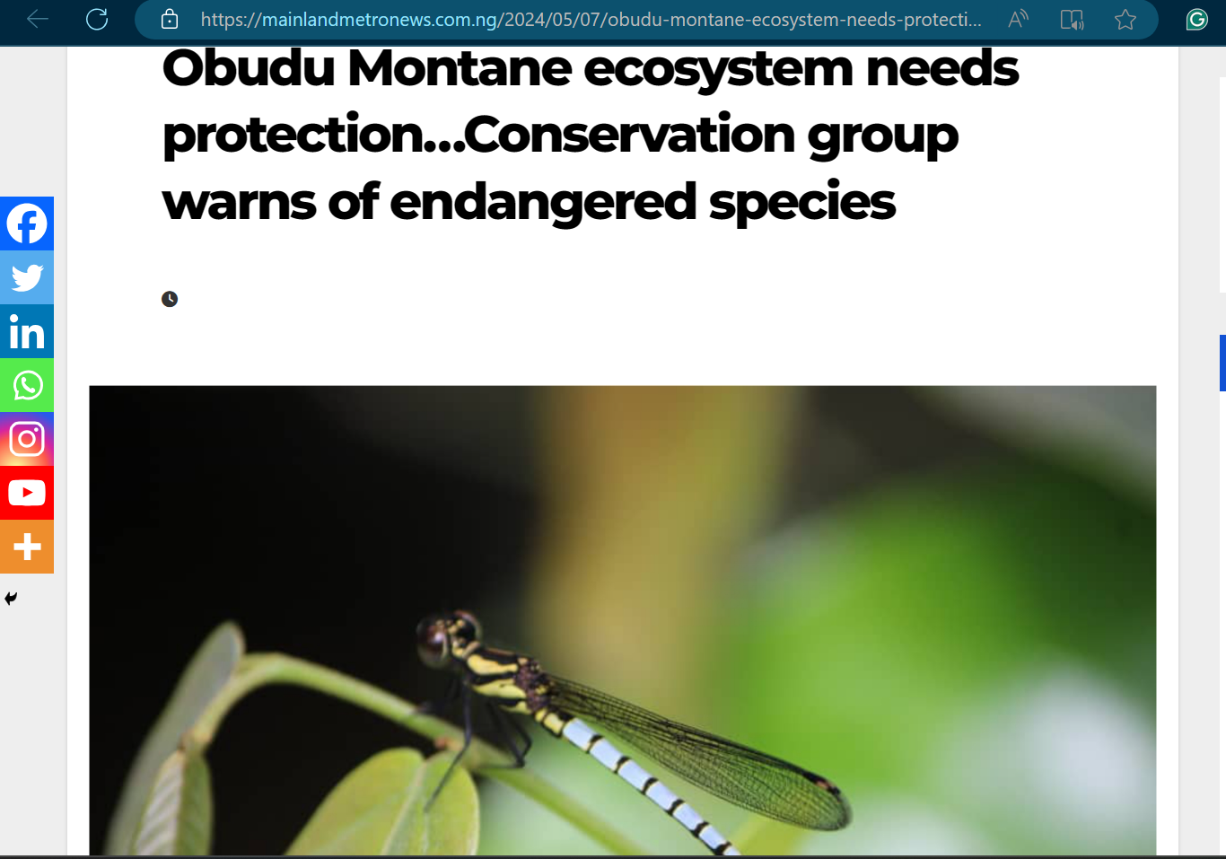

Conservation projects on the threatened Damselflies of Obudu mountains, Nigeria – Ecophilic Scientific Research and Innovations Limited (ecophilicnetwork.com)
