(Project 232526282)
THE ROLE OF COMMUNITY RANGERS AS CITIZEN SCIENTISTS IN RESEARCH AND CONSERVATION OF PANGOLINS IN THE DENG-DENG NATIONAL PARK (DDNP)
REPORT ON CAMERA TRAPS AND REFRESHER COURSE FOR THE COMMUNITY RANGERS

May 2024 By
Esong Lionel Ebong
Buea, SWR Cameroon
+237679869280

ACKNOWLEDGEMENT: I and the Community Rangers Project team do express our heartfelt gratitude to Mohammed Bin Zayed through the MBZCF for giving the opportunity for this project to come to fruition. This project has not merely taken us a step forward to conserving pangolins, it was a wonderful chance to build a positive and confident relationship between the researchers, the project team and the park agents. The project has equally enhanced my team and project management skills
GENERAL OBJECTIVE: The general objective of this project’s phase was to retrieve camera traps and conduct biomonitoring after the second phase (rainy season) of surveys.
SPECIFIC OBJECTIVES: The specific objectives include (i) to recover installed camera traps after 03 months of surveys to confirm local’s knowledge in identifying the Giant pangolin stronghold habitats, (ii) monitor and evaluate field assistants’ mastery and use of SMART for biomonitoring and ethics in conservation (iii) and to provide refresher training to the local guides (Community Rangers).
RESEARCH SITE: Deng-Deng National Park (DDNP), East Region of Cameroon
TEAM MEMBERS:
- Esong Lionel Ebong (Team Leader)
- LIYONG Giscard Léon, Eco-guard MINFOF
- Wapan Floribert, (Disengaged Hunter and Local Field Guide)
- DODO Fridolin, (Disengaged Hunter and Local Field Guide)
- Abba Jackson (Disengaged Hunter and Local Field Guide)
- Hanboa Esaie (Disengaged Hunter and Local Field Guide)
- Mola (Disengaged Hunter and Local Field Guide)

APPROACH/METHOD
Upon arrival in Bertoua we were welcomed by the Conservator of the Divisional Delegation of Forestry and Wildlife, Mr Meka Jean who once again verified the project permit. He then ushered us to proceed to Deng-Deng village, where we welcomed by Mr Liyong Giscard an ecoguard that has been dedicated to this project. The local guides were already mobilized by Mr Liyong, and the following day May 2nd 2024) we moved into the park through the Deng-Deng village navigating through the direction where the greatest number of cameras were located.
- RETRIEVAL OF CAMERA TRAPS
The GPS coordinates of the Mp-C2 camera located at a distance of 09 km from the village (Figure 1) was our target point at the entrance to the park; this distance was covered in 2 days. The Cbi-02, Zsl-b60 and Mp-c3 cameras were removed on the third day while we were also recording vital ecological and human features. The remaining target cameras were Zsl-C70, Mp-C5, Zsl-b59, Mp-C7, Mp-C4, Cbi-01, Zsl-C60 and Zsl-b80, Zsl-C43, Zsl-c13 and Zsl-C74. Each camera was removed after taking the last one photo; which is an A4 format filmed with the name of the team removing the camera and the camera removal date. We noted the type of forests and the characteristics of each habitat where the cameras were removed, recorded the GPS coordinates of all the rivers crossed to determine the distance from the closest watercourse to habitat.
Preliminary results
The presence of Pangolins in the study site of the Deng-Deng National Park (DDNP) based on Cameras installed in the southern forest zone shows a majority with successful detection and taking images of animals in general and mainly that of the Pangolin. The cameras confirmed the presence of Pangolins in the park as well as in the different installation locations considered namely: simple dead tree trunks dead tree trunks with burrows housing and ground housing burrows (Fig 3E), tree trunks with sites nutrition and ground nutrition sites. And in different types of forests namely: mixed forests with open undergrowth (FMSO), mixed forests with closed undergrowth (FMSF), in mixed liana forests (FML), in a savannah-forest transition zone (F-S) and the marsh/swamps with Raphia. The pangolin species photographed in this area of the park is mostly Phataginus tricuspis, (White-bellied Pangolin) with just two photos of the giant pangolin.
Distribution of Pangolins according to installation sites
Twelve (12) camera traps out of fifteen (15) photographed the Pangolin in its habitat. Three (03) camera traps did not show photos of Pangolins. Cameras installed on single tree trunks showed a large success in photographing Pangolins (Mp-C2, Cbi-02, Zsl-b60, Mp-c3) with 88 photos, followed by the camera installed on the tree trunk with nutrition sites of termites (ZSL-C13) with 11 photos and cameras installed on ground nutrition site (Zsl-b80, Zsl-C43 and Zsl-C74) with 10 photos. Cameras installed on tree burrows (Zsl-C70, Zsl-b59, Mp-C7, Zsl-C60) and those installed on the ground burrows (Cbi-01) have showed little success in photographing Pangolins with 2 photos for each site (see attached map on media section).
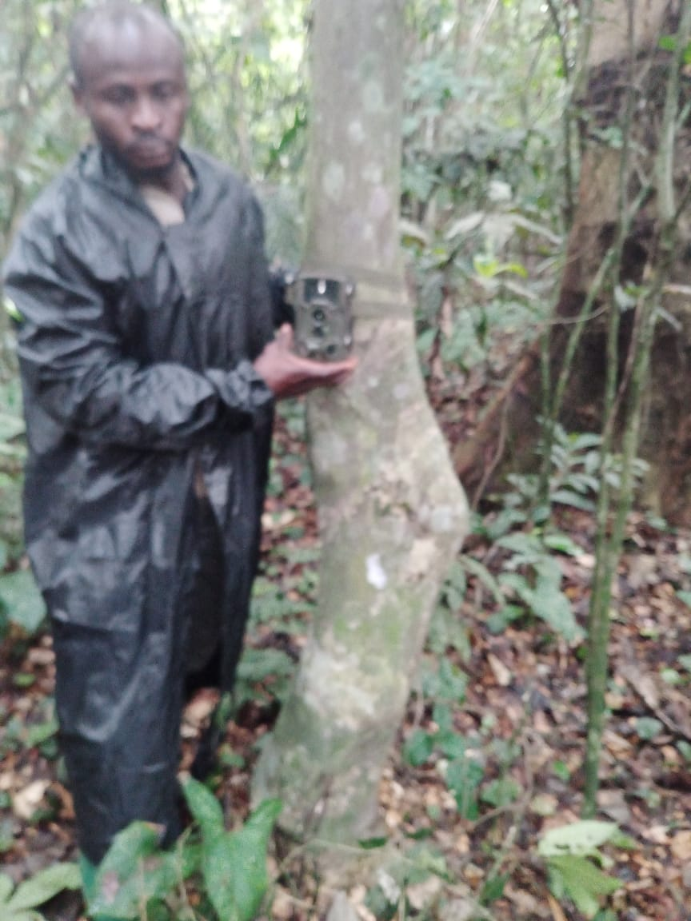
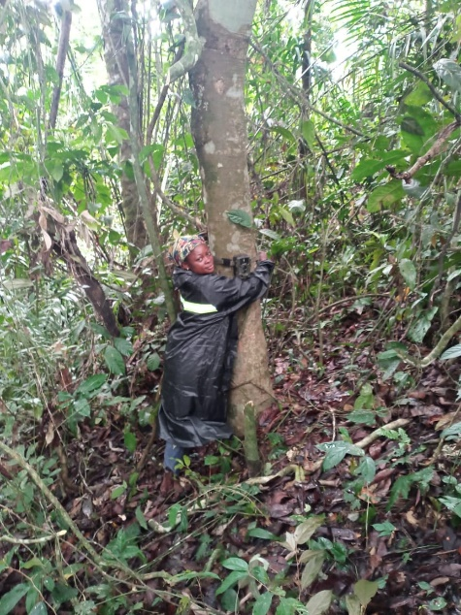
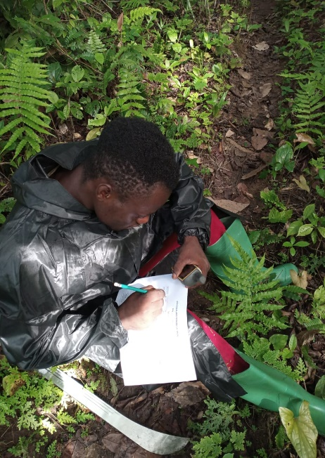Community Ranger filling data sheet Camera trap set up by a community Ranger
Distribution of Pangolins depending on forest type
Cameras installed in mixed liana forests (MLF) have shown great success in the photography of Pangolins with 90 photos, followed by the cameras installed mixed forests with open understory (FMSO) with 19 photos and cameras installed in swamp forests (FM) with 4 photos. The camera installed in the transition zone savannah-forest (F-S) (zone of replacement of savannah by forest) showed low success in the photography of Pangolins with 2 photos (see table below).
Distribution of the cameras as a function of their place of installation, thestate of operation and the success in the photography of Pangolins
Cameras installed | Types of forests | installation Sites, | operating condition | Number of photos  of pangolins
Mp-C2 | FML | Tree Trunk simple | good | 2
Cbi-02 | FML | tree Trunk simple | good | 9
Zsl-b60 | FM | tree Trunk simple | good | 2
Mp-c3 | FML | tree Trunk simple | good | 3
Zsl-C70 | FMSO | Terrier on tree | good | 0
Mp-C5 | FML | Trunk of a tree with terrier | good | 2
Zsl-b59 | FML | Terrier on tree | good | 0
Mp-C7 | FM | Terrier on tree | good | 0
Mp C4 | FML | tree Trunk simple | good | 3
Cbi-01 | FMSO | Terrier on the ground | good | 2
Zsl-C60 | FM | Terrier on tree | good | 2
Zsl-b80 | FMSO | Website of nutrition for the soil | good | 5
Zsl-C43 | F-S | Site-based ground nutrition - | good | 2
Zsl-c13 | FMSO | tree Trunk with site nutrition | good | 11
Zsl-C74 | FMSO | Website of nutrition for the soil | good | 3
Total images captured 46
Some captured species
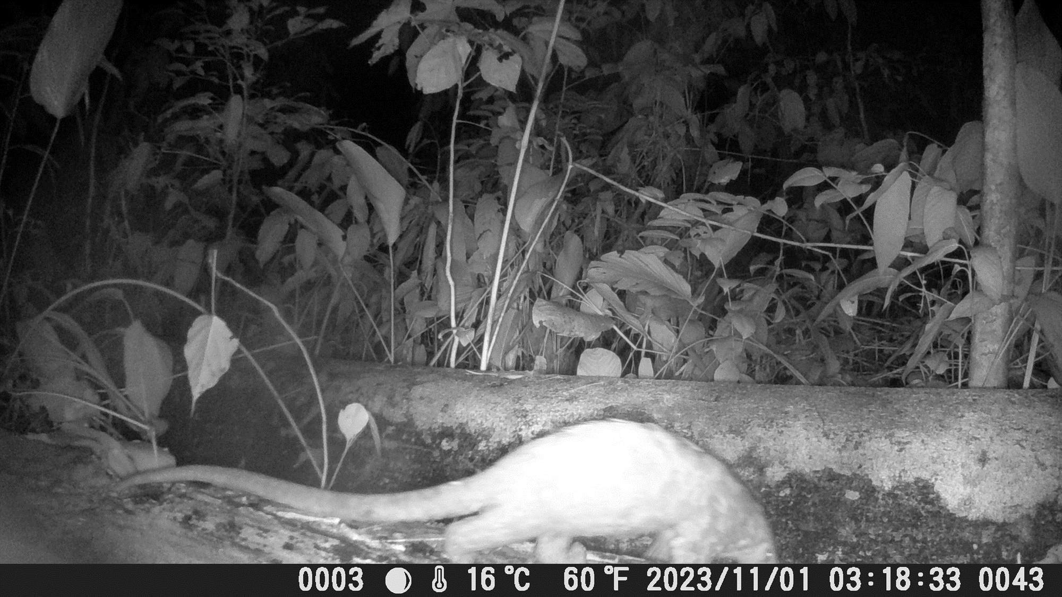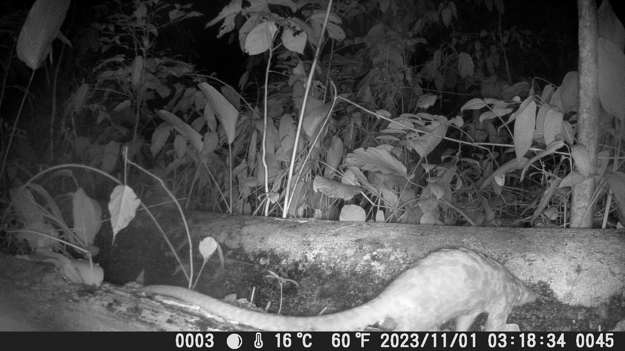
Giant Pangolin captured at a site confirmed by the community ranger
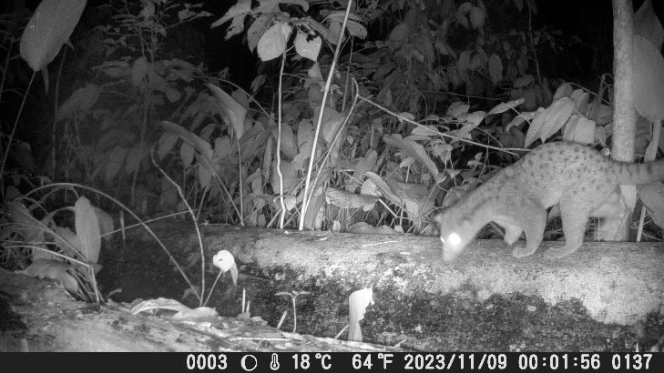
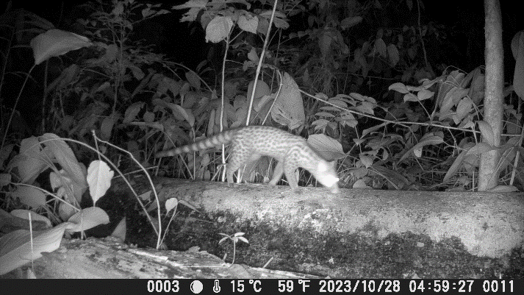

Genet (Genetta 1816) Captured
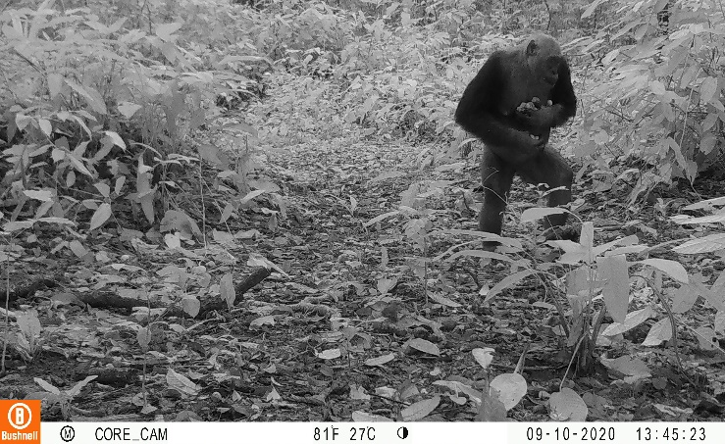
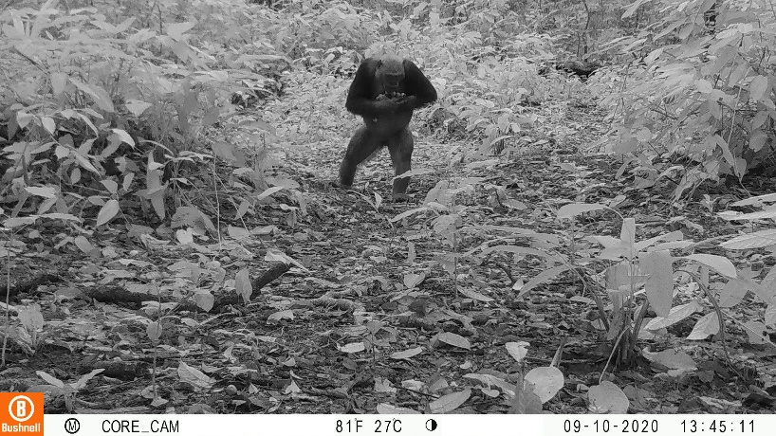
Gorilla captured walking on two foot (more investigation underway with Primate organisations to ascertain the specie.

Difficulties encountered
The main difficulties encountered during this study were;
- 02 camera traps that I was awarded from the project failed to function upon set up, while one of the cameras (CuddleBack) was retrieved while not working with just a video of squirrel all through.
- Error installing one of our cameras that has not been placed at the exact displacement site in the field as planned due to no sign of pangolin presence. This however provided images of different species that are exploitable to illustrate the parks diversity.
- Two camera traps that were installed by the community rangers were not properly calibrated with wrong dates. This causes data inconsistency when used for analysis. However, we expected such outcomes from trainees at the early level.
- One of the community rangers (Baba Abel) was injured from a commercial motorbike, and this caused gaps in the level of capacity building we had progressed for the number of committed field assistants (Community rangers).

