
COMMUNITY RANGERS (CRs) TRAINING MANUAL
‘Enhancing Community Field Assistants' Capacity for Long-term Collaborative Conservation Management of Pangolins

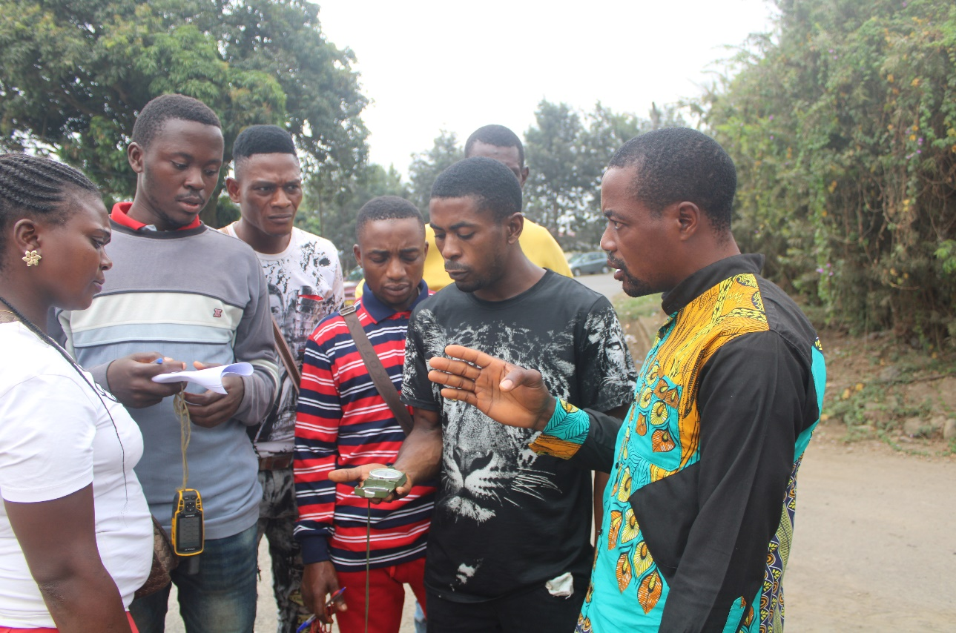

Prepared by with input from
ESONG Lionel Ebong Mr Ichu Godwill
Coordinator, CRs Project Landscape Officer, UNESCO Head
Buea, SWR Cameroon Office, Yaoundé-Cameroon

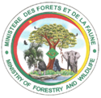

Table of contents . . . . . . . . . . . . . . . . . . . . . . . . . . . . . . . . . . . . . . . . . . . . . . . . . . . . . . . . . . . …………. . . …….ii
List of figures . . . . . . . . . . . . . . . . . . . . . . . . . . . . . . . . . . . . . . . . . . . . . . . . . . . . . . . . . . . . . . . . . ……………….ii
Acknowledgements . . . . . . . . . . . . . . . . . . . . . . . . . . . . . . . . . . . . . . . . . . . . . . . . . . . . . . . . . . . . ……………….iii
Acronyms . . . . . . . . . . . . . . . . . . . . . . . . . . . . . . . . . . . . . . . . . . . . . . . . . . . . . . . . . . . . . . .. . . . . . ………………iv
PART 1: BACKGROUND AND CONTEXT……………………………………………………………………5
PART 2: BACKGROUND TO THE PRINCIPLES OF RANGER-BASED DATA COLLECTION……….6
2.1 Standardized data collection………………………………………………………………………………….6
2.2 Benefits of Community Ranger-based data collection………………………………………………………6
PART 03: THE ROLE OF COMMUNITY RANGER-BASED DATA COLLECTION IN PROTECTED AREA MANAGEMENT …………………………………………………………………………………………8
3.1 Design of the patrol data sheet……………………………………………………………………………….8
PART 4: FIELD INSTRUCTIONS……………………………………………………………………..............10
  - General rules…………………………………………………………………………………………………10
4.2 Additional principles…………………………………………………………………………………………10
PART 5: VISIONS FOR CRS BIOMONITORING TRAINING…………………………………………….13
5.1 Empowering Remote Communities………………………………………………………………................13
5.2 Traditional Governance and Leadership ………………………………………………..………….……...13
5.3 Teaching Skills and Building Capacity……………………………………………………………………...13
5.4 Empowering Women………………………………………………………………………………………….14
5.5 Future opportunities………………………………………………………………………………………….14
THWS CRs TRAINING PROGRAM FOCUS…………………………………………………………………15
Training Materials and Equipment……………………………………………………….…………………….16
Trainers…………………………………………………………………………………………………..……….16
Conclusion……………………………………………………………….…………….………………………….16
Appendices………………………………………………………………………………………………………...17
Appendix 1: Survey Data Collection Sheet …………………………………………………………………17
Appendix 2: Sheet of Camera Trap location description ……………………………………………………..18
Appendix 3: Codes of Species…………………………………………………………………………………19
LIST OF FIGURES
Fig. 1: The role of ranger-based data collection in the protected area management cycle. . . . . . . . . . . . . . . ..8
Fig. 2: Adaptive management cycle . . . . . ………………………………………………………………………..12

ACKNOWLEDGEMENT
We are grateful to the Mohammed Bin Zayed Conservation Fund (MBZCF) for the financial support towards the launching of the community-based research and pangolin conservation Program in the Deng-Deng National Park (DDNP), Cameroon. We want to thank the Ministry of Forestry and Wildlife (MINFhhhOF) for their technical support.
We also give special thanks to the Community Rangers (CRs) who have dedicated their efforts in ensuring that the project vision of long-term collaboration for the conservation and management of pangolins and other species in the DDNP. We also thank the local chiefs for their collaboration and support in identifying suitable Community rangers and focused individuals with passion in conservation.

ACRONYMS
DDNP : Deng-Deng National Park
MINFOF : Ministry of Forestry and Wildlife
CRs : Community Rangers
CRBDC : Community Ranger Based Data Collection
RBDC : Ranger Based Data Collection
GPS : Geographic Positioning System
VFMC : Village Forest management Committee
NTFP : Non Timber Forest Products
GIS : Geographic Information System
M&E : Monitoring and Evaluation
SMART: Spatial Monitoring and Reporting Tools

BACKGROUND AND CONTEXT
The MBZCF for the Community Rangers Project entails an in-depth skill building and awareness of the local guides to be able to effectively function as citizen scientists. It is in line that this working document is developed to guide the training and expansion of the community rangers program.
The concept of Community Ranger-based data collection (CRBDC) was introduced in Cambodia in 2003 by Dr. Robbie Robinson. Community-driven development relies on the leadership and mentoring of individuals, groups, and communities. By fostering the development of local leaders, the CRBMP will build stronger governance within traditional owner-led groups and empower communities to work towards their sustainability goals.
Managers of protected areas require up-to-date information on a wide range of subjects including ecology, species status, park protection, tourism, and socio-economics to manage parks effectively. Use of information should form an integral part of protected area management, or in other words: form an integral part of decision making, monitoring, evaluation, and planning in protected area management. For information to be useful, it must be based on the timely analysis of up-to-date data and presented in such a way that managers can understand it.
Relevant and geo-referenced data on wildlife and illegal activities collected by the Community Rangers (CRs) on park protection patrols can easily be processed into information and made available in a timely manner to protected area managers. It is usually of importance to make this information is used for monitoring, data collection, and patrol deployment, and must follow the ERuDeF Ranger-based Data collection (RBDC) procedures proposed here in this handbook that also highlights on the utilization of Spatial Monitoring and Reporting Tools (SMART) like GPS, Compass, camera traps, data collection/recording and environmental ethics.
This reference guide and training manual describe in detail the requirements for RBDC. It is written as a reference guide for other protected area managers as well as managers (conservators) at the Ministry of Forestry and wildlife (MINFOF), as a guide for the set-up of range-based data collection at the protected area and landscape level.
The Convention on Biological Diversity (CBD) programme of work on protected areas (CBD Secretariat 2005) lists in decision VII/28, under goal 1.4 - to substantially improve site-based protected area planning and management - several activities which can only be carried out if up-to-date data are available.
Furthermore, there is a growing demand to monitor the effectiveness of protected area management and donor countries and organizations increasingly demand accountability and quantifiable achievements in return for their assistance.

PART A: COURSE DETAILS
Module 1: Introduction to Pangolins Socio-ecology
This section of the training will be elaborating on the dynamics in species populations and evolutions in the ecology of pangolins and other species. Training will also identify the possible causes to such evolutions and how there can be monitored.
- The topography and elevation: Cameroon Pangolins are proven to live in different habitat types including forest, marshy areas, farmlands and savanna zones.
- Water points: The streams and rivers in a forest landscape determines the distribution and availability of pangolins across habitats. Pangolins generally have not been recorded at high rates around water points.
- Weather: The wetness or dryness of a habitat, or how cloudy the sky greatly determines the distribution of species. Pangolins do prefer dry moist milieus. This is a reason why it is easier to encounter a pangolin in dry seasons.
- Foliage and Vegetation Canopy: The foliage refers to the greenery and nature of undergrowth of a vegetation. The canopy is the covering or shade provided by the leaves and its branches. These contribute to determine the nature of habitat of a specie.
- Other species and man: pangolins actually have no other natural predators like animals. Their greatest threat is the human race.

Module 2: Ecology of DDNP
Generally speaking, the ecology of the DDNP involves the combination of its vegetation types, species diversity, slope variation, water bodies and seasonal variation.
- Vegetation type: This refers to whether the sanctuary is characterized with forest, grassland or savanna as well as the vegetation’s related features like canopy cover, understory and visibility.
- Species diversity: The different species found in the THWS makes up part of the ecology of the sanctuary. Past biomonitoring work by researchers has proven that the park is also endemic to Chimps, Gorillas, Duikers, antelope, River hog, monkeys, porcupine, and squirrels.
- Slope variation: Slope variation refers to the disparity in the landscape of the area. In this aspect, the slope types can be highland or lowland with a steep, gentle undulating or plain.
- Water bodies: The nature and number of water points is another vital aspect of the Deng-Deng ecology. Such water points can be rivers or streams of perennial or intermittent and have an influence on species distribution and activities.

Module 3: Survey methods of Pangolins
- Recce methods: Recces are a form of random movements. It is a method of moving in a haphazard manner in order to maximize the possibility of coming across relevant observations. Using a recce walk to survey great apes, the targeted indices are usually the nests, feeding signs, tracks/trails, and even direct observations.
- Direct observation: Pangolins are rare to find, especially considering that they are nocturnal. However, encountering one will give an opportunity to count and sum the species encountered over a study period. This counts help in giving a full assessment of species populations.
- Local Ecological knowledge (LEK) and community opinion is usually a good source of information about species population status and threats. In the field, the LEK serves well in identifying species sign, age of sign, track, and possibly the direction of movement.

Module 4: Habitat quality assessment and threat factors assessment
Habitat quality refers to the ability of the ecosystem to provide conditions appropriate for the individual and population persistence. Habitat quality assessment entails an understanding of habitat features including;
- Food: availability is a vital determinant of habitat quality. A habitat that has a species feeding source, coupled with the other habitat features is usually of good quality and suitable for species habitation.
- Water: Water just like food is another vital component of good habitat. Water in a habitat can be as small as a stream (perennial or intermittent) or as big as a river. All living things need water and its availability works to ameliorate the status of any wildlife species found in that habitat.
- Cover: Assessing habitat quality in terms of cover entails understanding the forest canopies and foliage. The cover of the habitat will also determine the rate of penetration of sunlight or rainfall. This controls the wetness and dryness of the habitat.
- Space: In any habitat, space is the open area below tree canopies, which also determines visibility and the ease of movement of the species. Understanding the undergrowth type in a habitat is reflects the habitat space and consequently, its quality. Different species prefer different sizes of space.
Module 5: Anthropogenic factors
Understanding anthropogenic or human activities and threats in an ecosystem is explained through;
- Farms: Farmlands of different sizes are considerations to be taken in account as an anthropogenic factors in a wildlife and ecology environment. The farm sizes and the number of farms reflect the extent of anthropogenic impact in an ecosystem.
- Hunting: This is another important anthropogenic factor in an ecosystem. This is usually determined by the number of bullet shells, snares and gun shots.
- Tracks and roads: These can be in the form of active or old roads and tracks. Tracks used by hunters or farmers or old exploitation roads are part of anthropogenic factors worth considering.
- Farmers’ and hunters’ huts (Bush house) are anthropogenic factors that reflect the degree of pressure or threat in an ecosystem.

Module 6: Survey of households’ socioeconomic status and conservation stakeholder analysis in the landscape
- Earmarking potential socioeconomic activities: This requires knowledge and skills by CRs on the different socio-economic survey methods like questionnaires, interviews, group discussions, and key informant survey techniques. They will be taught the method to use targeting a particular outcome.
- Classification of data: This entails the classification of survey information based on age, sex, livelihood activities, and opinions about conservation. They shall also have the capacity to tally locals under different economic opportunities.
Module 7: Assessment of the impact of households due to the crisis on conservation in the area
- Identification of potential impacts: This aspect entails a detailed understanding of the different categories of social impacts.
- Classification of impacts: This requires prioritization of the impacts based on the CRs experience both on the community households and the conservation landscapes.

Module 8: Assessment of security and risk
- Classification of risks: Within the framework of the DDNP, this assessment is important and directs where projects interventions can take place feasibly in the conservation landscape.
- Potential security measures: This action requires capacity building and understanding ways of collecting reliable data, conducting socioeconomic surveys in the target communities, and knowing the community members’ opinions through the socio-economic surveys.
- Risk mitigation measures: In line with the security issues hampering the communities due to unrest, CRs will be encouraged to establish good relationships with members of their communities, educate them on the benefit of their projects to both livelihood conditions and also to the sustainability of their forest habitats and the species there in.
Module 9: Setting up survey tools, Data cleaning, sorting and entry
Here, the CRs will be trained on entering the correct GPS waypoints, entering the right observations at the correct entry column, registering the time, weather, and forest features as well as avoiding double entries.
- Configuring Camera traps on the correct date/time, mode), Identifying an ideal site (animal sign, distance between cameras (1000m), elevation depending on the height and size of species (0,5m for big mammal), direction of camera traps.
- Marking GPS Waypoints: They will be drilled upon Also, Knowing compass directions and cardinal points, and Understanding positions and locations on Maps.
- Datasheet filling and naming observations: During datasheet classification, the CRs will follow the step-by-step data cleaning, sorting, and entry. This process will strengthen the training on data collection entry by the CRs.

PART 2: BACKGROUND TO THE PRINCIPLES OF RANGER-BASED DATA COLLECTION
2.1 Standardized data collection. It is essential that Community Ranger-based data collection procedures and data nomenclature, i.e. the terms used to describe observations, (as well as monitoring, evaluation and reporting) are standardized throughout the protected area system. Only then can ERuDeF effectively manage a Landscape and national protected area system.
Ranger-based data collection requires patrol data sheets which ensure standardization and at the same time allow for protected area-specific issues to be included if necessary. Such patrol data sheets must be based on the following principles;
- Standardized - data need to be recorded in a consistent and unambiguous way between rangers and over time.
- Simple - the system must have a low learning curve and be easy to use with a minimal amount of formal education. Handling of patrol data sheets in the field must be easy.
- Fast - the primary duty for ranger patrols is park protection. Writing and time spent recording data other than illegal activities must be kept to a minimum.
- Flexible - it must be possible to adapt data collection to meet the needs of different users and for different types of natural resource management, reflecting differences in issues, objectives, and threats in different protected areas and different protected area categories.
- Specific - only data which can be processed into information useful for protected area management decision-making should be recorded by rangers.
- Regular recording of waypoints is important in denoting points and tracks made or areas already surveyed by the Community Rangers.
- Use of standardized terminology. For ERuDeF, through the CRs biomonitoring activity to provide data which can be analyzed in a computerized management information system and used at protected area and national level, it is absolutely essential that standardized nomenclature and recording procedures are followed. Recording of observations is made at four hierarchical levels:

  - Observation groups
Observation groups are related sets of observations such as animals, birds, reptiles, amphibians, plants and illegal activities.
- Animal observations: Examples of animal observations are Nigeria Cameroon Chimps, Cross River Gorillas, pangolins, duiker, and elephants.
- Threat observations (illegal activities): The following nomenclature is used to record illegal activities: Poaching, Plant harvesting, Encroachment, and Fire. For each of these four observations, a distinction between direct evidence and sign must be made.
- Observations’ code
Codes are a further specification of the observation. They can be grouped into codes for animals and for illegal activities. Examples of animal observation codes are sighting, call, footprint, and nest. The observation codes are specific (e.g. Elephant footprint; nest for example does not apply to Elephant) and must also be standardized throughout the protected area system. Examples of observation codes for illegal activities are hunting, logging, mining gold etc.
2.3 Benefits of Community Ranger-based data collection
• It requires a minimum of training and education, with close collaboration.
• It requires little additional equipment because equipment can be rotated in the field.
• It uses existing patrol systems and no extra patrols or expenses for monitoring are required.
• It provides data for monitoring, without the need for expensive baseline data.
• It provides timely information for the day-to-day decision-making of protected area managers.
PART 03: THE ROLE OF COMMUNITY RANGER-BASED DATA COLLECTION IN PROTECTED AREA MANAGEMENT
Managers at all levels require up-to-date and timely information to enable them to make informed decisions for planning, implementation and monitoring, and evaluation of the activities for which they are responsible. Information is based on the analysis of data and range-based data collection provides, in a timely manner, exactly those data which are necessary for effective and timely decision-making in protected area management.
Management decision-making has effects on the real world; for example, it can lead to a reduction of poaching. Over time such effects/outcomes can be proven through monitoring and evaluation based on the analysis of data from ranger-based data collection.
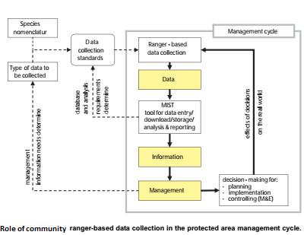
Figure 1.

3.1 Design of the patrol datasheet
The results from the first step of the information needs assessment are used to design the protected area-specific patrol datasheet. The patrol data sheet is not a static document, it can be adjusted any time once adaptive management provides the feedback from surveys which makes additions to, or modifications of, the patrol data sheets necessary. In order for the patrol datasheet to be suitable for Community range-based data collection the following criteria must be considered:
- Only data that can be processed into useful information is to be collected
The patrol data sheet must as a minimum provide space to record (1) the names of survey members, (2) the date of the patrol, (3) co-ordinates and time of waypoints based on GPS readings, (4) the observation, and (5) remarks. All observations and remarks which rangers should record should be clearly listed on the datasheet or on a separate sheet that needs to be carried by patrols to ensure that only data which can be processed into information that is useful to managers are collected.

- Data recording needs to be easy and fast
For each observation, a three-letter code has been assigned, and for each observation code a one or two-letter abbreviation (code) has been assigned as shown in the boxes at the bottom of the patrol data-sheet in appendix 4. These abbreviations/codes must be listed either on the patrol datasheet itself or on a separate sheet that needs to be carried by patrols. The codes are used to complete the field ‘Observation Code’ in the patrol data sheet in order to minimize writing in the field and at the same time
to ensure that only observations chosen by management are recorded.

- Patrol data sheets need to meet RBDC requirements and must be easy to use
For RBDC data to be used for monitoring it is essential that waypoints are recorded at least every 30 minutes while a patrol is moving – even if no observation is made. If waypoints are taken at regular intervals, the distance covered by patrols can be calculated at a reasonable accuracy. Distance is required to calculate indices for monitoring which take effort into account. Regular recording of waypoints also
ensures that the routes covered by patrols can be recorded. The more waypoints are taken, the greater the accuracy of the route and distance covered.

NB: All recordings made as part of range-based data collection must be geo-referenced using a hand-held GPS receiver. This will provide sufficiently accurate position information to record where patrols have been and to geo-reference (i.e. provide a co-ordinate reference for) ecological and illegal activity data collected.

PART 4: FIELD INSTRUCTIONS

The field instructions given below form the basic contents of the RBDC training for rangers. A protected area specific training can only be carried out after an information needs assessment and the development of a patrol data sheet. If this is not the case the training must use the patrol data sheet and terminology from a protected area where RBDC procedures are already in place as an example.

4.1 General rules
- Before starting a new patrol, make sure all waypoints from previous patrols have already been downloaded to the computer and deleted from the GPS unit.
- Do not change the settings of the GPS unit.
- Read the WAYPOINT number, LOCATION (48P-UTM) and TIME off the GPS unit.
- Do NOT change the Waypoint number. Use the number generated by the GPS unit.
- Do NOT change the symbol of a Waypoint. The symbol must be the default symbol.
- Record the time in 24 hour format.
- Waypoints stored in the GPS and written down on the patrol data sheet must match.
- Each waypoint must be stored in the GPS and recorded on the patrol data sheet.
- Follow the instructions recording of patrol observations when recording an observation.
- Take a waypoint whenever recording an observation. If you encounter more than one observation at the same location, take a separate waypoint for each observation.
- Use only the OBSERVATION CODES listed in the boxes in the boxes at the bottom of the patrol data sheet.
- Only record those observations of which you are 100% sure.
- For wildlife observations enter the number of individuals under TOTAL.
- For all other observations (illegal activities, physical features and degraded areas) and take a waypoint at the start and end of each patrol day.
- If you cannot get a GPS reading due to poor satellite cover or dense canopy record the observation and time only, continue the patrol and take a GPS reading as soon as the openness of the canopy allows it and enter this waypoint as 'position'.

  - Additional principles
- Only record what is specified in the patrol data sheet and on the remarks chart. NB. There is one exception: if you do encounter something in the field that you consider important to management, describe it in detail under remarks and write 'position' for observation.
- Record observations about animals and birds only if 100% certain. For example, if, due to its size, rangers cannot tell the difference between a tiger and a leopard footprint, they need to record "big cat footprint” (providing it is in the list of observations identified during the information needs assessment).
- Quality, not quantity, is important. A recorded observation is only useful if it is accurate. Only record those observations of which you are 100% sure.
Example: You see a large mammal about 200 metres away for a glimpse in dense vegetation. You cannot accurately identify it, though as a CR, you know it exist in the forest area. In this case you cannot accurately identify the animal, therefore do not record it.
- Record species observations only if they fulfil the criteria listed below:
The species can be correctly identified, the observation is a recent sign which clearly indicates the presence of the species, If you cannot identify the species without any doubt from a sighting, sign, or dead body, either:
- do not record it, or
- record it in general terms such as cat sp., deer sp. etc.
- There are 4 types of species observations:
- direct sightings - an observation is recorded as a sighting if an animal species is directly sighted and positively identified
- calls - some animals, such as Elephants for example, can be positively identified by their distinct call, while others can be identified to genus level, for example Hornbill.
- Fresh signs - some animal species leave distinct signs that can only be of that particular animal species, e.g. elephant footprint. An observation should be recorded only if the sign is fresh, i.e. less than one day old, and thus indicates a recent presence of the species.
- Carcasses - the cause of the death should be recorded as natural death or cause of death unknown. NB. if the animal has been poached (e.g. died caught in snare) record it as illegal activity and describe the method of poaching used, e.g. gunshot, snare, spear etc. in remarks.
- When encountering a herd of animals do not record "1 group". Either count all individuals if the herd is relative small, or estimate the number of species using the following technique. Count five (or ten) animals, look at space they occupy, estimate how many times the ‘space of five’ fits within the size of the entire herd, and multiply this number by five (or ten) to get the estimated total number. In such a case write 'number estimated' in remarks.
- Recording of direction and distance to an animal observation may be required in protected areas with open vegetation. In such areas wildlife observations can be made over large distances, but the actual waypoint will be taken at the position of the observer and not at the position of the wildlife species. In such cases rangers should record direction (compass) and estimate the distance to the wildlife. Recording of direction and distance is only required if the observation is more than 100 m away from the GPS. If the patrol data sheet provides columns for direction and distance fill these in, otherwise write direction and distance in the remarks column.
- When recording mammals the number of adult males and females and number of young should be recorded if possible. Do this only if you are 100% certain. Young mammals are those which fit under the belly of their mother. If the patrol data sheet provides columns for number of adult males and females and number of young fill these in.
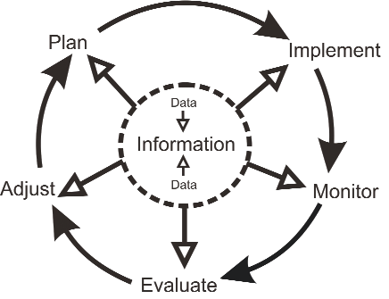
Figure 2: adaptive Management Cycle of Community Rangers Surveys

PART 5: OUR VISIONS FOR THE COMMUNITY RANGERS PROJECT
5.1 Empowering Remote Communities
Remote and regional communities in the Cameroon and African regions include some of the most impoverished and disadvantaged people in the world. Many of these communities practice traditional ways of life and receive little support from government, resulting in poor basic services and infrastructure. Conventional approaches to aid have generally failed to improve outcomes for communities in this region.
The Community Ranger Program is a community-driven initiative that addresses many of these issues. The Program helps communities to build their capacity and resilience in the areas of food security, livelihoods, clean water and sanitation, disaster risk reduction, disease prevention and health promotion. It works because local people become key agents and partners in the planning and ongoing delivery of the Program, and ‘own’ the outcomes. While the tangible “hard infrastructure” that locals build – rainwater tanks, wells, medical centers, sanitation facilities – are important, it is the “soft infrastructure” – new community leaders – that provides the long-term legacy. New community leaders gain vital skills and the confidence to continue to assist their communities into the future.
5.2 Traditional Governance and Leadership
The Community Ranger approach is adapted from the successful Land and Sea Ranger programs pioneered in the Torres Strait and northern Australian Aboriginal communities over the last decade. It has now been implemented in remote and regional areas of Papua New Guinea and focuses on strengthening traditional governance using a ‘bottom-up’ approach at a village and clan level. These existing traditional structures support more formal local and national planning and governance driven by the community to deliver:
Enhanced village governance and leadership, Community skills, capacity and access to learning, Food and water security, Stronger local disaster risk management, response and recovery, Livelihoods and livelihood skills, Improved infection control, disease prevention and health promoting behavior, Greater women’s participation in decision-making and building community.
5.3 Teaching Skills and Building Capacity
The Community Ranger Program can provide training in a range of locally relevant skills:
• Job-relevant literacy and skill including food garden techniques and sustainable permaculture, and agricultural standards to access markets
• Communications and effective SMART use,
• First aid use, basic hygiene and disease prevention,
• Innovation, adapting to field realities, courage, focus, disaster preparedness and response.
• Ecosystem-based approach to resource management,
• Basic accounting.
5.4 Empowering Women
Women are disproportionately affected by increasing social and environmental hardships across the region, yet also have vital specialized knowledge in critical areas such as infant health and nutrition, and childbirth. The specific inclusion of female CRs in the Program empowers women to take on greater leadership roles in public and community life, and participate in the economy, contributing to improving long-term sustainability outcomes for the whole community.
5.5 Future opportunities
The Community Ranger Program is a successful model and can deliver improved sustainability in remote and regional communities throughout the Congo Basin region. The inclusive, self-determination ‘Council of Elders’ approach brings clan leaders from each village together for community-level planning and priority-setting with the intent to shield community progress from the vagaries of political change that can impact government processes. This approach empowers local communities to develop skills in areas relevant to their specific needs, and drives future progress towards sustainability goals. This approach can be tailored to any local context and produces outcomes for community development that provides for long-term success
Conclusion
The Community Rangers Project (CRs) has been highly successful in setting the grounds for community involvement and management of their biodiversity, and laying the foundations for future sustainable development. Critically important for success of the CRs Program is the involvement of community leaders in nominating candidates for ranger training, and whole-of-community involvement in identifying priority issues to be addressed. Once Community Rangers are able to address these high priority issues facing wildlife and their habitats, they can begin working to tackle second-order problems focused on food security, disaster preparedness and sustainable natural resource management.

Appendix 1: Survey Data Collection Sheet

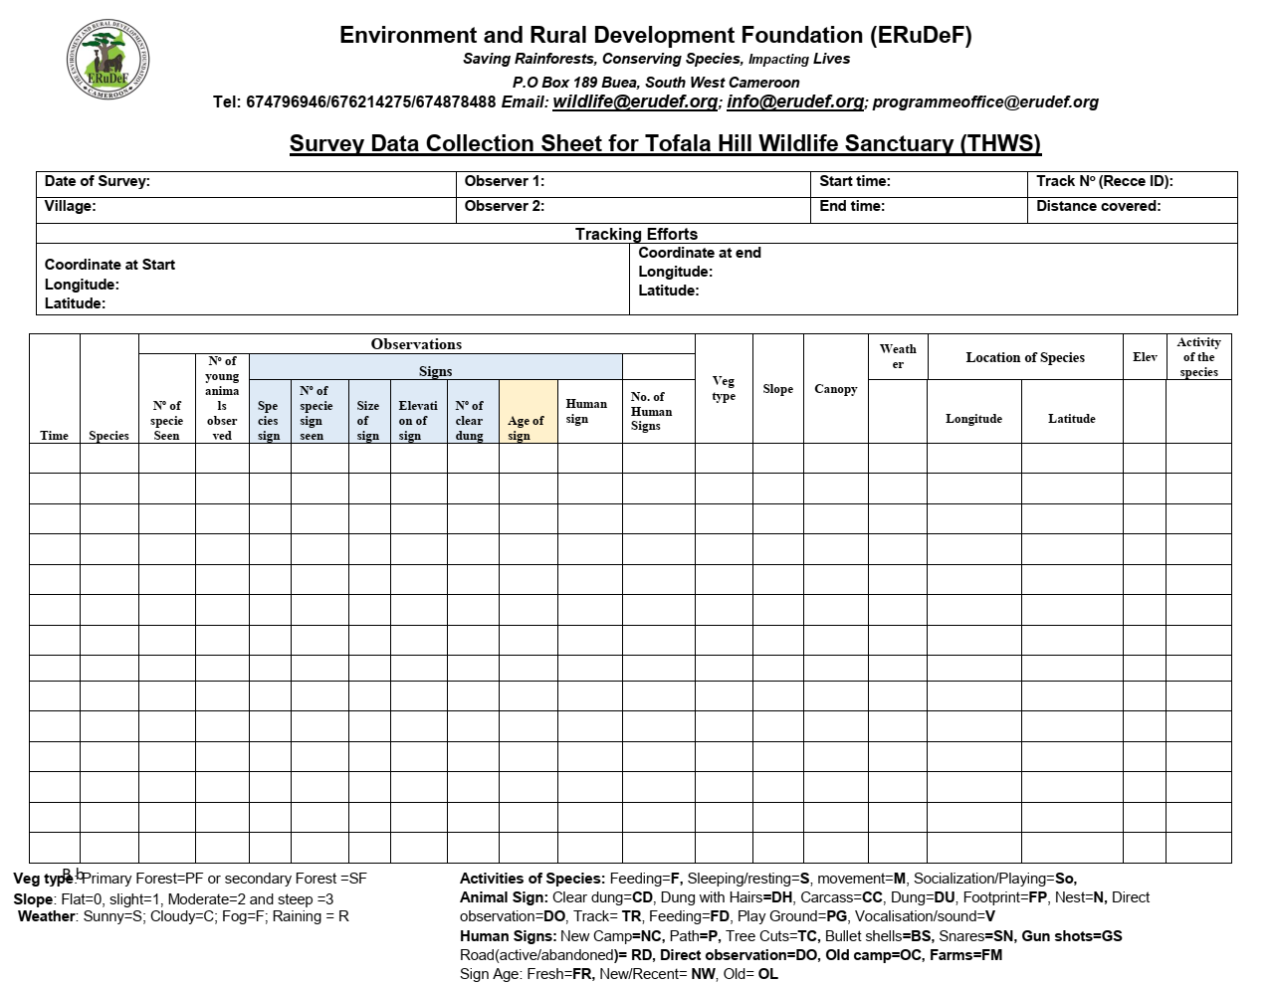

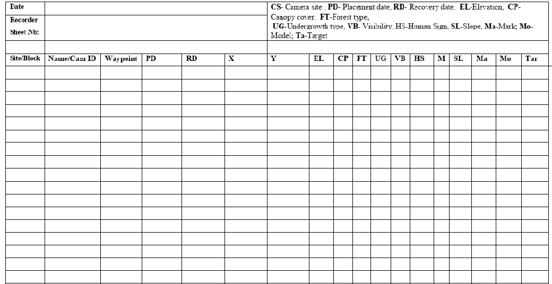
Appendix 2: Sheet of Camera Trap location description

Appendix 3: Species Code
Species | Code | Comments
- Cross River Gorilla | GL
- Chimpanzees | CH
- Bush Pig | BP
- Monkey | MK
- Duiker | DK
- Pangolin | PG
- Bush baby | BB
- Fox | FX
- Snakes | SK
- Porcupine | PP
- Civet | SV
- Giant Squirrel | SQ
- Birds (New unidentified) | NU
- Mongus | MG
- Rat mole | RM

