Project: Establishment of community-based livestock breeding center to sustain the livestock seedbank project at Bire Kpatuos Game Reserve, South Sudan

Report on Grant 222530456

Reasons for delayed project reporting
South Sudan still remains turbulent with over a million of its population living in exile in the neighboring countries, mainly, Uganda and Democratic Republic of Congo. Communities that remain in the country are under constant internal displacement, often caught between government forces and various armed opposition forces fighting the sitting government. Our project area in Western Equatoria State has been greatly affected in these insurgences over the past two years (see appendix I). This affected our project operations four months into the grant implementation and setting the small conservation gains back a few steps. Nevertheless, we remain resilient and wake up after each set back.

Background:
The African golden cat (AGC) is rated Vulnerable by the IUCN Red list and is Africa’s least understood wild felid (Bahaa-el-din, et al., 2015; Brodie 2009; Mugerwa et al. 2013). The population of the AGC is reported to be decreasing across its range mainly due to indiscriminate poaching and poaching techniques. Poaching at Bire Kpatuos is widespread mainly with snares, pitfall traps, nets and rifles. Whereas the target animals are different, the AGC is a frequent incidental capture. For example, Badru Mugerwa (unpublished report) recorded estimated 71 AGCs unintentionally perished in poaching as bycatch in Uganda. Bire Kpatuos game reserve is so far the only place in South Sudan where the AGC has been confirmed. The initial efforts to start the conservation of the AGC and the rich faunal diversity in and around Bire Kpatuos Game Reserve has been supported by the Mohammed Bin Zayed Species Conservation Fund (Grants 210528009 and 222530456) and intermittent supports from the Small Wild Cat Conservation Foundation (SWCCF). These interventions primarily focus on threat reduction by filling community livelihood gaps that drive people into poaching.
In the first intervention (Grant 210528009), the target was to reduce threats by initiating a goat seedbank as a sustainable alternative to animal protein and household income. Learning from the experiences of the first grant, we found that due to the decades long armed conflicts, communities have been constantly displaced. This disrupted the practice of keeping livestock and informed the community’s prioritization of animal seedbanks for restocking during community needs assessment. Goats could only be sourced from neighbouring countries rendering the procurement process very expensive. In the second grant (Grant 222530456), the focus was to establish a community-based animal breeding center to provide a training ground for hands-on livestock management practices and to multiply livestock within the community in order to sustainably expand the animal restocking program in the communities and reduce the dependence on neighbouring countries for livestock demands.
Objectives of the project
The main objectives of Grant 222530456 were (i) to establish a community-based livestock breeding center to help sustainably expand the reach of the current livestock seedbank project to more beneficiaries as a viable alternative source of protein and income for communities so as to reduce the pressure of poaching and ultimately enhance the conservation of AGC and other species within the habitat; and (ii) to support local communities build predator proof fencing for the current 48 beneficiary households on a 50% cost sharing basis where each household will provide local materials for the fence.

Progress of the project objectives

Objective | Progress
Establish a community-based livestock breeding center to help sustainably expand the reach of the current livestock seedbank project to more beneficiaries as a viable alternative source of protein and income | - Community offered land to establish the animal breeding center.  - A temporary structure for keeping the goats was put together.  - An animal enclosure with a solar security light was installed.  - A caretaker was hired.  - Seed goats to start the breeding center were bought from across the neighbouring Democratic Republic of Congo (DRC) and brought to the facility and the project started.  Challenges:  - Management gaps  Caretaker had no accommodation to stay close to the breeding center to provide constant care. In addition, due to very low pay, caretakers balanced the day between looking after the goats and working in the crop fields to support their families; further reducing the attention in managing the facility.  - Internal displacement due to armed rebellion  Before the facility could run after operationalization, another armed rebellion against the government started in the area that internally displaced the residents for about a year which led to a temporary closure of the facility for the equivalent period. Caretakers had to move along with the goats during displacement. This further complicated management and most of the goats died in the due course from diseases. At some point, communication broke down and the whereabouts of the caretakers and the goats was not known.  Reactivation of the breeding center after a period of halt  Over a year’s period of disarray and closure of the community-based animal breeding center after its brief start, the community is re-energizing amidst sporadic episodes of violence. The caretakers of the breeding center have returned from wherever they were displaced with some few remaining goats. Most of the goats perished due to diseases and limited management during the period of displacement. The facility premises had grown back into a bush. With some small funds from Rewild and SWCCF, the area was cleared, an accommodation structure is being put for caretakers to be resident. The animal breeding center activities restarted, this time from a very low-key position. The objective is to revamp it to achive its intended purpose.
To support local communities, build predator proof fencing for the current 48 beneficiary households on a 50% cost sharing basis where each household will provide local materials for the fence. | This objective was not realized because the community was internally displaced due to armed conflict. Most community members lost the few animals given for them during the phase one of project. Funds for this objective were used to support the caretakers of the breeding center who were displaced along with the project goats for some time.

Next steps
It is so easy to give up dreams in South Sudan. The circumstances that presented themselves during the implementation of this project almost pushed us close to giving up the humble conservation efforts started for the African golden cat and other species in the rich and biodiverse habitats in Western Equatoria state. Operations are typical of taking ‘one step forward and two steps backwards’ where positive progress taken are canceled almost immediately. However, giving up may worsen the situation and make it impossible for future recovery. It is better to maintain the status-quo and prevent further deterioration.
Based on the above rationale, our next step is to improve the management of the animal breeding center and assess the impact of the internal displacement on the communities that had benefitted from the animal seedbank project and had left poaching. This will enable us to jointly device a win-win solution that befits the circumstances of the community.

Apendix I: security situations that lead to community displacements





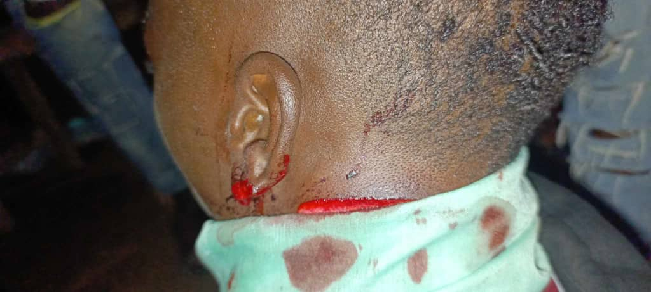
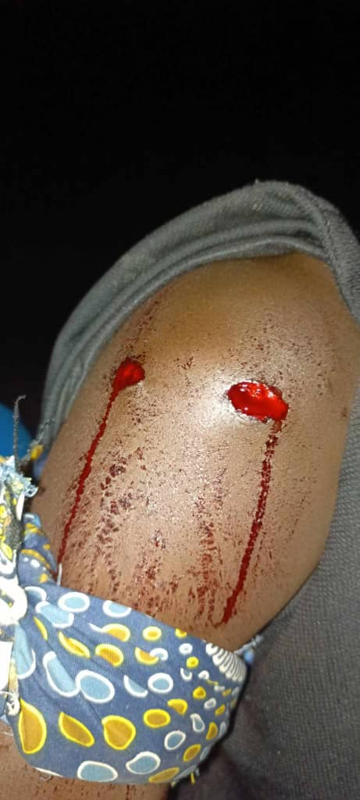

This is a press release from one of the hold out groups after a security incident which occurred recently in August claiming lives and injuring people. This led to a complete lock down of Yambio and surrounding communities. Such have been frequent occurrences that halted our project and affected our mental wellbeing over the past one and half years.
Appendix II: stage wise pictorial account of the animal breeding center

a) Stepwise process of constructing a simple goat house from material gathering to security enclosure for both wild predators and theft from the human community complete with solar security lights.
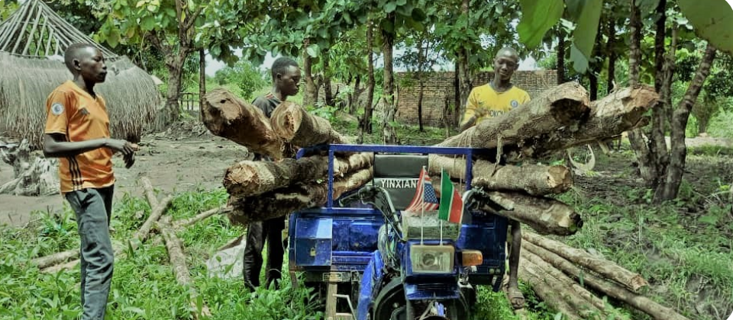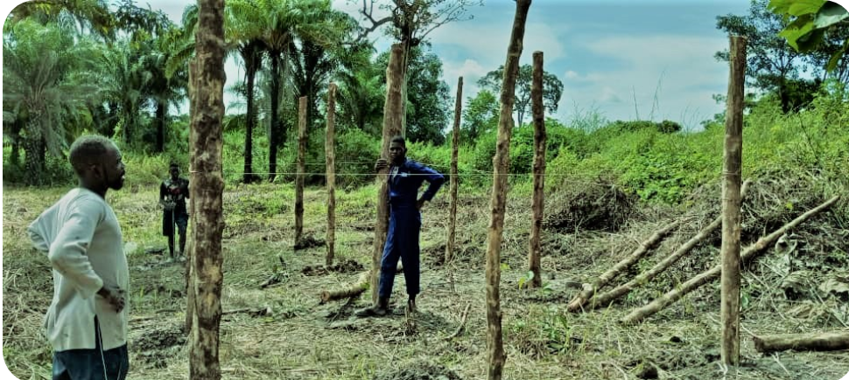

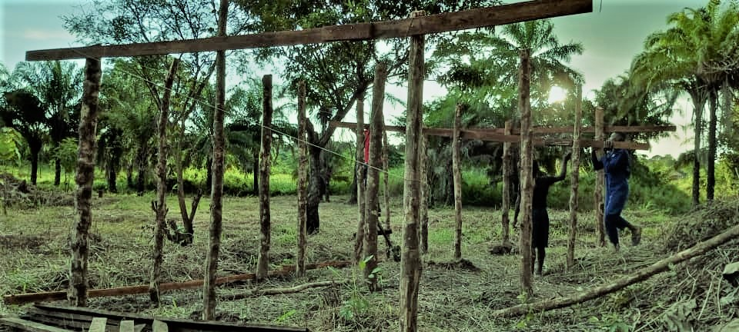
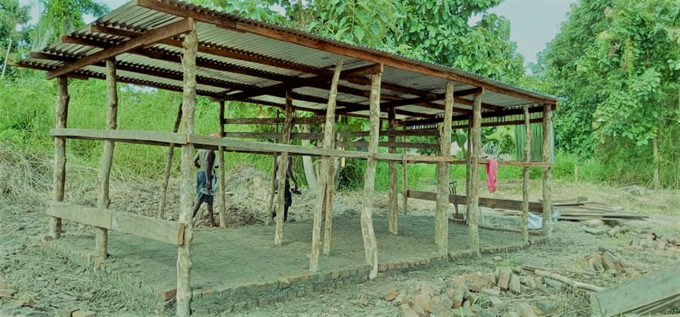
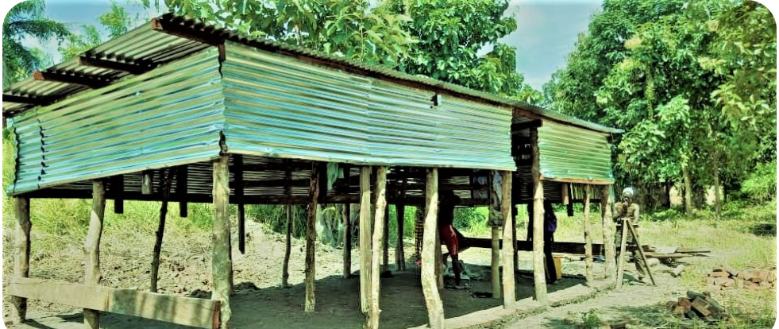

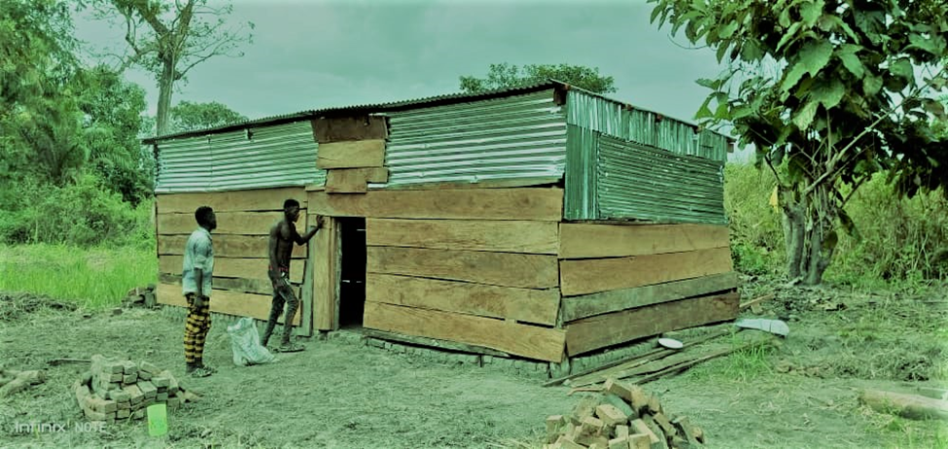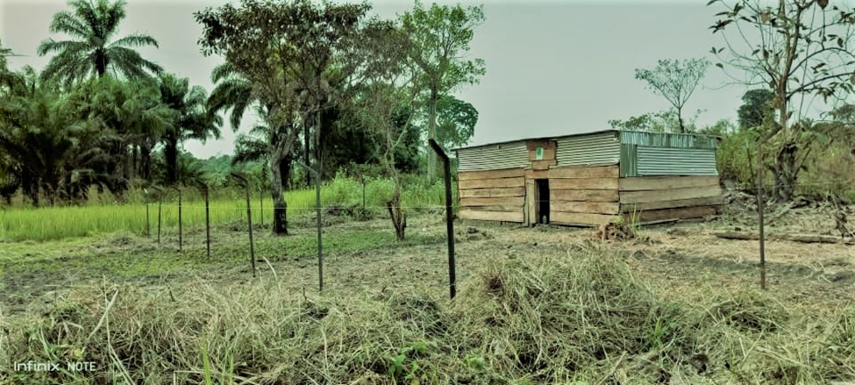
Fully enclosed animal structure with a door and outer gated fence for double protection.

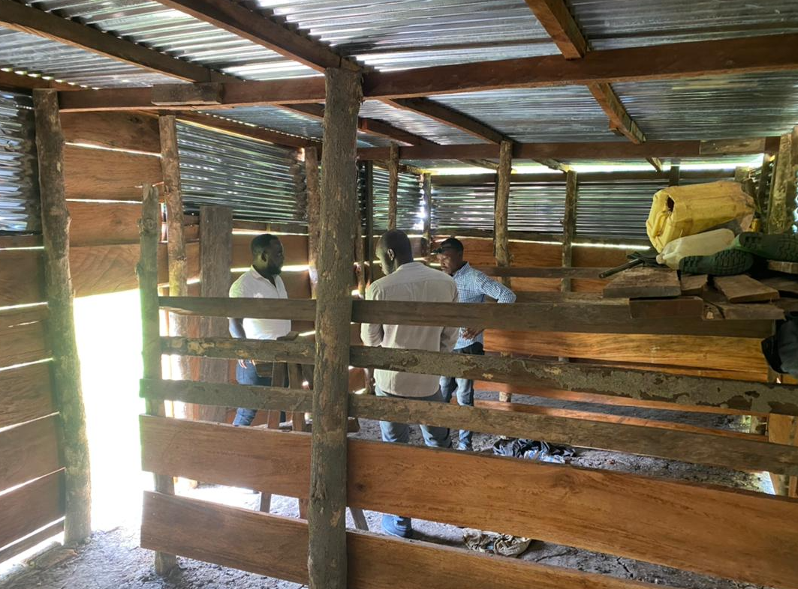
Inside the goat house
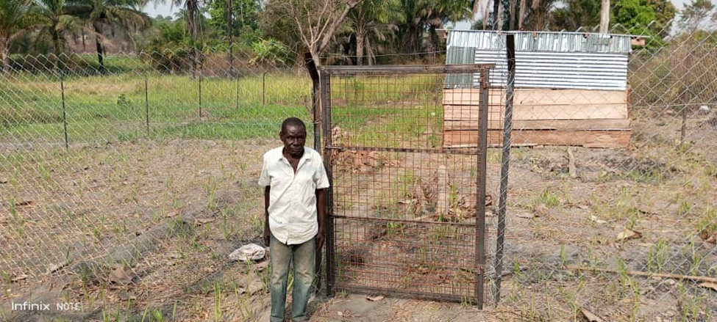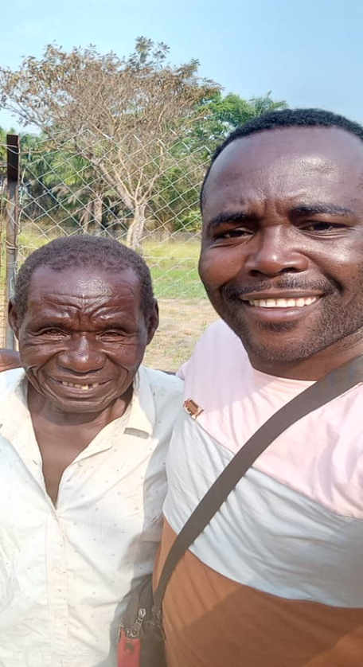
Caretakers of the facility.

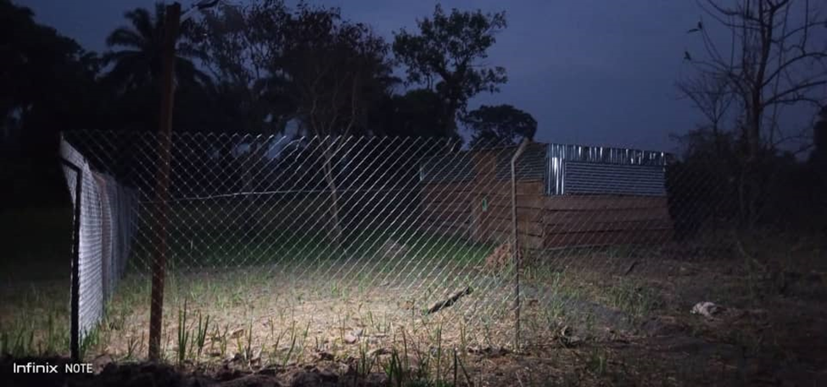
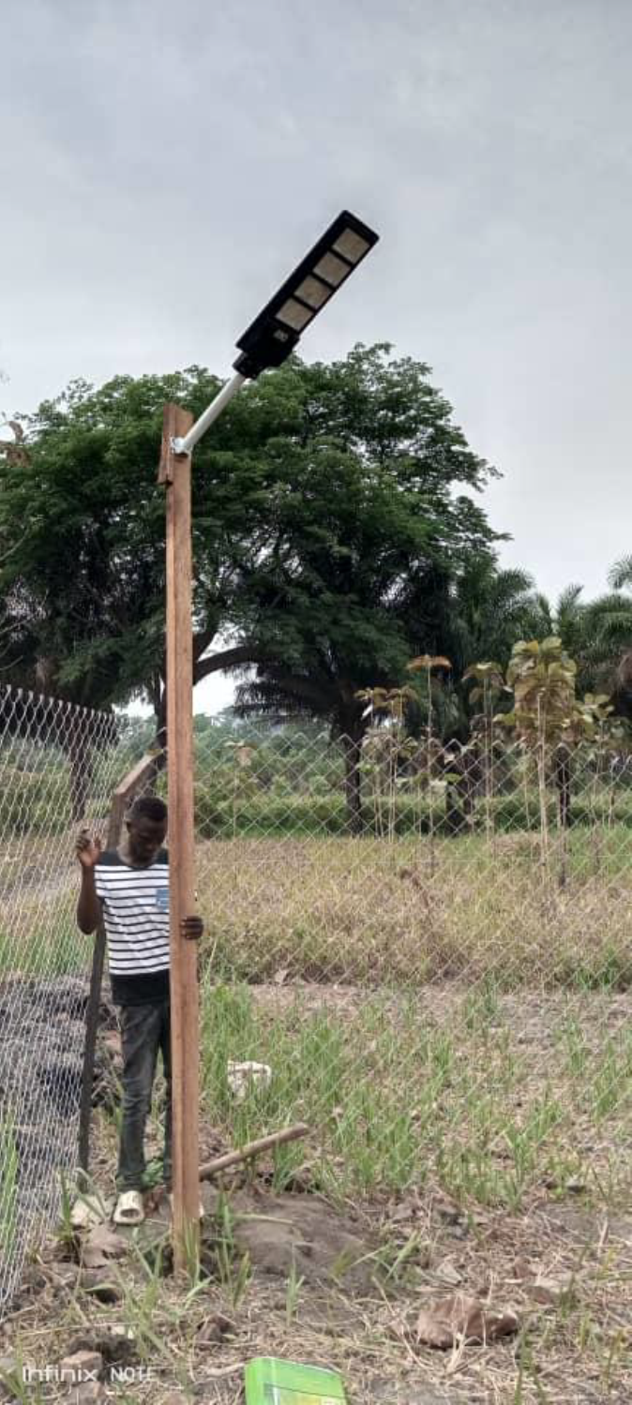
Putting in place an animal enclosure and solar security lighting to deter predators and thieves

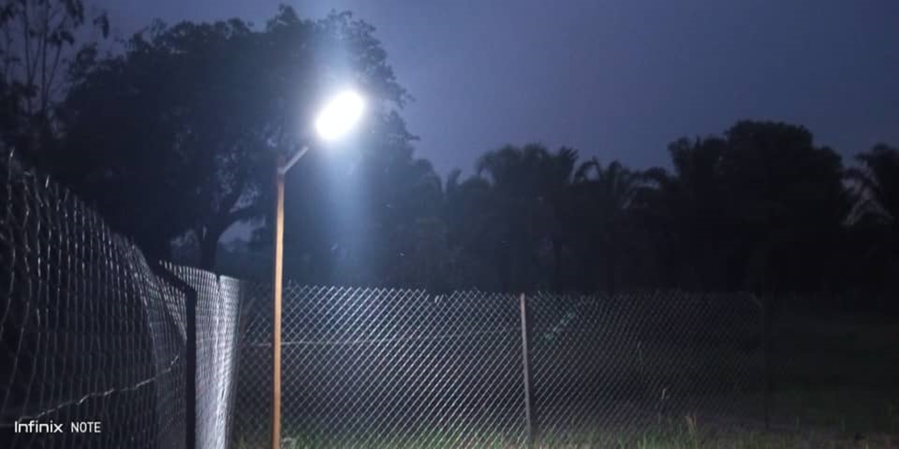

Chainlink fencing and solar security light.
b) Stocking of the goats to operationalize the breeding center

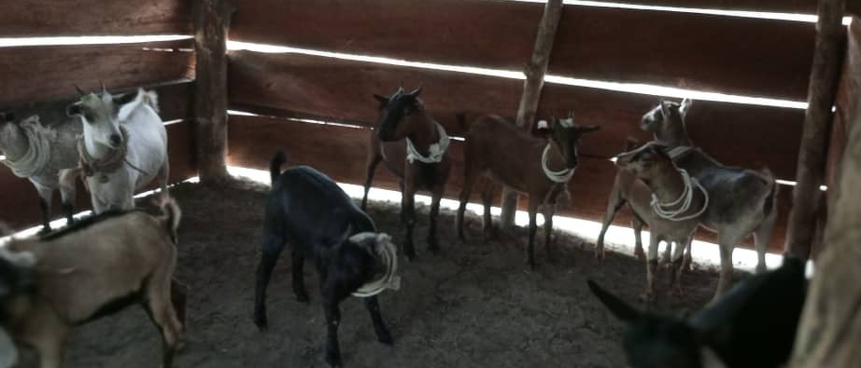

c) Abandonment of the breeding center due to insecurity

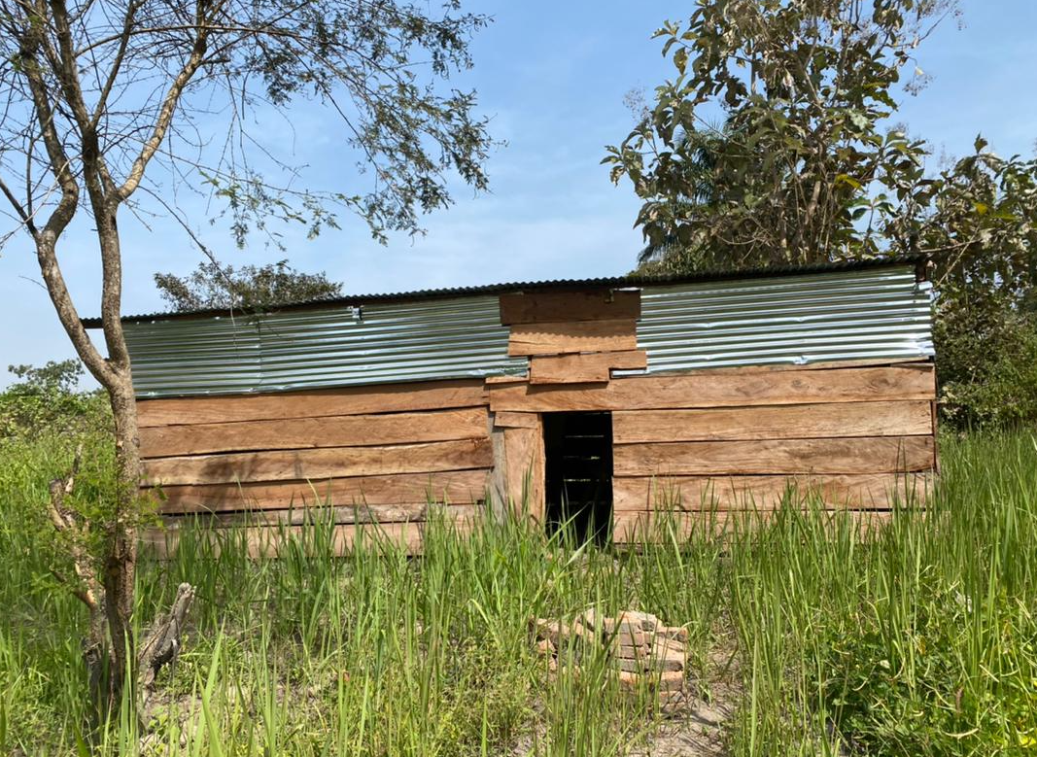

c) September-October 2024: reactivating the breeding center

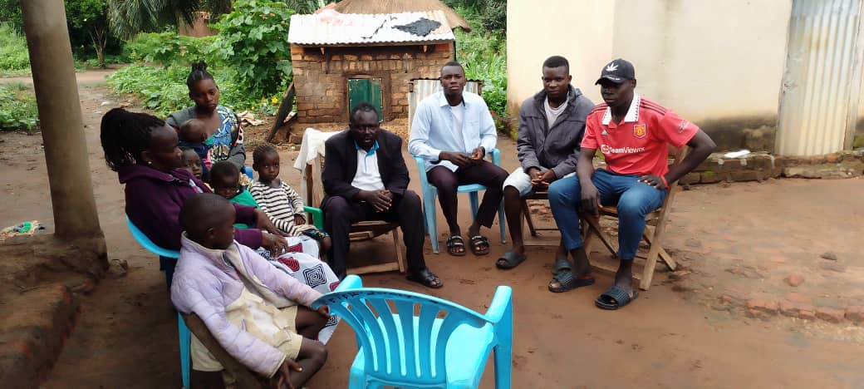
Meeting with community leaders to re-activate the breeding

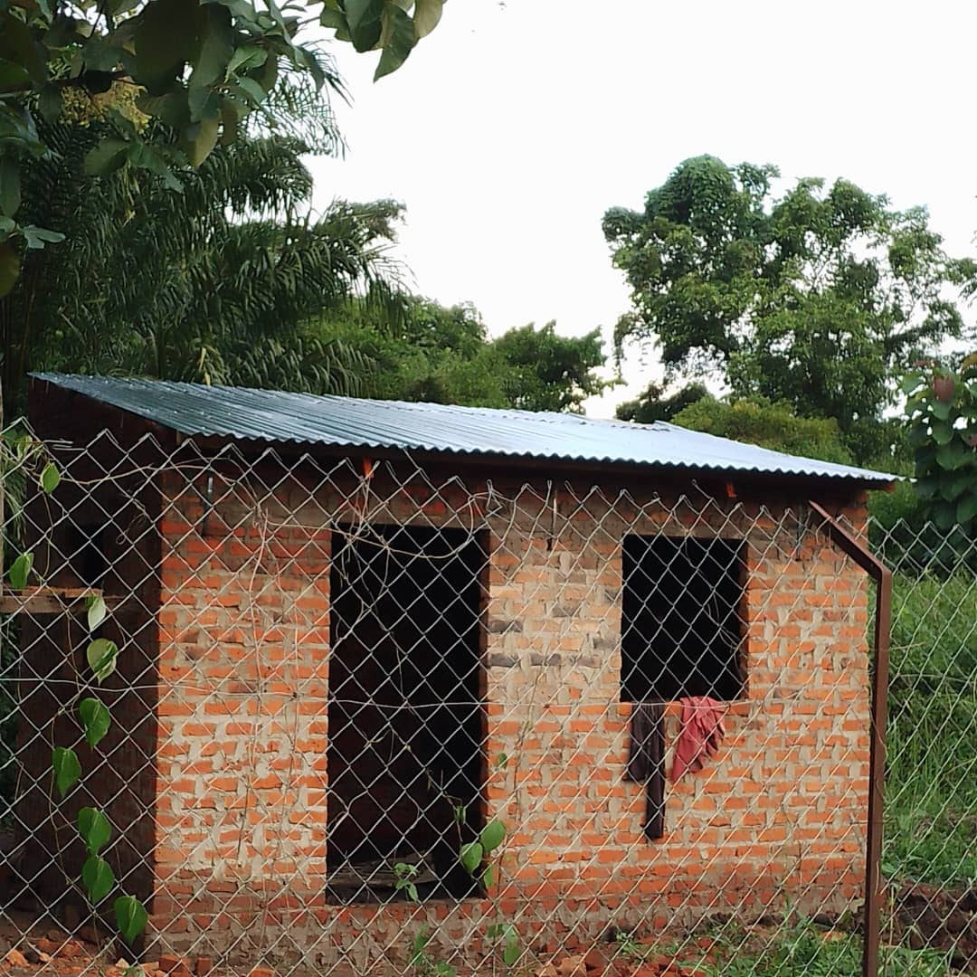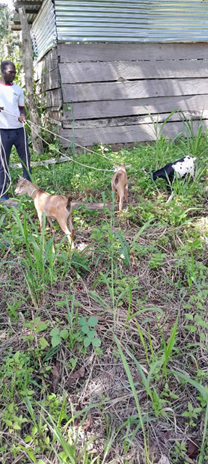
House for caretaker on site Returning the goats to the breeding center

