Phase 1 Project Report: Conservation Efforts for Afghanodon mustersi in Afghanistan
1st Project Progress Report
Project Number: 252537245
Funder: The Mohamed bin Zayed Species Conservation Fund
Date: July 07, 2025
By: Muhammad Hassan Jafari,
Title of the project: Integrating Education and Research: A Holistic Approach to Conserving Endangered newt, Afghanodon mustersi in Afghanistan's Fragile Ecosystems
Project Overview
This report summarizes the activities and outcomes of Phase 1 of the project funded by the MBZ Species Conservation Fund, focusing on the conservation of the endangered Afghanodon mustersi (Afghan salamander or newt). The project aims to educate and raise awareness among students, teachers, university professors, and local communities in selected provinces of Afghanistan about the protection of this endemic species. Phase 1 covered fieldwork, surveys, and educational outreach from April 2025 (corresponding to the Afghan solar month of Hamal 1404) to October 2025 (Mizan 1404). The primary provinces targeted were Baghlan, Parwan, and Logar, with additional references to potential sites in Wardak, Bamyan, and Daykundi.
The grant from the MBZ Fund has been instrumental in advancing my skills as a conservation biologist, enhancing field research capabilities, and aligning with our organization's mission to protect lesser-known and endangered species in Afghanistan. This phase emphasized habitat assessments, species registrations, and community engagement to foster long-term biodiversity conservation.

Objectives
- Conduct field surveys to assess the presence and status of Afghanodon mustersi in targeted areas.
- Educate local stakeholders, including students, teachers, and residents, on the importance of protecting this species.
- Collect GPS coordinates and environmental data to map habitats and identify threats.
- Engage communities through seminars, discussions, and mosque-based talks to promote conservation awareness.

Methodology
Fieldwork involved travel to multiple districts within the provinces of Baghlan, Parwan, and Logar. Surveys included visual inspections of streams, springs, and mountainous areas known or suspected to host the species. Educational activities comprised seminars at universities and schools, discussions with local elders in mosques, and opinion surveys on endangered animals. Environmental data, such as air and water quality indicators (e.g., CO2 levels, HCHO, TVOC, temperature, and humidity), were collected using portable detectors to evaluate habitat suitability.
GPS coordinates were recorded for key sites in Baghlan, Parwan, and Logar to document locations of observations or absences. No new installations or additional equipment beyond basic detectors were used. Community interactions focused on sharing knowledge about the species' ecology and threats, such as drought, floods, and habitat destruction.

Activities and Findings by Province

Baghlan Province
Fieldwork began at Baghlan University, where seminars were presented on the conservation of Afghanodon mustersi, including discussions with conference judges and participants. Educational sessions were held for students and professors, followed by surveys in districts such as Baghlan Markazi, Doshi, and Khinjan.
- Baghlan Markazi: Surveys in the Pasht-e Karkar area and central mountains yielded no observations of the species.
- Doshi District: In the Iskor Valley and the base of Iskor Pass, a re-registration of the species was confirmed, building on previous records from the prior year.
- Khinjan District: The Valiyan Valley was surveyed, featuring cold springs and clear water along the Salang mountains connecting to Parwan. No registrations were made, though local elders reported possible sightings, which may confuse the salamander with reptiles. Education was provided to local schools and residents.
- Northern Salang: Multiple visits to the northern Salang area (part of Khinjan) resulted in no observations.
Additional activities included preparing meals for conference attendees and the research team, as well as laboratory measurements of salamander specimens where found.
GPS coordinates for Baghlan sites were recorded, including longitude, latitude, and altitude data for surveyed locations.

Environmental data from air quality detectors:
No | Village | District | Province | C0₂ PPM | HCHO mg/M³ | TVOC mg/M³ | TEMP^{O}C | HUMI % | Color
1 | Hosainkhil | Pulikhumri | Baghlan | 0550 | 0.003 | 0.003 | 31 | 43
2 | Qishlaq | Pulikhumri | Baghlan | 1024 | 0.000 | 0.000 | 32 | 61
These readings indicate varying habitat conditions, with potential implications for water quality affecting amphibian survival.
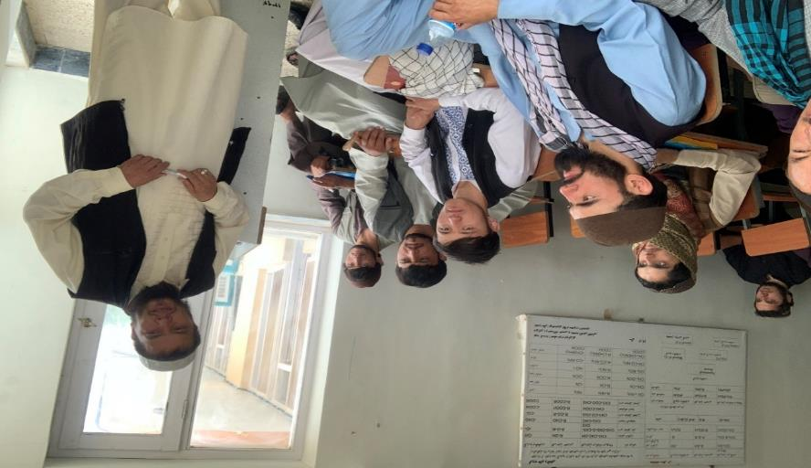
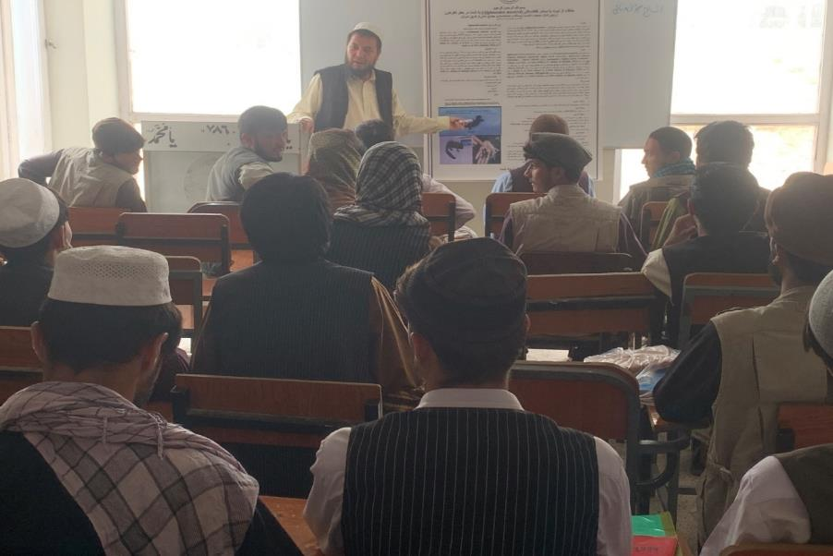
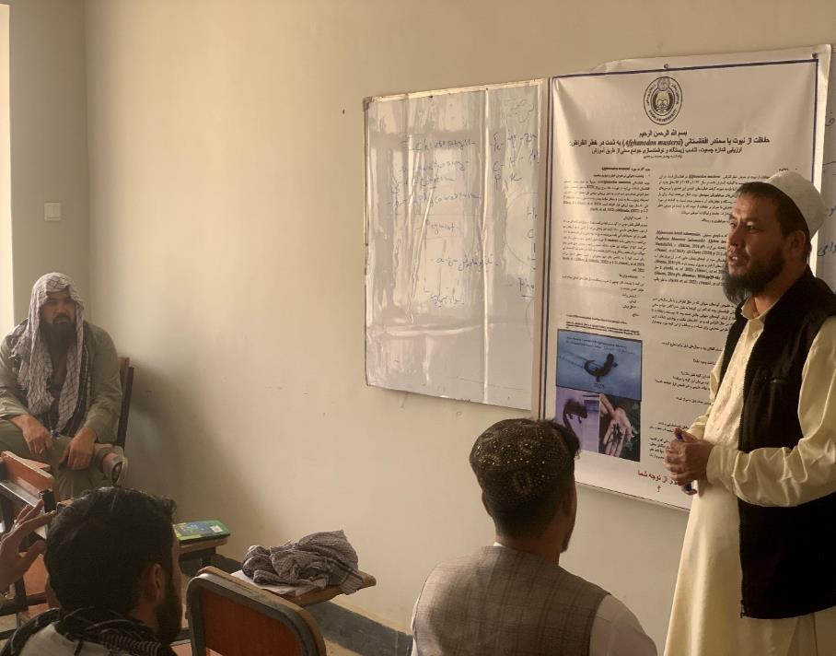

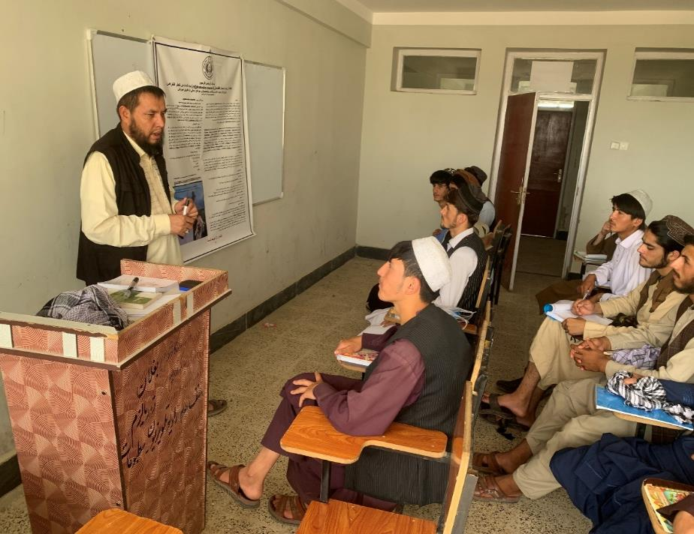
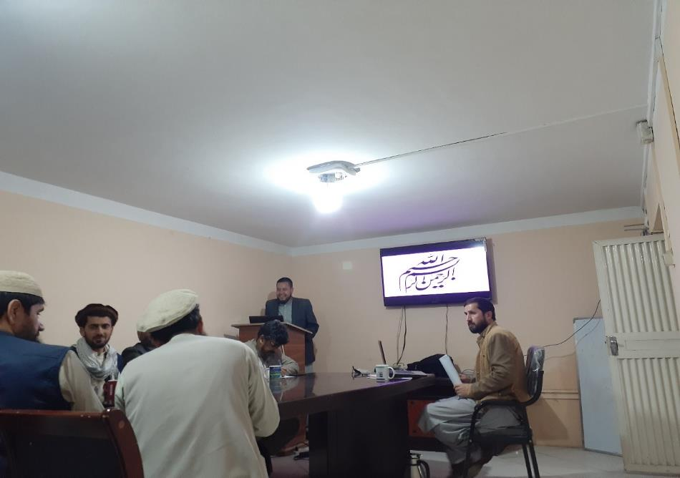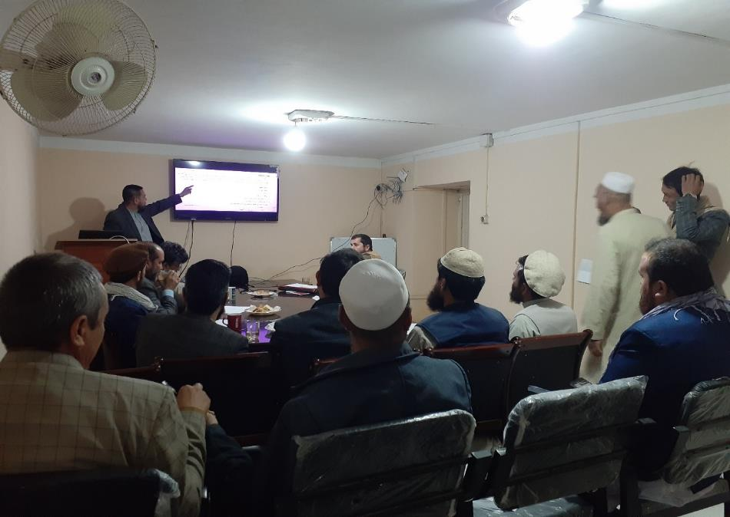

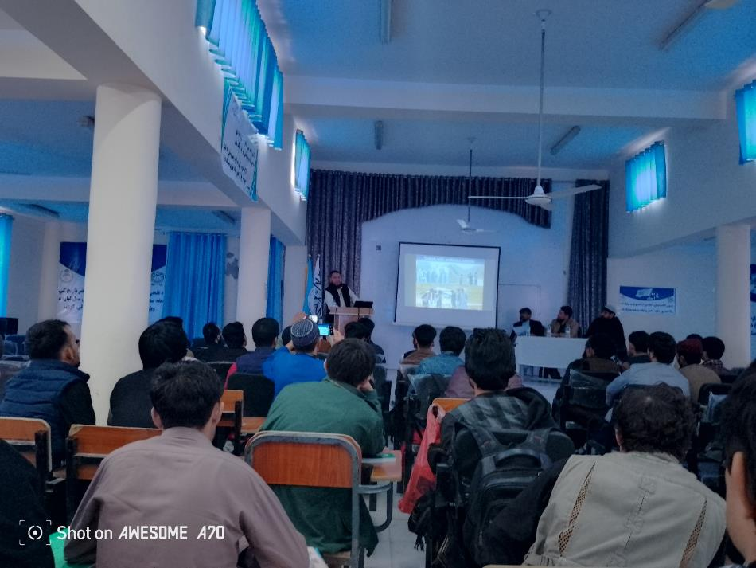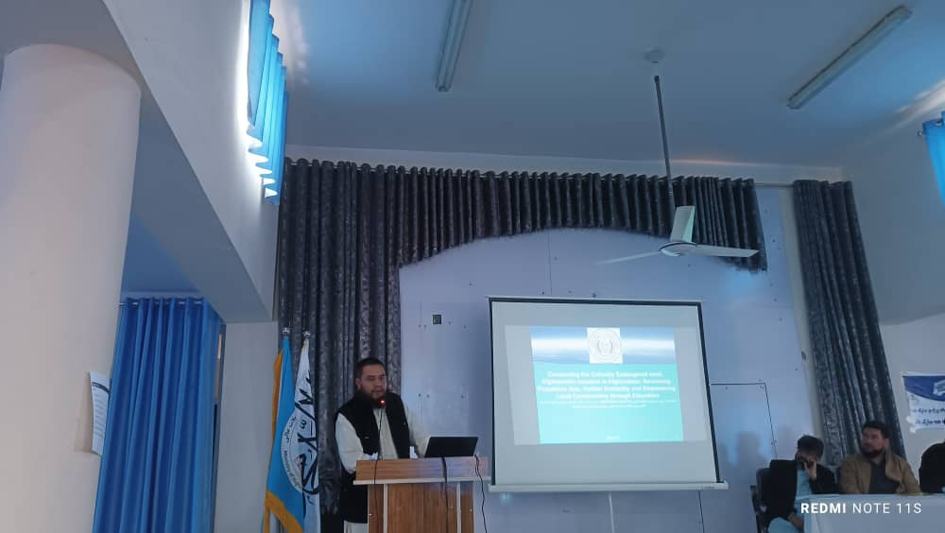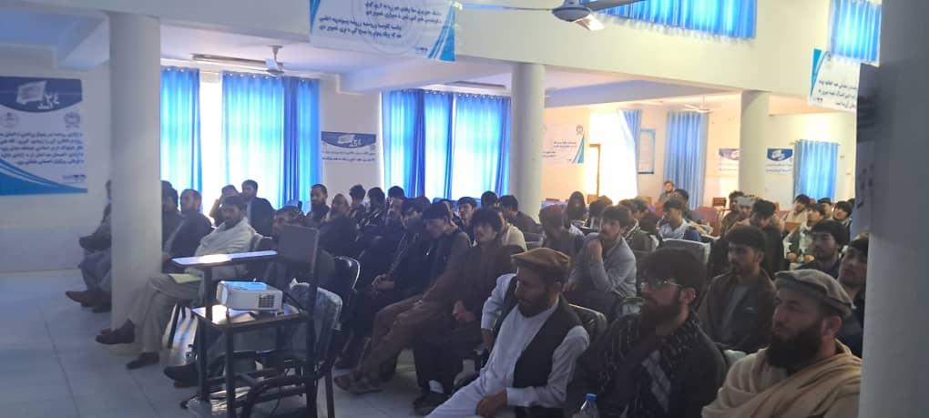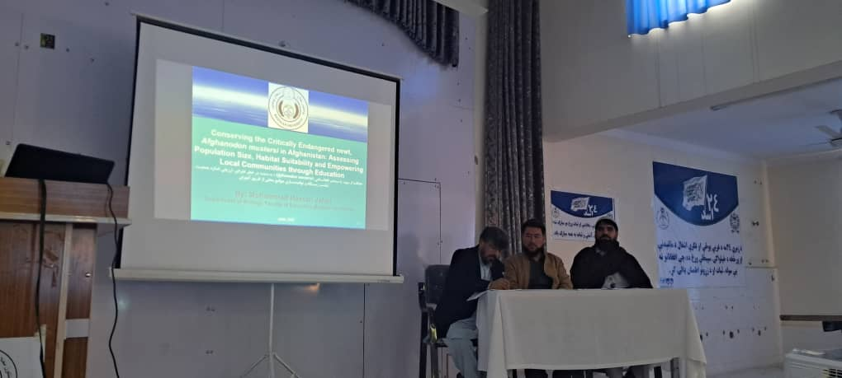
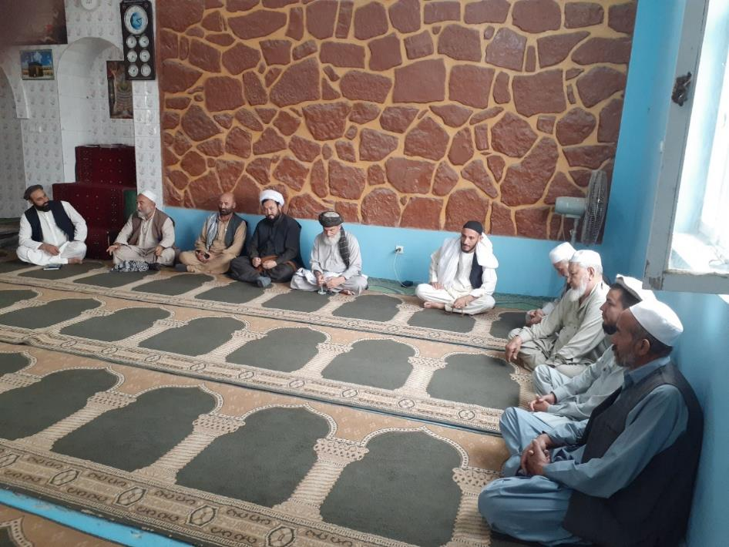
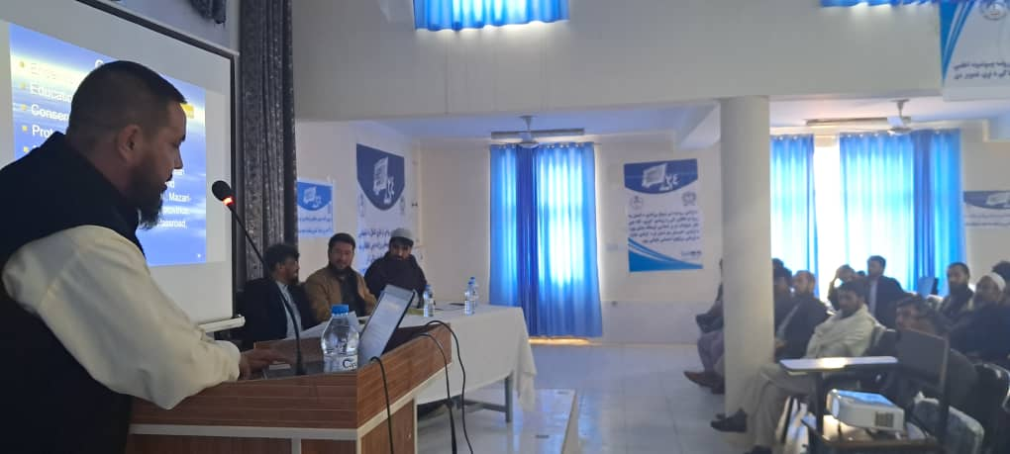
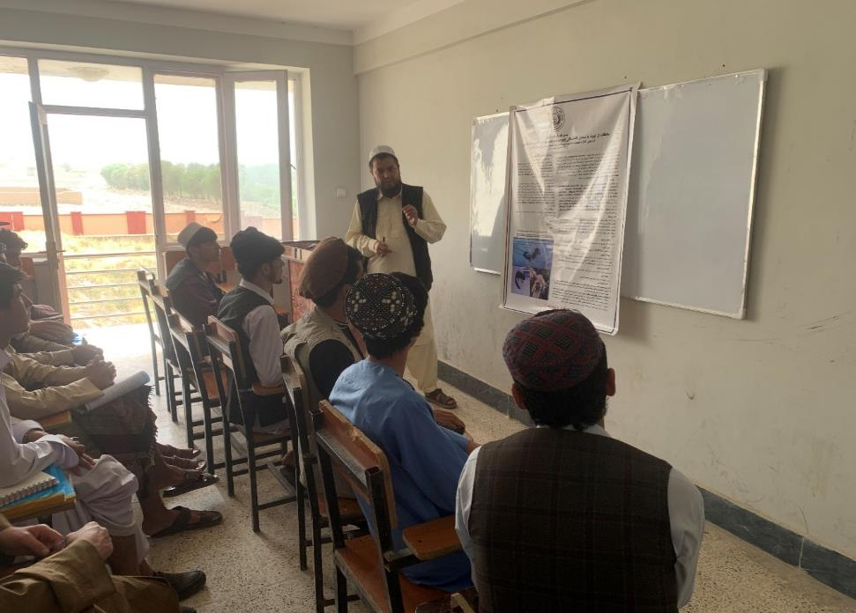
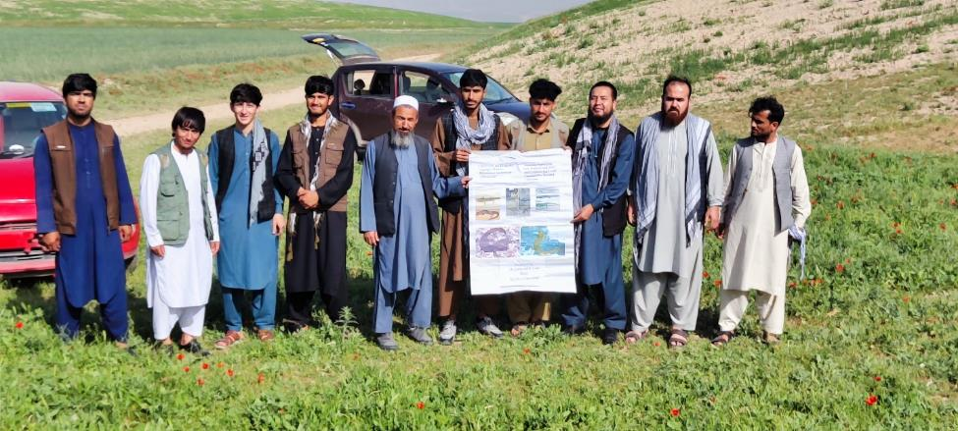
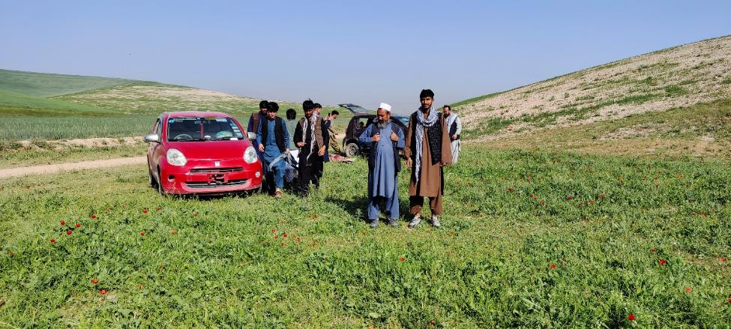

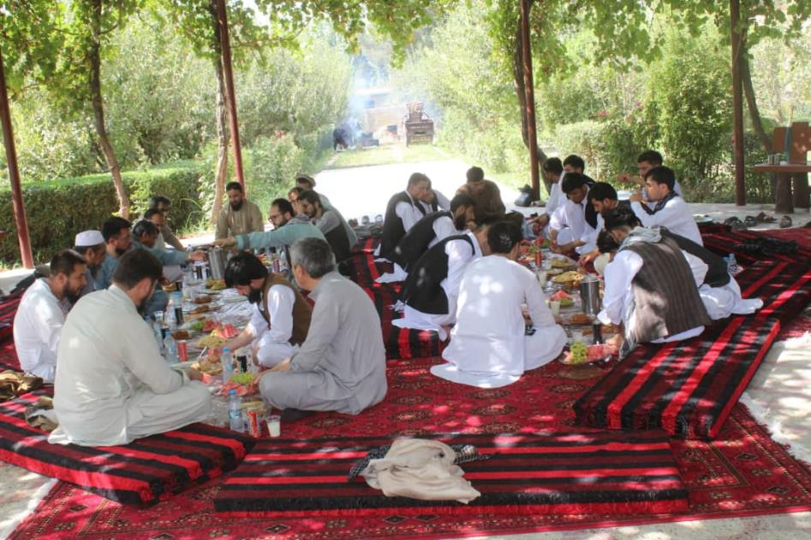
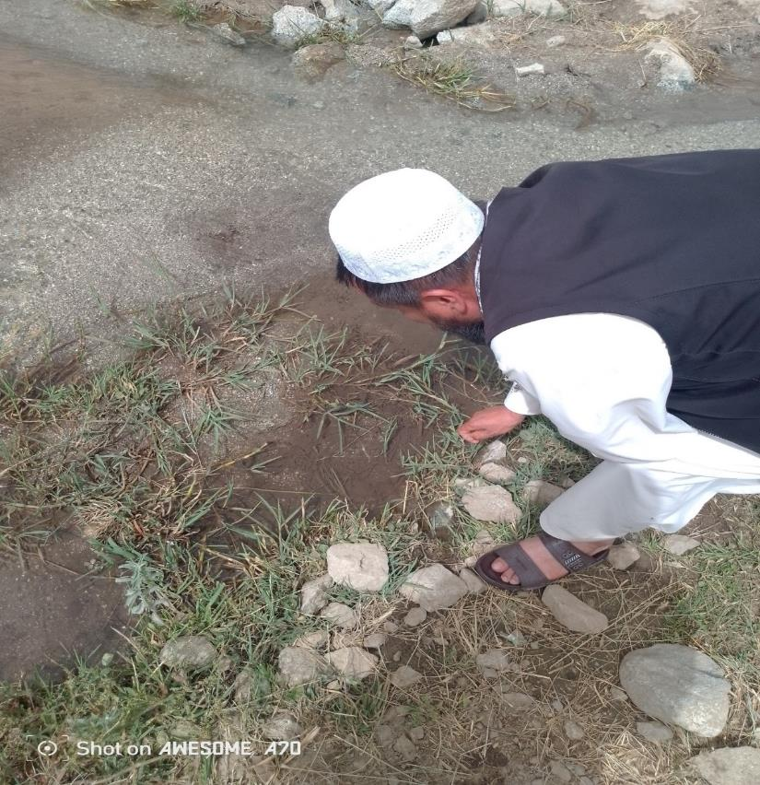

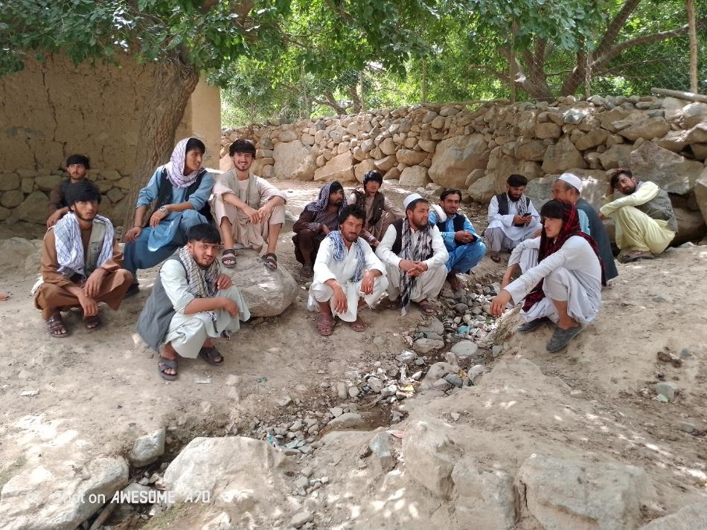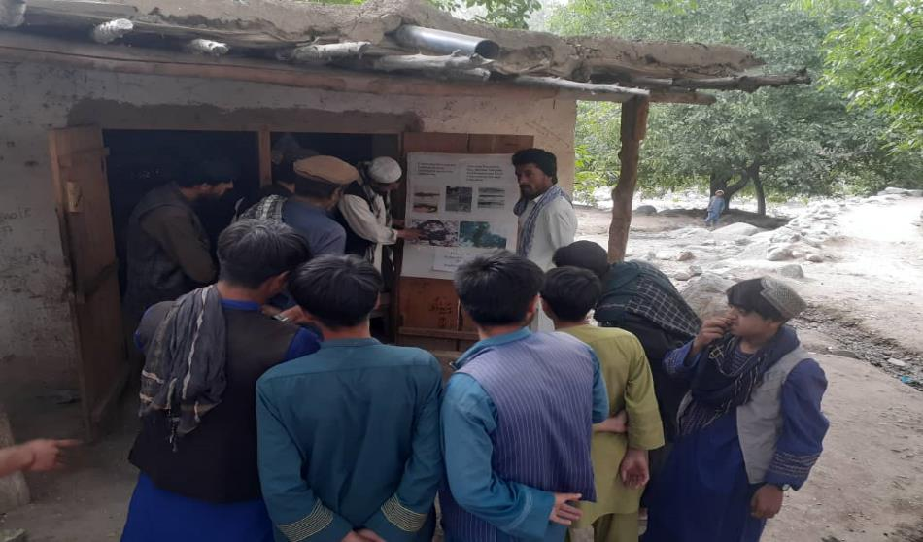
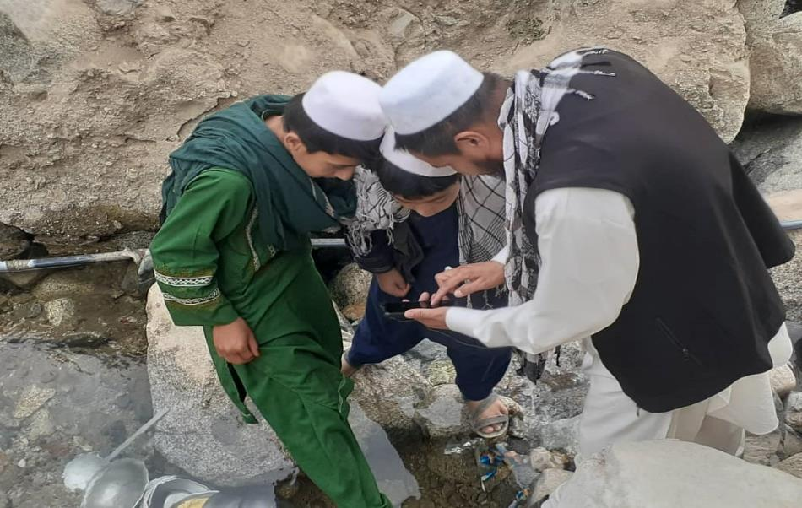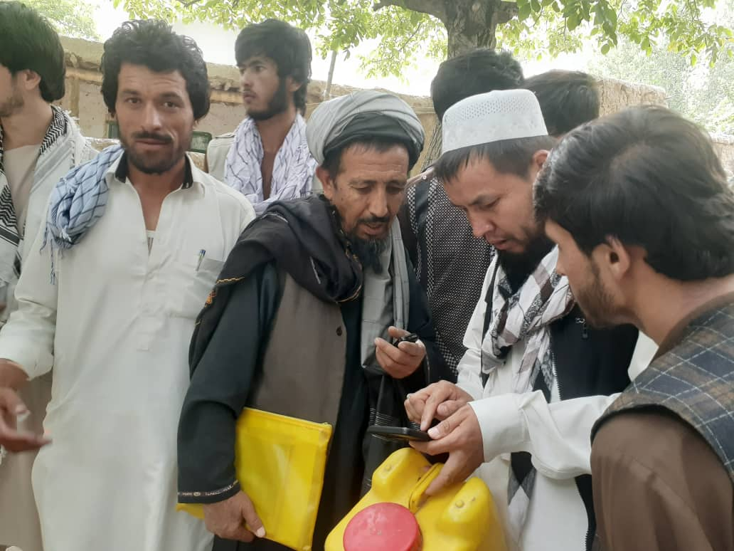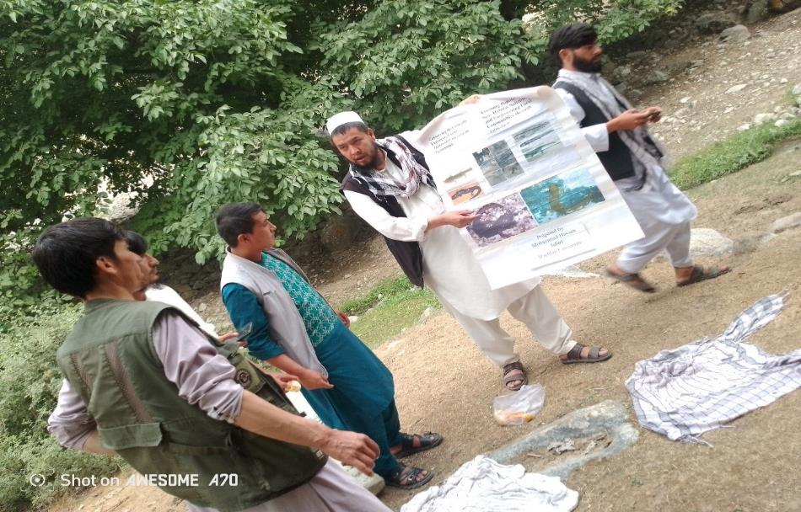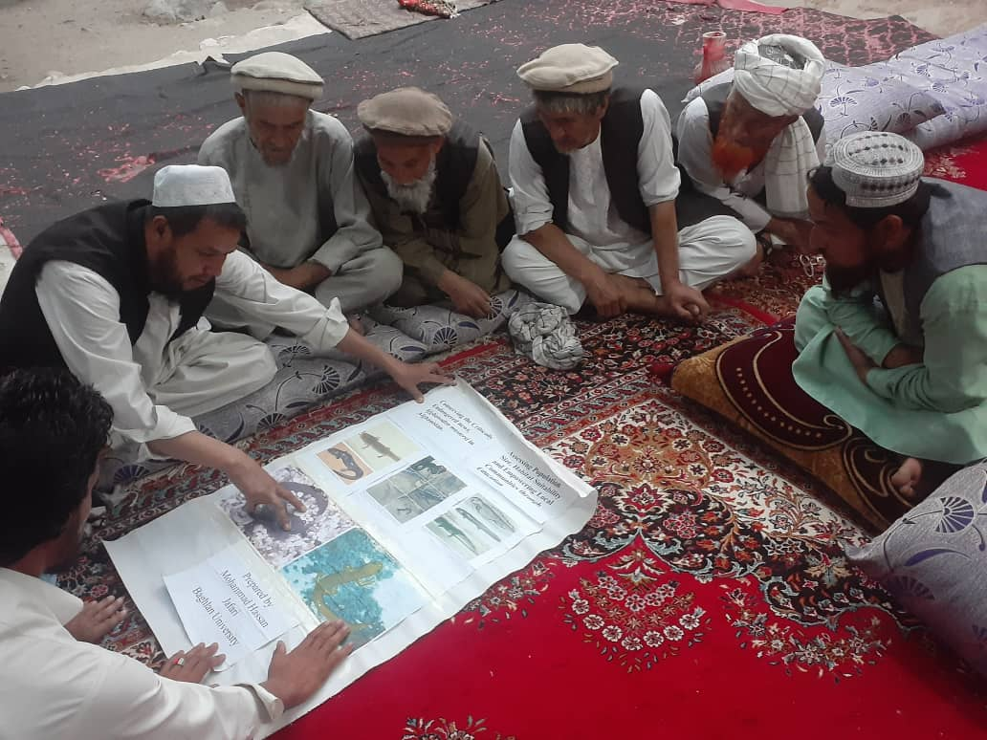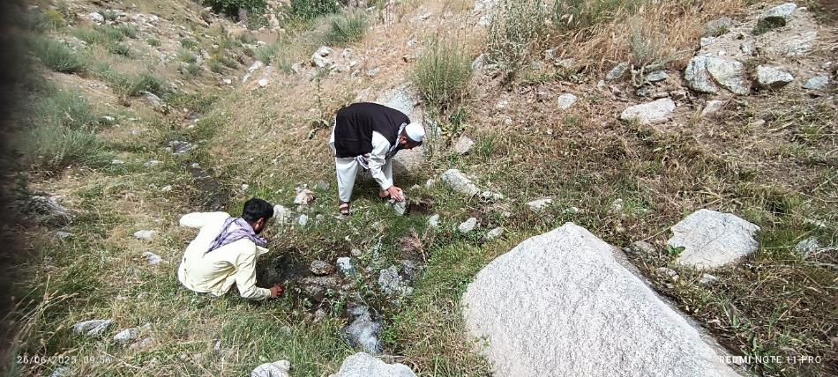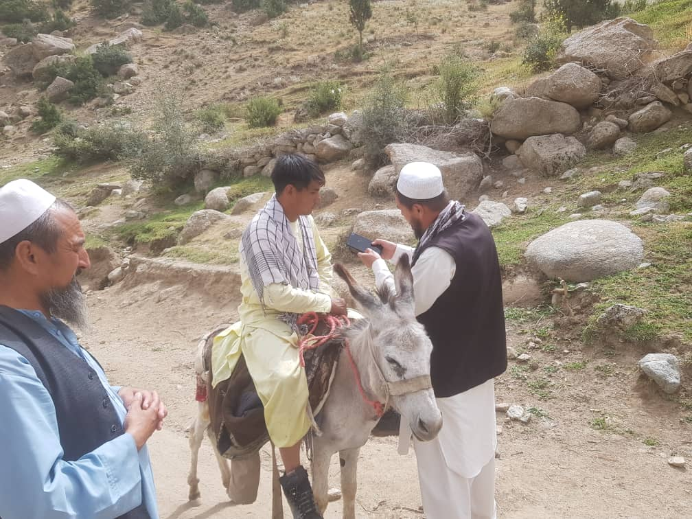
.
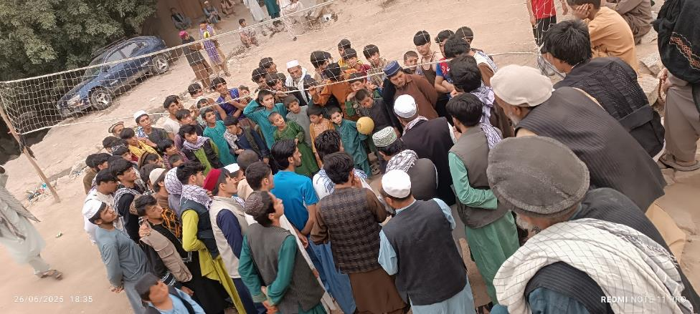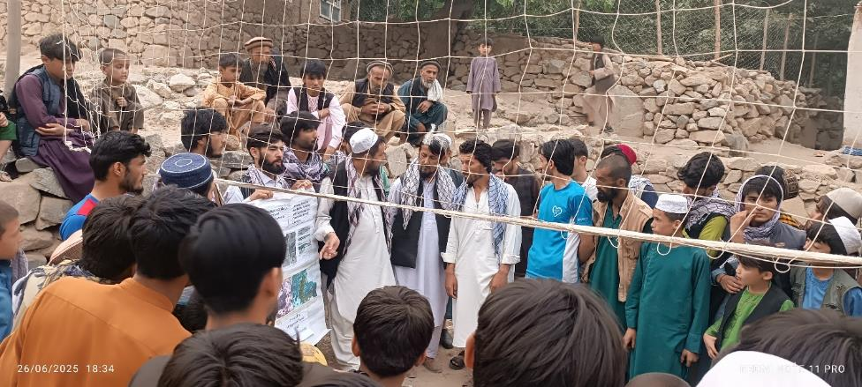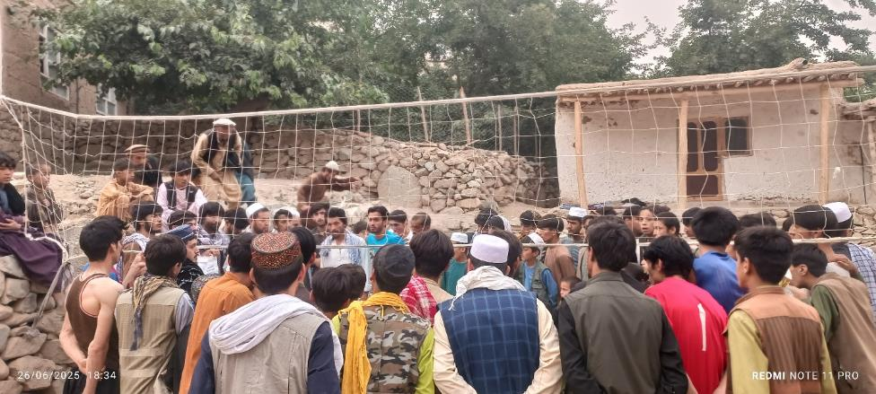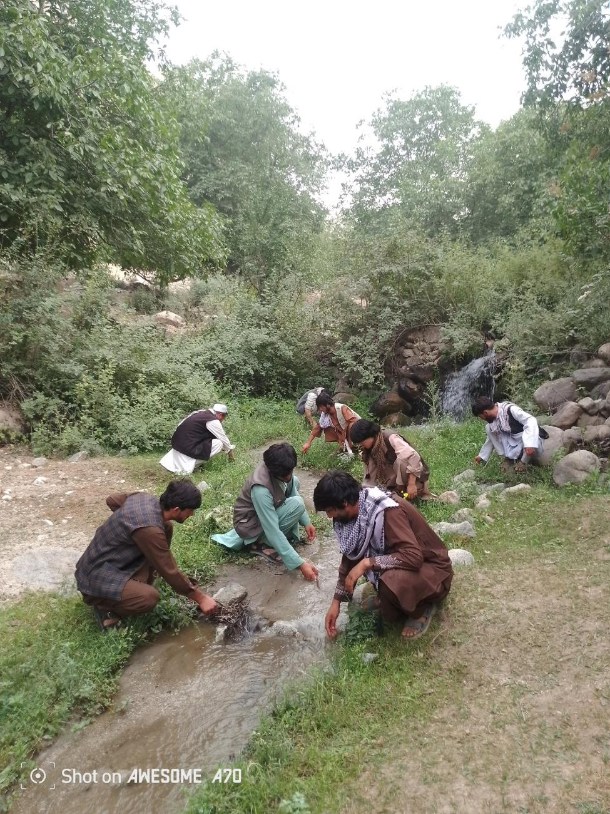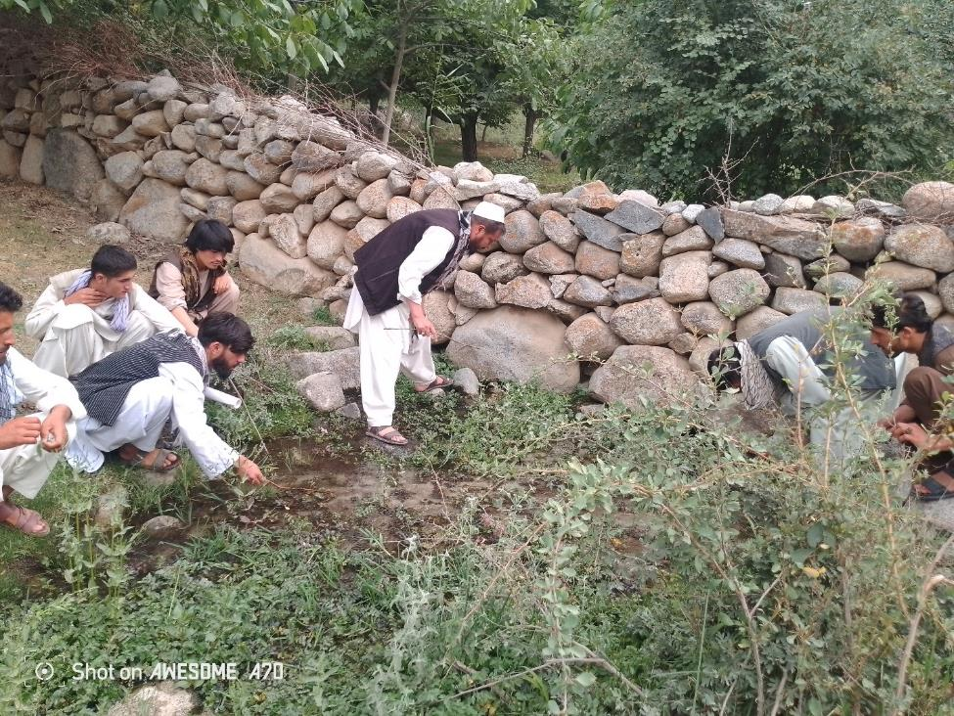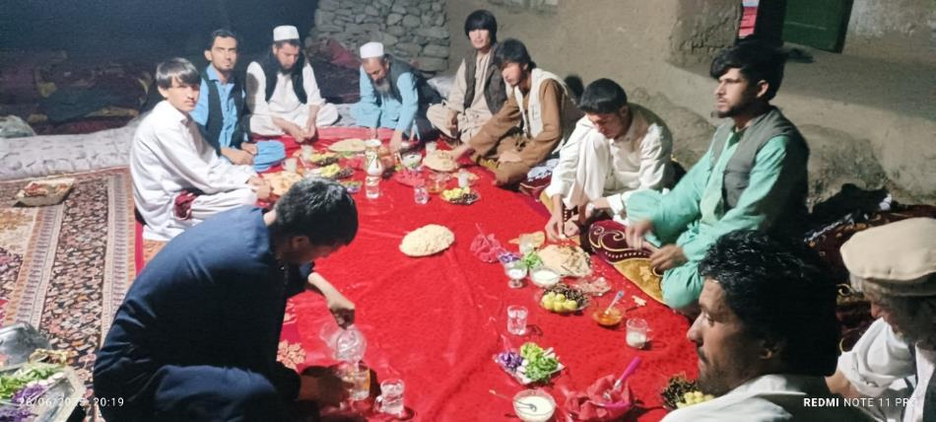
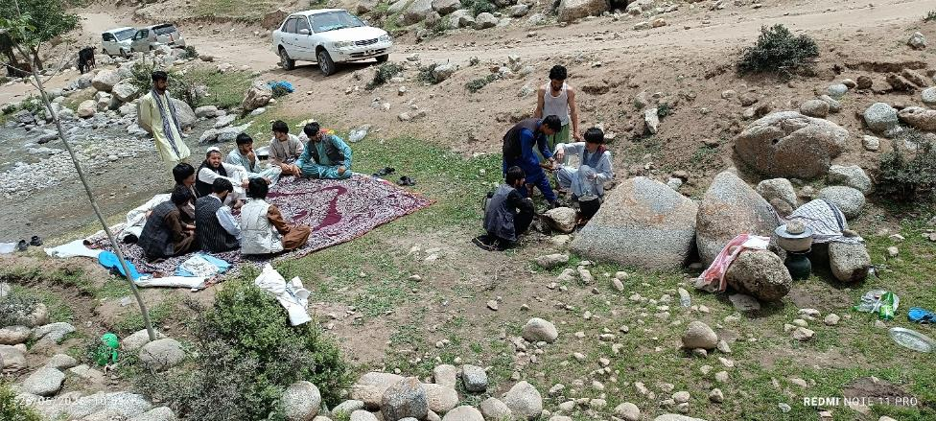
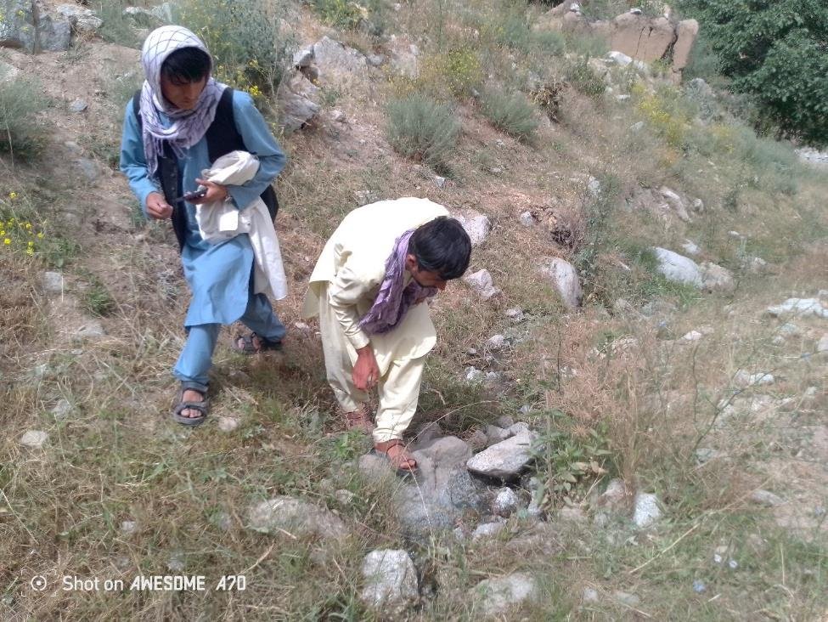
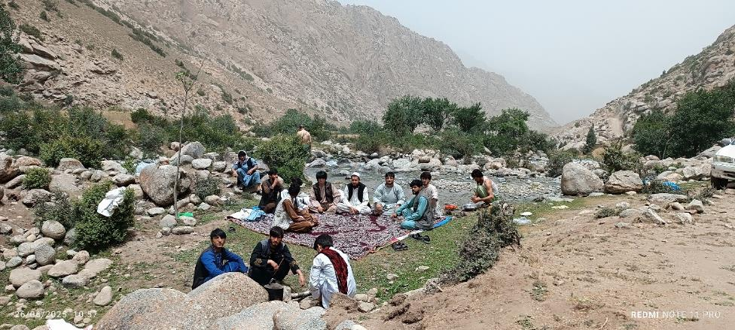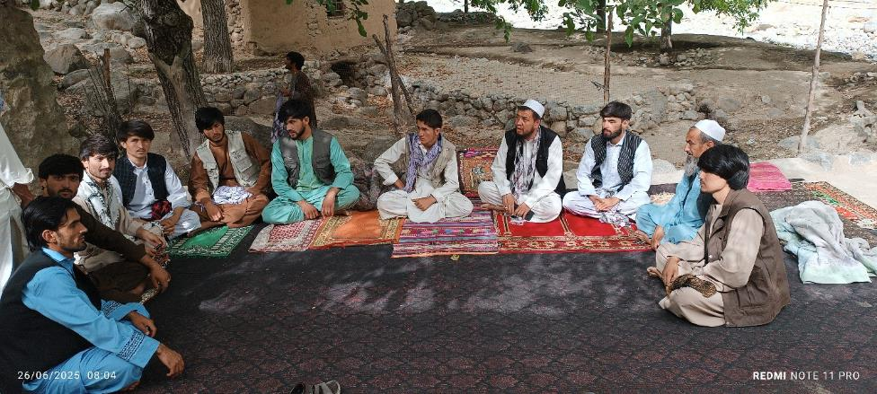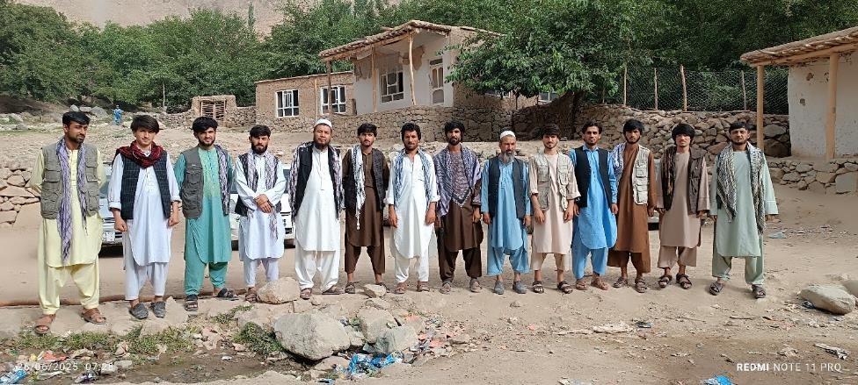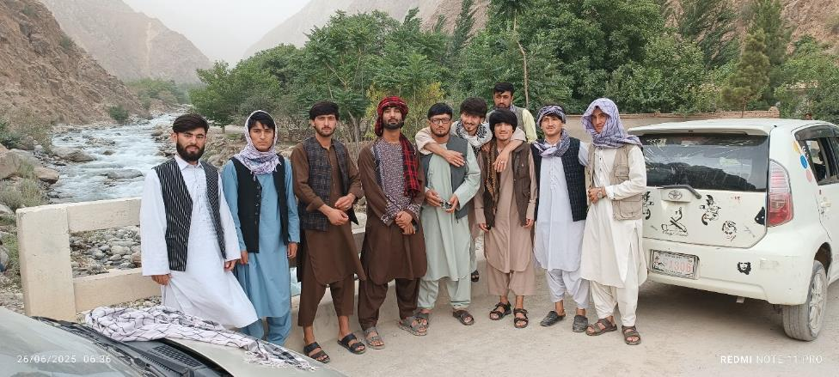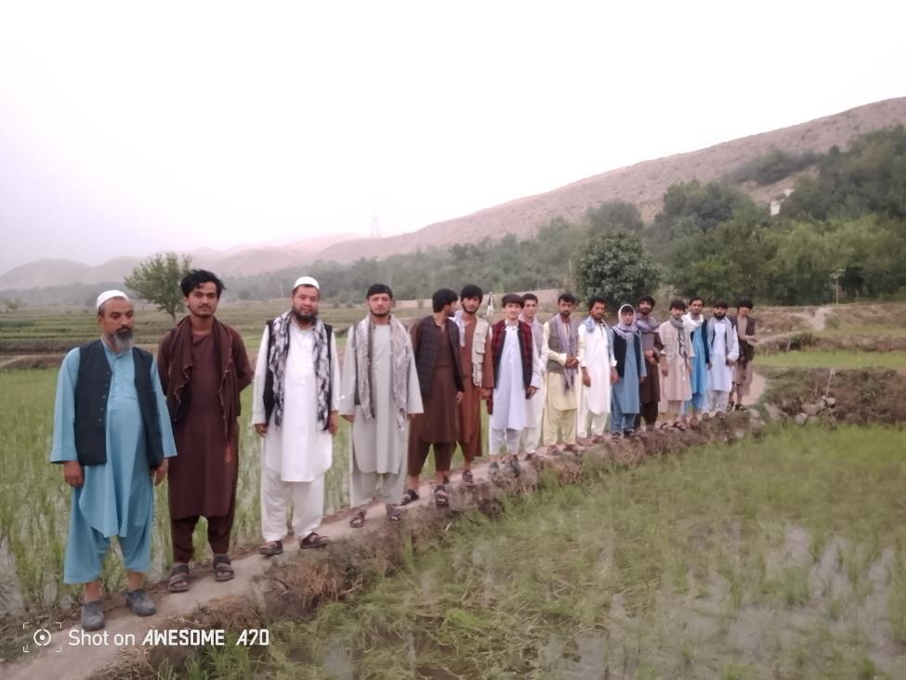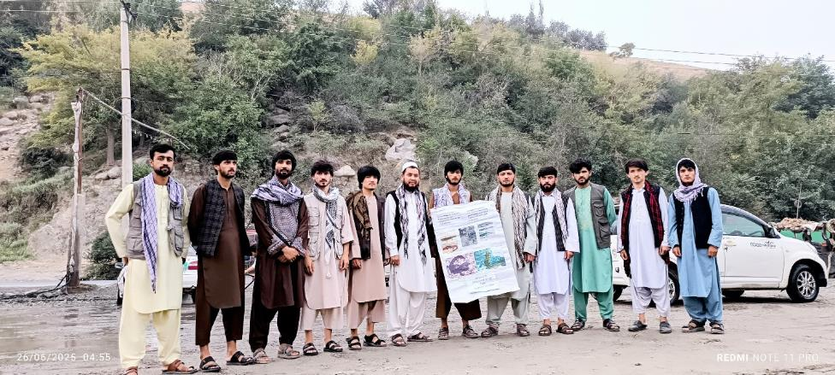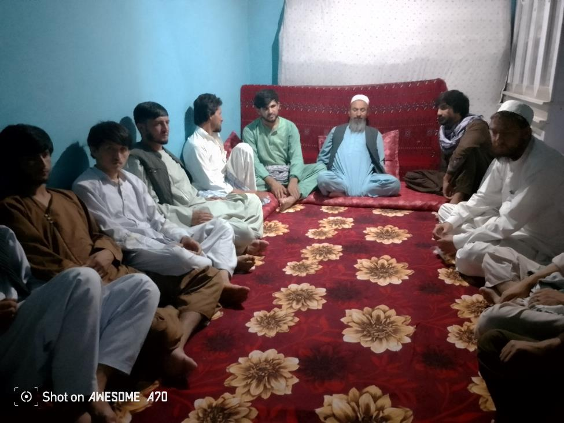
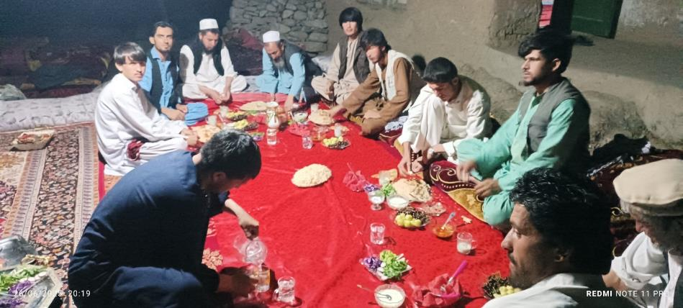

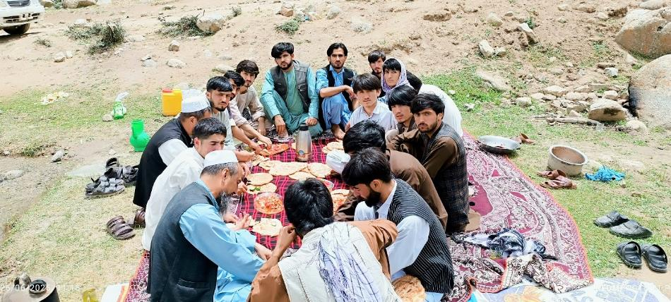

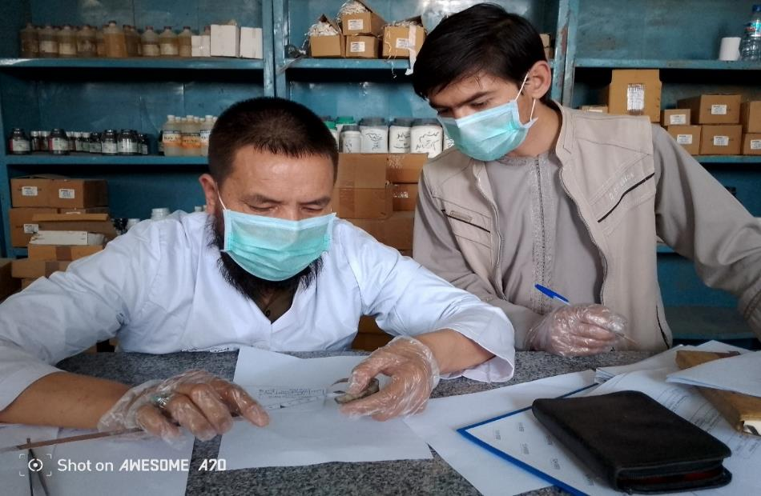Parwan Province
Surveys built on previous reports, focusing on areas like Qulich Valley in Baks village, where prior new registrations occurred.
- A spring in Qulich was destroyed by floods, resulting in no observations there, but normal populations were found in adjacent paths.
- New assessments: Hindu Spring and Khwishki Valley (a new registration site). However, ongoing droughts have dried many springs, placing the species at serious risk of extinction.
GPS coordinates for Parwan sites were documented, including longitude, latitude, and altitude.

Logar Province
Surveys targeted multiple sites in the southeast, including Qala-e Nura, Qala-e Naw, Mola area, Pangram, Takhtak, Doshakh, Kharwar, Koh-e Patank, Papal village, Qala-e Mirak, Qala-e Mulla Habib, White Mosque, city center, Kaj Darah, Bazi Khil, Kandir Khil, Kharuti, Pul-e Alam, Sayed Abad, Purak, and the special area of Mola and Kharwar.
- Despite abundant rivers and cold springs suggesting suitable habitat, no registrations of Afghanodon mustersi were made across these sites.
- Community education was conducted, including discussions with locals on species protection. Collaboration with Ms. Ra'i was maintained during surveys.
GPS coordinates for Logar sites were recorded, though no species reports were confirmed.
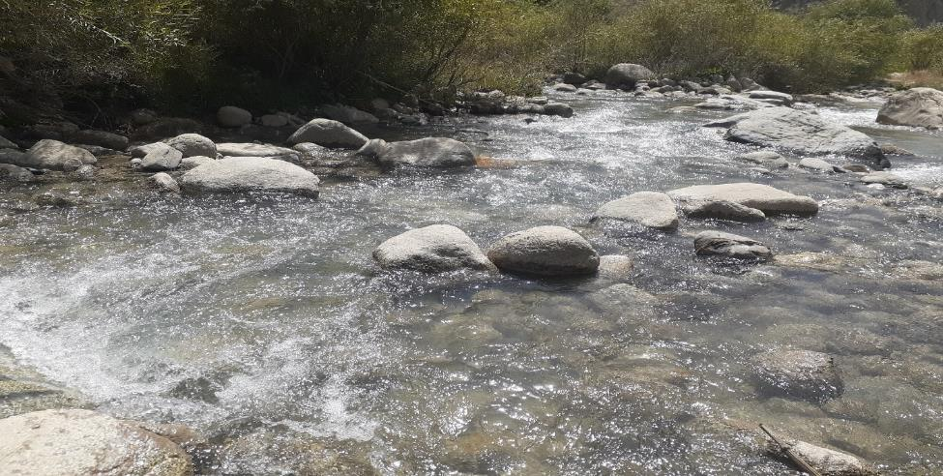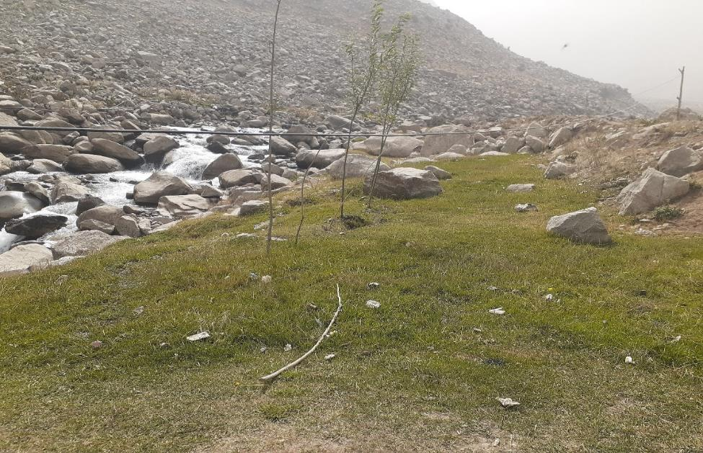

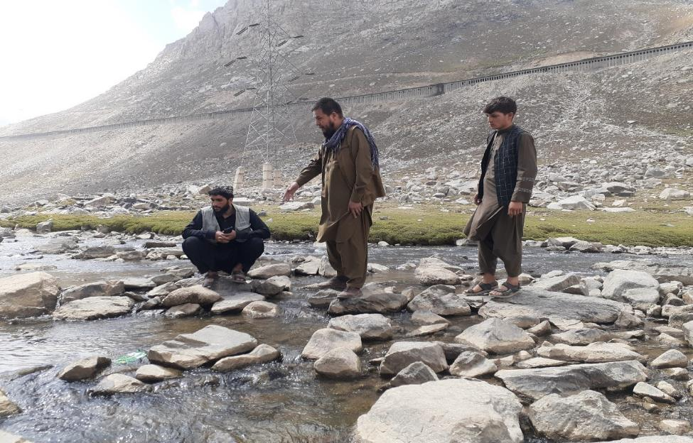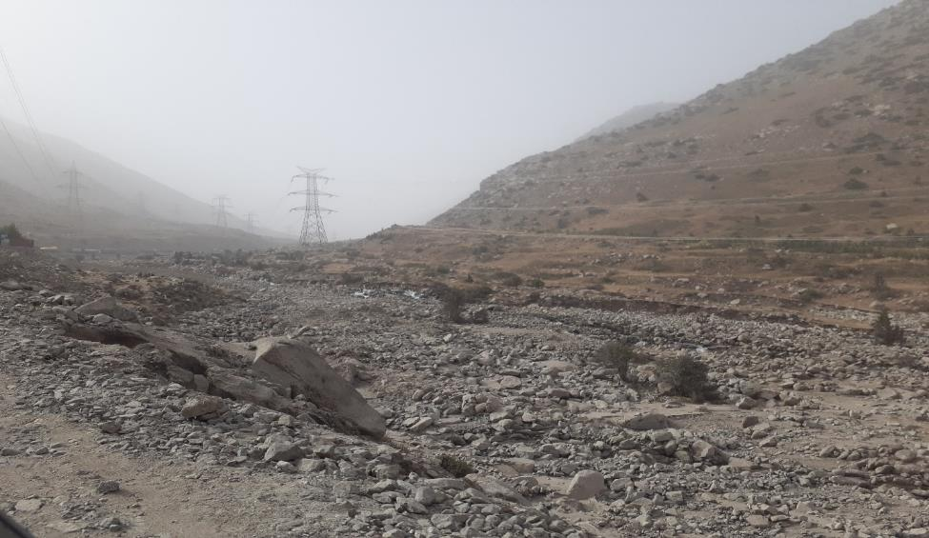
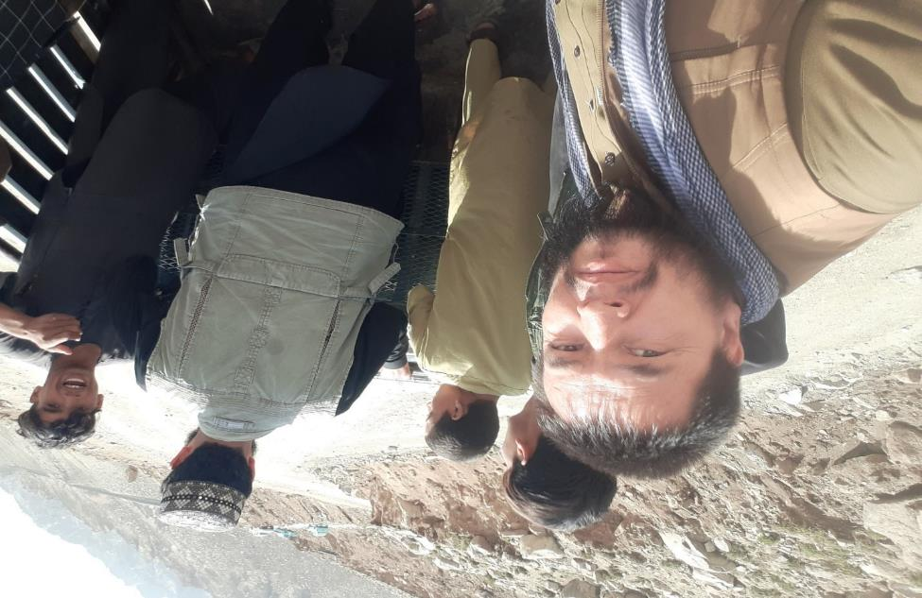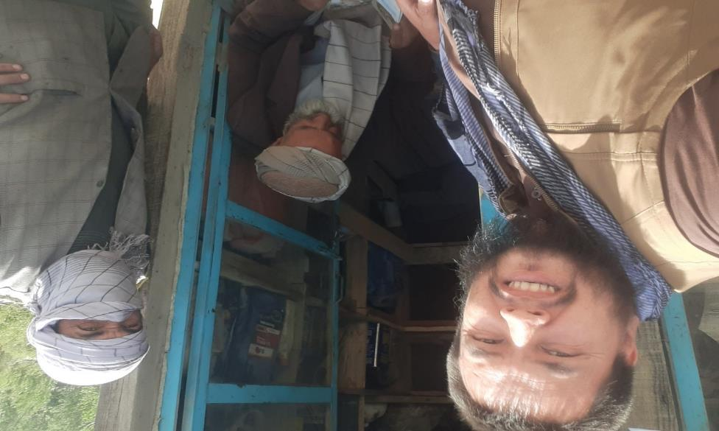
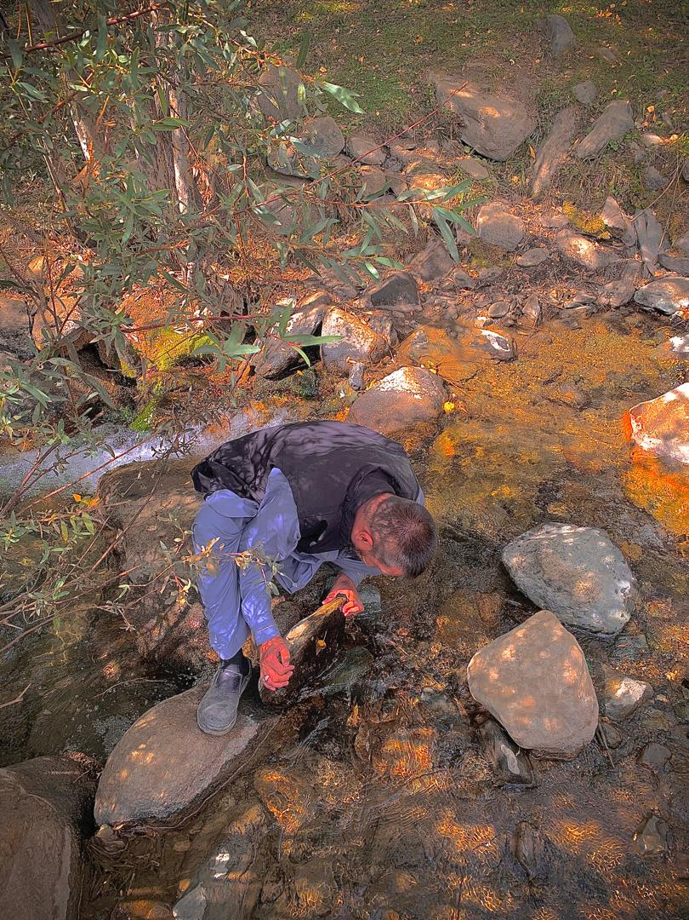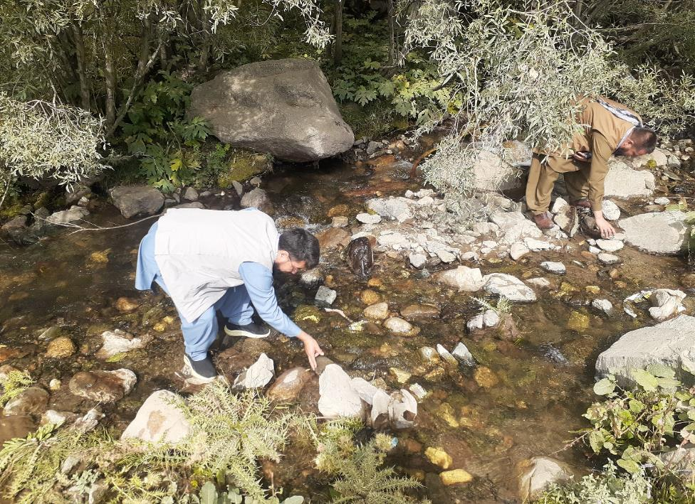

Additional Provinces
Preliminary notes indicate a new registration in Daykundi Province, with potential extensions to Wardak and Bamyan for future phases. No detailed surveys were conducted in these areas during Phase 1, but educational outreach is planned.

Challenges and Threats
- Droughts and floods have severely impacted habitats, leading to dried springs and reduced populations.
- Local misidentifications (e.g., confusing salamanders with reptiles) highlight the need for continued education.
- No species observations in many surveyed areas underscore the urgency of conservation actions.

Outcomes and Impacts
- Educational outreach reached students, teachers, professors, and local communities in mosques and schools, raising awareness about endangered species.
- Re-registrations in Doshi and new assessments in Parwan provide updated data on species distribution.
- Collected GPS and environmental data will inform habitat mapping and threat assessments for future phases.
- Community engagement fostered positive discussions, with locals expressing interest in protection efforts.

Next Steps for Phase 2
- Expand surveys to Wardak, Bamyan, and Daykundi based on preliminary leads.
- Develop targeted conservation strategies, including habitat restoration plans.
- Enhance community partnerships and monitor identified threats like climate impacts.
This phase has laid a strong foundation for ongoing conservation of Afghanodon mustersi, contributing to biodiversity sustainability in Afghanistan. Thank you to the MBZ Species Conservation Fund for supporting this vital work.

Travel and educate local people about endangered Afghanodon mustersi By Jafari In Baghlan, Parwan, Logar
GPS Baghlan Province Longitude, latitude and Altitude by jafari reported
No | People  Observed | Locality | District | Province | Altitude  (Meter) | Longitude & latitude
1 | + | Skar | Doshi | Baghlan | 1111 | 35˚ 35΄ 01˝ N  68˚ 52΄ 35˝ E
2 | _ | Daraie valiant pain | Khenjan | Baghlan | 1111 | 35˚ 35΄ 01˝ N  68˚ 52΄ 35˝ E
3 | _ | Balai doab housecha | Khenjan | Baghlan | 2019 | 35˚ 27΄ 10˝ N  68˚ 52΄ 55˝ E
4 | - | Karkar | Baghlan | Baghlan | 1400 | 36˚ 05΄ 31˝ N  68˚ 49΄ 27˝ E

GPS Parwan Longitude, latitude and Altitude by jafari reported
No | People  Observed | Locality | District | Province | Altitude  (Meter) | Longitude & latitude
1 | + | Godara Bakas | Siagerd Gorband | Parwan | 2700 | 35˚ 04΄ 24˝ N  068˚ 43΄ 04˝ E

GPS Logar Province Longitude, latitude and Altitude by jafari reported we don`t have any report.
No | People  Observed | Locality | District | Province | Altitude  (Meter) | Longitude & latitude
1 | _ | Sarband Right Mawlana | Charkh | Logar | 2305 | 33˚ 44΄ 33˝ N  68˚ 53΄ 29˝ E
2 | _ | Mawlana | Charkh | Logar | 2305 | 33˚ 45΄ 14˝ N  68˚ 54΄ 49˝ E
3 | _ | Sarband Mawlana | Charkh | Logar | 2493 | 33˚ 44΄ 07˝ N  68˚ 54΄ 33˝ E
4 | _ | Takhtak | Charkh | Logar | 2148 | 33˚ 46΄ 03˝ N  68˚ 55΄ 06˝ E
5 | _ | pingoram | Charkh | Logar | 2093 | 33˚ 47΄ 26˝ N  68˚ 56΄ 12˝ E
Submitted by: Pohandoy Mohammad Hassan Jafari Date: December 29, 2025

